1. Project

Title: SISAL (Speleothem Isotopes Synthesis and AnaLysis Working Group) database Version 1.0
Dates: 2017-2018
Funding organisations: Past Global Changes (PAGES) programme, European Research Council (ERC 694481_GC2.0), JPI-Belmont through the UK Natural Environmental Research Council (NE/P006752/1), Geological Survey Ireland Short Call 2017 (2017-SC-056), University College Dublin Seed Funding award (SF1428), European Geosciences Union (W2017/413), University of Reading, Irish Centre for Research in Applied Geosciences (iCRAG), European Association of Geochemistry (Early Career Ambassadors program 2017), Geological Survey Ireland, the Quaternary Research Association UK, Navarino Environmental Observatory, Stockholm University, Savillex, John Cantle.
Grant number: ERC 694481_GC2.0, NE/P006752/1, 2017-SC-056, SF1428, W2017/413

2. Dataset

Title: SISAL (Speleothem Isotopes Synthesis and AnaLysis Working Group) database Version 1.0
Summary description. Stable isotope records from speleothems provide information on past climate changes, most particularly information that can be used to reconstruct past changes in precipitation and atmospheric circulation. SISAL (Speleothem Isotope Synthesis and Analysis) is an international working group of the Past Global Changes (PAGES) project. The working group aims to provide a comprehensive compilation of speleothem isotope records for climate reconstruction and model evaluation. The first version of the SISAL database contains oxygen and carbon isotope measurements from 371 individual speleothem records, and 10 composites from 174 cave systems worldwide, and metadata describing the cave settings and age models of these records.
Publication year: 2018
Creators: Kamolphat Atsawawaranunt, Sandy P. Harrison, Laia Comas Bru
Organisation: Geography and Environmental Science, University of Reading, UK and School of Earth Sciences, University College Dublin, Belfield. Dublin 4, Ireland
Rights Holder: University of Reading, University College Dublin

3. Terms of use
This dataset is licensed by the rights-holder(s) under a Creative Commons Attribution 4.0 International Licence: https://creativecommons.org/licenses/by/4.0/.

4. Contents

Abstract: Stable isotope records from speleothems provide information on past climate changes, most particularly information that can be used to reconstruct past changes in precipitation and atmospheric circulation. These records are increasingly being used to provide “out-of-sample” evaluations of isotope-enabled climate models. SISAL (Speleothem Isotope Synthesis and Analysis) is an international working group of the Past Global Changes (PAGES) project. The working group aims to provide a comprehensive compilation of speleothem isotope records for climate reconstruction and model evaluation. The SISAL database contains data for individual speleothems, grouped by cave system. Stable isotopes of oxygen and carbon (δ¹⁸O, δ¹³C) measurements are referenced by distance from the top or youngest part of the speleothem. Additional tables provide information on dating, including information on the dates used to construct the original age model and sufficient information to assess the quality of each data set and to create a standardized chronology across different speleothems. The metadata table provides location information, information about the full range of measurements carried out on each speleothem and information about the cave system that is relevant to the interpretation of the records, as well as citations for both publications and archived data.

There is a single MySQL database file (sisalv1.sql). Please check https://dev.mysql.com/downloads/ to download and install MySQL. Once MySQL Community Server and MySQL Workbench are installed, the database can be imported and visualised. A schema must be created upon import. To import the SQL file, you follow:
- Open MySQL Workbench
- Connect to the connection you would like to store your database in. A connection is usually created during the installation process (usually root@localhost with the password defined during the installation process)
- Server>Data Import>Import from Self-contained file
- Browse to the SQL file you have downloaded
- Press New… next to the Default Target Schema to create a new schema (name this as appropriate, such as sisalv1)
- Press Import

Please note that once the database is imported, there are packages and modules in several programming languages which will allow you to connect to the database such as RMySQL in R, and MySQLdb in python.

There is a single compressed archive file (sisalv1.zip) comprising 14 CSV files corresponding to the 14 individual tables in the MySQL database. The CSV file names correspond to the table names. As these are flat CSV files, no relationships are defined here but the tables can be joined in different programming languages (R, Python, etc.) based on the foreign keys (shared column names between tables such as site_id in the site and entity tables). The relationships are described in Figure 1 and the characteristics of each table are described in Table 1 – 14. Please note that CSV files are in UTF-8 characters, and special characters (such as Greek characters, and letters with accents which may appear in names and in citations) may not be reproduced correctly when open as default in Excel. Please see https://scrapehero.freshdesk.com/support/solutions/articles/5000617795-how-to-open-csv-files-that-have-unicode-unprintable-or-weird-looking-characters-in-excel to see how to open this in Excel.

There is a single compressed archive file (sisalv1_codes.zip) comprising examples of codes and queries that can be used with the MySQL database, but also with the CSV files. Within this compressed archive file, there is:
- An html file (sisal_intro_example.html) which shows example SQL queries on the database
- A python file (sisal_connect2db.py) demonstrating how to connect python to the database once the database has been uploaded into MySQL.
- An R file (sisal_connect2db.R) demonstrating how to connect R to the database once the database has been uploaded into MySQL.
- An R file (sisal_csv_db.R) demonstrating how to load the CSV files into R and query these CSV files without the need to install MySQL.
File structure: The data is stored in a relational database (MySQL), which consists of 14 linked tables. Specifically: Site, entity, sample, dating, dating lamina, gap, hiatus, original chronology, d13C, d18O, entity link reference, references, composite link entity. Figure 1 shows the relationships between these tables. The structure and contents of each table is described below.
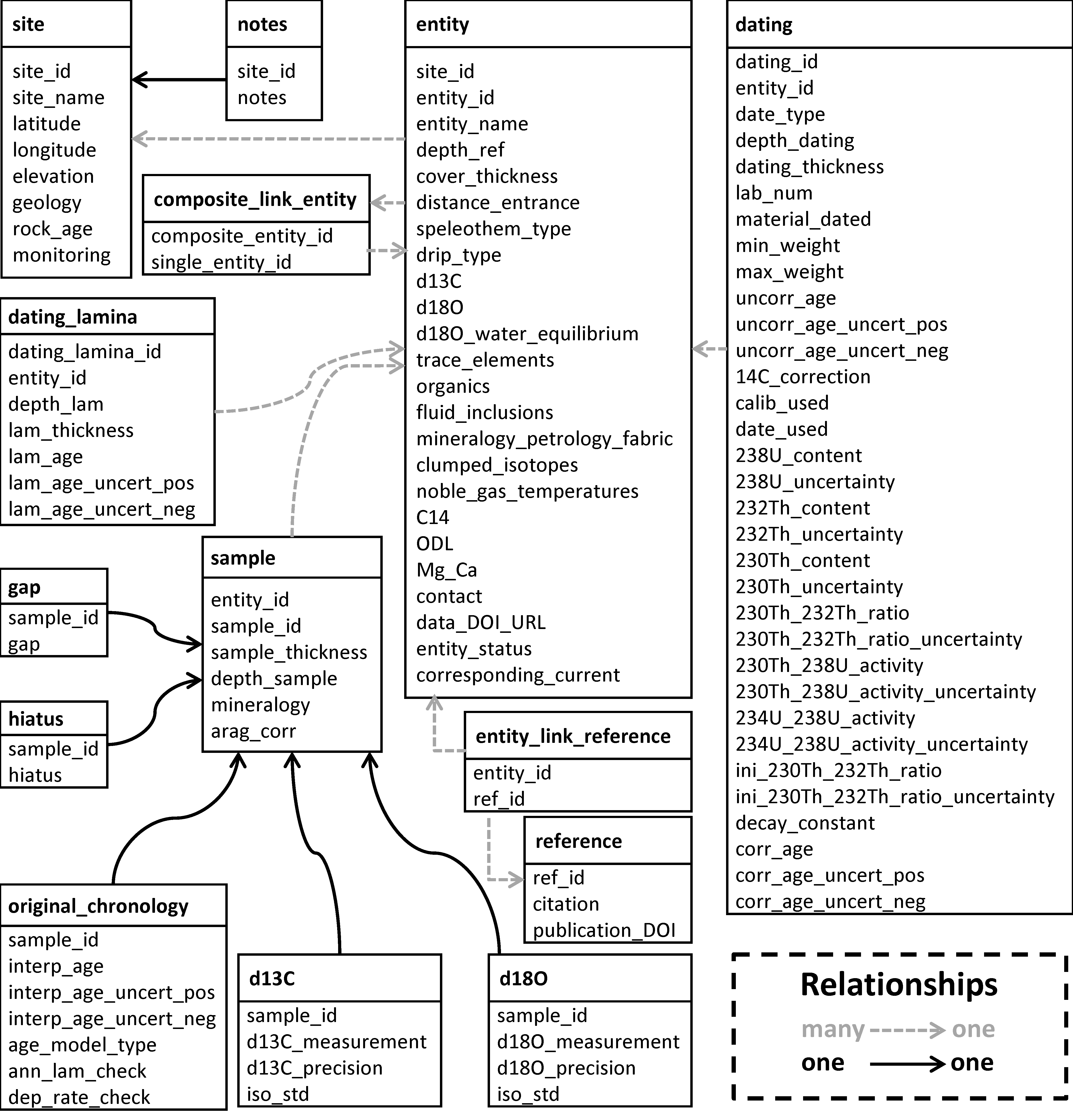
Figure 1: The structure of the SISAL database, showing individual tables (and their contents) and the nature of the relationships between them (where “many to one linkages” indicate that it is possible to have several entries in one table linked to a single entry in another table).

Table 1: Characteristics of the site table

Field label | Definition | Format | Constraints
site_id | Unique identifier for each site, where a site is defined as a cave or cave system | Numeric | Positive integer
site_name | Site name as given by original authors or as defined by us where there was no unique name given to the site | Text | None
latitude | Latitude of the cave site, given in decimal degrees, where N is positive and S is negative | Numeric | None
longitude | Longitude of the cave site, given in decimal degrees, E is positive and W is negative | Numeric | None
elevation | Elevation of the cave, in meters above sea level (where negative values indicate elevations below sea level) | Numeric | None
geology | Description of the rock type | Text | selected from pre-defined list
rock_age | Description of age of the rock | Text | selected from pre-defined list
monitoring | Indication of whether long-term monitoring of cave conditions have been carried out | Text | selected from pre-defined list

Table 2: Characteristics of the entity table

Field | Definition | Format | Constraints
site_id | Refers to the unique identifier for each site (as given in site table) | Numeric | Positive integer
entity_id | Unique identifier for each entity, where an entity is defined as a speleothem or a speleothem composite | Numeric | Positive integer
entity_name | Entity (speleothem) name as given by the author | Text | None
entity_status | Status of the entity record, specifically whether it is current, is current but includes modifications or additional information, or it has been superseded by another record | Text | selected from pre-defined list
corresponding_current | This refers to the entity_id of the record which replaces a superceded record or to the entity_id of other current records that are linked to a current but partially modified record. | Numeric | Positive integer
depth_ref | Indication of whether the reference point is the top or base of the speleothem | Text | selected from pre-defined list
cover_thickness | Thickness of overlying bedrock above the speleothem (m) | Numeric | Positive decimal
distance_entrance | Distance of the speleothem from the cave entrance (m) | Numeric | Positive decimal
speleothem_type | Description of the speleothem type | Text | selected from pre-defined list
drip_type | Description of the drip type | Text | selected from pre-defined list
d13C | Indication of whether δ¹³C measurements have been made of the speleothem | Text | selected from pre-defined list
d18O | Indication of whether δ¹⁸O measurements have been measured | Text | selected from pre-defined list
d18O_water_equilibrium | Indication of whether studies assessing if the speleothem is precipitating in equilibrium with dripwaters have been done | Text | selected from pre-defined list
trace_elements | Indication of whether trace elements have been measured | Text | selected from pre-defined list
organics | Indication of whether organics have been measured | Text | selected from pre-defined list
fluid_inclusions | Indication of whether fluid inclusions have been measured | Text | selected from pre-defined list
mineralogy_petrology_fabric | Indication of whether fabric measurements have been made | Text | selected from pre-defined list
clumped_isotopes | Indication of whether clumped isotopes have been measured | Text | selected from pre-defined list
noble_gas_temperatures | Indication of whether noble gases have been measured | Text | selected from pre-defined list
C14 | Indication of whether ¹⁴C measurements have been made | Text | selected from pre-defined list
ODL | Indication of whether the optical density of luminosity measurements have been made | Text | selected from pre-defined list
Mg_Ca | Indication of whether the Mg/Ca ratio measurements have been made | Text | selected from pre-defined list
contact | Name of the person who entered the data into the workbook | Text | None
data_doi_url | Digital Object Identifier (DOI) of the data or URL of the webpage from which the data can be obtained. | Text | None

Table 3: Characteristics of the sample table

Field | Description | Format | Constraints
entity_id | Refers to the unique identifier for each entity (as given in entity table) | Numeric | Positive integer
sample_id | Unique identifier for the sample | Numeric | Positive integer
sample_thickness | Thickness of the sample analysed (mm) | Numeric | Positive decimal
depth_sample | Distance in mm from a reference point | Numeric | Positive decimal
mineralogy | Description of the mineralogy of the sample | Text | selected from pre-defined list
arag_corr | Indication of whether the isotope measurements have been corrected in aragonite samples | Text | selected from pre-defined list

Table 4: Characteristics of the dating information table

Field | Description | Format | Constraints
dating_id | Unique identifier for each date | Numeric | Positive integer
entity_id | Refers to the unique identifier for each entity (as given in entity table) | Numeric | Positive integer
date_type | Description of the dating method used | Text | selected from pre-defined list
depth_dating | Distance in mm from a reference point | Numeric | Positive decimal
dating_thickness | Thickness of dated sample in mm | Numeric | Positive decimal
lab_num | The laboratory number of the dated sample | Text | None
material_dated | Mineralogy of the dated sample | Text | selected from pre-defined list
min_weight | Minimum weight of the dated sample in mg | Numeric | Positive decimal
max_weight | Maximum weight of the dated sample in mg | Numeric | Positive decimal
uncorr_age | Uncorrected age of the dated sample in years | Numeric | None
uncorr_age_uncert_pos | Positive uncertainty of the uncorrected age of the dated sample in years | Numeric | Positive decimal
uncorr_age_uncert_neg | Negative uncertainty of the uncorrected age of the dated sample in years | Numeric | Positive decimal
14C_correction | Percentage dead carbon present in dated sample | Numeric | Positive decimal
calib_used | Calibration method used to convert C¹⁴ dates to calendar years | Text | selected from pre-defined list
date_used | Indication of whether the date is used in the original age model | Text | selected from pre-defined list
238U_content | ²³⁸U content of the dated sample in ppb | Numeric | None
238U_uncertainty | ²³⁸U 2-sigma uncertainty of dated sample in ppb | Numeric | None
232Th_content | ²³²Th content of the dated sample in ppt | Numeric | None
232Th_uncertainty | ²³²Th 2-sigma uncertainty of the dated sample in ppt | Numeric | None
230Th_content | ²³⁰Th content of the dated sample in ppt | Numeric | None
230Th_uncertainty | ²³⁰Th 2-sigma uncertainty of the dated sample in ppt | Numeric | None
230Th_232Th_ratio | ²³⁰Th/²³²Th activity ratio of the dated sample | Numeric | None
230Th_232Th_ratio_uncertainty | ²³⁰Th/²³²Th activity ratio 2-sigma uncertainty of the dated sample | Numeric | None
230Th_238U_activity | ²³⁰Th/²³⁸U activity ratio of the dated sample | Numeric | None
230Th_238U_activity_uncertainty | ²³⁰Th/²³⁸U activity ratio 2-sigma uncertainty of the dated sample | Numeric | None
234U_238U_activity | ²³⁴U/²³⁸U activity ratio of the dated sample | Numeric | None
234U_238U_activity_uncertainty | ²³⁴U/²³⁸U activity ratio 2-sigma uncertainty of the dated sample | Numeric | None
ini_230Th_232Th_ratio | Initial ²³⁰Th/²³²Th activity ratio for the detrital correction | Numeric | None
ini_230Th_232Th_ratio_uncertainty | Initial ²³⁰Th/²³²Th activity ratio uncertainty for the detrital correction | Numeric | None
decay_constant | Description of the half-life used for ²³⁰Th and ²³⁴U for U/Th samples | Text | selected from pre-defined list
corr_age | Corrected age of the dated sample in years | Numeric | None
corr_age_uncert_pos | Positive uncertainty of corrected age of the dated sample in years | Numeric | Positive decimal
corr_age_uncert_neg | Negative uncertainty of corrected age of the dated sample in years | Numeric | Positive decimal

Table 5: Characteristics of the lamina dating table

Field | Description | Format | Constraints
dating_lamina_id | Unique identifier for each lamina | Numeric | Positive integer
entity_id | Refers to the unique identifier for each entity (as given in entity table) | Numeric | Positive integer
depth_lam | Depth of the midpoint of the lamina in mm from a reference point | Numeric | Positive integer
lam_thickness | Thickness in mm of the sample dated | Numeric | Positive decimal
lam_age | Age in years of individual lamina | Numeric | None
lam_age_uncert_pos | Positive counting uncertainty of individual lamina in years | Numeric | Positive decimal
lam_age_uncert_neg | Negative counting uncertainty of individual lamina in years | Numeric | Positive decimal

Table 6: Characteristics of the hiatus place mark information table

Field | Description | Format | Constraints
sample_id | Refers to the unique identifier for each sample (as given in sample table) | Numeric | Positive integer
hiatus | Indication of an hiatus | Text | selected from pre-defined list

Table 7: Characteristics of the gap place mark information table

Field | Description | Format | Constraints
sample_id | Refers to the unique identifier for the sample (as given in sample table) | Numeric | Positive integer
gap | Indication of a gap | Text | selected from pre-defined list

Table 8: Characteristics of the original chronology information table

Field | Description | Format | Constraints
sample_id | Refers to the unique identifier for the sample (as given in sample table) | Numeric | Positive integer
interp_age | Calendar age of the sample in years | Numeric | Positive decimal
interp_age_uncert_pos | Positive uncertainty on the age of the sample in years | Numeric | Positive decimal
interp_age_uncert_neg | Negative uncertainty on the age of the sample in years | Numeric | Positive decimal
age_model_type | Description of the age model used in the original publication | Text | selected from pre-defined list
ann_lam_check | Indication that verification that laminae are annual, in cases where lamina counting is used to construct the age model | Text | selected from pre-defined list
dep_rate_check | Indication that verification of the deposition rate has been made | Text | selected from pre-defined list

Table 9: Characteristics of the carbon isotope data table

Field | Description | Format | Constraints
sample_id | Refers to the unique identifier for the sample (as given in sample table) | Numeric | Positive integer
d13C_measurement | Original δ¹³C measurement | Numeric | None
d13C_precision | Laboratory precision on the δ¹³C measurement | Numeric | None
iso_std | Description of isotopic standard used | Text | selected from pre-defined list

Table 10: Characteristics of the oxygen isotope data table

Field | Description | Format | Constraints
sample_id | Refers to the unique identifier for the sample (as given in sample table) | Numeric | Positive integer
d18O_measurement | Original δ¹⁸O measurement | Numeric | None
d18O_precision | Laboratory precision on the δ¹⁸O measurement | Numeric | None
iso_std | Description of isotopic standard used | Text | selected from pre-defined list

Table 11: Characteristics of the publication information table

Field | Description | Type | Constraints
ref_id | Unique identifier for the reference | Numeric | Positive integer
Citation | Full citation for the original publication | Text | None
publication_DOI | Digital Object Identifier (DOI) of publication | Text | None

Table 12: Characteristics of the link entity and publication information table

Field | Description | Format | Constraints
entity_id | Refers to the unique identifier for the entity (as given in entity table) | Numeric | Positive integer
ref_id | Refers to the unique identifier for the publication (as given in the publication information table) | Numeric | Positive integer

Table 13: Characteristics of the link composite and entity table

Field | Description | Format | Constraints
composite_entity_id | Refers to the unique identifier for a composite entity (as given in entity table) | Numeric | Positive integer
single_entity_id | Refers to the unique identifier for each single entity in the composite (as given in entity table) | Numeric | Positive integer

Table 14: Characteristics of the notes table

Field | Description | Format | Constraints
site_id | Refers to the unique identifier for each site (as given in site table) | Numeric | Positive integer
notes | Notes and additional information about the site | Text | None

