Abbaye, France

The lac de l'Abbaye (ca 46°40'N, ca 5°52'E, 871m above sea level) lies in a closed basin in the High Jura (Magny et al., 1988). The lake is about 2 km long by about 600 m wide, with an area of ca 120 ha. There appears to be a small inflow at the northern end, but the lake is chiefly fed by precipitation. The catchment area is only about 350ha. Water is lost via a sinkhole (Magnin, 1904).

A west-east transect of eight cores from the end of a peninsula at the southern end of the lake provides a sedimentary record back to before 2000 yr B.P. (Magny et al., 1988). Core 1 is the most landward of the cores; Core 8 was taken in a water depth of ca 60cm at the outer edge of the emergent macrophyte zone. Changes in water depth are reconstructed on the basis of changes in lithology and the position of the sediment limit. The chronology is based on two radiocarbon dates (Magny et al., 1988; Evin, 1994).

The basal sediments (Unit 7) in all the cores consist of a fine-grained, yellow lacustrine chalk, typical of relatively deep water. A decrease in water depth is indicated by the occurrence of brown, organic chalks (Unit 6). This drying trend culminated around 1460 yr B.P. and is marked by the deposition of peat (Cores 1-3), grading laterally into peaty chalk (Cores 4 and 5) and organic chalk (Cores 6, 7 and 8).

An increase in water depth is indicated by organic chalk deposition (Unit 4). The position of the sediment limit (between Cores 2 and 3) indicates that the lake level was not as high as during the deposition of the organic chalks of Unit 6.

A pronounced regression, dated to about 1380 yr B.P., is indicated by the occurrence of peat in Cores 1 to 5 inclusive. The interval appears to have been marked in the deeper-water cores by an increase in the organic content of the sediments.

A return to deeper water conditions is recorded by the deposition of peaty chalks (Cores 2, 3 and 4) organic chalk (Core 5, 6, 7 and 8). The sediment limit of the organic chalk (between Core 4 and 5) indicates that the water level was not as high as during the deposition of the organic chalks of Unit 4.

A subsequent decrease in water depth is indicated by a transition to peaty chalk in Core 5. The position of the sediment limit of organic chalk deposition between Core 5 and 6 indicates a water depth somewhat higher than during the deposition of Unit 5.

The uppermost deposits in Cores 1, 2 and 3 are peats and probably represent infilling of the basin.

In the coding, low (1) is indicated by Unit 3; moderately low (2) by Unit 5; intermediate (3) by Unit 2; moderately high (4) by Unit 4; high (5) by Unit 6; and very high (6) by Unit 7.

References

Evin, J., 1994. Personal communication. Fax.
Magnin, A., 1904. Monographies Botaniques de 74 Lacs Jurassiens. Klincksieck, Paris, 426 pp.
Magny, M., Richard, H. and Evin, J., 1988. Nouvelle contribution a l'histoire holocène des lacs du Jura français: recherches sédimentologiques et palynologiques sur les lacs de Chalain, de Clairvaux et d l'Abbaye. Revue de Paléobiologie 7: 11-23.

Radiocarbon Date

Ly-4161 1380±150 0.73-0.85m, peat, Core 3
Ly-4162 1460±130 0.50-0.60m, peat, Core 3, ATO?

Coding

ca 2630-1930 yr B.P. very high (6)
ca 1930-1490 yr B.P. high (5)
ca 1490-1320 yr B.P. moderately low (2)
ca 1320-1050 yr B.P. moderately high (4)
ca 1050-790 yr B.P. low (1)
ca 790-350 yr B.P. intermediate (3)
ca 350-0 yr B.P. intermediate (3)

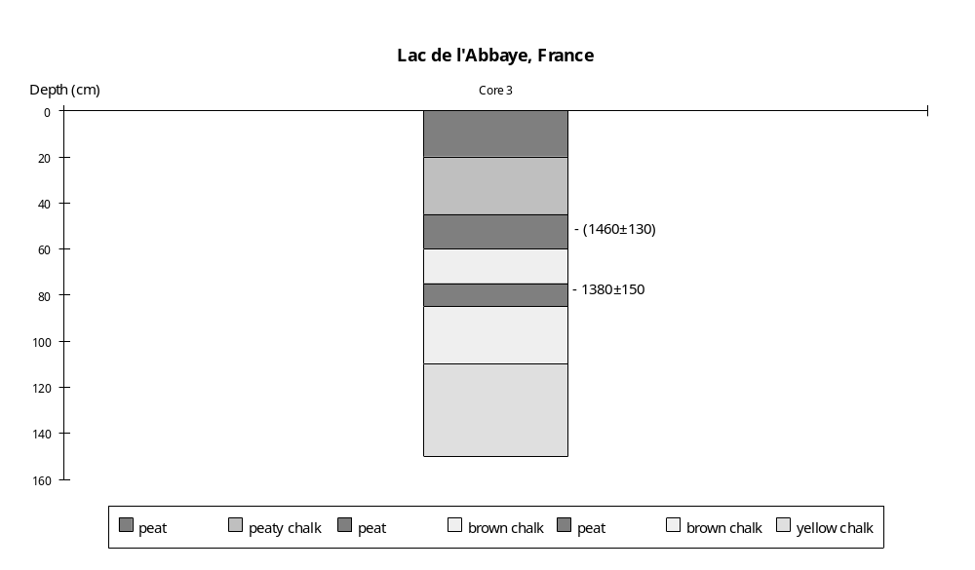

Preliminary coding: 30th November 1990; Final coding: November 1994
Coded by: SPH
Chalain, France

The lac de Chalain (46°40'30"N, 5°46'E, 488m above sea level) lies within a blind valley cut into the western edge of the calcareous plateau which forms the western margin of the Ain Valley (Magny et al.,1988). The basin is of glacial origin and the lake lies behind a moraine ridge. The lake is about 2.8 km long by 0.8 km wide, with an area of ca 224ha. It is fed by a karst spring, du Gour Bleu (Frachon, 1980), itself derived from overflow from the lac de Narlay and the lac du Vernois, which lie some six kilometers to the east on the calcareous plateau (Magnin, 1904). The lake has a natural outlet northwestwards via the Bief de l'Oeuf to the Ain river, but the outflow has been controlled since the beginning of the century as part of a hydroelectric scheme.

There are a number of drowned Neolithic and Bronze Age archaeological sites around the margin of the lake (Bourdier, 1962; Duret and Martini, 1965; Lambert et al., 1983), indicating that the lake was lower than present between ca 5600 and 3600 yr B.P. Pile fragments, artefacts and charcoal from these a number of these sites have been radiocarbon dated to between 4170 and 5850 yr B.P. (Hassko et al., 1974; Evin et al., 1973, 1983; Delibrias et al., 1986).

A 2m-long core from the southwestern corner of the lake provides a sedimentary sequence believed to span most of the postglacial (Duret and Martini, 1965). Unfortunately the sequence is not radiocarbon dated. The basal sediments are blue clays. The overlying sediments (0.55-1.11m) are lacustrine chalk, indicating moderately deep water. The mollusc assemblage in the uppermost 10cm of the unit consists of Planorbis carinatus, Lymnaeae ovata, Valvata piscinalis and Pisidium nitidum, and is consistent with deep water. A diffuse ash layer, thought to be derived from the last phase of volcanic activity in the Massif Central around 8000-9000 yr B.P., occurs within the uppermost part of this unit (ca 0.60m).

The overlying unit (0.50-0.55m) is a brown chalk, which may indicate a decrease in water depth. There is, however, no change in the mollusc assemblage except for the addition of Pisidium subtruncatum, a species which is also characteristic of deep water.

The overlying unit (0.40-0.50m) is a compressed peat, indicating shallow water conditions. The mollusc assemblage contains Lymnaea truncatula, carychium tridentatum, Succinea pfeifferi, Vertigo pygmaea, Vallonia costata, Cochlicopa lubrica and Fruticicola edentula, a mixture of aquatic, marsh and terrestrial species. Palynological evidence suggests that this peat is Neolithic in age, which is consistent with the occurrence of drowned Neolithic settlements elsewhere around the lake.

A more detailed record of the stratigraphy of the lacustrine deposits has been reconstructed from a transect of six cores perpendicular to the western shore at the archaeological site known as Station 7 (Magny et al., 1988). Cores 6 and 5 lie in the zone above highest modern water level; cores 4, 3 and 2 were taken in the zone between highest and lowest modern water level; and core 1 lies offshore in a water depth of ca 0.5m. Stratigraphic, and palynological analyses were made on Core 4 (Magny et al., 1988). Changes in water depth are reconstructed on the basis of changes in stratigraphy, sedimentology and aquatic pollen assemblages. The chronology is based on a single radiocarbon date from Core 4 (Magny et al., 1988). There is an inexplicable discrepancy of some 1500 to 2000 yr between the age given by radiocarbon dating and that suggested by pollen analysis. In view of the poor pollen preservation in the sediments, the radiometric date seems to provide the most reliable chronological information.
The basal sediments (Core 4: 1.10-1.50m) are fine-grained homogenous yellow lacustrine chalks, typical of moderately deep water. The occurrence of Chara oogonia and concretions mainly of the coarse tube and cauliflower type is consistent with moderately deep water. The occurrence of Nymphaea and Nuphar is consistent with this interpretation. The sediments contain molluscs. Geochemical (organic and calcium carbonate) analyses suggest the transition to the overlying unit was abrupt.

The overlying unit (Core 4: 0.43-1.10m) is peat, indicating a marked drop in water level. In Core 4 there is a single peat layer, which varies somewhat in degree of decomposition. A sample from 0.50-0.85m was radiocarbon dated to 1420+120 yr B.P. (Ly-4199). This gives a sedimentation rate for the upper part of the core of 0.48 mm/yr and suggests that the interval of peat deposition lasted from ca 2290 to 900 yr B.P. In Core 1 (which lies furthest offshore) the equivalent unit (0.12-0.50m) consists of three separate peat layers (ca 0.12-0.15m, 0.30-0.35m, 0.38-0.40m) intercalated with lacustrine chalk. Geochemical (organic and calcium carbonate) analyses suggest the transition to the overlying unit was relatively gradual.

The overlying unit (Core 4: 0.00-0.41m) consists of a grey lacustrine chalk. In the onshore cores (5 and 6) this unit is represented by a peaty chalk. The basal part of the unit in Core 4 contains quite high amounts of coarse material and organic debris, characteristic of deposition in relatively shallow water in the littoral zone. The abundance of platy concretions, and the comparative rarity of tube or cauliflower-type concretions, is consistent with shallow conditions, as is the abundance of Cyperaceae pollen. The increasing abundance of tube or cauliflower-type concretions and the disappearance of platy concretions suggests an gradual increase in water depth. The decrease in abundance of Cyperaceae is consistent with increased depth, although levels remain higher than in the basal chalk. The sediments contain molluscs. The pollen in all but the uppermost 0.10m of the unit is corroded and suggests that the sediments were subject to oxidation, which is consistent with relatively shallow conditions.

The uppermost unit is peat, which is apparently forming in the modern littoral vegetation zone.

In the coding, low (1) is indicated by peat deposition or by the presence of archaeological sites below modern lake levels; intermediate by fairly coarse-grained, organic lacustrine chalk deposition with moderately abundant Cyperaceae and corroded pollen; high (3) by fine-grained lacustrine chalk deposition and modern (uncontrolled) lake level.

References

Bourdier, F., 1962. Le bassin du Rhône au Quaternaire. Editions du C.R.N.S., Paris, 364pp.
Delibrias, G., Guillier, M.-T. and Labeyrie, J., 1986. Gif natural radiocarbon measurements X. Radiocarbon 28: 9-68.
Duret, J-J. and Martini, J., 1965. Un niveau de cendres volcaniques dans la craie lacustre du lac de Châlain (Jura français). Arch. Sc. Soc. Phys. Hist. Nat. Genève 18: 679-686.
Evin, J., Marien, G. and Pachiaudi, Ch., 1973. Lyon natural radiocarbon measurements III. Radiocarbon 15: 134-155.
Evin, J., Marechal, J. and Marien, G., 1983. Lyon natural radiocarbon measurements IX. Radiocarbon 25: 59-128.
Frachon, J.C., 1980. La grotte du Gour Bleu (Fontenu, Jura). Bulletin de l'Association Spéléologique de l'Est, 3ème série, 16: 17-24.
Hassko, B., Guillet, B., Jaegy, R. and Coppens, R., 1974. Nancy natural radiocarbon measurements III. Radiocarbon 16: 118-130.
Lambert, G., Petrequin, P. and Richard, H., 1983. Périodicité de l'habitat lacustre néolithique et rythmes agricoles. L'Anthropologie (Paris) 87: 393-411.
Magnin, A., 1904. Monographies Botaniques de 74 Lacs Jurassiens. Klincksieck, Paris, 426pp.
Magny, M., Richard, H. and Evin, J., 1988. Nouvelle contribution a l'histoire holocène des lacs du Jura français: recherches sédimentologiques et palynologiques sur les lacs de Chalain, de Clairvaux et d l'Abbaye. Revue de Paléobiologie 7: 11-23.

Radiocarbon Dates

Ly-4199 1420±120 peat, 0.50-0.85m, Core 4 station 7
Ly-2008 4170±130 wood, Station 6, pile fragment
Gif-2637 4220±140 wood stake, Station 1
Ly-2007 4250±130 wood,pile fragment, Station 5
Gif-2638 4280±180 wood stake, Station 2
Gif-4369 4400±110 wood, littoral village, Marigny
Ly-385 4640±140 wood, upper part level 0, Les Roseaux; ATO; probably reworked materal.
Ny-144 5790±220 charcoal, Les Roseaux, Level 1
Ny-143 5850±180 charcoal, Les Roseaux, Level 4

Coding

ca 9000 yr B.P. high (3) -- n.b. dating poor
5800-3600 yr B.P. low (1)
3600-2290 yr B.P. high (3)
2290- 900 yr B.P. low (1) and fluctuating
900- 0 yr B.P. intermediate (2)

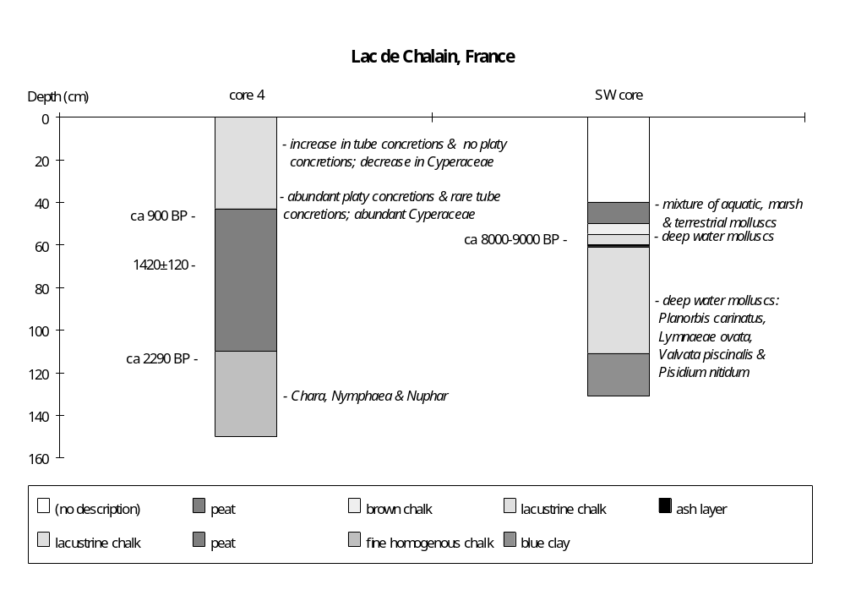

Final coding: November 1991
Coded by SPH

Clairvaux, France

The lacs de Clairvaux (46°34'N, 5°45'E, 526m above sea level) are two closely connected lakes lying within a blind valley cut into the western edge of the calcareous plateau which forms the western margin of the Ain Valley (Magny et al., 1988). The basin is of glacial origin and both lakes are dammed behind moraine ridges. The upstream lake (the Petit Lac de Clairvaux) is about 270m long by 170m wide, with an area of ca 4.5 ha. The Grand Lac de Clairvaux is about 500m long by 250m wide, and has an area of ca 12.5 ha (Magny et al., 1988). The Grand Lac de Clairvaux has a maximum depth of 19.5m (Pétrequin, 1986). The lakes are fed by karst springs, and overflow via the Drouvenant to the Ain river.

A number of authors have attempted to reconstruct changes in lake level at Clairvaux (e.g. Magny, 1978; Lambert et al., 1983; Pétrequin, 1986; Magny et al., 1988). These reconstructions are based on archaeological information and sedimentological studies. The reconstruction presented here is based on a consensus interpretation of the available evidence. The chronology is based on radiocarbon dating (Delibrias et al., 1974; Hassko et al., 1974; Evin et al., 1973, 1975, 1978; Pétrequin and Olive, 1986).

A 6m core from the eulittoral zone of the Petit Lac de Clairvaux provides a lithological and pollen record back to the Boreal (Richard, 1989). However, this record provides no indication of changes in water depth. The sediments consist of lacustrine chalk, with individual layers distinguished on the basis of being more or less granular. A major break in the pollen record at 3.0-3.05m, dated to 3300-3200 B.C., could indicate a sedimentary hiatus, but is more likely to reflect the first human impact in the basin (Richard, 1989).

At least nine drowned Neolithic and Bronze Age archaeological sites occur along the shores of the Grand Lac de Clairvaux (e.g. Station II, III, IV, VIII, La Motte aux Magnins) These sites show that the lake was lower than present between ca 5600 and 3600 yr B.P. (Lambert et al., 1983). Artefacts and charcoal from some of these sites have yielded radiocarbon dates in the range 4070 to 5890 yr B.P. (Hassko et al., 1974; Evin et al., 1975, 1978; Pétrequin and Olive, 1986). While the presence of drowned archaeological sites is an indication that the lake was lower during the period of settlement, Lambert et al. (1983) argue that the abandonment of the sites may not have been synchronous with (or caused by) the subsequent increase in water level. A pollen core, taken in the nearshore zone, shows an hiatus in sedimentation between ca 3300 and 3000 yr B.P. (Lambert et al., 1983), which suggests that lowered water levels persisted after the archaeological sites were abandoned.

A transect of three cores from the northern shore of the Petit Lac provides a sedimentary record back to the early Atlantic (Magny et al., 1988; Magny and Richard, 1989). Core 1 is ca 2m long and was taken in a water depth of ca 30cm in the nearshore zone. Cores 2 and 3 were taken in water depths of ca 60cm in the emergent macrophyte zone. Core 2 is ca 2.5m long. Core 3 is 1m long and only encompasses the record since ca 2500 yr B.P. Changes in water depth are reconstructed on the basis of changes in lithology, sedimentology and aquatic pollen assemblages. There is only one radiocarbon date from Core 3.

The basal deposits (0.80-1.00m in Core 3) are white lacustrine chalk. Chara oogonia are common. The relative abundance of concretions of the tube- and cauliflower-types is consistent with relatively deep water, as is the comparative paucity of Cyperaceae.

The overlying unit (0.75-0.80m in Core 3) is a granular chalk, containing a relatively high proportion of coarse material. The sediments suggest a decrease in water depth.

The further decrease in water depth is marked by the deposition of a brown organic chalk (0.47-0.75m in Core 3). The organic content, which reaches 40% at the base of the unit, consists predominantly of aquatic macrophyte roots and indicates relatively shallow water. The marked decrease in abundance of concretions indicative of deep water and the increase in ball-type concretions is consistent with this interpretation, as is the abundance of Cyperaceae and the peak in the abundance of Ranunculaceae in the upper part of the unit. A sample from 0.50-0.60m was radiocarbon dated to 1310±180 yr B.P. (Ly-4198).

An increase in water depth is indicated by the deposition of white, fine-grained lacustrine chalk between 0.32-0.47m (in Core 3). Chara oogonia are common. The relative abundance of concretions of the cauliflower-type is consistent with relatively deep water. The absence of tube-type concretions suggests that water depth was not as great as during the deposition of the basal unit (Magny et al., 1988). The marked decrease in Cyperaceae abundance is also consistent with deeper water.

The overlying unit (0.27-0.32m in Core 3) is an organic lacustrine chalk. The organic content (ca 25%) consists predominantly of aquatic macrophyte roots and indicates that water depth was relatively shallow.

A slight increase in water depth is indicated by deposition of granular chalk (0.26-0.27m in Core 3) containing a relatively high proportion of coarse material.

The uppermost unit (0.00-0.26m in Core 3) is a white fine-grained lacustrine chalk. The abundance of concretions of the cauliflower-type is consistent with relatively deep water, although not as deep as that indicated by the basal deposits.

In the status coding, very low (1) is indicated by now-drowned archaeological sites or by an hiatus in sedimentation in the pollen core; low (2) by fairly coarse-grained, organic lacustrine chalk deposition; moderately low (3) by granular chalk deposition; intermediate (4) by fine-grained lacustrine chalk deposition, with concretions of the cauliflower-type; and high (5) by fine-grained lacustrine chalk deposition with both cauliflower- and tube-type concretions.

References

Delibrias, G., Guillier, M.T. and Labeyrie, J., 1974. GIF natural radiocarbon measurements VIII. Radiocarbon 16: 15-94.
Evin, J., Marien, G. and Pachiaudi, Ch., 1973. Lyon natural radiocarbon measurements III. Radiocarbon 15: 134-155.
Evin, J., Marien, G. and Pachiaudi, Ch., 1975. Lyon natural radiocarbon measurements V. Radiocarbon 17: 4-34.
Evin, J., Marien, G. and Pachiaudi, Ch., 1978. Lyon natural radiocarbon measurements VII. Radiocarbon 20: 19-57.
Hassko, B., Guillet, B., Jaegy, R. and Coppens, R., 1974. Nancy natural radiocarbon measurements III. Radiocarbon 16: 118-130.
Lambert, G., Pétrequin, P. and Richard, H., 1983. Périodicité de l'habitat lacustre néolithique et rythmes agricoles. L'Anthropologie 87: 393-411.
Magny, M. and Richard, H., 1989. Contribution à l'histoire du Petit Lac de Clairvaux. Recherches palynologiques et sédimentologiques. In: Pétrequin, P. (ed.), Les Sites Littoraux Néolithiques de Clairvaux-les-lacs (Jura). II. Le Néolithique moyen. Editions de la Maison des Sciences de l'Homme, Paris, pp. 79-84.
Magny, M., Richard, H. and Evin, J., 1988. Nouvelle contribution a l'histoire holocène des lacs du Jura français: recherches sédimentologiques et palynologiques sur les lacs de Chalain, de Clairvaux et d l'Abbaye. Revue de Paléobiologie 7: 11-23.
Pétrequin, P. (ed.), 1986. Les Sites Littoraux Néolithiques de Clairvaux-les-lacs (Jura). I. Problématique générale. L'example de la station III. Editions de la Maison des Sciences de l'Homme, Paris.
Pétrequin, P. and Olive, P., 1986. Les dates carbone 14 de la station III. In: In: Pétrequin, P. (ed.), Les Sites Littoraux Néolithiques de Clairvaux-les-lacs (Jura). I. Problématique générale. L'example de la station III. Editions de la Maison des Sciences de l'Homme, Paris, pp. 168-170.
Richard, H. 1989. L'analyse pollinique du Petit Lac: les six mètres supèrieurs. In: Pétrequin, P. (ed.), Les Sites Littoraux Néolithiques de Clairvaux-les-lacs (Jura). II. Le Néolithique moyen. Editions de la Maison des Sciences de l'Homme, Paris, pp. 45-49.

Radiocarbon Dates

Ly-4198 1310±180 organic chalk, 0.50-0.60m, Core 3
Ly-854 1390±120 wood, submerged Station II, pile fragment
Gif-2300 1620±90 charcoal, Late Bronze age hearth in peat, 0.3m, the age disagrees with industry
Gif-2297 3660±110 lake coring, CZ 64
Gif-1844 3800±110 archaeological material, Mycenae
Gif-2299 3880±110 wood, Station III, level 0
CRG-206 4014±41 Station III, level 0
Ly-851 4070±140 wood, La Motte aux Magnins, flooring
CRG-201 4272±70 charcoal, Station III, Delta 3, no.4, IIe
CRG-203 4306±42 charcoal, Station III, Delta 3, no.7, IIb
Ly-1155 4340±140 wood, Station VII, fragment of pole and board from peat layer (core sample)
CRG-202 4412±56 charcoal, Station III, Delta 3, no 5, IIc
Ly-1153 4430±150 charcoal, Station IIb Delta 8
Ly-802 4450±150 wood, submerged Station III, pile fragment
Ly-1058 4620±130 charcoal, Station III Delta 2, Level IIb ?ATO (ca 500-750 yr)
Ly-384 4640±270 charcoal, Neolithic hearth, La Motte aux Magnins, ?ATO
Ly-1152 4650±130 wood, Station IIb, pile fragment
CRG-620 4685±65 archaeological material, Station II
CRG-621 4720±70 archaeological material, Station II
Gif-2298 4740±110 charcoal, Station II, ATO
Ly-1059 4780±130 charcoal, Station III Delta 2, Level IIe ?ATO (ca 500 yr)
Ly-850 4940±130 charcoal, La Motte aux Magnins, Level 5
Ly-1154 4950±140 wood, La Motte aux Magnins, Level 5
Ny-145 4960±140 archaeological material, Station III
Ly-852 5000±130 wood, submerged Station II, pile fragment
Ly-801 5050±200 wood, submerged Station II, pile fragment
Ly-1151 5520±150 wood, Station IIb, pile fragment, ?ATO
Ly-853 5890±140 wood, submerged Station I, pile fragment, ?ATO

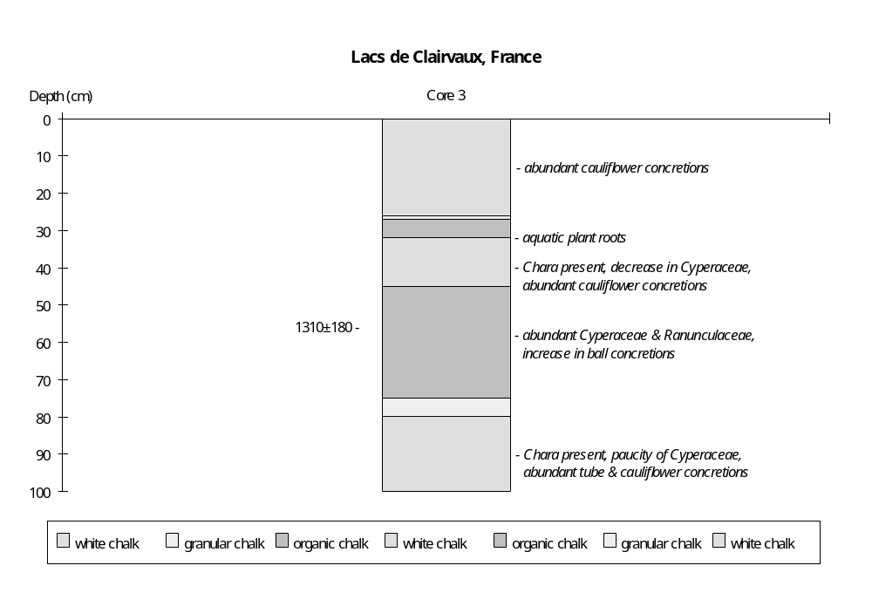
Coding

6000-3000 yr B.P. very low (1)
2500-2000 yr B.P. high (5)
2000-1875 yr B.P. moderately low (3)
1875-1175 yr B.P low (2)
1175- 800 yr B.P intermediate (4)
800- 675 yr B.P low (2)
675- 650 yr B.P. moderately low (3)
650- 0 yr B.P. intermediate (4)

Preliminary coding: November 1990; Final coding: January 1991
Coded by: SPH
Hières-sur-Amby, France

Hières-sur-Amby (45°47'27"N, 5°17'E, 212m above sea level) is an elongated lake, consisting of two sub-basins joined by a narrow channel (Clerc, 1985). The area of the larger sub-basin is about 3.75 ha, while that of the smaller is ca 0.65 ha. The lake overflows northeastwards via the ruisseau du Val d'Amby, a tributary of the Rhône. The basin lies within the frontal moraine system of the last glacial maximum. The southern margin of the basin is formed by a calcareous cliff. Springs along the base of this cliff are believed to be an important source of inputs to the lake (Clerc, 1985). A mediaeval archaeological site, the Camp de Larina, lies on the plateau to the south of the lake (Porte, 1980; Colardelle and Manipoud, 1978).

Three cores were taken from the marshes surrounding the lake: core I was taken just to the north of the narrow neck connecting the two sub-basins; core II from the zone between the lake and the cliff, to the south of the larger sub-basin; core III from south of the narrow neck. Clerc (1985) describes the stratigraphy and pollen from one of these cores, but it is not possible to identify which one. Changes in water depth are reconstructed from changes in stratigraphy and aquatic pollen assemblages. The chronology is based on four radiocarbon dates.

The basal deposits (12.00-12.50m) are grey lacustrine clays. The aquatic assemblage is characterised by moderate Cyperaceae and Ranunculaceae, and occasional Nuphar, consistent with moderate water depth.

The overlying unit (11.70-12.00m) is a clayey gyttja. The absence of Cyperaceae and Ranunculaceae suggests increased water depth. The appearance of Myriophyllum towards the top of the unit may indicate shallowing.

The deposition of lacustrine chalk containing molluscs (11.32-11.70m) is consistent with shallower water after ca 11,880 yr B.P. The aquatic assemblage is characterised by Myriophyllum, Nuphar and low values of Cyperaceae, and is consistent with shallow water. This drying trend culminated in peat deposition (11.30-11.32m).

An increase in water depth is indicated by the deposition of lacustrine chalk containing molluscs between 10.48-11.30m. The aquatic pollen assemblage is characterised by occasional Myriophyllum, Nuphar and Ranunculaceae. Cyperaceae values are generally low but variable. A sample from the base of the unit (11.20-11.30m) was radiocarbon dated to 11,130±450 yr B.P. (Ly-2603).

A short-lived interval of drier conditions around 9800-9850 yr B.P. is indicated by peat deposition (10.45-10.48m). The overlying unit (8.45-10.45m) is a lacustrine chalk with molluscs, indicating increased water depth after 9800 yr B.P.

The overlying unit (8.30-8.45m) is peat, indicating drier conditions. The marked increase in Cyperaceae and Ranunculaceae is consistent with shallowing. A sample from the transition between the chalk and the peat (8.40-8.50m) was dated to 6590±280 yr B.P. (Ly-2602).

Wetter conditions after ca 6540 yr B.P. are indicated by the deposition of lacustrine chalk with molluscs between 4.30-8.30m. The overlying unit (4.28-4.30m) is peat, indicating decreased water depth around 5290 yr B.P. The overlying lacustrine chalk (3.65-4.28m) indicates a return to moderate water levels until ca 5090 yr B.P.

The uppermost sediments are peat (2.40-3.65m) and moss peat (0.00-2.40m), indicating drier conditions or basin infilling after ca 5090 yr B.P. The abundance of Cyperaceae and Ranunculaceae is consistent with either interpretation.

In the status coding, low (1) is indicated by peat deposition; intermediate (2) by lacustrine chalk deposition; high (3) by clayey gyttja or clay deposition. The uppermost peat deposits may reflect hydroseral development, and have been omitted from the coding.
References

Clerc, J., 1985. Première contribution a l'étude de la végétation Tardiglaciaire et Holocène du Piémont Dauphinois. Documents de Cartographie écologique (Grenoble) 28: 65-83.
Colardelle, M. and Manipoud, B., 1978. Premiers résultats de la fouille d'un habitat du Haut Moyen Age au "Camp de Larina" (Hieres sur Amby - Isére). Bulletin du groupe d'etudes historiques et géographiques du Bas-Dauphiné 3: 81-92.
Porte, P., 1980. Un exemple de site fortifié du Haut-Moyen-Age. L'habitat mérovingien de larina à Hières-sur-Amby (Isère). Centre d'Archéologie historique des Musées de Grenoble et de l'Isère. D.E.A. Université d'Aix-Marseille I.

Radiocarbon Dates

Ly-2600 4110±170 moss peat, 1.90-2.00m, ?ATO (2ka)
Ly-2601 4760±220 peat, 2.60-2.70m
Ly-2602 6590±280 peat/lacustrine chalk, 8.40-8.50m
Ly-2603 11130±450 lacustrine chalk, 11.20-11.30m

Coding

ca 13200 - 11880 yr B.P. high (3)
11880 - 11250 yr B.P. intermediate (2)
11250 - 11200 yr B.P. low (1)
11200 - 9850 yr B.P. intermediate (2)
9850 - 9800 yr B.P. low (1)
9800 - 6590 yr B.P. intermediate (2)
6590 - 6540 yr B.P. low (1)
6540 - 5290 yr B.P. intermediate (2)
5290 - 5200 yr B.P. low (1)
5200 - 5090 yr B.P. intermediate (2)
5090 - 0 yr B.P. not coded
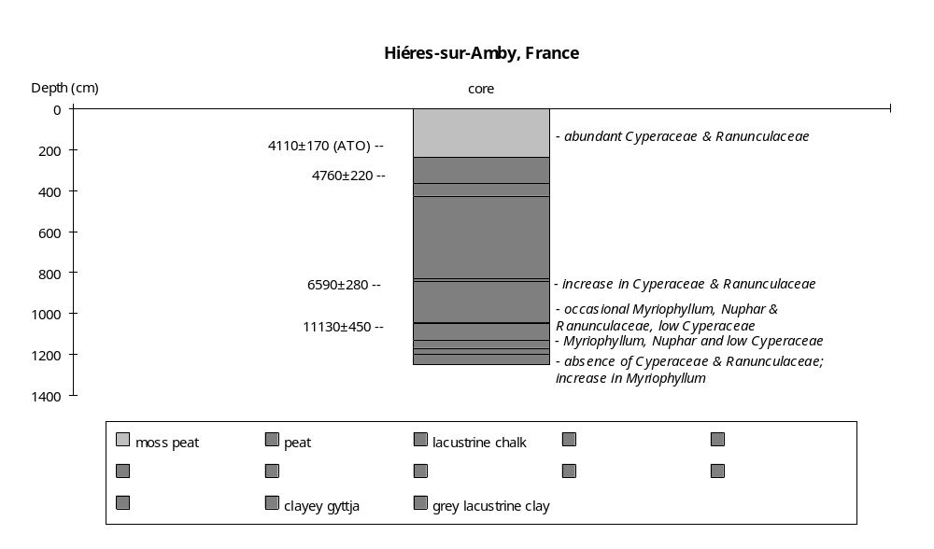
Preliminary coding: December 1990; Final coding: November 1991. Coded by SPH
Lac d'Issarlès, France

The lac d'Issarlès (44°48'N, 4°04'E, 997m above sea level) lies in a volcanic basin, perched above the Loire Valley on the western slopes of the Ardèche (Coûteaux, 1984). The lake has been exploited by the Electricité de France (EDF) since 1950 and the water level is allowed to fluctuate through the year between 960 and 1001m, controlled by pumping of water up from the Loire and its tributaries, the Gage and the Veyradeyre. The natural level of the lake is 997m (Coûteaux, 1984). The lake is ovoid in shape, with maximum length of 1100m from north to south and 1000m from east to west. The maximum depth is 108m (Delebecque, 1898). The catchment area is 220 ha and underlain by basaltic scoria, pyroclastics and granite. The basin is closed and the lowest point on the crest is 1003m (+6m above natural lake level). The lake is fed by two permanent streams, the ruisseau de la Clède and the ruisseau du Ravin des Charbonneyres, and two intermittent streams, the ruisseau de Montchamp and the ruisseau du Col de Gage. There is no surface outflow, but there may be some subsurface leakage northwards into the Veyradeyre valley and westwards (Coûteaux, 1984).

A 6m-long Mackereth core (1982-1) from the centre of the lake provides a sedimentary and pollen record back to the Younger Dryas (10,700-10,300 yr B.P.). However, the sequence is problematic since it shows signs of massive reworking, slumping and the overturning of large blocks of sediments. Thus, although the sediments from the uppermost 0.90m of the core present an apparently in situ sequence from modern back to the upper Subboreal, the underlying deposits (0.90-1.19m) are reworked and turbated material of Preboreal or Younger Dryas age. Between 1.19-1.54m there is a reversed sedimentary sequence from the Boreal to the lower Subatlantic. The material from 1.54-1.60m is reworked and turbated. The basal sediments (1.60-5.80m) again form a reversed sequence from Younger Dryas through to the upper part of the Subatlantic. Coûteaux (1984) argues that these reversals and zones of turbation reflect slumping and the overturning of large blocks of sediments during periods of changing water level. The presence of minor hiatuses and contamination of older sediments by recent pollen is consistent with slumping and sediment overturn. The absence of sediments older than the Younger Dryas suggests that lake levels before that time were lower than subsequently (Coûteaux, 1984).

Coûteaux (1984) has reconstructed changes in the level of the lake from sedimentary exposures around the lake margin. The most detailed record is based on a section through the lacustrine shelf beneath the delta at the mouth of the ruisseau de la Clède. The chronology is established by pollen correlation. The regional pollen chronology is well established from of a number of radiocarbon-dated sites in the Velay region (e.g. de Beaulieu et al., 1984).

The basal deposits (Unit 1) consist of stratified volcanic and granitic sandy gravels, most probably of periglacial origin. The base of these deposits was not observed but lies below 994.5m. The unit is thought to date to the last glacial maximum. The upper surface of the unit is truncated.

The overlying unit (2) consists of a sequence of beach deposits: a "beach pavement" of granite and basalt blocks, similar to those found around alpine lakes today (Coûteaux, 1983), overlain by organic sands. These deposits lie in the range 995.50-997.05m. The pollen assemblage from the organic sands indicates that the lake transgression occurred during the Younger Dryas (ca 10,700-10,300 yr B.P.).

The Younger Dryas beach deposits are directly overlain by beach and nearshore lacustrine deposits (Unit 3: organic sands, stratified coarse sands and micaceous lacustrine sand) of early Boreal age (after 9000 yr B.P.). The upper level of these deposits is at 998.04m, indicating a major lacustrine transgression. The presence of Boreal pollen as a contaminant in the Younger Dryas beach sands suggests that the lake level was probably lower than 995.5m during the Preboreal (ca 10,300-9000 yr B.P.).

A fall in lake level during the latter part of the Boreal is indicated by erosion of the upper surface of the early Boreal perilacustrine deposits and the deposition of a coarse sand unit (4). The presence of a peat (Unit 4b) which must have formed just above water level indicates that the lake level was below 995.97m. Coûteaux (1984) argues that the regression was not the result of climate change, both because of its rapidity and the fact that the pollen record does not show a change to drier conditions. He suggests that it could relate to seismic events, since there were several important volcanic eruptions in the region around 8300 yr B.P. However, lakes can respond dramatically to short-lived climate changes and the absence of change in the pollen record does not necessary militate against such an hypothesis.

The late Boreal peats are overlain by organic, stratified sandy gravels (Unit 5) indicating a rise in lake level at the beginning of Atlantic (ca 8000 yr B.P.). These deposits occur within the range 996.22 to 998.45m, and thus indicate a substantial increase in water level. Peaty shoreline deposits of Atlantic age in the delta of the Clède occur at 997.49-997.79m, and are consistent with rising water level.

Falling water levels during the mid-Atlantic resulted in erosion of deposits lying above 997.25m. Above this elevation, the mid-Atlantic is represented by peat deposition (Unit 6) intercalated with coarse fluvial deposits laid down by the stream itself.

An organic lacustrine mud, containing abundant Isoetes lacustris and dated to the Subatlantic, occurs at ca 996m on the northern shore of the lake. This suggests that the lake level was at about its pre-1950 level by ca 2600 yr B.P.

In the status coding, very low (1) is indicated by lake level below 994.5m; low (2) by levels below 996m; intermediate (3) by levels around the pre-1959 level of 997m; and high (4) by levels above 997.5m. Note that the quoted dating of the lake-level changes is very approximate.

References

Beaulieu, J.L. de, Pons, A. and Reille, M., 1984. Recherches pollenanalytiques sur l'historire de la végétation des Monts du Velay (Massif Central, France). Dissertationes Botanicae 72: 45-70.
Coûteaux, M., 1983. Fluctuations glaciaires de la fin du Würm dans les Alpes françaises, établies par les analyses polleniques. Boreas 12: 35-56.
Coûteaux, M., 1984. Recherches pollenanalytiques au lac d'Issarlès Ardèche (France): évolution de la végétation et fluctuations lacustres. Bulletin de la Société Royale de Botanique de Belgique 117: 197-217.
Delebecque, A., 1898. Les Lacs Français. Paris, 436 pp.

Coding

LGM below 994.5m very low (1)
10700-10300 yr B.P. 995.5-557.05m intermediate (3)
10300- 9000 yr B.P. lower than 995.5m low (2)
9000- 8500 yr B.P. 998.04m high (4)
8500- 8000 yr B.P. below 995.97m low (2)
8000- 6000 yr B.P. 996.22-99.45m high (4)
6400- 2600 yr B.P. ca 997.25m intermediate (3)
2600- 1000 yr B.P. ca 996m low (2)
1000- modern 997m intermediate (3)

Preliminary coding: September 1990; Final coding: May 1992
Coded by SPH
Landos, France

Landos (44°50'N, 3°48'E, ca 1000m above sea level) is a relatively small peatbog (ca 6ha) in a volcanic maar within the Monts du Velay. A 6.5m core provides a sedimentary record back to before 13,000 yr B.P. (de Beaulieu et al., 1984). Changes in water depth are reconstructed from changes in the stratigraphy, sedimentation rate and aquatic pollen assemblages. The chronology is established be eleven radiocarbon dates (de Beaulieu et al., 1984).

The basal deposits (5.80-6.50m), dated on palynological grounds to the Ancient Dryas (pre-13,000 yr B.P.) are brown clays. The lacustrine origin of these clays is attested by the presence of aquatic pollen, including abundant Ranunculus cf Batrachium, moderate Cyperaceae and occasional grains of Potamogeton and Myriophyllum. The abundance of Ranunculus cf Batrachium suggests the water was moderately deep, though not greater then ca 6m.

The overlying unit (4.70-5.80m) is a greenish gyttja. The aquatic pollen assemblage in the basal part of this unit (5.60-5.80m) is characterised by a marked decline in Ranunculus cf Batrachium and an increase in Cyperaceae. In the upper part of the unit the pollen assemblage is similar to that of the basal clays. Four samples from the gyttja were radiocarbon dated to 9480+110 (Gif-5782, 4.65-4.80m), 9880+110 (Gif-5783, 5.00-5.15m), 10,410+180 (Gif-5784, 5.30-5.50m) and 10,510+180 (Gif-5785, 5.60-5.80m) yr B.P. respectively. On palynological grounds, de Beaulieu et al. (1984) suggest that the lower two dates are too young and should be rejected. Palynological evidence suggests that the onset of gyttja deposition dates to ca 13,000 yr B.P.

The overlying unit (4.00-4.70m) is a brown gyttja. The apparently more organic nature of the unit suggests decreased water depth after ca 9500 yr B.P. The aquatic pollen assemblage is more diverse and characterised by moderate Cyperaceae, low Ranunculaceae, and occasional Sparganium, Potamogeton, Myriophyllum, Menyanthes and Typha, consistent with shallower water.

A further decrease in water depth after ca 7500 yr B.P. is indicated by peat deposition (1.60-4.00m). The aquatic pollen assemblage is characterised by extremely abundant Cyperaceae, low Ranunculaceae, and moderate Sparganium and Menyanthes, consistent with shallow water. A marked decline in Cyperaceae accompanied by an increase in Ranunculaceae and the disappearance of other aquatics around 2.00m may indicate a brief increase in water depth around 1800 yr B.P., although there is no change in the sediments.

An increase in water depth around 1400 yr B.P. is indicated by a thin bed of brown gyttja (1.50-1.60m). The overlying unit (1.40-1.50m) is a bed of amorphous organic material, the origin of which is uncertain.

There is an hiatus in deposition between these units and the overlying peat (0.00-1.40m). The onset of peat deposition is dated to 390±60 yr B.P.

In the status coding, an hiatus is indicated by 0; low (1) by peat deposition; intermediate (2) by brown gyttja deposition with a diverse aquatic pollen assemblage; high (3) by greenish gyttja deposition or clay deposition.

Reference

Beaulieu, J.L. de, Pons, A. and Reille, M., 1984. Recherches pollenanaltiques sur l'histoire de la végétation des Monts du Velay (Massif Central, France). Dissertationes Botanicae 72: 45-70.

Radiocarbon Dates

Gif-5775 modern peat, 0.60-0.70m
Gif-5776 390±60 peat, 1.25-1.35m
Gif-5777 1470±60 peat, 1.60-1.70m
Gif-5778 1890±60 peat, 2.10-2.20m
Gif-5779 4590±75 peat, 2.90-3.00m
Gif-5780 5410±80 peat, 3.25-3.35m
Gif-5781 6600±90 peat, 3.50-3.65m
Gif-5782 9480±110 greenish gyttja, 4.65-4.80m
Gif-5783 9880±110 greenish gyttja, 5.00-5.15m
Gif-5784 10410±180 greenish gyttja, 5.30-5.50m
Gif-5785 10510±180 greenish gyttja, 5.60-5.80m

Coding

ca 13000 - 9500 yr B.P. high (3)
9500 - 7500 yr B.P. intermediate (2)
7500 - 1400 yr B.P. low (1)
1400 - 1300 yr B.P. intermediate (2)
1300 - 400 yr B.P. hiatus (0)
400 - 0 yr B.P. low (1)

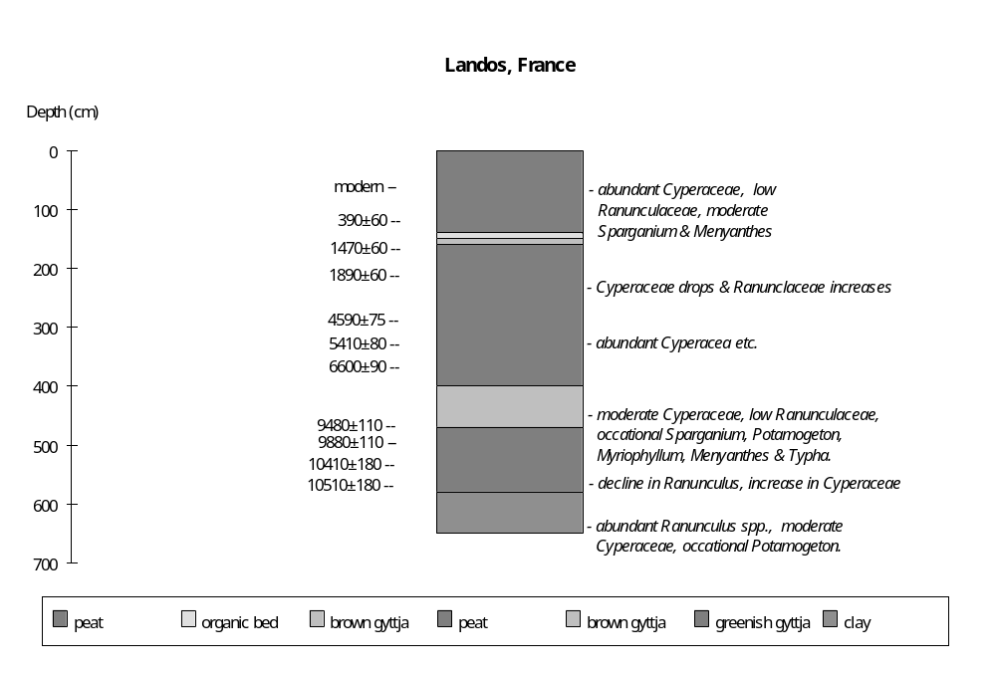

Preliminary coding: December 1990; Final coding: September 1991
Coded by SPH
Le Grand Lemps, France

Le Grand Lemps (45°28'24"N, 5°25'E, 456m above sea level) lies within the frontal moraine system marking the maximum advance of the Rhône glacier during the last glaciation (Clerc et al., 1989). The lake is underlain by morainic material. The southern margin of the basin is marked by the sandstone hills of Le Banchet. The lake basin is ca 80 ha, but there is little open water since most of the surface is occupied by reedbeds. The basin is fringed by Sphagnum peatbog and alder carr. The catchment area is about 300 ha. Two small streams flow into the lake from the north, and there is an outflow into the Vallée de Violet to the south.

The stratigraphy of the lake deposits has been reconstructed from a transect of 11 corings (cores 1 to 11) within the reedbeds in the northern part of the basin (Clerc et al., 1989). A further two cores (A and B) were taken from near the western margin of the lake. Four of these cores (9, 10, 11 and A) have been studied for pollen (Clerc et al., 1989). Additional cores were taken near core 10 for sedimentological analyses (Clerc et al., 1989). Mollusc analyses were apparently carried out on cores 10 and 11 (Clerc et al., 1989). Radiocarbon dates were obtained from samples from pollen diagram III (core 10), IV (Core 11) and V (core unknown) (Clerc et al., 1989).

Extremely detailed reconstructions of water-level changes have been made by the original authors on the basis of the mollusc assemblages and changes in sedimentological characteristics. The reconstructions from these two sources are somewhat different, and are not always consistent with gross stratigraphical evidence nor with the aquatic pollen assemblages. In this study, the broad scale changes in water depth are reconstructed from a consensus interpretation of changes in stratigraphy, sedimentology, aquatic pollen, diatom and mollusc assemblages. The chronology is based on 10 radiocarbon dates.

The oldest sediments occur in the basal part of Core 11, and consist of varved clays (15.50+m) and clays (15.40-15.50m) attributed to the Older Dryas on palynological grounds. The aquatic pollen assemblage is characterised by abundant Cyperaceae, with some Lemna and Potamogeton and occasional Typha and Myriophyllum. The origin of these sediments is uncertain.

The overlying sediments are clayey, calcareous gyttja (15.08-15.40m), suggesting shallow water. A decline in Cyperaceae abundance towards the top of the unit suggests an increase in water depth. This trend towards deeper water culminates in the deposition of a thin layer of gyttja (15.05-15.08m).

The overlying unit (14.94-15.05m) is a diatomaceous gyttja. The diatom assemblage is dominated by Navicula diluviana. The aquatic pollen assemblage is characterised by abundant Cyperaceae, with some Typha, Potamogeton and Myriophyllum, and suggests decreased water depth.

The overlying sediments are calcareous gyttja (14.50-14.94m), consistent with relatively shallow water, as is the abundance of Cyperaceae pollen. Between 14.36-14.50m the sediments are diatomaceous, calcareous gyttja. A thin sand unit (14.35-14.36m) marks the culmination of this shallow water interval.

Increased water depth is marked by the deposition of calcareous, diatomaceous gyttja (14.30-14.35m) and lacustrine lime (14.18-14.30m). The aquatic pollen assemblage in both these units is still characterised by abundant Cyperaceae with Typha, Potamogeton and Myriophyllum.

The overlying unit (13.00-14.18m) is a diatomaceous lacustrine lime containing molluscs. Aquatic pollen is sparse with only occasional grains of Cyperaceae, Typha, Potamogeton, Nuphar and Myriophyllum. This suggests increased water depth. The mollusc assemblage below 13.90m is depauperate and contains only a few shells of Bythnia tentaculata, a tolerant pioneer species. In the upper part of the unit Valvata piscinalis and Pisidium nitidum are co-dominant. These species are characteristic of the mid-littoral zone and thus the mollusc assemblage is consistent with moderately deep water.

The overlying unit (ca 12.75-13.00m) is a peat, indicating a marked shallowing. This change in depth is not recorded by the aquatic pollen or mollusc assemblages.

There are problems with the dating of the lowermost part of core 11. Samples from the gyttja (15.04-15.08m) and the top of the diatomaceous gyttja (14.94-15.00m) were radiocarbon dated to 13760±290 yr B.P. (Ly-4813) and 13420±430 yr B.P. (Ly-4812) respectively. Both samples were low in organics, and the dates appear to be about 1000 yr too old on palynological grounds. Clerc et al. (1989) suggest this may be due to a hard water effect. A sample from the lacustrine lime (14.20-14.25m) was dated to 9830±240 yr B.P. (Ly-4811). On palynological evidence this date is about 500 yr too old, again possibly reflecting the hard water effect. The dates from above the peat unit in core 10 appear to be unaffected by hard water error and provide a reasonably good chronology for the Holocene water-level changes. The pre-Holocene chronology is based on the pollen-corrected dates from core 11 and is therefore less certain.

An increase in water depth around 8900 yr B.P. is indicated by the deposition of lacustrine lime, containing abundant molluscs (10.05-12.75m in core 10). A sample from near the base of this unit in core 10 (12.60-12.68m) was radiocarbon dated to 8880+170 yr B.P. (Ly-3970). Initially (12.10-12.75m) the aquatic pollen assemblage is characterised by low levels of Cyperaceae and occasional grains of Myriophyllum and Potamogeton, consistent with moderately deep water. The mollusc assemblage, in which Valvata piscinalis and Pisidium nitidum are co-dominant, is also consistent with moderately deep water. Pronounced changes in the aquatic pollen and mollusc assemblages above 12.10m indicate shallower water after ca 8760 yr B.P. The aquatic pollen assemblage above 12.10m is characterised by very abundant Myriophyllum, with Nymphaea and Cyperaceae. Minor fluctuations in depth are suggested by changes in the relative abundance of Myriophyllum and Nymphaea. The mollusc assemblage is characterised by a marked decline in Valvata piscinalis and Pisidium nitidum, the disappearance of the littoral species Pisidium hibernicum, and pronounced increases in phytophilous and shallow-water species such as Armiger crista, Gyraulis laevis and Bathyomphalus contorta. An increase in the abundance of Valvata piscinalis above 11.10m may indicate a slight increase in water depth after ca 8545 yr B.P. However, the co-dominance of Valvata cristata, the decreased but still moderate levels of Armiger crista, Gyraulis laevis and Bathyomphalus contorta, the relative paucity of Pisidium nitidum, and the absence of P. hibernicum indicate that water depth was not as great as formerly. A sample from near the top of this unit (10.30-10.40m) was radiocarbon dated to 8380+170 yr B.P. (Ly-3969).

The overlying unit (9.85-10.05m) is peat, indicating lowered water levels between ca 8200 and 8300 yr B.P. As might be expected, the unit does not contain molluscs. A brief return to wetter conditions between 8100 and 8200 yr B.P. is marked by deposition of lacustrine lime with abundant molluscs (9.60-9.85m). The mollusc assemblage is characterised by the dominance of Valvata cristata, with abundant V. piscinalis, Armiger crista, Gyraulis laevis and Bathyomphalus contorta, and is consistent with relatively shallow water. Peat deposition between 9.35-9.60m indicates a return to drier conditions. Again, molluscs are absent from this unit.

An increase in water depth after ca 8000 yr B.P. is indicated by the deposition of lacustrine lime containing abundant molluscs (4.80-9.35m). The aquatic pollen assemblage is initially characterised by abundant Myriophyllum. The mollusc assemblage is characterised by abundant Valvata cristata, Bithynia tentaculata, Planorbis carinatus, Armiger crista, Gyraulis laevis and Bathyomphalus contorta, and is consistent with relatively shallow water. An increase in water depth is suggested by the decline in molluscs typical of the upper littoral and an increase in Pisidium nitidum and P. milium above 8.75m. The pollen assemblage between 7.50-8.75m is characterised by moderate Cyperaceae, with occasional Myriophyllum, Nymphaea and Potamogeton, and is consistent with increased water depth. Low values for Cyperaceae and the absence of other aquatics between 6.00-7.50m may indicate a further increase in water depth between ca 7325 and 6675 yr B.P. The mollusc assemblage, in which Pisidium nitidum and Physa tontinalis increase and Lymnaea palustris is recorded, while Armiger crista and Planorbis carinatus are scarce and Gyraulis laevis absent, is consistent with increased water depth. Cyperaceae pollen once more becomes moderately abundant in the uppermost part of the unit (4.80-6.00m) and occasional Myriophyllum, Nymphaea and Typha pollen grains are recorded, suggesting decreased water level after ca 6675 yr B.P. The mollusc assemblage, which is characterised by a decrease in the abundance of both Bithynia tentaculata and Valvata cristata, the disappearance of Lymnaea palustris, the reappearance of Gyraulis laevis and the increasing abundance of Planorbis carinatus and Armiger crista, is consistent with shallowing. A sample from near the top of the unit (5.15-5.30m) is radiocarbon dated to 6480±180 yr B.P. (Ly-3968).

The overlying sediment sequence of diatomaceous lacustrine lime with molluscs (4.50-4.80m), diatomaceous peat (4.10-4.50m) and peat (2.55-4.10m) indicates a progressive decrease in water depth after ca 5860 yr B.P. The aquatic pollen is characterised by extremely abundant Cyperaceae, which is consistent with shallowing. The diatoms are apparently species characteristic of shallow environments (Clerc et al., 1989). There are no molluscs. A sample from the base of the peat (3.95-4.10m) is dated to 4750±110 yr B.P. (Ly-3967).

The uppermost deposits in core 10 (1.50-2.55m) are lacustrine lime, indicating deeper water after ca 1200 yr B.P. The disappearance of Cyperaceae and the increased abundance of Myriophyllum is consistent with increased depth. Molluscs are not as abundant as formerly, but the occurrence of Valvata piscinalis, V. cristata, Bithynia tentaculata, Armiger crista and Pisidium hibernicum is consistent with moderate water depths. A sample from the base of the unit (2.48-2.55m) was radiocarbon dated to 1190±110 yr B.P. (Ly-3966).

Although not present in core 10, the youngest sediments in the basin are peats, indicating a decrease in water depth and overgrowing of the basin in the last ca 700 years. Clerc et al. (1989) suggest that the increase in depth indicated by lacustrine lime deposition after ca 1200 yr B.P. resulted at least partly from the construction of a small dam on the outlet stream near the settlement of Grand-Lemps, and that the return to peat deposition from the destruction of this dam.

In the status coding, low (1) is indicated by peat deposition; moderately low (2) by diatomaceous peat or sand deposition; low-intermediate (3) by lacustrine lime or calcareous gyttja deposition, with abundant Cyperaceae and shallow-water mollusc or diatom assemblages; intermediate (4) by lacustrine lime or clayey calcareous gyttja deposition, with moderate levels of Cyperaceae and/or abundant Myriophyllum, Typha, Nymphaea, and a mollusc assemblage characterised by an admixture of shallow and deeper water species; intermediate-high (5) by lacustrine lime deposition, with low aquatic pollen and deep water molluscs; high (6) by gyttja deposition.

Reference

Clerc, J., Magny, M. and Mouthon, J., 1989. Histoire d'un milieu lacustre du Bas-Dauphiné: Le Grand Lemps. Etude palynologique des remplissages Tardiglaciaires et Holocène, et mise en evidence de fluctuations lacustres à l'aide d'analyses sédimentologiques et malacologiques. Revue de Paléobiologie (Génève) 8: 1-19.

Radiocarbon Dates

Ly-3966 1190±110 2.48-2.55m, lk chalk, GL III, core 10
Ly-3967 4570±110 3.95-4.10m, peat, GL III, core 10
4830±170 dates same event as Ly-3967 in GL V
Ly-3968 6480±180 5.15-5.30m, lk chalk, GL III, core 10
7310±160 dates same event as Ly-3968 in GL V
Ly-3969 8380±170 10.30-10.40m, lk chalk, GL III, core 10
ly-3970 8880±150 12.60-12.68m, lk chalk, GL III, core 10
Ly-4811 9830±240 14.20-14.25m, lk chalk, GL IV, core 11 ?ATO (500 yr) according to pollen
Ly-4812 13420±430 14.94-15.00m, gyttja, GL IV, core 11, ATO (1000 yr) hard water ? low organics
Ly-4813 13760±290 15.04-15.08m, gyttja, GL IV, core 11, ATO (1000 yr) hard water ? low organics

Coding

- 12800 yr B.P. intermediate (4)
12800 - 12700 yr B.P. high (6)
12700 - 10000 yr B.P. low-intermediate (3)
10000 yr B.P. moderately low (2)
10000 - 9300 yr B.P. low-intermediate (3)
9300 - 8975 yr B.P. intermediate-high (5)
8975 - 8900 yr B.P. low (1)
8900 - 8760 yr B.P. intermediate-high (5)
8760 - 8545 yr B.P. low-intermediate (3)
8545 - 8300 yr B.P. intermediate (4)
8300 - 8200 yr B.P. low (1)
8200 - 8100 yr B.P. intermediate (4)
8100 - 8000 yr B.P. low (1)
8000 - 7800 yr B.P. low-intermediate (3)
7800 - 7325 yr B.P. intermediate (4)
7325 - 6675 yr B.P. intermediate-high (5)
6675 - 5860 yr B.P. intermediate (4)
5860 - 5430 yr B.P. low-intermediate (3)
5430 - 4800 yr B.P. moderately low (2)
4800 - 1200 yr B.P. low (1)
1200 - 700 yr B.P. intermediate (4)
700 - 0 yr B.P. low (1)

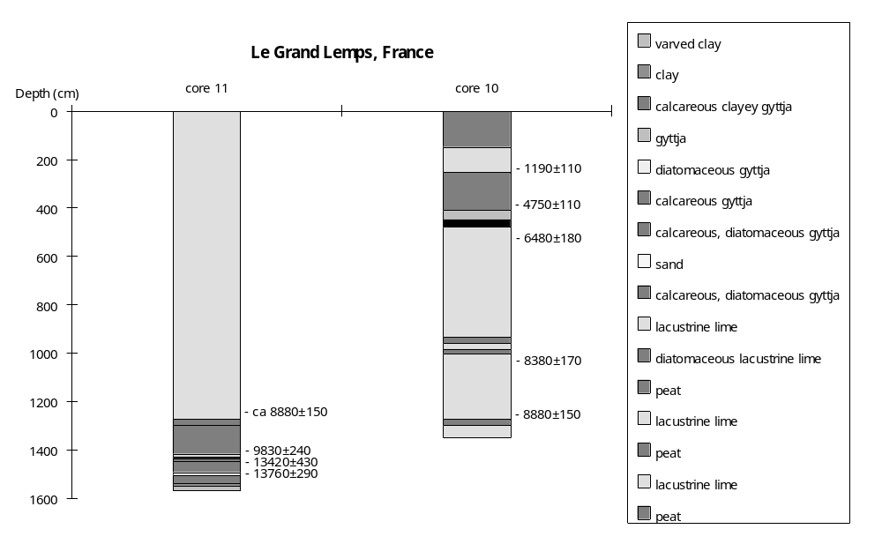

Preliminary coding: 1990; Final coding: September 1991
Coded by SPH
Paladru, France

The lake of Paladru (45°25'N, 5°30'E, 492m above sea level) lies in the eastern part of the Terres Froides Bas-Dauphinois, at the foot of the Chartreuse mountains (Borel et al., 1985a). The lake occupies a kettle hole, formed after the retreat of the Rhone glacier at the end of the last glaciation (Brochier and Bocquet, 1991). The lake is 5km long, about 1km wide and has a surface area of 400 ha; the mean depth is 25m and the maximum depth is 35m. The catchment area is only 4500ha. The lake is fed by two small streams, the Courbon and the Chantabot, and overflows southwards via the Fure into the Isère River.

Four 6m-long Züllig cores, taken in a water depth of 30m from the centre of the lake, provide a record of Holocene sedimentation (Borel et al., 1985b; Brochier and Druart, 1993). The sediments consist of carbonaceous lacustrine silts. Variations in water depth are shown by changes in colour (from white to grey), organic content, and in the presence/absence of laminations. The core is undated, but shows a major transition at ca 1.5m depth. Brochier and Druart (1993) correlate this transition with mediaeval occupation of the Paladru basin, ca 1000 yr B.P. The sediments below 1.50m are chiefly pale-coloured silts, rich in carbonate (90%). In the lowermost part of the core (below ca 3.10m) there is very little organic matter, but between 1.50-3.10m there are distinct thin beds of organic debris. The diatom assemblage is characterised by a mix of planktonic (Diatoma, Synedra), and benthics and/or epiphytic (Pennales) species. Brochier and Druart (1993) interpret the absence of the more fragile species (Cyclotella) as indicating a strongly reducing environment. The lithological and diatom evidence suggests deep water conditions. Above 1.50m, the sediments consist of grey-coloured silts. The sediments are more organic, but the organic material does not occur in discrete beds. The carbonate content is lower than previously, between 33-90%. These changes in lithology suggest a decrease in water depth. The diatom assemblages are dominated by Cyclotella spp. (65-90%), consistent with shallowing.

The more recent history is known chiefly through archaeological investigations. The modern shoreline is formed by depositional lake terraces. Evidence of lower lake levels in the past is provided by submerged archaeological sites of Neolithic and mediaeval age on drowned lacustrine terraces (Borel et al., 1985a).

Les Baigneurs (45° 25'N, 5° 30'E) is a Late Neolithic village site at the southern end of Lake Paladru (Brochier and Bocquet, 1991). It lies on a terrace of lacustrine chalk which is 2-6m below modern lake level. Excavations show two separate phases of occupation, separated by an interval of lacustrine chalk deposition. Dendrochronological dating suggests the second phase of occupation occurred ca 2750-2730 B.C. (Brochier and Bocquet, 1991).

The basal unit is a thick (> 4m) micritic lacustrine lime, indicating a long period of stable and relatively deep water. The first archaeological unit (B3) is an organic detrital unit ca 15-20cm thick. Brochier and Bocquet (1991) state that most of this unit was formed when the terrace was slightly above water level, so that the lake was of the order of 2.5m below modern level. Charcoal and fragments of wooden piles from the lower part of this unit have been radiocarbon dated to between 4100+120 (Ly-906) to 4440+230 (Ly-793) yr B.P. (Evin et al., 1976).

The overlying unit (B2) consists of 10-15cm of lacustrine chalk, containing numerous carbonate concretions (tube-forms) and Chara oogonia. The basal part of the unit contains detritic material, which Brochier and Bocquet (1991) argue was derived by erosion and reflects slight variations in lake level. This material could have been derived by reworking during the initial increase in lake level. The lithological character of the unit suggests an increase in water depth of ca 0.5-1.0m (i.e. a lake level ca 1.5m lower than today). Dendrochronological dating of the overlying unit indicates that this lacustrine chalk was laid down in ca 40 years.

The uppermost unit (A-B1) is a bipartite archaeological unit, with a basal organic detrital component (B1) overlain by a somewhat more minerogenic component (A). Both parts of the unit contain artefacts and charcoal. Radiocarbon dates on material from this unit are in the range 4190+150 (Ly-792) to 4540+120 (Ly-908) yr B.P. (Evin et al., 1976), overlapping with those from the lower archaeological unit. Dendrochronological dating suggests that the site was occupied for only ca 18 years before it was abandoned.
Brochier and Bocquet (1991) suggest that the increase in lake level that led to the interruption of occupation at Les Baigneurs need not have been the result of a major climatic change. They point out that heavy winter rains in 1845 are known to have increased the lake level between 70-90cm above the average (1.2m above the outlet elevation), and argue that a few years of heavier than normal rains may have been sufficient to cause the observed increase indicated by unit B2 at Les Baigneurs. This is consistent with preliminary results of O18 analyses of a pine log from the site, which apparently show that most of the period during which B2 was deposited was characterised by drier and warmer conditions than during the phases of occupation. However, the controls on the O18 content of living trees are complex, and the relationship between the O18 record and the occupation record is not described, so it is unclear what significance to attach to these results in terms of the climatic interpretation of the lake-level record.

Colletière (45°25'N, 5°30'E; also known as Charavines) is a mediaeval village site at the southern end of the lake about 100m from Les Baigneurs, and lying on a similar terrace of lacustrine chalk at a depth of 2-6m below modern lake level (Borel et al., 1984). Archaeological material, including coins, from this site has been dated to between 980-1050 A.D. (900-970 yr B.P.) (Colardelle and Colardelle, 1980). Samples of charcoal, bark and seeds from the site (Layer II) have been radiocarbon dated to between 1240 and 900 yr B.P. (Evin et al., 1985; Colardelle and Colardelle, 1980), suggesting a somewhat older date than indicated by the archaeological and historical evidence.

The three-dimensional stratigraphy of the Colletière site has been reconstructed from ca 50 borings along three transects (Profiles I, II and III), supplemented by a number of additional cores (Brochier and Druart, 1993). Profiles I and II run north-southwards from the supralittoral zone down into the lake. Profile III runs parallel to the lake shoreline. Detailed lithological, geochemical and diatom studies have been carried out on several cores, including Cores 1210, C and D.

The depositional sequence in the supralittoral zone of profile I shows two phases of lower lake level. The basal deposits are lacustrine chalk. These are overlain by beach sands, corresponding to a shoreline position between 1.1-1.3m lower than today. Wood from these beach sands has been radiocarbon dated to 4022±70 yr B.P. (CRG-796) (Brochier and Druart, 1993). The beach sands are overlain by a thin clay bed associated with a large gravel mound, about 1m high and 5m across, of anthropogenic origin. The mound is not dated but is thought to date to the Gallo-Roman period (ca 2 and 3rd centuries A.D., Borel et al., 1985b). Brochier and Druart (1991) suggest the lake was of the order of 1.5-2.5m lower than today. The overlying unit is an apparently homogenous littoral peat. Four radiocarbon samples suggest this unit was laid down between 750-1660 yr B.P. Thus, the upper part of this unit is coeval with the mediaeval settlement at Colletière. The peat unit is overlain by slope deposits and reworked lacustrine debris.

The deepest-water core (Core 1210), taken ca 105m out from the modern shore (Profile I) in a water depth of 6m, provides a record from a site that experienced continuous lacustrine conditions. The basal sediments are relatively pure, microlaminated lacustrine chalk, indicating moderately deep water conditions. There is a marked changes in sedimentation at a depth of ca 56-58cm, with the deposition of grey non-laminated organic chalk containing detrital material, and indicating a pronounced shallowing. An abrupt change in diatom abundance, accompanied by an increase in epiphytic (Fragilaria, Achnanthes, Navicula and Cymbella) at the expense of planktonic (Cyclotella spp.) species, is consistent with a pronounced drop in water level. Brochier and Druart (1993) correlate this interval of lowered lake level with the beginning of the mediaeval occupation of Colletière, ca 1000 yr B.P.

Sedimentological, palynological and plant macrofossil analyses of four short cores (D, D', C and C') from the Colletière site provide more detailed information about the changes in lake level associated with the mediaeval settlement (Borel et al., 1984, 1985a, b; Brochier and Druart, 1993). The cores were taken on the landward side of the site, in an area outside the main zone of habitation but just within the surrounding palisade. Core D was 65cm long and Core D' 85cm long.

The basal unit is a white, non-organic lacustrine chalk, characteristic of deep sublittoral sediments. The pollen assemblage includes occasional grains of deep water aquatic vegetation (e.g. Potamogeton, Nuphar and Nymphaea). The water depth was probably greater than 2-3m but not more than 5m (Borel et al., 1984, 1985a, b).

The overlying unit comprises interbedded sand lenses, sandy lacustrine chalks and grey clayey chalks. The lacustrine chalk layers contain molluscs or organic debris. The sand lenses apparently result from intervals of erosion or disturbance in the nearshore zone. Aquatic vegetation was abundant and there was a marked increase in Cyperaceae pollen. In the upper part of the unit Chara oogonia are abundant, and the seeds and fruits of aquatic plants and sedges occur. The unit is characteristic of the shallow sublittoral zone, with water depth probably between 1-3m (Borel et al., 1984).

The overlying unit is highly organic and corresponds to the mediaeval occupation level, dated to 980-1050 A.D. The site was apparently built when the main part of the lacustrine terrace was slightly above water level. Water depth at the coring site was less than 0.5m. The village site was occupied for 20-30 years. Dendrochronological evidence suggests that the buildings were partially reconstructed or restored 15 years after the initial date of occupation (Leboutet et al., 1983).

The uppermost unit consists of grey lacustrine chalk with sandy lenses, pellet-shaped concretions and organic lenses, and is characteristic of the eulittoral-sublittoral zone. The sediments indicate the water depth was about 1m (Borel et al., 19849, but the polyphased nature of the chalks and the presence of sand lenses suggest fluctuating water levels. The pollen assemblage is characterised by abundant Cyperaceae, consistent with relatively shallow water. The poor pollen preservation is consistent with low and fluctuating water levels. The macrofossil assemblage is also consistent with shallow water since it includes the remains of reeds and sedges whereas deeper water vegetation is represented by only a single example of Naias marina. It is not clear whether the lake transgression was synchronous with (and the cause of) the abandonment of the site or took place subsequently.

Two other sites, Grands Roseaux and Pré d'Ars, are known to be mediaeval from early archaeological studies (e.g. Chantre, 1871, 1896; Charvet, 1886) but have not been radiocarbon dated. Lithological and diatom studies (Brochier and Druart, 1993) suggest that the archaeological site is underlain by shallow-water lacustrine chalk. The site was occupied in the 11th century. A thin layer (10 cm) of chalk overlies the archaeological unit, indicating a return to shallow-water lacustrine conditions.

In the Fure channel (45°25'N, 5°31'E), lacustrine chalk stratigraphically equivalent to the terrace on which Les Baigneurs and Colletière were built is overlain by a metre-thick layer of peat. A sample from the base of this peat was radiocarbon dated to 4780±150 yr B.P. (Ly-1664; Evin et al., 1979). A sample from the top of the peat was radiocarbon dated to 1210±130 yr B.P. (Ly-1663; Evin et al., 1979), suggesting that low lake levels persisted for some time. A second series of dates obtained from the peat (CRG-133, CRG-125 and CRG-131; Colardelle and Colardelle, 1980) suggests the interval of lowered lake level occurred between ca 3500 and 1000 yr B.P. The overlying unit is lacustrine clay, indicating a return to high levels ca 1000 yr B.P.

In the coding, low (1) is indicated by the presence of dated archaeological sites and peat deposition in the Fure channel; intermediate (2) by the sub-littoral deposits at Colletière and Les Baigneurs; high (3) by lacustrine chalk deposition in the Fure channel and by modern lake level.

References

Borel, J.L., Brochier, J.L. and Lundstrom-Baudais, K., 1985a. Water level fluctuations of the lake Paladru (Isère, France) in the Xth and XIth centuries AD. Ecologia Mediterranea 11: 179-183.
Borel, J.L., Brochier, J.L., Lundstrom-Baudais, K. and Colardelle, M., 1985b. Une expérience de recherche concertée sur le paléoenvironnement de l'habitat médiéval immergé de Colletière (Charavines-les-Bains, Isère): sédimentologie, pollens, macrorestes végétaux. Actes des Journées, Palynologie archéologique, CRNS, pp. 313-330.
Brochier, J.L. and Druart, J.-C., 1993. Le milieu lacustre. In: M. Colardelle and E. Verdel (eds), Les habitats du Lac de Paladru (Isère) dans leur environnement. pp 39-58. Editions de la Maison de Sciences de L'Homme, Paris.
Brochier, J.L. and Bocquet, A., 1991. Histoire d'une inondation: La couche de craie B2 du site Néolithique des Baigneurs a Charavines, Lac de Paladru, France. 116e Congr. nat. des Soc. sav., Chambéry, 1991, Préprotohistoire. pp 61-82.
Chantre, E., 1871. Les palafittes ou constructions lacustres du lac de Paladru prés de Voiron (Isère). Bulletin de Soc. Stat. Isère, pp. 397-417.
Chantre, E., 1896. Les dernières découvertes opérées en 1885 dans les palafittes du lac de Paladru (Isère). Association français pour l'Avancement des Sciences, p. 175
Charvet, B., 1886. Inventaire d'objets retirés du lac de Paladru dans les mois de février et mars 1885. Association français pour l'Avancement des Sciences, pp. 175-176.
Colardelle, R. and Colardelle, M., 1980. L'habitat médiéval immergé de Colletière à Charavines (Isère). Premier bilan des fouilles. Archéologie médiévale 10: 167-269.
Evin, J., Marechal, J. and Marien, G., 1985. Lyon natural radiocarbon measurements X. Radiocarbon 27: 386-454.
Evin, J., Marien, G. and Pachiaudi, Ch., 1976. Lyon natural radiocarbon measurements VI. Radiocarbon 18: 60-88.
Evin, J., Marien, G. and Pachiaudi, Ch., 1979. Lyon natural radiocarbon measurements VIII. Radiocarbon 21: 405-452.
Leboutet, L., Colardelle, M., Charles, E. and Dangreux, B., 1983. L'étude dendrochronologique de l'habitat médiéval immergé de Colletière, à Charavines (Isère): interprétations archéologiques. Archéologie médiévale 13: 131-154.
Olive, P., 1993. Le radiocarbone. In: M. Colardelle and E. Verdel (eds), Les habitats du Lac de Paladru (Isère) dans leur environnement. pp 287-289. Editions de la Maison de Sciences de L'Homme, Paris.

Radiocarbon Dates

CRG-459 442±45 wood, CH2 La Neyre (1426-1454 A.D.)
CRG-478 520±50 wood, CH14 (1331-1433 A.D.)
CRG-481 628±40 wood, CH5 Loyasse (1283-1392 A.D.)
ETH-5876 650-890 A.D. AMS date, organic debris, from laminated sediments ? ca 85cm in core 1210
CRG-894 679±60 bone, archaeological layer, Colletière
CRG-480 710±50 wood, CH5 Loyasse (1262-1284 A.D.)
CRG-460 721±50 wood, CH3 La Genevrière (1260-1285 A.D.)
CRG-787 751±50 peat, upper part of peat, profile I/II (not clear), Colletière (1225-1281 A.D.)
CRG-479 850±51 wood, CH5 Loyasse (1073-1275 A.D.)
Ly-1959 900±110 seeds, Colletière, Layer II of lake sediments (910-1270 A.D.)
CRG-445 939±60 bark, archaeological layer, Colletière
CRG-891 980±50 nuts, archaeological layer, Colletière
CRG-131 1013±145 peat, Fure channel, top of peat layer
CRG-446 1135±40 bark, archaeological layer, Colletière
CRG-788 1141±50 peat, upper middle part of peat, profile I/II (not clear), Colletière (780-980 A.D)
Ly-1870 1200±150 bark, Colletière, Layer II of lake sediments, ?ATO (590-1050 A.D.)
Ly-1663 1210±130 peat, Fure channel, top of peat layer ca -1.3m below lake level
CRG-126 1227±70 wood, Colletière, pile fragment, ?ATO
Ly-1869 1240±140 charcoal, Colletière, Layer II of lake sediments, ?ATO (570-1030 A.D.)
CRG-794 1537±50 peat, lower middle part of peat, profile I or II (not clear), Colletière (429-577 A.D.)
CRG-458 1656±50 wood, CH1 Bilieu (263-428 A.D.)
CRG-795 1658±70 peat, lower part of peat, profile I or II (not clear), Colletière (260-527 A.D.)
CRG-125 1676±76 wood, Fure channel, middle of peat (256-428 A.D.)
CRG-462 1877±55 wood, CH13 Ourcière (60-217 A.D.)
CRG-461 2954±70 wood, CH4 Bilieu (1367-1052 B.C.)
CRG-133 3453±95 peat, Fure channel, base of peat unit (1917-1641 B.C.)
CRG-796 4022±70 wood in beach sand, Colletière (2853-2468 B.C.)
Ly-906 4100±120 charcoal, Les Baigneurs (Ch 4), from lower part of layer B3 (2150 B.C.)
Ly-792 4190±150 wood, Les Baigneurs (Cha 3) from monoxyl barge in upper archaeological layer (2240 B.C.)
Ly-907 4230±130 wood, Les Baigneurs (Cha 5), pile fragment from 1st occupation of site (2280 B.C.)
Ly-794 4360±130 charcoal, Les Baigneurs (Cha 1) from lowest archaeological layer (2410 B.C.)
Ly-793 4440±230 wood, Les Baigneurs (Cha 2), pile fragment from 1st occupation of site (2490 B.C.)
Ly-908 4540±120 wood, Les Baigneurs (Cha 6), pile fragment from last occupation of site (2590 B.C.)
Ly-1664 4780±150 peat, Fure channel, bottom of peat layer, ca -2.3m below lake level
CRG-463 9061±120 wood, CH14
Ly-909 9940±130 twigs and bark ("lacustrine dung"), Les Baigneurs (Cha 7), from upper part of layer B1, ATO (?reworked material) (7990 B.C.)

Coding

-4500 yr B.P. high (3)
4800-1000 yr B.P. low (1)
3900-1300 yr B.P. intermediate (2)
1000- 900 yr B.P. low (1)
900- 0 yr B.P. high (3)

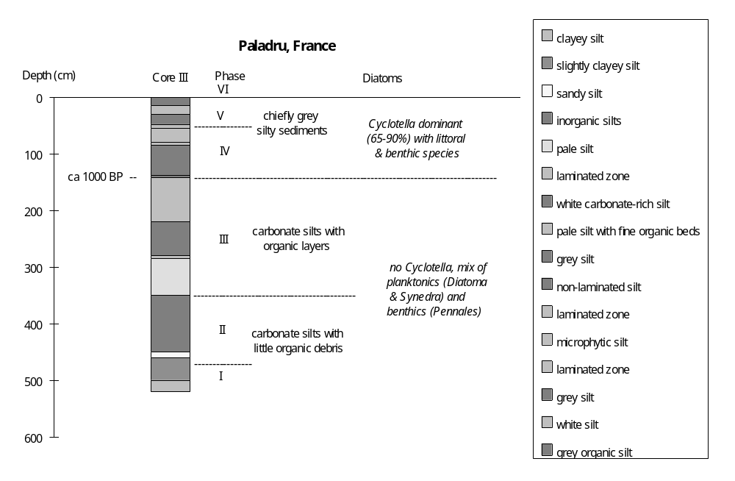

Preliminary coding: November 1990; Final coding: September 1994
Coded by SPH
Pelléautier, France

The lac de Pelléautier (also referred to as La-Motte-qui-Tremble peat bog: 44°31'2"N, 6°11'E, 975m above sea level) lies in a glacial trough carved in Jurassic marls on the Freissinouse upland (de Beaulieu, 1977; de Beaulieu and Reille, 1983). During the last glacial maximum, glaciers from the Durance flowed through the Gap trough, across the sill at Freissinouse and debouched into the Buech basin. A complex series of lateral moraines mark multiple oscillations in ice cover during the last glaciation (Gidon and Monjuvent, 1969).

The Pelléautier basin consists of two sub-basins: the more northerly is occupied by a large marsh (ca 34 ha), which was artificially flooded in 1972 to form a shallow lake. The southern sub-basin is smaller (ca 6 ha) and is still occupied by reedbeds because it lies at a somewhat higher elevation. There is a surface drainageway from the northern sub-basin.

Three cores from the northern sub-basin (I, II and III) provide a postglacial sedimentary record. The stratigraphy of the southern sub-basin has been reconstructed from a transect of six cores, running from northwest to southeast across the southwestern corner of the basin. Two cores (IV and V) from this sub-basin have been studied for pollen. Changes in water depth are reconstructed on the basis of changes in stratigraphy, sedimentation rate and aquatic pollen. The chronology is established by 21 radiocarbon dates (Evin et al., 1979, 1983; de Beaulieu and Reille, 1983).

The oldest sediments in Core V, the more central core in the southern sub-basin, are grey clays (Vb: 7.00-7.80m). These clays are thought to have been laid down in relatively quiet water after the retreat of the ice from the Pelléautier basin. The aquatic pollen assemblage is characterised by moderate levels of Cyperaceae and occasional grains of Sparganium and Potamogeton, consistent with moderately deep, quiet water. Calcareous clays or marls were deposited at this time around the margin of the sub-basin (Core IV).

The basal grey clays are low in organic matter and it is therefore difficult to date the onset of sedimentation. Three samples from between 6.70 and 7.08m in Core Vb were radiocarbon dated to 15,920±700 (Ly-1943), 19,660+4100-2700 (Ly-1942) and 23,730+1900-1500 (Ly-1796) yr B.P. This suggests that still water conditions were established sometime before ca 16,000 yr B.P.

The overlying unit in Core Vb is also a grey clay with many fine rootlets. The presence of rootlets suggests that the basin became shallower, allowing colonisation of the surface by plants. Since deposition in Core Vb is continuous, it must be presumed that these were rooted aquatics. An hiatus in marl deposition in Core IV, corresponding to the uppermost part of the interval of grey clay deposition in Core Vb (local pollen zone 3), is consistent with shallowing. Three samples from within the grey clay from the top of local pollen zone 2 are radiocarbon dated to 14,560±420 (Ly-1794), 14,770±300 (Ly-1468) and 15,090±430 (Ly-1795) yr B.P. respectively. This suggests that the water-level lowering occurred sometime after ca 14,500 yr B.P. A sample from ca 5.45-5.55m in Core Vb yielded an anomalously old date of 15,300±320 yr B.P. (Ly-1342); this is also consistent with the hypothesis of shallowing, since older material is often incorporated into sediments through subaerial erosion during intervals of drawdown.

An increase in water depth to intermediate levels is indicated by the subsequent deposition of marl (4.20-5.00m in Core Vb). The aquatic pollen assemblage is characterised by moderate levels of Cyperaceae and the occurrence of Sparganium, consistent with moderate water depth. The sediments corresponding to this marl unit in Core Vc consist of a sequence of thin beds of clay, lacustrine chalk, gyttja and lacustrine chalk. In Core IV the sediments consist of marl (5.45-6.08m) overlain by clayey lacustrine chalk (3.35-5.45m). The variability of the sediments in Cores Vc and IV suggest fluctuating water level. Marked variations in Cyperaceae pollen abundance are consistent with this interpretation. A sample from the top of the marl in Core IV was dated to 13,210±410 yr B.P. (Ly-1216). Interpolation between this and the overlying date in Core IV suggests that the increase in water level indicated by marl deposition occurred around 13,300 yr B.P.

A decrease in water depth around 12,800 yr B.P. is indicated by the deposition of lacustrine chalk (2.85-4.20m in Core Vb, 3.15-3.35m in Core IV). The occurrence of thin interbeds of gyttja near the base of the chalk in Core IV suggests that the water level oscillated somewhat until ca 11,800 yr B.P.

The deposition of peat (2.0-2.85m in Core Vb, 1.60-3.15m in Core IV) indicates a further decrease in water depth after ca 9100 yr B.P. A pronounced increase in Cyperaceae abundance is consistent with reduced water depth. Two samples from near the top of the peat in Core IV were dated to 6430±190 (Ly-1211, 1.75-1.80m) and 7600±230 (Ly-1212, 1.88-1.92m) respectively.

A further decrease in moisture levels after ca 6000 yr B.P. is indicated by the deposition of a sequence of peaty clay, peat, clay, peat and finally colluvial clays in Core Vb. There is an hiatus in deposition, corresponding to local pollen zone 14, in Core IV. The uppermost deposits in Core IV (0.00-1.60m) are colluvial clays.

The fragmentary and less well-dated cores from the larger sub-basin provide some additional insights into the lake-level record from Pelléautier. The record from Cores I and II, taken in the deeper part of the northern basin, indicate gyttja deposition during local pollen zone 7 (ca 12,800-9650 yr B.P.). The overlying unit, deposited during local pollen zone 8, is lacustrine chalk. Lacustrine chalk was deposited continuously through these two zones in both the more marginal part of the northern basin (Core III) and in the southern basin (Core Vb), although gyttja interbeds occur near the base of zone 7 in Core IV. It would seem that maximum water depths occurred between 12,800 and 9650 yr B.P.
Peat deposition, corresponding to a marked decrease in water depth, began in the southern basin around 9100 yr B.P. This shallowing is registered in the nearshore zone of the northern basin (Core III) by an hiatus in sedimentation corresponding to local pollen zones 10 and 11 (ca 9300-7500 yr B.P.). However, lacustrine chalk was deposited in the central part of the northern basin (Core II) until sometime after 7000 yr B.P., when peat was deposited. Thus the record from the northern basin indicates a more gradual decrease in water level than is apparent from the sedimentary record in the southern basin.

The uppermost deposits in the northern basin are marls (Core I, 0.00-0.85m) indicating an increase in water depth during the recent past. A sample from 0.70-0.75m was radiocarbon dated to 660±210 yr B.P. (Ly-581). This increase in water level is not registered in the southern basin, which was already infilled and stabilised by this time.

In the status coding, very low (1) is indicated by peat deposition in the northern basin, with interbedded peats and clays in the central part of the southern basin, and an hiatus in sedimentation in the nearshore core from the southern basin; low (2) by peat deposition in both nearshore and central cores from both basins; moderately low (3) by lacustrine chalk deposition in the northern basin and peat deposition in the southern basin; intermediate (4) by lacustrine chalk deposition in both basins; moderately high (5) by marl deposition in the northern basin, with either rooted aquatics growing in the central part of the southern basin or with colluvial clay deposition when the southern basin is nearly infilled; high (6) by marl deposition in both basins; very high (7) by gyttja deposition in the northern basin and lacustrine chalk deposition in the southern basin, or by still water clays in the southern basin.

References
Beaulieu, J.L. de, 1977. Contribution pollenanalytique à l'histoire tardiglaciaire et holocène de la végétation des Alpes méridionale françaises. Thèse ès sciences, Université Aix-Marseille III, 358pp.
Beaulieu, J.L. de and Reille, M., 1983. Paléoenvironnement tardiglaciaire et holocène des lacs de Pelléautier et Siguret (Hautes-Alpes, France). Histoire de la végétation d'après les analyses polliniques. Ecologia Mediterranea 9: 19-36.
Evin, J., Marechal, J. and Marien, G., 1983. Lyon natural radiocarbon measurements IX. Radiocarbon 25: 59-128.
Evin, J., Marien, G. and Pachiaudi, Ch., 1979. Lyon natural radiocarbon measurements VIII. Radiocarbon 21: 405-452.
Gidon, M. and Monjuvent, G., 1969. Essai de coordination des formations quaternaires de la moyenne Durance et du Haut Drac. Bulletin A.F.E.Q. 19: 145-161.

Radiocarbon Dates
Ly-581 660±210 clayey peat + molluscs, Core I, 0.7-0.75m
Ly-797 4640±190 peat, Core I, 2.55-2.65m
Ly-582 4850±250 lacustrine chalk, Core III, 1.45-1.50m
Ly-1211 6430±190 peat, Core IV, 1.75-1.80m
Ly-1212 7600±230 peat, Core IV, 1.85-1.95m
Ly-1213 9090±230 peat, Core IV, 3.05-3.15m
Ly-1217 10990±660 marl, Core V, 5.87-5.95m, aberrant
Ly-1214 11000±460 chalk, Core IV, 4.65-4.75m, low organics
Ly-674 11500±170 gyttja, ?depth, ? mix of I and II
Ly-1215 11750±500 chalk, Core IV, 5.04-5.13m, low organics
Ly-1775 12810±280 peaty marl, Core VI (Vb), 4.15-4.22m
Ly-1776 13200±550 marl, Core VI (Vb), 4.62-4.70m
Ly-1216 13210±410 marl, Core IV, 5.40-5.50m
Ly-1218 14320±680 marl, Core V, 5.65-5.74
Ly-1794 14560±420 peaty marl, Core VI (Vb), 6.05-6.15m
Ly-1468 14770±300 peaty marl, Core VI (Vb), 6.25-6.35m
Ly-1795 15090±430 peaty marl, Core VI (Vb), 6.20-6.25m
Ly-1342 15300±320 organic marl, Core VI (Vb), 5.45-5.55, aberrant result, ATO
Ly-1943 15920±700 clay, Core VI (Vb), 6.78-6.90m
Ly-1942 19700+4100-2700 clay, Core VI (Vb), 6.70-6.78m, sample very low in organics
Ly-1796 23730+1900-1500 clay, Core VI (Vb), 6.90-7.08m, low organics, probably ATO

Coding
pre-16000 - ca 14500 yr B.P. very high (7)
ca 14500 - 13300 yr B.P. moderately high (5)
13300 - 12800 yr B.P. high (6)
12800 - 9650 yr B.P. very high (7)
9650 - 9100 yr B.P. intermediate (4)
9100 - 7000 yr B.P. moderately low (3)
7000 - ca 6000 yr B.P. low (2)
ca 6000 - 670 yr B.P. very low (1)
670 - 0 yr B.P. moderately high (5)
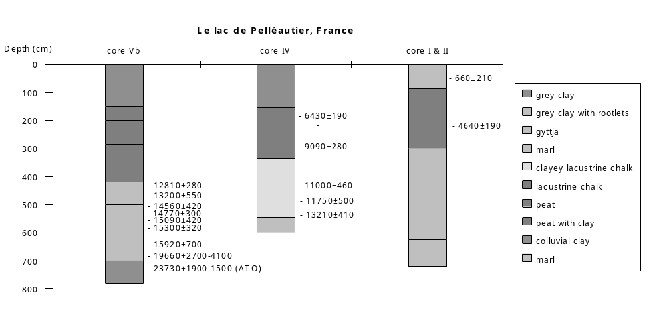
Preliminary coding: December 1990; Final coding: September 1991. Coded by SPH
Pluvis, France

The lac de Pluvis (45°38'N, 5°38'E, 215m above sea level) lies in a trench that cuts transversely through the southern Jura mountains (Borel et al., 1990). The valley, which is occupied today by the River Rhône, was sculpted by glaciers during the last glaciation. The lac de Pluvis basin lies in a glacio-lacustrine terrace (La Bruyère, 225m a.s.l.) within the Rhône Valley and was formed by melting of an ice lens during deglaciation. The Saint Benoît Mountains, which are primarily composed of calcareous rocks, lie to the north of the basin and the Mont de Cordon lies to the south. Glaciolacustrine deltaic terraces (Pluvis, Petit-Cuchet, la Bruyère) occur to the east and west of the lake basin.

The lake was drained in 1983, in the course of improvement works made in connection with the generation of hydro-electric power. Prior to drainage, the lake was ca 640m long, 180m wide and had a maximum depth of slightly over 15m (Borel et al. 1990). The lake basin had an area of ca 30 ha. The lake level at the time of drainage was 214.75m above sea level.

The stratigraphy of the lake bottom sediments was reconstructed from over 40 borings (Borel et al. 1990). Four cores (Pluvis 1-4) were obtained for detailed study. The deepest core (Pluvis 4) is 19.72m long and provides a postglacial sedimentary record (Borel et al., 1987). All of the cores show a similar gross stratigraphy. The basal sediments are blue plastic clays or clayey sands and silts, overlain successively by lacustrine chalk and peats. There are 11 radiocarbon dates on the uppermost lacustrine and peat sediments from various sites in the basin (Borel et al., 1990).

A detailed record of changes in water depth during the Holocene has been reconstructed on the basis of stratigraphic, magnetic susceptibility, mollusc and pollen analyses of Pluvis 4, combined with information from Pluvis 6, Pluvis 8 and Pluvis Pont C.N.R. (Borel et al., 1987, 1990). Archaeological information, specifically the elevations of shore settlements, provided additional information about the changes in water level.

The lowermost Holocene sediments in Pluvis 4 (2.20-10.22m, measured from the contact between the peat and the lacustrine chalk) are lacustrine chalk. The overlying sediments (1.72-2.20m) are lacustrine chalk with an admixture of organic material. The change in lithology is interpreted as indicating a slight shallowing. The overlying unit (1.64-1.72m) is lacustrine chalk, indicating an increase in water depth. The overlying unit (1.45-1.64m) is lacustrine chalk. The base of the unit contains abundant organic material, indicating a marked shallowing. A sample from this part of the unit has been radiocarbon dated to 3330±100 yr B.P. (Gif 6998). The overlying unit (1.32-1.45m) is lacustrine chalk, indicating an increase in water depth. The overlying unit (0.98-1.32m) consists of 3 peat layers separated by brown organic chalk. This unit is interpreted as indicating a major shallowing, allowing peat to invade the site, and interrupted briefly by two slight transgressive phases. The overlying unit (0.0-0.98m) is lacustrine chalk, indicating an important increase in water depth.

The uppermost sediments are peat. A sample from the base of the peat is radiocarbon dated to 2100±90 yr B.P. (Gif 6996).

Magny (in Borel et al., 1990) has summarised the Holocene history of the lake. The lake was low between 10,000 and 9500 yr B.P., 8500-8000 yr B.P., 5000-4700 yr B.P., ca 4000 yr B.P., 3300 and 3100 yr B.P. and after 3000 yr B.P. The lake was high ca 9000 yr B.P., between 4700 and 4000 yr B.P., ca 3000 yr B.P., and after 2600 yr B.P. Between 8000 and 5000 yr B.P., the lake appears to have been stable at moderately high levels. Our status coding follows this synthesis.

References

Borel, J.L., Damblon, F., Montjuvent, G., Mouthon, J. and Yates, G., 1987. Le lac de Pluvis (Bas-Bugey): paléoécologie et variations de niveau durant l'Holocène d'après le sondage 4. Travaux et Documents de Géographie tropicale 59: 25. (Résumés des communications, Xe Symposium, Associations des Palynologues de Langue Française, Bordeaux-Talence.) Centre d'Etudes de Géographie tropicale, C.R.N.S.
Borel, J-L., Bravard, J-P. and Monjuvent, G. (Eds), 1990. Pluvis, lac disparu: du retrait glaciaire a l'emenagement hydroelectrique. Revue de Paléobiologie, Special Volume 4: 1-101.

Radiocarbon Dates

Ly-3615 modern peat, Pont CNR 4
Ly-3449 1640±110 peat, Pluvis south
Gif-6996 2100±90 peat, Pluvis 4
Ly-2774 2170±140 wood, Pluvis west
Ly-3448 2460±120 peat, Pluvis 6
Ly-3614 3100±140 peat, Pont CNR 10
Gif-6998 3330±100 organic debris in chalk, Pluvis 4
Gif-7344 3980±60 wood, South Bank
Ly-3050 7470±130 wood, Sans
Ly-3049 9400±120 wood from pine log resting on contact between chalk and peat, Pluvis 1 & 2
Ly-2773 9730±180 peat, Sans

Coding

10000-9500 yr B.P. low (1)
9500-9000 yr B.P. intermediate (2)
ca 9000 yr B.P. high (3)
9000-8500 yr B.P. intermediate (2)
8500-8000 yr B.P. low (1)
8000-5000 yr B.P. high (3)
5000-4700 yr B.P. low (1)
4700-4000 yr B.P. high (3)
ca 4000 yr B.P. low (1)
4000-3300 yr B.P. intermediate (2)
3300-3100 yr B.P. low (1)
3100-3000 yr B.P. high (3)
3000-2600 yr B.P. low (1)
2600- 0 yr B.P. high (3)
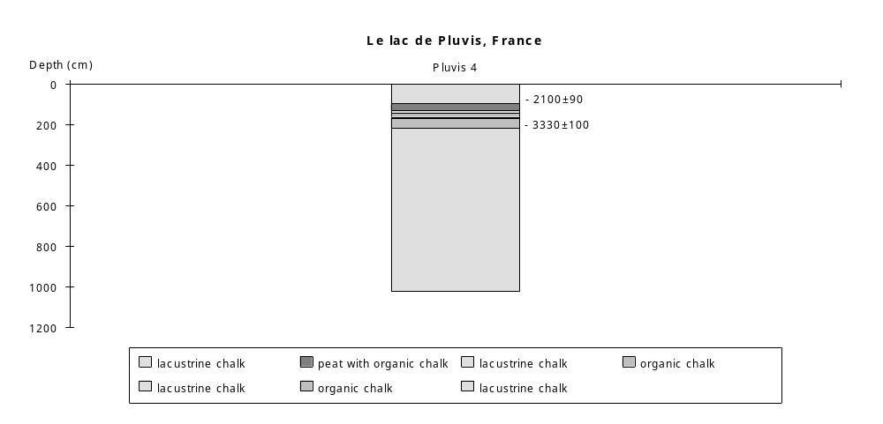
Preliminary coding: 6/12/1990; Final coding: September 1994. Coded by SPH
Rousses, France

Lac des Rousses (1058m above sea level) lies in an anticlinal valley between the Massif du Riseaux, to the north, and the Massif du Noirmont, to the south, in the French Jura (Magny and Richard, 1987). The valley is mantled by glacial deposits. The Lac des Rousses is the uppermost of a chain of lakes on the Orbe River. It overflows northeastwards, via the Orbe, into the Lac de Joux and the Lac de Brenet, some 15km downstream. The outflow from these lakes disappears underground for some distance, ultimately emerging near Vallorbe, Switzerland. The catchment area of the three lakes on the upper Orbe is about 20,000ha.

The Lac des Rousses itself is about 2km long, has an area of ca 90ha and a maximum depth of 18m. It freezes over during the winter (December through to April) every year. The immediate catchment area is 1900ha. The lake is fed by two major and three minor streams. The area around the lake, particularly the area around the two major inflows at the south end of the lake, is occupied by extensive peatbogs. The valley of the Orbe downstream of the lake is also occupied by peatland.

Several transects of cores provide information on the subsurface stratigraphy of the Lac des Rousses basin (Magny and Richard, 1987). Transect 1 runs across the Orme Valley at the mouth of the lake. Detailed studies were carried out on cores 5, 6 and 8 from this transect. Transect 2 runs across the lake perpendicular to Transect 1. Transect 3 runs perpendicular to the southeastern shore of the lake. Transect 4 runs along the talweg of the most important inflow stream, the Bief Noir. Transects 5 and 7 provide sections along the talweg of the Orbe, the former just below the mouth of the Lac des Rousses and the latter at the far end of the peatbog. Transect 6 runs perpendicular to the Orbe, across the widest part of the surrounding peatbog.

Magny and Richard (1986) have reconstructed changes in the water level of the Lac des Rousses on the basis of changes in stratigraphy and carbonate concretionary forms. The chronology is based on terrestrial pollen correlation with the regional pollen chronosequence. The reconstruction of changes in relative water depth presented here broadly follows the reconstructions in Magny and Richard (1986).

All of the transects show the same basic stratigraphic sequence. The basal sediments are morainic material. These sediments are overlain by glacio-lacustrine clays and silts. The overlying unit consists of laminated yellow lacustrine chalk. Magny and Richard (1986) interpret this unit as a deposit of the middle or upper sublittoral zone. The overlying unit consists of non-laminated yellow lacustrine chalk. The absence of laminations is consistent with a decrease in water depth, though the unit remains characteristic of sublittoral deposition.

The overlying unit is a compacted lake chalk, with very abundant oncoliths (carbonate concretions). The oncoliths form distinct layers, particularly towards the top of the unit. The compacted nature of the sediments, and the abundance of oncoliths, suggests that this unit was deposited in shallow conditions. The nature of the concretions changes upunit, from predominantly cauliflower-type near the base of the unit to ball- or platy-type towards the top of the unit. Magny and Richard (1986) interpret this unit as marking a major shallowing, and suggest that the topmost part of the unit was deposited in the eulittoral zone.

The terrestrial pollen sequence indicates that there is an hiatus in sedimentation during the Subboreal and initial phase of the Subatlantic. This is consistent with the lithological evidence for shallowing, and in particular the compacted nature of the lake chalk unit.

The overlying unit is a brown-coloured chalk, with occasional oncoliths. The change in the lithology is consistent with increased water depth. Although Magny and Richard (1986) indicate that this unit is characteristic of the eulittoral zone, they suggest that the relative paucity of concretions indicates a slight transgression.

The uppermost unit is peat, and is a consequence of infilling of the basin. Magny and Richard (1986) indicate that the deposition of ca 1.5m of peat must indicate a continual though slight trend towards increased water depth.

In the status coding, an hiatus is indicated by (0), low (1) by brown-coloured chalk or peat deposition, intermediate (2) by eulittoral zone deposits with relatively abundant oncoliths, high (3) by non-laminated lacustrine chalk characteristic of the sublittoral zone, and very high (4) by laminated lacustrine chalk characteristic of the middle or upper sublittoral zone. Note that it is difficult to arrive at a detailed correlation of the lithology and the pollen stratigraphy, so only the most general pattern of changes is given in the coding.

Reference

Magny, M. and Richard, H., 1987. Contribution a l'histoire du Lac des Rousses (Jura, France): recherches sedimentologiques et palynologiques. Revue de Paléobiologie 6: 89-103.

Coding

10000-9000 yr B.P. very high/high (4/3)
9000-4000 yr B.P. intermediate (2)
4500-2000 yr B.P. hiatus (0)
2000- 0 yr B.P. low (1)
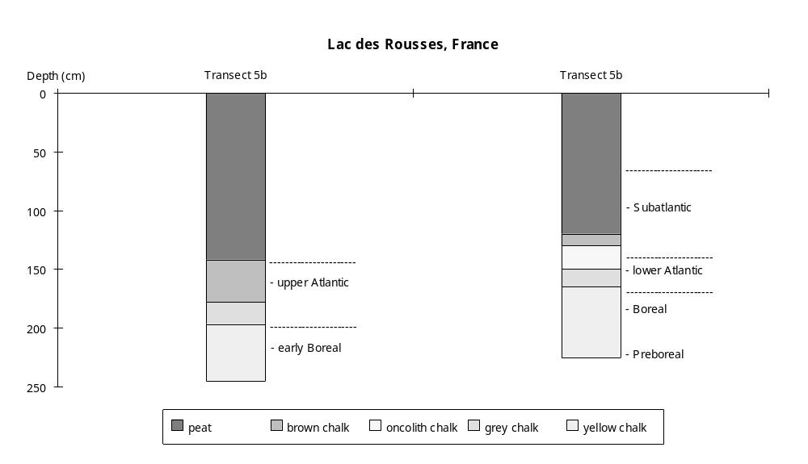

Preliminary coding: March 1989; Final coding: April 1989
Coded by: SPH

Saint-Julien-de-Ratz, France

Saint-Julien-de-Ratz (45°21'N, 5°37'24"E, 650m above sea level) is a small lake (6 ha) in the Ratz anticline. The underlying bedrock is calcareous, but the lake basin is infilled with clays and sands from the last glaciation and the lake water is acid (pH 5.5). A 10.9m core from the Sphagnum bog on the eastern shore of the lake provides a sedimentary record back to ca 13,000 yr B.P. (Clerc, 1985). Changes in water depth are reconstructed from changes in lithology and aquatic pollen assemblages. The chronology is established by four radiocarbon dates (Clerc, 1985).

The basal deposits (9.90-10.90m) are grey clays. The aquatic pollen assemblage is characterised by moderate Cyperaceae, with Myriophyllum and Potamogeton. The abundance of the club moss Selaginella suggests that the lake was spring-fed.

The overlying unit (9.40-9.90m) is a clayey gyttja. The aquatic assemblage is marked by a decline in Cyperaceae, and the presence of Potamogeton and occasional Nuphar. A sample from 9.80-9.90m was radiocarbon dated to 12,100 yr B.P. (Ly-2517).

The overlying unit (9.00-9.40m) is a clayey gyttja with peats beds, indicating fluctuating water levels between about 11,500 and 11,000 yr B.P. The aquatic assemblage is depauperate, with only small amounts of Cyperaceae and Typha.

A return to higher and more stable water levels after 11,000 yr B.P. is indicated by the deposition of clayey gyttja between 8.80-9.00m.

The overlying unit (6.00-8.80m) is an organic gyttja, suggesting a further increase in water depth after ca 10,735-10,795 yr B.P. The aquatic assemblage contains occasional Cyperaceae, Typha and Potamogeton, and is consistent with moderately deep water.

The uppermost sediments are moss peat (4.40-6.00m) and peat (1.0-4.40m) indicating decreased water depth after ca 7100-7600 yr B.P. This probably reflects hydroseral development around the lake margin. The top metre of the record is missing, apparently destroyed by peat cutting or burning.

In the status coding, low (1) is indicated by interbedded clayey gyttja and peat; intermediate (2) by clay or clayey gyttja deposition; and high (3) by organic gyttja deposition. The uppermost peat probably reflects hydroseral development and is, accordingly, not coded.

Reference

Clerc, J., 1985. Première contribution a l'étude de la végétation Tardiglaciaire et Holocène du Piémont Dauphinois. Documents de Cartographie écologique (Grenoble) 28: 65-83.

Radiocarbon Dates

Ly-2620 2200±210 peat, 2.55-2.65m
Ly-2807 5000±550 peat, 3.60-3.80m
Ly-2516 11450±310 clayey gyttja, 9.30-9.40m
Ly-2517 12100±360 clayey gyttja, 9.80-9.90m

Coding

ca 13000-11500 yr B.P. intermediate (2)
11500-11000 yr B.P. low (1)
11000-10750 yr B.P. intermediate (2)
10800- 7100 yr B.P. high (3)
7600- 0 yr B.P. not coded (hydroseral development)

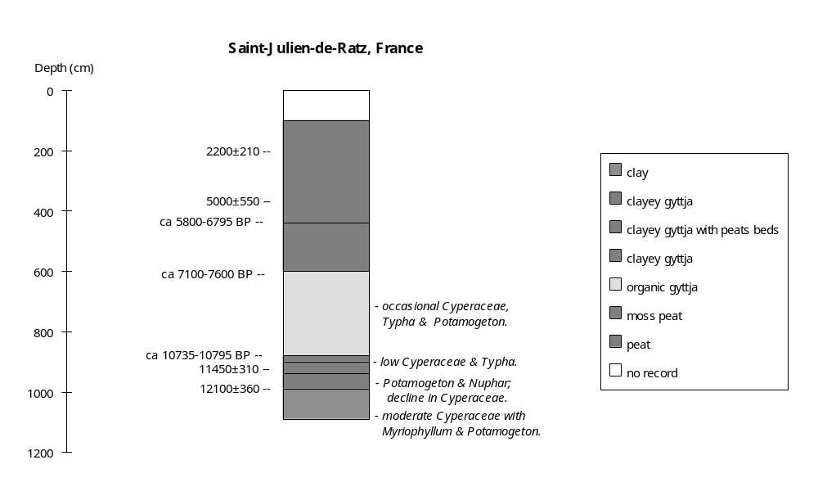

Final coding: December 7th, 1990
Coded by SPH
Sewensee, France

Sewensee (47°49'N, 6°52'E, 501m above sea level) is a small (6ha) lake, surrounded by peat bog, in the southern Vosges (Schloss, 1979). The maximum depth is 12m. The lake is fed by numerous small streams, but the chief inflow comes from the Lac d'Alfeld. There is an outflow into the Doller River system. The lake was formerly more extensive, consisting of three sub-basins. The two downstream basins have been infilled by alluvial deposits. The catchment area is ca 50 ha. The surrounding mountains reach elevations of up to 1247m above sea level (Ballon d'Alsace). The basin was glaciated during the last glacial maximum, and moraines occur on the southern side of the lake. The catchment bedrock includes granite, greywacke, breccias and trachyte.

The stratigraphy of the bottom deposits was reconstructed by means of 94 cores, taken along 3 longitudinal profiles and 11 cross-profiles across the lake and the former lake basin (Schloss, 1979). Changes in water depth are reconstructed primarily on the basis of hiatuses in sedimentation. Additional information is provided by lithology, and aquatic pollen and macrofossil assemblages. The chronology is based on the presence of the Laacher tephra and on terrestrial pollen correlation with other radiocarbon-dated sites in the southern Vosges (Grand Chemin IV, Frère Joseph, Feigne d'Artimont).

The gross stratigraphy (Schloss, 1979) is relatively simple. The basal deposits are detrital. The basal lacustrine deposits are clay, overlain by organic mud (fine detritus mud) and grading upwards into peat in the marginal (and infilled) areas. The Laacher tephra (dated to ca 11,000 yr B.P.) occurs near the base of the organic mud/fine detritus mud in several cores.

The aquatic pollen and macrofossil records show a transition from a late glacial assemblage characterised by Chara, Isoetes and Potamogeton to a more diverse Holocene assemblage including Nuphar, Nymphaea, Trapa natans, Scirpus, Sparganium, Typha, Scheuchzeria and Menyanthes. This sequence is consistent with the broad-scale pattern of progressive shallowing shown by the lithological sequence.

Sedimentary hiatuses during the Atlantic (VI/VII) and the Subboreal (VIII) indicate that the lake was low between ca 5600 and 2800 yr B.P. (Schloss, 1979).

In the status coding, hiatuses are indicated by (0); low (1) by organic mud deposition; and high (2) by clay deposition.

Reference

Schloss, S., 1979. Pollenanalytische und stratigraphische Untersuchungen im Sewensee. Ein Beitrag zur späat- und postglazialen Vegetationsgeschichte der Südvogesen. Dissertationes Botanicae 52: 1-138.

Coding

pre-11200 yr B.P. high (2)
11200-5600 yr B.P. low (1)
5600-2800 yr B.P. hiatus (0)
2800-0 yr B.P. low (1)

Preliminary coding: February 1987; Final coding: November 1987
Coded by: SPH
Federsee, Germany

Federsee (48°10'N, 9°35'E, 578m above sea level) is located in the southern piedmont of the Swabian Alps. The lake is 136 ha in area and has a maximum depth of 2.4m. The catchment area is 3540 ha (LAWA, 1985). The lake is fed by the Seekircher Aach in the north of the basin. Before 1981, there were several artificial drainage ditches draining into the lake. The outflow, Kanzach, flows from the southeast of the basin to the Donau River (Kuhn, 1961). The lake is surrounded by a wide zone of Phragmites and there is an discontinuous zone of floating-leaved aquatics (Nymphaea). The basin was initially formed by glacial erosion during the penultimate (Riss) ice age. The northern part of the basin was filled by moraine of last (Würm) ice age. The lake was artificially lowered by 2m in 1787/88 and in 1809. Before then the lake was 1095 ha in area (Kuhn, 1961).

The extent of the lake during prehistoric times has been reconstructed from the distribution of archaeological sites on the basin floor (Wall, 1961; Liese-Kleiber, 1984). The basin floor is a lacustrine plain, formed when the lake was more extensive. The earliest settlements in the basin have been dated to the early Stone Age (beginning in ca 6000 yr B. P.: Overbeck, 1975). The first settlement period was terminated by a lake transgression. The limnic sediments corresponding to this transgression occur up to an elevation of 582m. During the later Stone Age, the lake level fell and settlement again occurred on the basin floor. The occurrence of limnic sediments overlying later Stone Age settlement sites, and the apparent absence of settlements from the early Bronze Age (beginning in ca 3700 yr B.P.: Overbeck, 1975) suggest the lake level rose after ca 4000 yr B.P. Settlements from the middle and late Bronze Age occur on the basin floor above an elevation of 577m. Limnic deposits overlying Bronze Age sites and the absence of settlements from the Iron Age (beginning in ca 2800 yr B.P.: Overbeck, 1975) suggest that lake level was again high after ca 2800 yr B.P. The lake appears to have remained at this high level until ca 800 yr B.P.

The early history of the lake, and a more detailed record of the prehistoric period, is provided by studies of the basin floor deposits. Sixty-four cores from the basin provide a detailed stratigraphic record (Wall, 1961; Gronbach, 1961; Liese-Kleiber, 1984). All of the cores were taken from marginal areas and have been studied palynologically. The longest and most complete record of the lake history is provided by Profil Ga (580.7m above sea level) and Profil Gb (580.2m), taken from the southern part of the basin and 5m and 2.3m long respectively. Wall (1961) reconstructed the preliminary water-level changes from ca 15000 yr B.P. to the present, based on lithology and archaeology. Here, changes in water depth are reconstructed from changes in lithology, aquatic pollen and archaeologicalinformation (Wall, 1961; Gronbach, 1961; Liese-Kleiber, 1984) and broadly follows that of Wall (1961). The chronology is based on the local terrestrial pollen chronosequence (Gronbach, 1961; Overbeck, 1975).

The basal unit is clay deposited during the last glacial maximum (Wall, 1961). At this stage, the lake was fed directly by glacial meltwater and had an overflow at a height of 580.5m. The lake fell after the ice retreat ca 16000 yr B.P. This resulted in deposition of sand in the littoral zone, the formation of erosion gullies and emergence of the southern part of the lake bed (Wall, 1961; Overbeck, 1975). The lake fell below the outflow level. The lake appears to have remained at a very low level for several thousand years. Aquatics (Ranunculus) are abundant (Profil Ga: Gronbach, 1961), consistent with shallower conditions.

An increase of water depth after ca 12700 yr B.P. is indicated by the extension of limnic deposits (clayey, sandy gyttja) up to elevations of 581.5m. Aquatic pollen became less abundant (Profil Ga: Gronbach, 1961), consistent with deeper water. Traces of an overflow channel occur at a height of 581.5-581.7m.

A decrease of water depth after ca 9500 yr B.P. is indicated by a transition to sand in the littoral zone and the reduced extent of limnic deposits. Organic gyttja was deposited in the centre of the basin (Wall, 1961). The presence of Typha (Profil Ga: Gronbach, 1961) is consistent with shallower water. There was no outflow from the lake. The water level was below 580m.

An increase of water depth after ca 9000 yr B.P. is indicated by the presence of calcareous gyttja in the littoral zone. The disappearance of Typha (Profil Ga: Gronbach, 1961) is consistent with deeper water. The lake once again had an outflow.

A decrease of water depth after ca 8500 yr B.P. is indicated by the transition to sand in the littoral zone. Organic gyttja was deposited in the centre. Typha was present (Profil Ga: Gronbach, 1961), consistent with shallower water.

An increase of water depth after ca 8000 yr B.P. is indicated by the deposition of calcareous gyttja in the littoral zone. The disappearance of Typha (Profil Ga: Gronbach, 1961) is consistent with deeper water.

A decrease of water depth after ca 6000 yr B.P. is indicated by the occurrence of human settlement sites in the littoral areas. The distribution of archaeological sites suggests the lake was very small and shallow. There was no outflow. The abundance of aquatics (Typha, Menyanthes, Ranunculus and Nymphaea; Profil Gb: Gronbach, 1961) is consistent with very shallow water.

An increase of water depth after ca 4500 yr B.P. is indicated by the deposition of gyttja over the archaeological sites. The limnic sediments occur up to a height of 582m, indicating the water was deep. The lake was probably overflowing at this stage.

A decrease in water depth after ca 4400 yr B.P. is indicated by the occurrence of later Stone Age sites in the littoral zone.

An increase of water depth after ca 4000 yr B.P. is indicated by deposition of calcareous gyttja over the later Stone Age living areas.

A decrease of water depth after ca 3500 yr B.P. is indicated by settlements dated to the middle and late Bronze Age in the littoral zone. Organic gyttja was deposited in the centre of the lake, consistent with shallower water. The abundance of Menyanthes (Profil Gb: Gronbach, 1961) is in agreement with shallower water.

An increase of water depth after ca 2800 yr B.P. is indicated by the extension of limnic deposits to cover the Bronze Age sites. There is no settlement of Iron Age in the basin, suggesting that deep water conditions persisted for some considerable time.

A decrease of water depth after ca 800 yr B.P. is indicated by peat deposition in the littoral zone and the emergence of the littoral area.

In the status coding, low (1) is indicated by archaeological sites in the littoral zone and the occurrence of limnic sediments sand only below 580m; intermediate (2) by calcareous gyttja or the peat deposition in the littoral zone; high (3) by the occurrence of limnic sediments above 581m and the absence of archaeological sites in the littoral zone. The interval when the lake was directly fed by glacial meltwater, and the fall in lake level consequent on the retreat of the ice are not coded.

References

Gronbach, G., 1961. Pollenanalytische Untersuchungen zur Geschichte des Federsees und zur vorgeschichtlichen Besiedlung. In: Zimmermann, W. (ed) 1961. Der Federsee. pp. 316-365.
Kuhn, L., 1961. Die Verlandungsgesellschaften des Federseerieds. In: Zimmermann, W. (ed) 1961. Der Federsee. pp. 1-69.
Länderarbeitsgemeinschaft Wasser (LAWA), 1985. Seen in der Bundesrepublik Deutschland. 27pp.
Liese-Kleiber, H., 1984. Pollenanalysen am Federsee-Forschungsstand und neue Untersuchungen. Berichte zu Ufer- und Moorsiedlungen Südwestdeutschlands 1: 80-100.
Wall, E., 1961. Der Federsee von der Eiszeit bis zur Gegenwart. In: Zimmermann, W. (ed) 1961. Der Federsee. pp. 228-315.

Coding

16000-12700 yr B.P. low (1)
12700-9500 yr B.P. high (3)
9500-9000 yr B.P. low (1)
9000-8500 yr B.P. intermediate (2)
8500-8000 yr B.P. low (1)
8000-6000 yr B.P. intermediate (2)
6000-4500 yr B.P. low (1)
4500-4400 yr B.P. high (3)
4400-4000 yr B.P. low (1)
4000-3500 yr B.P. intermediate (2)
3500-2800 yr B.P. low (1)
2800-800 yr B.P. high (3)
800-0 yr B.P. intermediate (2)

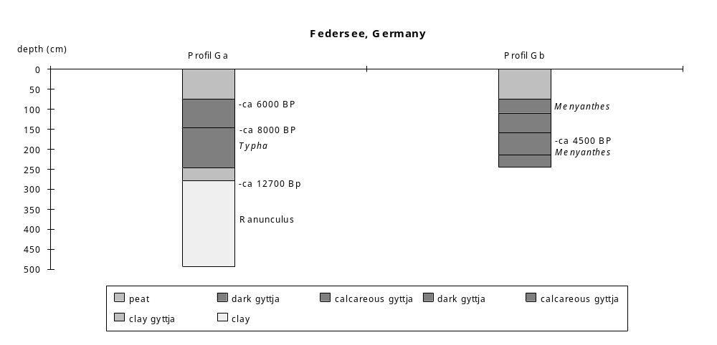

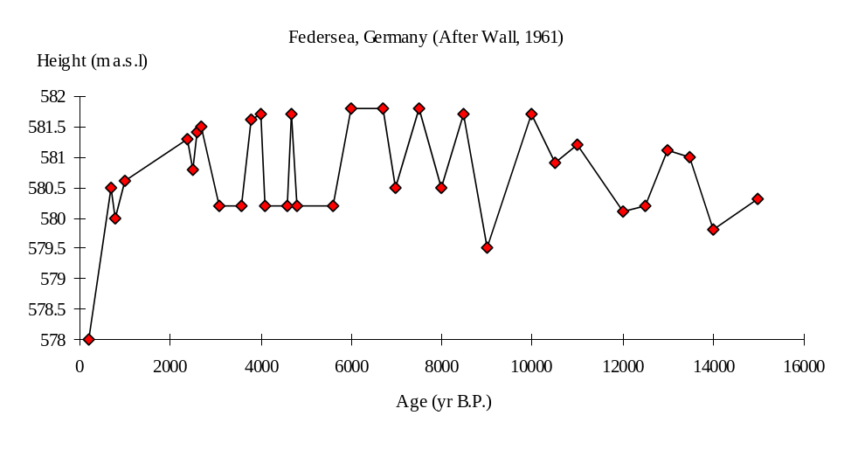

Preliminary coding: 11th April 1994; Final coding: 22nd May 1994.
Coded by: XY and SPH
Großer Plöner See, Germany

Großer Plöner See (54°10'N, 10°25'E, < 40m above sea level) has an area of 3000 ha. The maximum length and breadth are 8.3km and 8.2km respectively. The lake has an average depth of ca 13m (Erlenkeuser and Willkomm, 1979; 13.7m Groschopf, 1936) with a maximum depth of ca 60m (Die Landesvermessungsämter der Bundesrepublik Deutschland und das Institut für Angewandte Geodäsie, 1977). There are 14 small streams flowing into the lake and an outflow to Kleiner Plöner See (Die Landesvermessungsämter der Bundesrepublik Deutschland und das Institut für Angewandte Geodäsie, 1977). The watershed divides are very near (2-300m) to the shore line (Erlenkeuser and Willkomm, 1979). The lake basin, which consists of several small glacial basins and troughs, was mainly formed during the last glaciation. The lake bed is underlain by calcareous ground moraine.

Seven cores from the lake provide a Holocene sedimentary history (Averdieck, 1978 and 1979). Stadttief 1 and Stadttief 2 were taken close together in a water depth of 41m from the north-central part of the lake. Stadttief 1 is 7.65m long and Stadtief 2 is 15.12m long. Five other cores (A1, A2, B, C and D) were taken in the northwestern littoral zone, in water depths from 0.92m (A1) to 3.30m (C). The A2 core was drilled at the same place as A1. Cores B and D were taken in water depths of 1.10m and 2.60m respectively.

The changes in water depth are reconstructed from changes in lithology, aquatic pollen and macrofossils, and diatom assemblages in cores Stadttief 2 and A1, B, C and D, and from old shore lines. The lithology of Stadttief 1 was not described (Averdieck, 1978). Diatom analyses were carried out only on the uppermost 0.5m of Stadttief 2 (Averdieck and Saar, 1973). There are 32 radiocarbon dates from Stadttief 2, and four radiocarbon dates from core A1 (Averdick, 1978 and 1979; Erlenkeuser and Willkomm, 1979; Averdieck, 1994, pers. comm.). Nine of the dates from Stadttief 2 are stratigraphically inverted. The uppermost four dates from this core yield ages considerably older than expected, and are thought to be contaminated (Kock, 1970; Erlenkeuser and Willkomm, 1979). The chronology is therefore based on 19 dates from Stadttief 2, the four dates from core A1, and an additional date on shoreline deposits above modern lake level. Extrapolation from the reliable dates on Stadttief 2 suggests that the modern sediment has a radiocarbon age of 1025±93 years (Erlenkeuser and Willkomm, 1979). Comparison of the terrestrial pollen assemblages with the regional chronosequence also suggests that the radiocarbon ages are systematically too old by ca 1000 years (Overbeck, 1957; Averdieck, 1978; Erlenkeuser and Willkomm, 1979). This is attributed to a hard-water effect. A correction of 1020 years (Averdieck, 1978) has been applied to all the reliable radiocarbon dates to construct the chronology of water depth changes.

The basal sediments (below 15.03m in Stadttief 2) are glacial sands, extremely poor in pollen. This layer was deposited some time during the late glacial (Averdick, 1979), but the exact date when the glacier disappeared from the basin is not known.

The overlying sediments are clay, containing fine sand (14.80-15.03m in Stadttief 2). In a littoral core (D) sand was deposited. The nature of the sediments indicates shallow water. The aquatic pollen assemblage from Stadttief 2 is characterised by Sparganium reaching its maximum abundance, and abundant Cyperaceae, consistent with relatively shallow conditions. The terrestrial pollen assemblages suggest that deposition of this unit started at the beginning of the Younger Dryas (ca 10800 yr B.P.: Schmitz, 1961; Averdieck 1978; Overbeck, 1975).

A decrease in water depth ca 10550 yr B.P. is indicated by the transition to fine sand containing clay, coarse sand and plant remains (14.65-14.83m in Stadttief 2). The frequent occurrence of Sparganium and Cyperaceae (Averdieck, 1978) in the aquatic pollen assemblages is consistent with shallower water.

An increase in water depth ca 10300 yr B.P. is indicated by the transition to clay gyttja with fine sand (14.48-14.65m in Stadttief 2). Clay gyttja was also present in a littoral core (C), consistent with deeper conditions (Averdieck, 1979). The decrease of Sparganium and Alisma (Averdieck, 1978) is also consistent with deeper water.

A decrease in water depth ca 10100 yr B.P. is suggested by the transition to black, fine detritus gyttja containing silt and fine sand (14.12-14.48m in Stadttief 2). The occurrence of Alisma and Cyperaceae in littoral cores (C and D: Averdieck, 1979) is consistent with shallower water.

The overlying deposits in Stadttief 2 (13.35-14.12m) are gyttja, rich in clay and silt. It was dark grey in colour from 13.44m to 13.89m, and black from 13.89-14.12m. Limnic materials, including lacustrine lime of biological origin, were recorded in all littoral cores for the first time. The extention of limnic deposits in the littoral zone indicates an increase in the lake area, and hence increased water depth (Averdieck, 1979). Cyperaceae declined in abundance, and Sparganium and Nymphaea became dominant in aquatic pollen assemblages in C and D, consistent with deeper water. A sample of organic material from the base of the gyttja (13.84-14.04m) is radiocarbon dated to ca 9790 yr B.P. (KI-246.41, 10810±170). Two other samples from 13.74-13.81m and from 13.54-13.71m have the ages of ca 8610 yr B.P. (KI-246.01, 9630±90) and ca 8190 yr B.P. (KI-246.40, 9210±140) respectively. A sample of old lake calcite, from 1.3m above the modern water surface, is radiocarbon dated to 9220±160 yr B.P. (KI-917).

The overlying sediments in Stadttief 2 (12.35-13.35m) are gyttja. Calcareous sediments continued to be deposited in a deeper littoral core (B) but peat was deposited in core A1 (0.12-0.77m). The occurrence of peat suggests decreased water depth. The occurrence of Sparganium in the aquatic pollen assemblages of core B is consistent with shallower conditions. Samples from 0.73-0.79m and 0.39-0.45m of A1 were dated to 7870±100 yr B.P. and 6950±90 yr B.P. The sample at the depth of 12.73-13.05m from Stadttief 2 was dated to ca 5660 yr B.P. (KI-246.43, 6680±70).

The overlying sediments in Stadttief 2 (10.35-12.35m) are gyttja. In the littoral core B the sediments are calcareous deposits intercalated by inwashed humus and plant remains (Averdieck, 1979). Peat sedimentation rates are lower (ca 0.1 mm/year) in the littoral core A1. The nature of the sediments in the littoral zone indicates decreased water depth. The presence of Sparganium in core B and the occurrence of Carex in core A1 are consistent with shallower water. A sample at the depth of 0.05-0.10m from core A1 was dated to 4360±75 yr B.P. The sample from the base of this unit (12.15-12.35m in Stadttief 2) was radiocarbon dated to ca 4460 yr B.P. (KI-246.47, 5480±90).

The overlying sediments in Stadttief 2 (0.89-10.35m) are gyttja intercalated with leaves and wood fragments (Averdieck, 1978). The presence of inwashed leaves and wood suggests the coring site was near the lake margin at this time, and that the lake was very shallow. Local pollen zones X, XI and XII (ca 3000-0 yr B.P.: Averdieck, 1979; Overbeck, 1975) are absent in core A1, suggesting an hiatus in sedimentation. Pollen zones XI and XII (ca 2200-0 yr B.P.: Averdieck, 1979; Overbeck, 1975) are absent in core B. The top of D consists of calcareous deposits formed in the early Holocene (local pollen zone VII, ca 8800-8000 yr B.P.: Averdieck, 1979; Overbeck, 1975). Sediments which cover the last ca 8800 years (Averdieck, 1979; Overbeck, 1975) are absent from core C. A possible explanation is that the present littoral was above water and underwent erosion. Radiocarbon dates from the interval 6.80-7.35m in Stadttief 2 are stratigraphically inverted. The sample from 6.80-7.10m was radiocarbon dated to ca 1140 yr B.P. (KI-85.24, 2160±110), from 6.82-7.19m to ca 740 yr B.P. (KI-246.33, 1760±90) and from 7.10-7.35m to ca 1090 yr B.P. (KI-85.25, 2110±75) respectively. A similar inversion took place between 5.50-6.80m. Such inversions are consistent with limited water depth with high turbulent flow. The sedimentation rate in Stadttief 2 increased from 0.04 to 0.08 cm/year ca 2000 yr B.P. to as high as 0.1 cm/year during the last 700 years. The accelerated sedimentation may have been caused by agricultural activity in the catchment (Erlenkeuser and Willkomm, 1979). A sample from the base of this unit (10.00-10.35m in Stadttief 2) was dated to ca 2470 yr B.P. (KI-246.36, 3490±90) and a sample from the top (0.91-1.57m in Stadttief 2) to ca 120 yr B.P. (KI-246.26, 1140±45).

Nowadays all the littoral coring sites are below the water surface, indicating increased water depth after ca 120 yr B.P. The top of Stadttief 2 (0-0.89m) is laminated fine detritus gyttja, consistent with the deep water observed today at the coring site. The dominance of planktonic species like Melosira islandica and Stephanodiscus astraea in the diatom assemblages is consistent with deeper water. Groschopf (1936) suggested that the recent rise of lake level may partly reflect the damming of the lake in 1256 A.D. However, the deposition of laminated sediments happened much later than this. We therefore interpret the change as a reflection of climatically-induced change in the water balance.

In the status coding, an hiatus (0) is indicated by missing pollen zones in all the littoral cores; very low (1) by fine sand containing clay, plant remains and coarse sand, and the presence of Sparganium and Cyperaceae in Stadttief 2; low (2) by clay containing fine sand, fine detritus gyttja containing silt and fine sand in Stadttief 2, sand and the occurrence of Alisma in deeper-littoral cores (C and D); intermediate (3) by clay gyttja or gyttja in Stadttief 2, calcareous deposits in deeper-littoral core (B), low peat sedimentation rates in core A1; high (4) by laminated gyttja in the core Stadttief 2, high peat sedimentation rates in core A1 and calcareous sediments in deeper-littoral core (B); very high (5) by lacustrine sediments in all the littoral cores and a shore line above modern lake level.

References

Averdieck, F.-R., 1978. Palynologischer Beitrag zur Entwicklungsgeschichte des Großen Plöner Sees und der Vegetation seiner Umgebung. Archiv für Hydrobiologie 83: 1-46.
Averdieck, F.-R., 1979. Paläobotanische Untersuchungen am Litoral des Großen Plöner Sees. Archiv für Hydrobiologie 86: 161-180.
Averdieck, F.-R., 1994. Personal communication (letter 24/2/94)
Averdieck, F.-R. and Saar, A. D., 1973. Pollen- und diatomeenanalytische Untersuchungen an jüngsten geschichteten Sedimenten aus dem Großen Plöner See (Schleswig-Holstein). Meyniana 23: 1-8.
Erlenkeuser, H. and Willkomm H., 1979. 13C- und 14C-Untersuchungen an Sedimenten des Großen Plöner Sees. Archiv für Hydrobiologie 85: 1-29.
Groschopf, P., 1936. Die postglaziale Entwicklung des Großen Plöner Sees in Ostholstein auf Grund pollenanalytischer Sedimentuntersuchungen. Archiv für Hydrobiologie 30: 1-84.
Kock, U.J., 1970. Untersuchungen mit der 14C-Methode an Süßwassersedimenten. Staatsexamenarbeit, Universität Kiel. 180pp.
Die Landesvermessungsämter der Bundesrepublik Deutschland und das Institut für Angewandte Geodäsie, 1977. Topographischer Atlas Bundesrepublik Deutschland.
Overbeck, F., 1975. Botanisch-geologische Moorkunde. Neimünster. 719pp.
Schmitz, H., 1961. Pollenanalytische Untersuchung in Hohen Viecheln am Schweriner See. Schriften der Sektion zur Vor- und Frühgeschichte 10: 14-38.

Radiocarbon dates

KI-246.26 1140±45 0.91-1.57m, gyttja, Stadttief 2
KI-319.01 1160±65 0.36-0.46m, gyttja, Stadttief 2, contaminated
KI-246.28 1250±55 1.86-2.60m, gyttja, Stadttief 2
KI-318.08 1290±80 0.30-0.33m, gyttja, Stadttief 2, contaminated
KI-85.14 1300±65 3.60-3.90m, gyttja, Stadttief 2, strat.invert.
KI-246.29 1340±50 2.76-3.50m, gyttja, Stadttief 2, strat.invert.
KI-85.15 1520±80 3.90-4.20m, gyttja, Stadttief 2
KI-85.21 1540±80 5.80-6.08m, gyttja, Stadttief 2, strat.invert.
KI-85.20 1620±65 5.50-5.80m, gyttja, Stadttief 2, strat.invert.
KI-85.22 1700±80 6.08-6.34m, gyttja, Stadttief 2, strat.invert.
KI-85.23 1700±90 6.50-6.80m, gyttja, Stadttief 2, strat.invert.
KI-246.33 1760±90 6.82-7.19m, gyttja, Stadttief 2, strat.invert.
KI-318.02 1940±70 0.025-0.08m, gyttja, Stadttief 2,contaminated
KI-85.25 2110±75 7.10-7.35m, gyttja, Stadttief 2, strat.invert.
KI-85.24 2160±110 6.80-7.10m, gyttja, Stadttief 2, strat.invert.
KI-318.06 2340±55 0.21-0.25m, gyttja, Stadttief 2, contaminated
KI-246.34 2530±40 9.10-9.35m, gyttja, Stadttief 2
KI-246.36 3490±90 10.40-10.69m, gyttja, Stadttief 2
KI-331.01 4360±75 0.05-0.10m, peat, A1
KI-246.50 4390±75 10.69-10.97m, gyttja, Stadttief 2
KI-246.51 4590±90 10.96-11.16m, gyttja, Stadttief 2
KI-246.04 4630±110 11.14-11.35m, gyttja, Stadttief 2
KI-246.45 5070±100 11.55-11.85m, gyttja, Stadttief 2
KI-246.03 5200±130 11.80-11.91m, gyttja, Stadttief 2
KI-246.46 5410±80 11.95-12.45m, gyttja, Stadttief 2
KI-246.47 5480±80 12.15-12.35m, gyttja, Stadttief 2
KI-246.43 6680±70 12.73-13.05m, gyttja, Stadttief 2
KI-331.03 6950±90 0.39-0.45m, peat, A1
KI-246.44 7450±120 13.05-13.35m, gyttja, Stadttief 2
KI-331.02 7870±100 0.73-0.79m, peat, A1
KI-331.04 7970±55 0.79-0.85m, gyttja, A1
KI-246.40 9210±140 13.54-13.71m, gyttja, Stadttief 2
KI-917 9220±160 lake calcite, old shoreline deposits
KI-246.01 9630±90 13.74-13.81m, gyttja, Stadttief 2
KI-246.41 10810±170 13.84-14.04m, gyttja, Stadttief 2

Coding

10800-10550 yr B.P. low (2)
10550-10300 yr B.P. very low (1)
10300-10100 yr B.P. intermediate (3)
10100-9700 yr B.P. low (2)
9700-7900 yr B.P. very high (5)
7900-4300 yr B.P. high (3)
4300-2400 yr B.P. intermediate (2)
2400-120 yr B.P. hiatus (0)
120- 0 yr B.P. high (4)

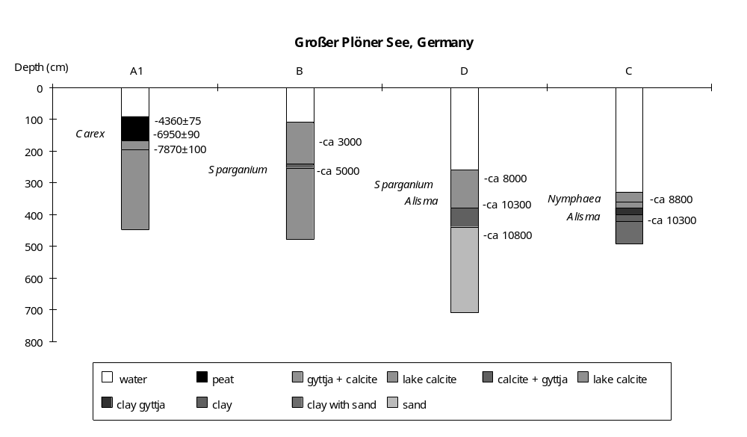

Preliminary coding: 14/12/1993; Final coding: 5/4/1994. Coded by: XY and SPH

Schleinsee, Germany

Schleinsee (47°45'N, 9°30'E, 474m above sea level) is a small (14.9 ha) lake in southwest Germany. The lake is long, with a length of 700m and a breadth of 250m. The maximum depth is 11.6m, the average depth is 6.5m and the catchment area is 60 ha (Müller, 1962; Geyh et al., 1971). The lake is fed by two streams. There is an intermittant outflow which often dries up during summer. The lake basin was formed by glacial erosion during the last glaciation and is underlain by calcareous ground moraine, which includes boulder-sized material. There is thick layer of clay across the basin, which acts as a watertight seal against ground water (Geyh et al., 1971).

Two cores from the lake provide a sedimentary record covering the Holocene. Core A is 11.4m long, taken in a water depth of 11.6m (Geyh et al., 1971), and the FM core is 9.82m long, taken in a water depth of 11.4m (Frey, 1961; Müller, 1962). Pollen analysis was carried out on the FM core. Cladocera from the upper 7.5m of the FM core, and diatoms from the basal sediments of core A were investigated. Changes in water depth are reconstructed from changes in lithology, aquatic pollen, Cladocera and diatom assemblages. There are 50 radiocarbon dates on the annually-laminated gyttja from the middle section of core A. Eighteen of these dates are older or younger than expected, probably due to contamination. These anomalous dates cannot be due to stratigraphic inversions because the laminations are well preserved (Geyh et al., 1971). The chronology is therefore provided by 32 radiocarbon dates on the organic fraction, the presence of a dated tephra and pollen correlation with the regional chronostratigraphy (Firbas, 1949; Müller, 1962; Geyh et al. 1971; Overbeck, 1975; van den Bogaard and Schmincke, 1985). Correlation between cores A and FM is based on the lithology and terrestrial pollen assemblages.

The cores bottom out (10.3m in core A, 9.76m in core FM) in calcareous boulder clay. The overlying sediments are silt-rich, fine detritus gyttja in core A (10.05-10.3m), and grey sand mixed with clay in the FM core (9.45-9.76m). Those deposits mark the onset of lacustrine conditions in the basin. The coarse materials suggest shallow water. The presence of Sparganium in the pollen assemblages is consistent with shallow water. The terrestrial pollen assemblage indicates this unit was deposited during the Oldest Dryas (pre- ca 12700 yr B.P., Firbas 1949; Overbeck, 1975).

The overlying sediments consist of calcareous gyttja (9.4-10.05m in core A, 8.09-9.45m in core FM). The presence of turbidite deposits with inclined bedding suggests the water was shallow. The presence of shell remains is consistent with shallow water. The presence of Sparganium also suggests shallow water conditions. Numerous littoral diatoms were present. The sedimentation rate is relatively low (ca 0.019 cm/year), indicating low productivity. The Laacher-See tephra occurs as a 4mm thick layer at a depth of 9.92m in core A. This tephra has been dated to 11000±50 yr B.P. (Geyh, et al. 1971; van den Bogaard & Schmincke, 1985). This is consistent with the pollen evidence which indicates that this layer was accumulated during Bölling, Alleröd, Younger Dryas and Pre-Boreal times (ca 12700-9200 yr B.P., Müller, 1962; Firbas, 1949; Overbeck, 1975).

The overlying sediments (core A: 8-9.4m; core FM: 6.84-8.09m) are annually-laminated calcareous gyttja. The white, calcareous fraction was deposited during the summer months and the dark, organic detritus was accumulated during the whole year (Geyh, et al., 1971). The preservation of laminations is indicative of deep water. There are 4021 laminae in core A (Geyh et al., 1971) and roughly 3800 in core FM (Müller, 1962; Frey, 1961). The remains of leaves, wood, fruit and seed are rare. The absence of aquatics is consistent with deep water. Organic remains are very well preserved, for example, the insect and Cladocera were predominantly embedded as entire animals. The planktonic species, Bosmina, Ceriodaphnia and Daphnia, are abundantly present in the Cladocera assemblages. The supposition of restriction of open water (Frey, 1961), based on relatively low Bosmina content, is in agreement neither with the total abundance of planktonic Cladocera nor with the lithological evidence. Except for Alona quadrangularis and Pleuroxus trigonellus, most littoral species are comparatively rare. The sedimentation rate (ca 0.035 cm/year) doubled, suggesting higher productivity. There are 50 radiocarbon dates from this unit. A basal sample (9.4m) is dated to 9210±120 yr B.P., and one from a depth of 8.05m to 5260±75 yr B.P. If the sedimentation rate (0.035 cm/year) was constant, as suggested by radiocarbon dates, the top of this unit (8m) would have an age of 5000 years. The radiocarbon dates are in good agreement with the number of laminations, and consistent with the pollen dating.

The overlying sediments are non-laminated gyttja (core A: 0-8m, core FM: 0-6.84m), variously described as fine detritus gyttja (Geyh et al., 1971) and algal gyttja (Müller, 1962). The calcareous content is low. The disappearance of laminations is indicative of shallowing. The presence of aquatics, such as Potamogeton, is in agreement with shallowing. In the Cladocera assemblages, several new littoral species such as Sida crystallina, Alonella nana and Chydorus sphaericus are present. The percentage of most littoral species increased, consistent with decreased water depth. However, the abundance of Cladocera, especially the planktonic species Bosmina, indicates that the lake must have been moderately deep. The sedimentation rate (ca 0.14 cm/year) is much higher than that before, signifying a high productivity in the lake.

In the status coding, low (1) is indicated by silt-rich gyttja, calcareous gyttja with turbidite, the presence of Sparganium in pollen assemblages, the existence of shell remains and the presence of littoral diatoms; intermediate (2) by non-laminated gyttja, the increase of littoral Cladocera as well as the abundance of planktonic species Bosmina, and the presence of Potamogeton; high (3) by laminated sediments, the domination of planktonic species such as Bosmina, Ceriodaphnia and Daphnia in the Cladocera assemblages, and the absence of aquatic macrophytes.

References

Firbas, F., 1949. Spät- und nacheiszeitliche Waldgeschichte Mitteleuropas nördlich der Alpen. Erste Band: Allgemeine Waldgeschichte. Jena. 480pp.
Frey, D. G., 1961. Developmental history of Schleinsee. Verhandlungen Internationale Vereinigung für Limnologie XIV: 271-278.
Geyh, M.A., Merkt, J. and Müller, H., 1971. Sediment-, Pollen-, und Isotopenanalysen an jahrezeitlich geschichteten Ablagerungen im zentralen Teil des Schleinsees. Archiv für Hydrobiologie 69: 366-399.
Müller, H., 1962. Pollenanalytische Untersuchungen eines Quartärprofils durch die spät- und nacheiszeitlichen Ablagerungen des Schleinsees (Südwestdeutschland). Geologisches Jahrbuch 79: 493-526.
Overbeck, F., 1975. Botanisch-geologische Moorkunde. Neumünster. 719pp.
van den Bogaard, P. and Schmincke, H.-U., 1985. Laacher See Tephra: A widespread isochronous late Quaternary tephra layer in central and northern Europe. Geological Society of America Bulletin 96: 1554-1571.

Radiocarbon dates

Hv-2472 5260±75 8.05m, gyttja, core A
Hv-2471 5660±85 8.02m, gyttja, core A, ATO
Hv-2473 5780±70 8.12m, gyttja, core A, ATY
HV-2754 5795±135 8.10m, gyttja, core A
Hv-2474 5850±75 8.16m, gyttja, core A
Hv-2476 5990±85 8.24m, gyttja, core A, ATY
Hv-2477 6050±80 8.26m, gyttja, core A, ATY
Hv-2475 6065±80 8.20m, gyttja, core A
Hv-2756 6175±85 8.32m, gyttja, core A, ATY
Hv-2478 6250±85 8.30m, gyttja, core A
Hv-2479 6465±70 8.34m, gyttja, core A
Hv-2755 6500±75 8.28m, gyttja, core A, ATO
Hv-2480 6715±75 8.42m, gyttja, core A
Hv-2758 6770±70 8.46m, gyttja, core A
Hv-2760 6815±90 8.58m, gyttja, core A
Hv-2757 6845±75 8.40m, gyttja, core A, ATO
Hv-2759 6965±75 8.50m, gyttja, core A
Hv-2482 7005±65 8.54m, gyttja, core A
Hv-2483 7190±79 8.62m, gyttja, core A
Hv-2484 7020±60 8.66m, gyttja, core A
Hv-2485 7160±50 8.72m, gyttja, core A
Hv-2486 7195±75 8.76m, gyttja, core A
Hv-2489 7340±110 8.88m, gyttja, core A, ATY
Hv-2487 7475±80 8.80m, gyttja, core A
Hv-2490 7485±120 8.90m, gyttja, core A
Hv-2488 7525±80 8.84m, gyttja, core A, ATO
Hv-2763 7560±190 9.00m, gyttja, core A, ATY
Hv-2761 7565±115 8.92m, gyttja, core A
Hv-2500 565±170 9.30m, gyttja, core A, ATY
Hv-2491 7665±115 8.94m, gyttja, core A
Hv-2762 7720±105 8.96m, gyttja, core A
Hv-2492 7670±120 8.98m, gyttja, core A
Hv-2764 7825±165 9.04m, gyttja, core A
Hv-2494 8005±150 9.06m, gyttja, core A
Hv-2496 8025±130 9.14m, gyttja, core A
Hv-2493 150±115 9.02m, gyttja, core A, ATO
Hv-2765 8310±95 9.12m, gyttja, core A, ATO
Hv-2498 8510±75 9.22m, gyttja, core A, ATY
Hv-2766 8510±180 9.16m, gyttja, core A
Hv-2495 8535±125 9.10m, gyttja, core A, ATO
Hv-2870 8525±115 9.24m, gyttja, core A
Hv-2499 8655±65 9.26m, gyttja, core A
Hv-2869 680±155 9.20m, gyttja, core A, ATO
Hv-2871 8685±135 9.28m, gyttja, core A
Hv-2797 8739±90 9.18m, gyttja, core A, ATO
Hv-2872 8810±115 9.32m, gyttja, core A
Hv-2873 9135±80 9.36m, gyttja, core A
Hv-2502 9145±85 9.38m, gyttja, core A
Hv-2503 9210±95 9.40m, gyttja, core A
Hv-2501 9850±210 9.34m, gyttja, core A, ATO

Coding

12700 - 9200 yr B.P. low (1)
9200 - 5000 yr B.P. high (3)
5200 - 0 yr B.P. intermediate (2)

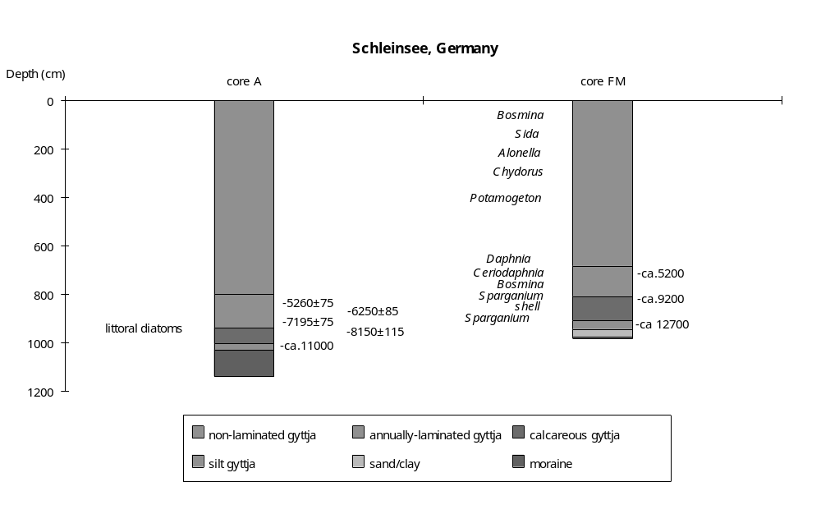

Preliminary coding: 30/1/1994; Final coding: 25/2/1994.
Coded by: XY and SPH

Seeburger See, Germany

Seeburger See (51°30'N, 10°10'E, 156m above sea level, also called See von Bernshausen) is the only natural water surface in Unterreichesfeld. It has a size of 91 ha, an average depth of 2.15m and a maximum depth of 4m (Streif, 1970). The catchment area is 32 km2. The lake has a well-developed macrophyte fringe, up to 100m wide on the western and southwestern shore, showing a regular zonation from Phragmites, through Scirpus-Typha to a Myriophyllum-Nuphar association. The river Aue flows through the lake from west to east. Geochemical studies show that the lake is fed by the Aue and that the underlying salty ground water does not influence the lake. The bedrock of the lake basin is sand stone overlain by loess. Sand stone, shelly limestone, fluvial and lacustrine deposits and loess appear in the catchment area. The lake was formed through salt leaching ca 10800 yr B.P. (Streif, 1970; Overbeck, 1975).

A tight network of cores across the lake basin and its marginal areas (including the lower part of the inflowing Aue valley) make it possible to reconstruct the extent of limnic deposits through the late Pleistocene and Holocene (Streif, 1970). The uppermost 2m of sediment was investigated by 800 Hiller and Livingstone cores, and there are 49 longer drill cores (up to 25m). A number of cores (127a, 128, 125, 26 and 93) were used for detailed biological analyses. Core 127a is 12.35m long and was taken in a water depth of 4m from the deepest part of the lake. Core 128, taken in a water depth of 3m, is 16.5m long. Core 125 is 7.15m long and was taken in a water depth of 3.35m. A 4m long littoral core (93) was taken in a water depth of 1.9m. Pollen analysis was carried out on the main part of core 127a, the basal section of core 128 and the top of core 125. Molluscs and macrorests were analysed from of core 26 (8.5m long) from the western margin. The chronology of the last ca 4000 years is provided by six radiocarbon dates from core deposits and a date on emerged lake deposits. The chronology for the earlier part of the record is based on pollen correlation with the regional pollen stratigraphy (Firbas, 1949; Overbeck, 1975). Changes of lake level are reconstructed from the extent of limnic units. Additional information on changes in water depth is provided by changes in lithology, molluscs, macrofossil and aquatic pollen assemblages. According to Streif (1970), salt leaching plays a large role in lake history and the extent of climatic influence is difficult to estimate. The results of geochemical analyses do not support this opinion and we therefore interpret the reconstructed changes in lake status as a reflection of climatically-induced changes in water balance.

The basal lake sediments are brown to black, silt-rich gyttja. The abundance of coarse plant detritus and wood remains suggests shallow water conditions. The presence of Menyanthes trifoliata in the pollen assemblage is consistent with very shallow water. The area of gyttja deposition was only 1.2 ha and peat was accumulating over most of the basin. These observations confirm that the lake was relatively small and shallow. This interval is dated to the Dryas (ca 10800-10100 yr B.P. Overbeck, 1975).

The overlying material is greenish gyttja. The average thickness of this layer is 1.06m and the maximum thickness is 2m. The change in lithology, and the lack of organic detritus, are consistent with increased water depth. The greenish gyttja unit is also more extensive in area (22.2 ha), consistent with an increase in lake depth. The mollusc Bithynia tentaculata, characteristic of relatively open-water conditions, was present in the marginal core 26. This, and the presence of beetle and fish remains, is consistent with increased water depth. A mass of Najas marina seeds is recorded in core 26, confirming that the coring site was under water. Pollen correlation suggests this unit was deposited during the Preboreal to the mid-Atlantic (ca 10100-6500 yr B.P.: Overbeck, 1975).

The overlying sediments are dark brown and grey gyttja, containing fine plant detritus and molluscs. The occurrence of plant detritus suggests conditions might have been shallower. However, this unit is more extensive in area (29.5 ha) than the underlying unit, which suggests an increase in water depth. The considerable decrease of Cyperaceae in the pollen assemblages, and the frequent occurrence of fish remains, is consistent with an increase in water depth. Given the evidence for deeper conditions, we assume that the presence of plant detritus reflects an increase in lake productivity rather than shallowing. Pollen correlation indicates this unit was deposited during the younger Atlantic and earlier Sub-Boreal (ca 6500-4000 yr B.P. Overbeck, 1975).

The overlying layer ("Leitschicht") consists of red-grey gyttja grading upwards to dark-brown gyttja. The sediments are very calcareous and contain plant remains. The Leitschicht is slightly less extensive (29 ha) than the underlying unit, and is relatively thin (0.26m on average; maximum 0.5m). The presence of Carex remains in the littoral zone and the abundance of Cyperaceae is consistent with relatively shallow water. There are three radiocarbon dates from this unit. A basal sample (5.70m in core 127a) yielded an age of 3650±115 yr B.P., a sample from 5.60m was dated to 3915±170 and a sample from the top of the unit (5.50m in core 127a) was dated to 3100±90 yr B.P. The apparent stratigraphic inversion could reflect incorporation of older material through subaerial erosion after the lake level dropped. A simpler explanation, since the lower two dates overlap within the error limits, is that this unit was deposited extremely rapidly. We assume that the unit began forming sometime between 4000 and 3600 yr B.P. and continued until ca 3100 yr B.P.

The overlying unit is ochre-coloured gyttja. It is more extensive (43.7 ha), suggesting the lake was bigger and deeper. The mollusc Valvata piscinalis, indicating open-water conditions, was abundant in the littoral core. This, and the frequent appearance of Bithynia opercula, beetle, fish and Chara remains, is consistent with increased water depth. The disappearance of Carex remains is also consistent with deeper conditions.

The overlying olive gyttja was deposited over an area of ca 97 ha and extended to 400m beyond the present lake margin in the west, suggesting the lake was deeper than today. The absence of aquatic macrofossils is consistent with deep water. The decline in the abundance of molluscs such as Valvata piscinalis and Bithynia could also reflect increasing depth. There are three radiocarbon dates from this layer. A basal sample (3.50-3.55m in the 127a core) yielded an age of 1365±75 yr B.P., a sample from 3.30-3.50m was dated to 1885±120 and a sample from the top of the layer was dated to 1770±75 yr B.P. The stratigraphic inversion could reflect contamination by old material through subaqueous erosion as the lake rose. The former bog forest in the south was drowned. The woods, which are not covered by sediments, emerged again when the lake became shallower later. A sample of wood from this forest was radiocarbon dated to 1125±95 yr B.P., implying the area became submerged after that time. This is consistent with a gradual increase in lake level, starting ca 1400 yr B.P. and continuing until at least 1100 yr B.P.

The overlying sediments consist of calcareous, mineral-rich mud, with a high silt content. The reduction in the area of sedimentation indicates shallowing. The increase in silt content is consistent with shallowing. The presence of plant remains and molluscs is also consistent with shallower water. Beetle, fish and Valvata piscinalis remains became less frequent.

The present lake level has been influenced by human activities. The Aue east of the lake was made deeper in 1901, resulting in a fall in lake level by ca 37-75cm (Ohlmer, 1955; 1956).

In the status coding, very low (1) is indicated by very small extent of gyttja, the presence of Menyanthes; low (2) by gyttja of small extent, the presence of mollusc and fish remains; moderately low (3) by moderate extent of gyttja with infilling sequence; intermediate (4) by intermediate extent of gyttja, the decrease of Cyperaceae and the presence of fish remains; moderately high (5) by moderately large extent of gyttja, decrease of Cyperaceae and frequent occurrance of fish remains; high (6) by large extent of gyttja, the presence of plant and fish remains; very high (7) by extension of lacustrine deposits beyond the modern lake margin, the absence of aquatic macrofossils and decline in the abundance of molluscs.

References

Beug, H.J., 1986. Vegetationsgeschichtliche Untersuchungen über das Frühe Neolithikum im Untereichsfeld, Landkreis Göttingen. In: Behre, K.-E. (ed.). Anthropogenic Indicators in Pollen Diagrams. P. 115-124. 1986.
Firbas, F., 1949. Spät- und nacheiszeitliche Waldgeschichte Mitteleuropas nördlich der Alpen. Erste Band: Allgemeine Waldgeschichte. Jena. 480pp.
Streif, H., 1970. Limnogeologische Untersuchung des Seeburger Sees (Untereichsfeld) (Geologische Untersuchungen an niedersächsischen Binnengewässern VII). Beihefte zum Geologischen Jahrbuch 83: 106pp.
Overbeck, F., 1975. Botanisch-geologische Moorkunde. Neumünster. 719pp.
Ohlmer, W., 1955; 1956. See und Burg. Ein erster Beitrag zur Burgengeschichte des Seeburger Sees. Die Goldene Mark, Zeitschrift für Heimatarbeit im Kreis Duderstadt 6: 17-28, 33-38. 7: 1-6, 41-43. Duderstadt (Mecke).

Radiocarbon Dates

N/A 1125±95 yr B.P. wood from drowned bog forest
N/A 1365±75 yr B.P. 3.50-3.55m, gyttja, core 127a
N/A 1770±75 yr B.P. 3.25-3.30m, gyttja, core 127a, ATO
N/A 1885±120 yr B.P. 3.30-3.50m, gyttja, core 127a, ATO
N/A 3100±90 yr B.P. 5.50m, gyttja, core 127a
N/A 3650±115 yr B.P. 5.70m, gyttja, core 127a
N/A 3915±170 yr B.P. 5.60m, gyttja, core 127a

Coding

10800-10100 yr B.P. very low (1)
10100- 6500 yr B.P. low (2)
6500 - 3600 yr B.P. intermediate (4)
4000 - 3100 yr B.P. moderately low (3)
3100 - 1300 yr B.P. moderately high (5)
1400 - 1000 yr B.P. very high (7)
1100 - 0 yr B.P. high (6)

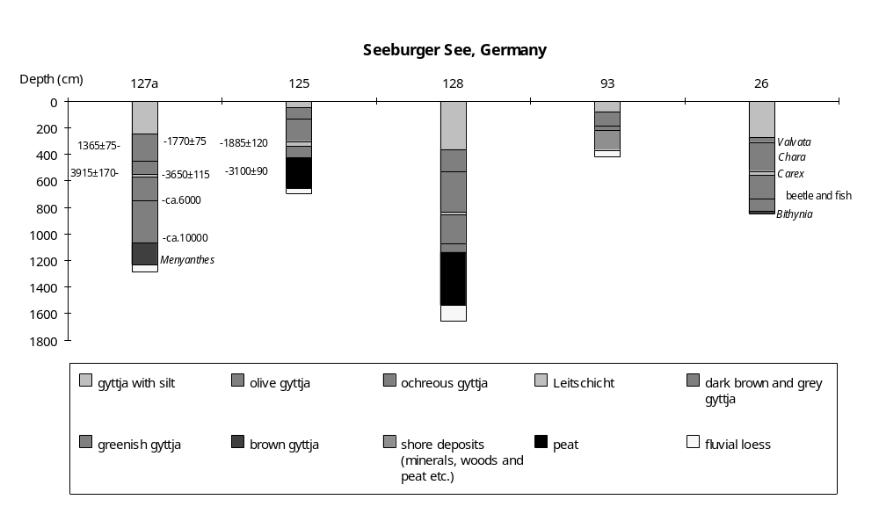

Preliminary version: 20/12/1993; Final coding: 25th February 1994
Coded by: XY and SPH
Tegeler See, Germany

Tegeler See (52°35'N, 13°15'E, 35m above sea level) is a rather large lake (406 ha) on the northwestern outskirts of Berlin (Bertzen, 1987; Übersichtskarte von Berlin West, 1988). The lake is 4km long and 1km wide. The maximum depth is 16m and the mean depth greater than 8m. The lake is fed by the Tegeler Fließ and the Havel River; there is an outflow from the southwestern shore via the Havel into the River Elbe. In this region, the Tertiary bedrock is overlain by ca 30-40 m of Weichselian sediments, including glacial sands and ground moraine. The lake basin originated by glacial erosion. An approximate age for the formation of the lake is provided by the fact that it is located between the moraines of the Brandenburger Stadium (ca 20000 yr B.P.: Hohl et al., 1985) and the Frankfurte Stadium (ca 17000 yr B.P.: Pachur, 1989). Late glacial aeolian sands occur near the lake shore in the west and southwest.

The lake history is recorded in two cores: Seemitte and Kleine Malche (Pachur and Haberland 1977; Pachur and Röper, 1984 and 1987; Bertzen, 1987). The Seemitte core is 33.50m long and was drilled in the centre of the lake. The Kleine Malche core is 15m long and was taken in a water depth of 8m. Diatom analysis was carried out on Seemitte (Bertzen, 1987). Pollen analysis was done on both cores and there is a pollen diagram for the lower part of Kleine Malche (Brande, 1980; Pachur and Haberland, 1977; Pachur and Röper, 1984; Bertzen, 1987). Bertzen (1987) reconstructed changes in minimum water depth based on the diatom assemblages from Seemitte, using the relationship between life-form/water depth ratios in pre-industrial times. Here, changes in lake depth are reconstructed from changes in diatom assemblages, aquatic pollen and lithology. Our reconstructions broadly follow those of Bertzen (1987). The chronology is established by pollen correlation with the regional pollen chronostratigraphy (Firbas, 1949; Overbeck, 1975; Brande, 1980). Tephra from the Laacher eruption, which has been radiocarbon dated to 11000±50 (van den Bogaard and Schmincke, 1985), serves as an absolute time mark.

The deepest sediments consist of fine to medium-grained sands with discrete organic remains (29.44-33.50m in Seemitte). Diatoms are not abundant, but the assemblage is diverse and characterized by planktonic species, such as Cyclotella and Stephanodiscus. The diatom assemblage suggests the water was rather deep. The coarse nature of the sediments may reflect erosion of glacial and glaciofluvial sands from the basin during the early stages of the lake history.

A decrease of water depth ca 12900 yr B.P. is suggested by the transition to organic sediments at 29.44m in the Seemitte core. Fragilaria, a littoral species, comprises more than 50% of the diatom assemblage and planktonic species comprise only 7% of the assemblage, consistent with shallower conditions.

The sediments between 28.60-29.30m in the Seemitte core are sands with discrete organic remains. In the lower part of the unit (28.80-29.30m), planktonic diatoms are dominant. The disappearance of diatoms above 28.80m, coincident with an increase in sedimentation rate to 0.47 cm/yr, probably reflects dilution by minerogenic material. The dominance of planktonic diatoms in this unit suggests relatively deep water. The change of lithology must then reflect increased erosion of glacial and fluvioglacial material from the catchment. The high sedimentation rate is consistent with such an interpretation.

The overlying sediments (28.50-28.60m) are laminated clay gyttja. Assuming that the coarse sand component of the sediments is derived from catchment erosion, the transition to more organic sedimentation suggests decreased water depth after ca 12700 yr B.P. This interpretation is consistent with the diatom record, which is dominated by Fragilaria and Amphora.

The overlying sediments in the centre of the basin (28.1-28.5m) are clay gyttja containing fine sand. The absence of laminations, and the presence of fine sand, are consistent with further shallowing after ca 12650 yr B.P. In the littoral zone silt-rich sand was deposited (15.03-15.15m in Kleine Malche). The presence of Nuphar and Sphagnum in the littoral core is consistent with shallow water.

The overlying sediments are laminated fine sand with clay in the centre of the basin (27.9-28.1m) and laminated calcareous gyttja (Kleine Malche: 14.9-15.03m) in the littoral zone. The laminated nature of the sediments and the decreased organic content indicates increased water depth after ca 11550 yr B.P. Cyclotella and Stephanodiscus are abundant in diatom assemblage, consistent with increased water depth. The disappearance of aquatics in the littoral core is consistent with deeper water.

The overlying sediments are laminated clay gyttja in the centre (Seemitte: 27.6-27.9m) and laminated calcareous gyttja (Kleine Malche: 14.4-14.9m) in the littoral zone. The increased organic content in the centre suggests water depth decreased. Littoral species, Fragilaria and Amphora, increased in the diatom assemblage, consistent with shallower water. The Laacher tephra, which has been radiocarbon dated to 11000±50 yr B.P. (van den Bogaard and Schmincke, 1985), occurs at 27.9m in Seemitte and 14.9m in Kleine Malche.

The overlying unit is laminated clay gyttja with fine sand in the centre (Seemitte: 27.3-27.6m) and laminated calcareous gyttja in the littoral zone (Kleine Malche: 14.0-14.4m). The diatom assemblage is dominated by Fragilaria and Amphora, consistent with relatively shallow conditions. However, the abundance of Melosira islandica, a planktonic species, suggests a slight increase in water depth.

An increase of water depth after ca 10560 yr B.P. is suggested by the transition to laminated clay gyttja in the centre (Seemitte: 26.5-27.3m). The littoral zone sediments (12.9-14.0m) are laminated calcareous gyttja. Melosira islandica became more abundant in the lower part of the unit consistent with deeper water. The absence of diatoms above 26.7m in Seemitte may reflect dilution or destruction of diatom frustules through turbulence as the depth increased.

The overlying sediments are laminated gyttja in Seemitte (23.25-26.5m) and non-laminated, calcareous gyttja in Kleine Malche: 11.15-12.9m. The change from clay gyttja to gyttja in the centre, and the disappearance of lamination in the littoral zone, suggest decreased water depth after ca 9950 yr B.P. The presence of Nymphaea and Ceratophyllum is consistent with shallowing. However, the abundance of planktonic diatoms indicates that the water was still moderately deep. A Cyclotella-Stephanodiscus society with varying representation of Melosira and Synedra was characteristic of the lake.

The overlying sediments are laminated gyttja in the central core (15.85-23.25m) and non-laminated, calcareous gyttja in the littoral core (6-11.15m). Littoral diatoms (Achnanthes, Amphora, Fragilaria and Epithemia) are rare, suggesting increased water depth after ca 8000 yr B.P. Based on the diatom assemblages, Bertzen (1987) came to the conclusion that the water depth in the centre of the lake was at least 30m.

The overlying sediments are poorly-laminated gyttja in the centre (6.3-15.85m) and calcareous gyttja in the littoral core (4-11.15m). The poor preservation of laminations is indicative of shallowing. Stephanodiscus, which need more nutrients than Cyclotella, became dominant and the importance of Cyclotella decreased. The importance of littoral diatoms increased and Fragilaria reached 20%. The change in the diatom assemblages is consistent with decreased water depth.

The uppermost sediments are non-laminated gyttja in Seemitte (0-6.3m) and calcareous gyttja in Kleine Malche (0-4m). The disappearance of laminations in the central core suggests shallower water. The percentage of littoral species increased (ca 20%), consistent with decreased depth (Bertzen, 1987). The relative abundance of planktonic species such as Stephanodiscus, Synedra and Cyclotella indicates the lake was not very shallow. Pollen dating indicates this unit accumulated during the last 2000 years (Firbas, 1949; Pachur and Röper, 1987; Bertzen, 1987; Overbeck, 1975).

In the status coding, very low (1) is indicated by deposition of non-laminated organic sediments and diatom assemblage dominated by epiphytics; low (2) by deposition of laminated organic sediments and a diatom assemblage dominated by epiphytics; relatively low (3) by laminated sediments containing fine sand and a diatom assemblage dominated by both epiphytics and planktonics, or non-laminated sediments with ca 80% planktonic diatoms; intermediate (4) by laminated sediments with no sand, and diatom assemblage dominated by both epiphytics and planktonics, or poorly-laminated sediments with ca 80% planktonic diatoms, or by coarse, catchment-derived sands and dominance of planktonic diatoms; high (5) by laminated sediments and dominance of planktonic diatoms, or by coarse, catchment-derived sands and dominance of planktonic diatoms; and very high (6) by maximum development of pelagic diatoms.

References

Bertzen, G., 1987. Diatomeenanalytische Untersuchungen an spätpleistozänen und holozänen Sedimenten des Tegeler Sees. Berliner Geographische Abhandlungen 45: 1-151.
Brande, A., 1980. Pollenanalytische Untersuchungen im Spätglazial und frühen Postglazial Berlins. Verhandlungen des Botanischen Vereins der Provinz Brandenburg 115: 21-72.
Firbas, F., 1949. Spät- und nacheiszeitliche Waldgeschichte Mitteleuropas nördlich der Alpen. Erster Band: Allgemeine Waldgeschichte. 480 pp. Jena.
Hohl, R., Altermann, M., Baumann, L., Daber, R., Franke, D., Gaedeke, R., Guntau, M., Hantzsche, E., Havemann, H., Helms, J., Hirschmann, G., Hoth, K., von Hoyningen-Huene, E., Klengel, K., Kolp, O., Krull, P., Lange, D., Lange, H., Lauterbach, R., Lotsch, D., Ludwig, A., Meinhold, R., Nöldeke, W., Olszak, G., Prescher, H., Reichstein, M., Richter, H., Röllig, G., Scheumann, H., Schwab, M., Seidel, G., Stammberger, F., Wagenbreth, O., Werner, C.-D., Wormbs, J. and Wünsche, M., 1985. Die Entwicklungsgeschichte der Erde. Hanau. 703pp.
Overbeck, F., 1975. Botanisch-geologische Moorkunde. 719 pp. Neumünster.
Pachur, H.-J., 1989. Geoecological aspects of the late Pleistocene and Holocene evolution of the Berlin lakes. Catena Supplement 15: 107-119.
Pachur, H.-J. and Haberland, W., 1977. Untersuchungen zur morphologischen Entwicklung des Tegeler Sees (Berlin). Die Erde 108: 320-341.
Pachur, H.-J. and Röper, H.-P., 1984. Geolimnologische Befunde des Berliner Raumes. Berliner Geographische Abhandlungen 36: 37-49.
Pachur, H.-J. and Röper, H.-P., 1987. Zur Paläolimnologie Berliner Seen. Berliner Geographische Abhandlungen 44: 1-150.
Der Senator für Bau- und Wohnungswesen V, 1988. Übersichtskarte von Berlin (West) 1:50000.

Tephra date

Laacher See Tephra 11000±50 yr B.P. Seemitte, 27.9m Kleine Malche, 14.8m

Coding

-12900 yr B.P. high (5)
12900-12850 yr B.P. very low (1)
12850-12700 yr B.P. high (5)
12700-12650 yr B.P. low (2)
12650-11550 yr B.P. very low (1)
11550-11000 yr B.P. high (5)
11000-10780 yr B.P. low (2)
10780-10560 yr B.P. relatively low (3)
10560-9950 yr B.P. intermediate (4)
9950-8000 yr B.P. high (5)
8000-5000 yr B.P. very high (6)
5000-2000 yr B.P. intermediate (4)
2000-0 yr B.P. relatively low (3)

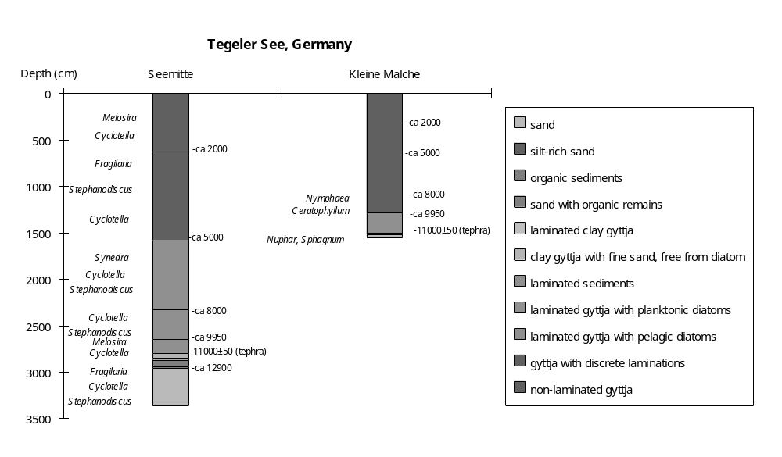

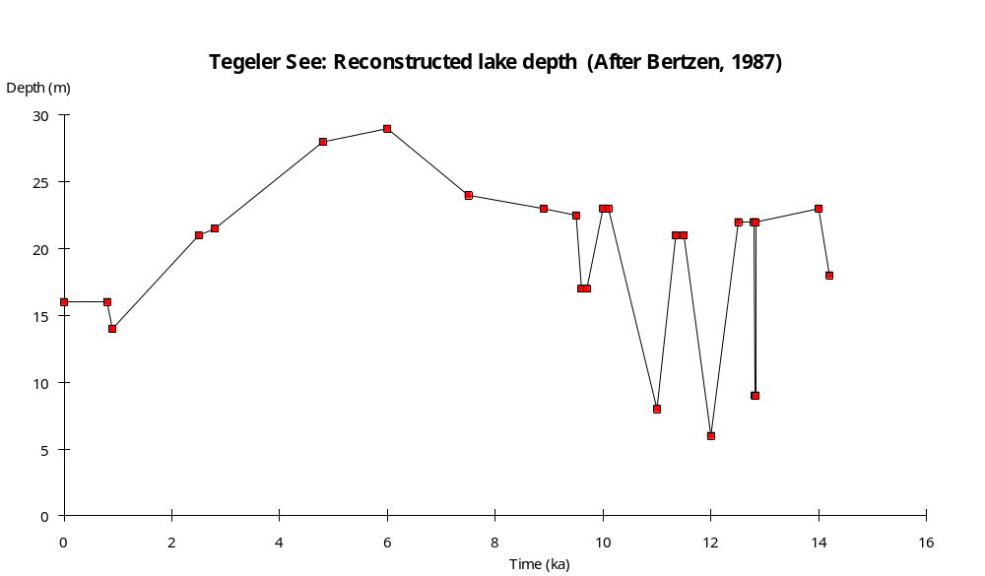

Preliminary coding: 30/12/1993; Final coding: 12/4/1994
Coded by: XY and SPH
Ioannina, Greece

Ioannina (39°40'N, 20°53'E, 469m above sea level) is a closed lake lying along the axis of the Perama syncline, which runs northwest-southeast (Higgs et al., 1967). The Mitsikeli ridge (maximum elevation 1810m) lies to the northeast and the Tomarokhoria plateau (over 1900m) lies to the southwest. The basin is formed in limestone, but the floor is covered by alluvial sediments. The origin of the basin was probably related to structural factors, but its present form is influenced by limestone solution. Estimates of the area of Lake Ioannina range from 1880-2400ha (Higgs et al., 1967; Bottema, 1974). The maximum depth is 11m (Fels, 1957). The lake is fed principally by springs along the foot of the Mitsikeli ridge. Underground drainage via swallow holes is an important control on the hydrological balance (Higgs et al., 1967). Flooding of the basin floor occurs during exceptionally heavy rains when the underground drainage is unable to cope with the increased discharge. Attempts to drain part of the basin date back to 1600 A.D. (Higgs et al., 1967). Since 1944 the lake level has been controlled by a canal through the northern end of the Tomarokhoria Plateau into the Thiamis basin. The modern lake is surrounded by a Phragmites reed marsh. Lake Ioannina is a remnant of a more extensive lake which once occupied the Ioannina basin. Other remnants of this lake, notably the shallow Lake Lapsisto and its adjacent marshes in the north of the basin, have disappeared as a result of recent drainage.

A well-defined fine gravel beach deposit containing fragments of freshwater mollusc shells, found during archaeological excavations in Kastritsa cave (south of the town of Ioannina), shows that the lake was formerly at least 3.2m higher than present (Higgs and Vita-Finzi, 1966; Higgs et al., 1967). Hearths within the beach deposits have been radiocarbon dated to 20,800±810 yr B.P. (I-2466) and 20,200±480 yr B.P. (I-2468). Lacustrine clays and silts, and deltaic sediments associated with this larger lake occur in the north of the basin (Higgs and Vita-Finzi, 1966). The extended lake would have been about 3.75 times bigger than the present lake.

Two cores from the Ioannina basin provide a sedimentary record dating beyond 40,000 yr B.P. (Bottema, 1967, 1974). An 11.65m-long core (Ioannina II) was taken from the former site of Lake Lapsisto (39°45'45"N, 20°43'50"E); a 5.65m-long core (Ioannina II) was taken from the northwest shore of Lake Ioannina (39°41'31"N, 20°50'23"E). Changes in water depth are reconstructed from changes in lithology, aquatic pollen assemblages and pollen preservation. The chronology is established by two dates from Ioannina II and three dates from Ioannina I.

The Ioannina I core provides a continuous record of sedimentation since about 40,000 yr B.P. The basal sediments are clays (10.65-11.65m) overlain by shelly clays (8.95-10.65m) and clay-gyttja (7.99-8.95m). Pediastrum is moderately abundant, consistent with relatively deep water. A sample from the base of the clay-gyttja (8.85-8.95m) has been radiocarbon-dated to 37,660±930 yr B.P. (GrN-6529). The overlying unit (7.79-7.99m) is peat or coarse detritus gyttja, indicating a decrease in water depth. The aquatic assemblage is characterised by Typha latifolia and Nuphar, which is consistent with such a decrease. A sample from the peat and gyttja layer (7.81-8.02m) has been radiocarbon-dated to 40,000±1000 yr B.P. (GrN-4793). Bottema (1974) suggests that this date is more reliable than the date from the clay-gyttja, but that both should be considered as minimum ages because of small sample size.

A return to deeper water is marked by the deposition of marly clays, clays, shelly clays and clay gyttja above the peat. The abundance of Pediastrum is consistent with this interpretation. Pediastrum decreases in abundance between 5.10-6.20m, at the same time as Potamogeton, Myriophyllum, Nuphar and Typha latifolia became more abundant. This is consistent with a decrease in water depth, although there is no sedimentary evidence of this. Pediastrum is extremely abundant again between 3.75-5.10m, indicating a return to deeper water sometime between 24,500 and 19,000 yr B.P. This interval can be correlated with the high lake level indicated by the beach sediments in Kastritsa cave, dated to 21,000-20,000 yr B.P.

A decrease in water depth sometime between 14,000 and 16,500 yr B.P. is indicated by the depositions of sandy clays between 2.88-3.74m. The marked decrease in Pediastrum above 3.74m is consistent with this interpretation. A brief increase in water depth is indicated by clay deposition between 2.59-2.88m. A sample from 2.65-2.77m has been radiocarbon dated to 10,190±90 yr B.P. (GrN-4975). The overlying unit (1.98-2.59m) is a sandy, marly clay. The sediments between 1.85-1.98m are shelly clays. The uppermost unit is an organic clay. The absence of Pediastrum and Potamogeton in the top 2m suggests the lake was relatively shallow. The diversity of the aquatic assemblage, the abundance of Myriophyllum, Nymphaea, Alisma, Polygonum-type, Cyperaceae, and subsequently Sparganium-type, with some Typha and Sagittaria is consistent with moderately shallow conditions.

The basal sediments in Ioannina II are sand with shells overlain by sandy gyttja. Shallow water is indicated by the deposition of peat between 4.48-5.03m. A sample from near the base of the peat in Ioannina II(4.95-5.00m) has been radiocarbon dated to 45,800 yr B.P. (GrN-6181). The unit is presumably equivalent to the peat or coarse detritus gyttja unit dated to around 40,000 yr B.P. in Ioannina I, but occurs about 3m higher. The uppermost peat is devoid of pollen and appears to have been oxidised during a major hiatus when the lake was dry.

The overlying sediments are clays (3.70-4.48m), marking a return to deeper water. The terrestrial pollen assemblages around 4.0m can be correlated with those dated to ca 10,200 yr B.P. at a depth of ca 2.70m in Ioannina I core. Thus, there is no record of the high lake levels recorded by the beach sediments at Kastritsa Cave and by the abundance of Pediastrum between 24,500 and 19,000 yr B.P. in Ioannina I. Nor is there any record of the subsequent interval of lower lake levels starting sometime between 16,500 and 14,000 yr B.P. Although the modern sediment surface appears to be at the same elevation in both cores, the sediment surface after the peat deposition was about 3m higher at Ioannina II than at Ioannina I. This makes it plausible that the deepwater sediments laid down between 24,500 and 19,000 yr B.P. would have been removed by erosion during the subsequent dry phase from Ioannina II, while sediments from both the deepwater and subsequent low water phase were preserved at Ioannina I.

The sediments between 3.25-3.70m in Ioannina II are shelly gyttja, indicating a decrease in water depth. A thin layer of detritus gyttja (3.16-3.25m) suggests a further decrease between 7500 and 7800 yr B.P. The overlying shelly clay (2.47-3.16m) indicates an increase in depth between 5200 and 7500 yr B.P.

A major shallowing after 5200 yr B.P. is shown by peat deposition between 1.60-2.74m. The aquatic pollen assemblage is characterised by peaks in Cyperaceae and Cladium, consistent with shallow water. A sample from 2.20-2.30m has been radiocarbon dated to 4535±40 yr B.P. (GrN-5426). Extrapolation from this date suggests that the lowered water levels persisted until ca 3200 yr B.P. The overlying sediments show a gradual change from clayey peat (1.45-1.60m) through highly organic clay (1.11-1.45m) to less organic clay (0.30-1.11m), suggesting a gradual increase in water depth. The uppermost sediments (0.20-0.30m) are peaty clays, which probably mark the historic decline in water levels as a result of drainage.

In the status coding, very low (1) is indicated by peat deposition; low (2) by coarse detritus gyttja or organic clay deposition, shallow water aquatic assemblages and the absence of Pediastrum; intermediate (3) by shelly, sandy or marly clays, shallow water aquatic assemblages and moderate amounts of Pediastrum; moderately high (4) by clay deposition and moderate amounts of Pediastrum; high (5) by abundant Pediastrum; very high (6) by clay deposition, abundant Pediastrum, and shorelines 3.2m above the modern level of the lake.

Radiocarbon dates

GrN-5426 4535±40 2.20-2.30m, peat, Ioannina II
I-1959 7380±240 red beds from Neolithic site
GrN-4875 10,190±90 2.65-2.77m, organics in clays, Ioannina I
I-1960 13,400±210 -1m, hearth, Kastritsa Cave
I-2468 20,200±480 -11m, hearth, beach deposits at Kastritsa Cave
I-2466 20,800±810 -11m, hearth, beach deposits at Kastritsa Cave
GrN-6529 37,660±930 8.85-8.95m, clay gyttja, Ioannina I, strat. invert., CS, SS, ATY? accepted by author
I-1957 >39,900 ca 9.8m, Asprochaliko Cave, level 19.
GrN-4793 40,000±1000 7.81-8.02m, peat, Ioannina I, SS ATY? accepted by author
GrN-6181 45,800+2500-1900 4.95-5.00m, peat, Ioannina II, SS, ATY?, strat. invert.

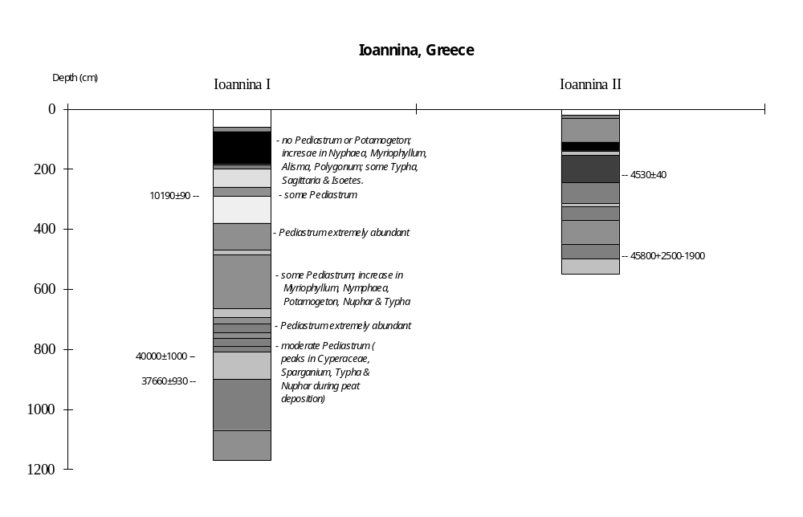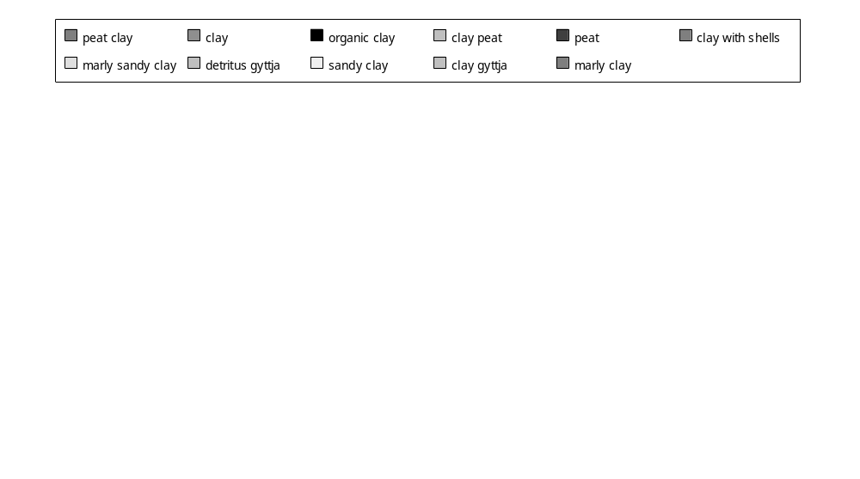
References

Bottema, S., 1967. A late Quaternary pollen diagram from Ioannina, north-western Greece. The climate, environment and industries of Stone Age Greece: part III. Proceedings of the Prehistoric Society 33: 26-29
Bottema, S., 1974. Late Quaternary vegetation history of Northwestern Greece. Proefschrift, University of Groningen, 190 pp.
Fels, E., 1957. Der Ioannina-See in Griechland. Stuttg. geogr. Stud. 69: 247-252.
Higgs, E.S. and Vita-Finzi, C., 1966. The climate, environment and industries of Stone Age Greece: part II. Proceedings of the Prehistoric Society 32: 1-29.
Higgs, E.S., Vita-Finzi, C., Harris, D.R. and Fagg, A.E., 1967., The climate, environment and industries of Stone Age Greece: part III. Proceedings of the Prehistoric Society 33: 1-29.

Coding

?-40000 yr B.P. high (5)
40000 yr B.P. very low (1)
40000-23000 yr B.P. high (5)
31000-19000 yr B.P. intermediate (3)
24500-14000 yr B.P. very high (6)
16500-10000 yr B.P. intermediate (3)
10500-10000 yr B.P. moderately high (4)
10000-7800 yr B.P. intermediate (3)
7800-7500 yr B.P. low (2)
7500-5200 yr B.P. intermediate (3)
5200-3200 yr B.P. very low (1)
3200-0 yr B.P. low (2)

Final coding: September 1988.
Coded by SPH
Kastoria, Greece

Lake Kastoria (40°33'7"N, 21°19'20"E, 650m above sea level) lies in the western Macedonia massif. Cretaceous and Triassic limestones, and Miocene and Pliocene sedimentaries occur in the Kastoria basin. The lake has an area of about 3000ha, a maximum depth of 6m, and overflows via a tributary of the Aliakmon River (Bottema, 1974). The bottom of the deepest part of the lake is covered by a thin layers of sand and gravel over a compact blue clay. Bottema (1974) argues that there are no recent sediments in the deepest part of the lake.

A 3.45m-long core from the marsh at the northeastern edge of the lake (Bottema, 1974) provides a sedimentary record back to about 5500 yr B.P. Changes in water depth are reconstructed from changes in sediment lithology and aquatic pollen assemblages. The chronology is established by two radiocarbon dates.

The core bottoms out in sand. The overlying sediments (3.25-3.43m) are detritus gyttja. The presence of Pediastrum and Nymphaea is consistent with moderately deep, open-water conditions.

The overlying sediments (2.69-3.25m) are peat, indicating a decrease in water depth after about 5000 yr B.P. The aquatic suite includes Pediastrum, Typha, Lemna, Myriophyllum, Nymphaea and Potamogeton, and is consistent with a decrease in depth. A sample from the top of the peat (2.75-2.79m) has been radiocarbon dated to 4080±55 yr B.P. (GrN-6600).

The deposition of coarse detritus gyttja (0.60-2.69m) indicates deeper water after about 4000 yr B.P. A sample from 1.35-1.40m has been dated to 1095±60 yr B.P. (GrN-6599). A pronounced increase in the abundance of Pediastrum and the virtual absence of other aquatics in the lower part of the gyttja is consistent with an increase in water depth. The occurrence and gradual increase in abundance of Sparganium, Myriophyllum, Nymphaea, Typha and Potamogeton in the upper gyttja suggests a gradual decrease in depth after ca 2700 yr B.P.

The uppermost sediments (0.0-0.60m) are peat and indicate a decrease in water depth after ca 500 yr B.P. The aquatic assemblage is characterised by an increase in Typha, the presence of Sparganium, the appearance of Alisma and Lemna, the decline in Nymphaea and Potamogeton, and only low values of Pediastrum. This assemblage is consistent with a decrease in water depth.

In the status coding, low (1) is indicated by peat deposition; intermediate (2) by detritus gyttja deposition, with a diverse aquatic assemblage including shallow-water species; high (3) by detritus gyttja deposition with Pediastrum and a virtual absence of other aquatics.

Radiocarbon dates

GrN-6599 1095±60 yr B.P. 1.35-1.40m, coarse detritus gyttja
GrN-6600 4080±55 yr B.P. 2.75-2.79m, peat

Reference

Bottema, S., 1974. Late Quaternary vegetation history of Northwestern Greece. Proefschrift, University of Groningen, 190 pp.

Coding

5500-5000 yr B.P. high (3)
5000-4000 yr B.P. low (1)
4000-2700 yr B.P. high (3)
2700-500 yr B.P. intermediate (2)
500-0 yr B.P. low (1)
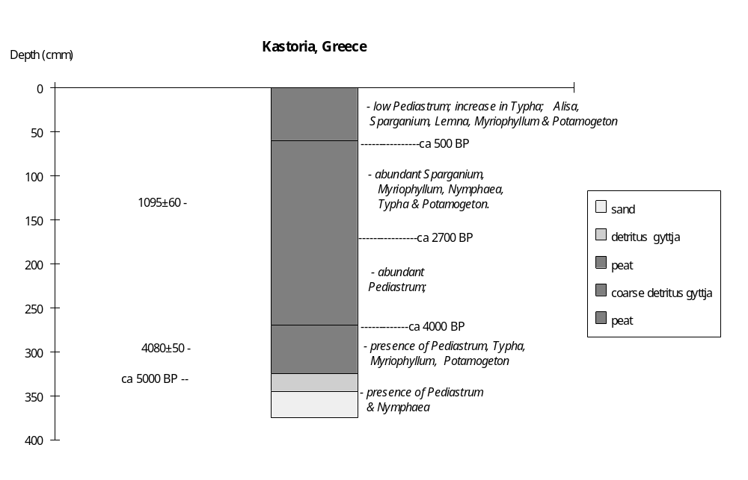

Final coding: September 1988
Coded by SPH
Khimaditis, Greece

Lake Khimaditis (40°35'53"N, 21°34'10"E, ca 560m above sea level) lies in the northwest of the Kozani Basin. The western and northwestern margin of the Khimaditis sub-basin is formed by the foothills of the Vernon mountains, which are predominantly metamorphic (gneiss). Some limestone occurs to the north. The lake has an area of about 550ha but was formerly more extensive (Bottema, 1974). An extensive peatbog occurs to the northeast of the lake. The lake was probably closed before the recent digging of a canal and draining of the northern part of the basin. The water level before drainage, however, appears to have been not much higher than present.

Three cores, two from the peat bog (Khimaditis I and IV) and one from the nearshore zone of the lake (Khimaditis III), provide a sedimentary record of the Holocene (Bottema, 1974). Khimaditis IV is not radiocarbon dated and has a less detailed record than the other cores, and will not be further discussed. Changes in water depth can be reconstructed from changes in lithology, sedimentation rates and aquatic pollen assemblages in the other two cores. The chronology is established by six radiocarbon dates, four from Khimaditis I and two from Khimaditis III (Bottema, 1974).

The basal deposits (4.47-5.36m) in Khimaditis I are clays, which are increasingly sandy downprofile. The abundance of Pediastrum and Sparganium-type, and the presence of Myriophyllum, Nymphaea, Alisma and Typha, indicates that the clay is lacustrine and suggests that the lake was more extensive than today.

The overlying sediments (4.19-4.47m) are peat, indicating a decrease in water depth. A sample from near the base of this unit (4.40-4.45m) has been radiocarbon dated to 9345±85 yr B.P. (GrN-6598). The increasing abundance of Myriophyllum, Nymphaea, Alisma, Batrachium-type and Cyperaceae over the transition from clay to peat is consistent with shallowing. The aquatic assemblage of the peat are characterised by the virtual disappearance of Pediastrum (except P. boryanum) and the increase in Typha, consistent with shallow water.

The deposition of coarse detritus gyttja between 3.65-4.19m indicates an increase in water depth around 8000 yr B.P. A sample from 4.00-4.05m has been radiocarbon dated to 7110±70 yr B.P. The abundance of Pediastrum, the appearance of Lemna, and the decrease in Sparganium, Typha and Cyperaceae are consistent with increasing depth.

A decrease in water depth after about 5000 yr B.P. is indicated by peat deposition between 2.75-3.65m. The aquatic assemblage is again characterised by the virtual disappearance of Pediastrum and an increase in Typha and Cyperaceae. A sample from near the top of the peat (2.80-2.85m) was dated to 3990±60 yr B.P. (GrN-6596).

The overlying deposits (2.00-2.75m) are coarse detritus gyttja, indicating increased water depth after ca 4000 yr B.P. The interval between 2.25-2.30m was dated to 975±60 yr B.P. (GrN-6595). The increasing abundance of Pediastrum, Lemna, Nymphaea and Batrachium-type, and the decrease in Typha and Cyperaceae are consistent with increased depth.

A decrease in water depth is indicated by the deposition of peat (0.0-2.0m) and corresponding changes in the aquatic assemblage after about 900 yr B.P.

The Khimaditis III core bottoms out at 2.12m in sand. The overlying deposits (1.55-2.08m) are coarse detritus gyttja, with gyttja above (0.0-1.55m). A sample from near the base of the detritus gyttja (1.87-2.00m) has been radiocarbon dated to 8020±75 yr B.P. (GrN-6183), while a sample from the transition to the overlying gyttja (1.50-1.60m) was dated to 3135±70 yr B.P. (GrN-6182). The extremely low aparent sedimentation rate (0.0079 cm/yr) strongly suggests there is an hiatus. This interval of non-deposition probably corresponds to the low water interval between 5000 and 4000 yr B.P. indicated by peat formation in Khimaditis I.

In the status coding, low (1) is indicated by peat deposition; intermediate (2) by clay deposition, with moderately values of Pediastrum and other aquatics; high (3) by detritus gyttja deposition, with abundant Pediatrum and a diverse aquatic assemblage.

Reference

Bottema, S., 1974. Late Quaternary vegetation history of Northwestern Greece. Proefschrift, University of Groningen, 190 pp.

Radiocarbon dates

GrN-6595 975±60 2.25-2.30m, coarse detritus gyttja, Khimaditis I
GrN-6182 3135±70 1.50-1.60m, gyttja, Khimaditis III
GrN-6596 3990±60 2.80-2.85m, peat, Khimaditis I
GrN-6597 7110±70 4.00-4.05m, peat, Khimaditis I
GrN-6183 8020±75 1.87-2.00m, detritus gyttja, Khimaditis III
GrN-6598 9345±85 4.40-4.45m, peat, Khimaditis I

Coding

ca 12000-9350 yr B.P. intermediate (2)
9350-8000 yr B.P. low (1)
8000-5000 yr B.P. high (3)
5000-4000 yr B.P. low (1)
4000-900 yr B.P. high (3)
900-0 yr B.P. low (1)

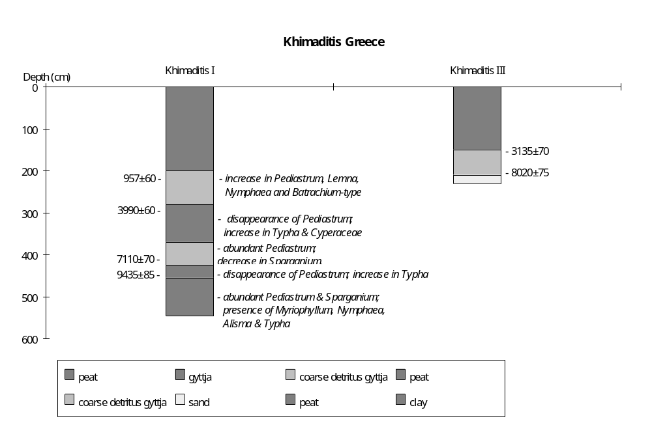
Final coding: September 1988
Coded by SPH
Vegoritis, Greece

Lake Vegoritis (40°45'N, 21°45'E, 570m above sea level) lies in the closed Ptolemais basin, northern Greece (Bottoma, 1982). The lake has an inflow from the south but no natural outflow. However, an artificial drainage channel towards Edessa has been created recently. The lake is 6830ha in area and has a maximum depth of 67m (Creer et al., 1981). The catchment area is 113,000ha. The Vermion and Voros mountains, which lie east and west of the lake respectively, are chiefly limestone (Bottema, 1982). Holocene alluvial sediments occur to the south, and there are extensive exposures of ophiolite to the north of the lake (Creer et al., 1981).

Nine 6m-long Mackereth cores (BE1-BE9) were collected from three sites in water depths of between 31 and 50m and used for geomagnetic and pollen analysis (Creer et al., 1981; Bottema, 1982). Changes in water depth are reconstructed from changes in aquatic pollen and green algae assemblages. There are four radiocarbon dates on the core, but they are apparently contaminated by old carbon (hardwater effect) and yield ages about 2500 yr older than is indicated by pollen or geomagnetic dating (Creer et al., 1981; Bottema, 1982). The chronology is therefore established by pollen correlation with nearby sites whereradiocarbon dates were obtained on peat or gyttja (e.g. Khimaditis, Edessa and Kastoria) and by geomagnetic dating (Bottema, 1982; Creer et al., 1981).

The presence of Pediastrum boryanum and P. duplex in the sediments of core 8 below 3.38m suggests relatively deep water. The paucity of aquatic pollen is consistent with this interpretation. The absence of Pediastrum boryanum and P. duplex above 3.38m, the increased diversity of the aquatic pollen assemblage, and the abundance of Cyperaceae and Sparganium-type pollen all indicate a decrease in water depth around 3300-3000 yr B.P. A decrease in the abundance of Cyperaceae and Sparganium-type above 2.40m, and an increase in Typha latifolia, Myriophyllum and Potamogeton suggests the depth increased somewhat about 800 yr B.P.

In the status coding, low (1) is indicated by high abundances of Cyperaceae and Sparganium-type; intermediate (2) by a diverse aquatic assemblage including Potamogeton, Myriophyllum, Typha, Sparganium-type and some Cyperaceae; high (3) by Pediastrum boryanum and P. duplex.

References

Bottema, S., 1982. Palynological investigations in Greece with special reference to pollen as an indicator of human activity. Palaeohistoria 24: 258-289.
Creer, K.M., Redman, P.W. and Papamarinopoulos, S., 1981. Geomagnetic secular variations in Greece through the last 6000 years obtained from lake sediment studies. Geophysical Journal of the Royal Astronomical Society 66: 193-219.

Coding

ca 7000-3000 yr B.P. high (3)
ca 3300-800 yr B.P. low (1)
ca 800-0 yr B.P. intermediate (2)

Final coding: September 1988
Coded by SPH
Xinias, Greece

Xinias (39.07°N, 22.26°E, 500m above sea level) is an artificially drained lake basin situated on the Plain of Thessaly. The Plain of Thessaly lies at a general elevation of 60-160m above sea level, but is surrounded by high and formerly glaciated mountains: the Ossa Mountains (maximum elevation 1978m) to the northeast, the Ano Olympus (2917m) and Kato Olympus (1587m) to the north, the Chasia Mountains to the northwest, the Pindus Chain to the west and the Tymfristos (2315m) and Oeta (2152m) Mountains to the southwest and south. The River Chiliadiotikos drains northward across the Plain of Thessaly, ultimately joining the Pinios River which flows northeastward to the sea. The southern part of the plain is drained by the Spercheois River. Xinias is one of a number of former lake basins within the region. The lowest point of the plain is the basin of the former Lake Viviis, which lies at an elevation of 50m and has no direct outlet to the sea. Most of the Plain of Thessaly is covered by Holocene deposits, but the underlying bedrock is limestone. The region has been subjected to tectonic disturbance, including tilting, during the Later Quaternary.

Two cores from the Xinias Basin provide a sedimentary record back beyond the limits of radiocarbon dating (Bottema, 1978, 1979). The core Xinias I, taken in the centre of the former lake at the end of a drainage ditch, has been studied in detail (Bottema, 1978). The core is 13.60m long. A section from the bank of the drainage ditch covers the most recent sediments.

Changes in water depth are reconstructed from changes in lithology and aquatic pollen. The chronology is based on five radiocarbon dates (Bottema, 1978).

The basal sediments (12.90-13.60m) are dark grey clay. A sample from the base of this unit has been radiocarbon dated to 46900 yr B.P. (GrN-6882), but the date is almost certainly infinite. The overlying sediments consist of an alternation of fairly inorganic gyttja and clay gyttja, with dark-grey clay gyttja (12.87-12.90m), brown-yellow gyttja (12.60-12.87m), dark-grey clay gyttja (12.57-12.60m), yellow-brown gyttja (12.10-12.57m), dark-blue grey clay gyttja (9.48-12.10m), yellow-brown gyttja (9.13-9.48m) and dark grey clay gyttja (6.04-9.13m). Extrapolation of the sedimentation rate between the lowermost non-infinite radiocarbon dates suggest that the uppermost dark grey clay gyttja was deposited between ca 32380 and 26200 yr B.P. The aquatic assemblage throughout these units is dominated by Pediastrum, with a constant and abundant representation of Sparganium-type and Cyperaceae.

The overlying sediments consist of more organic brown or grey gyttja (5.75-6.04m) overlain by grey clay-gyttja (3.06-5.75m). A sample from the transition (5.70-5.80m) to the clay gyttja was radiocarbon dated to 25,620+400 yr B.P. (GrN-6887). This unit is dated to between 18,230 and 25,620 yr B.P.

The overlying unit (2.07-3.06m) is clay. The overlying unit (1.80-2.07m) is blue sandy clay. The presence of sand is consistent with shallowing after ca 13,280 yr B.P. This shallowing trend appears to culminate in the deposition of a thin layer of blue sand between 1.75-1.80m. This unit is dated to between 11680 and 11930 yr B.P. An increase in water depth after ca 11680 yr B.P. is indicated by the deposition of sandy clay (1.57-1.75m). All three of these units are characterised by a very depauperate aquatic flora, with only Cyperaceae continuously registered, consistent with relatively shallow conditions. The proportion of indeterminate pollen grains also shows a marked increase during this interval, again consistent with shallow conditions and the increased possibility of pollen oxidation.

The overlying unit (+0.60-0m in the ditch section, 0-1.57m in the core) is gyttja, indicating a further increase in water depth. The aquatic pollen assemblage is characterised by the occurrence of Nymphaea and Isoetes, a pronounced drop in the representation of Cyperaceae, the absence of shallow-water species such as Menyanthes, Lemna and Butomus. This change in the aquatic assemblage is consistent with increased water depth. A sample from the transition to gyttja deposition was radiocarbon dated to 10680±90 yr B.P.

The uppermost unit (+0.80-0.60m) is grey clay. A soil is developed in the top of the unit. The clay was deposited after ca 910 yr B.P. The aquatic assemblage is characterised by the disappearance of Nymphaea, and a slight increase in Cyperaceae, consistent with somewhat shallower conditions.

In the status coding, very low (1) is indicated by sand deposition; low (2) by sandy clay deposition; intermediate (3) by clay, clay-gyttja or gyttja deposition, with an aquatic assemblage without Nymphaea; high (4) by gyttja deposition with an aquatic flora containing Nymphaea.

References

Bottema, S., 1978. The Late Glacial in the eastern Mediterranean and the Near East. In: W.C. Brice, (ed.). Ur: The Environmental History of the Near and Middle east Since the last Ice Age. pp 15-28.
Bottema, S., 1979. Pollen analytical investigations in Thessaly (Greece). Palaeohistoria 21: 20-40.

Radiocarbon Dates

GrN-6889 10680±90 organic fraction, 1.50-1.60m
GrN-6888 11150±130 calcareous fraction, 1.50-1.60m, ATO
GrN-6886 21390±430 3.70-3.80m
GrN-6887 25620±400 5.70-5.80m
GrN-6882 46900+5000 13.40-13.60m
-3060

Coding

32000-10700 yr B.P. intermediate (3)
11930-13280 yr B.P. low (2)
11680-11930 yr B.P. very low (1)
10700-11680 yr B.P. low (2)
13200-920 yr B.P. high (4)
920-0 yr B.P. intermediate (3)

Preliminary coding: March 1987; Final coding: September 1988
Coded by: SPH
Balaton, Hungary
Lake Balaton (46.8°N, 17.50°E, 105m above sea level) is the largest lake in central Europe. The lake, which is oriented northeast-southwest, is nearly 80 km long and has a maximum width of ca 15 km. The surface area is 60,000ha and the mean depth is 3.3m (Cserny, 1990). The lake is divided into two sub-basins, the Siofok-Balatonfüred sub-basin to the west and the smaller Akali-Balatonszemes sub-basin to the east. The two sub-basins are joined by a narrow neck of water about 2 km wide. The lake is fed by several rivers, the most important of which is the River Zala. Lake Balaton lies between the Transdanubian Midmountains, to the north, and the hilly region of Transdanubia, to the south. Geologically, this region is underlain by crystalline basement rocks, overlain by Pannonian sedimentaries (Pécsi, 1964). Pliocene volcanism is attested by outcrops of basalt tuffs. The basin is of tectonic origin, and evidence of faulting is clearly seen in the underlying basement rocks (Cserny and Corrada, 1989). Tectonic subsidence, and associated changes in the routing of e.g. the Zala River, continued up until at least the end of the last glaciation (Pécsi, 1964). It is unclear whether tectonism has played a role in the recent history of the lake. Bodor (1987) argues that apparent hiatuses in sedimentation in some cores are the result of recent tectonism. However. there is no mention of faults in the basal consolidated part of the lacustrine sediments (Cserny and Corrada, 1989), and several authors imply that the lithological evidence of changes in water depth are related to climatic (and not tectonic) changes (e.g. Cserny, 1987; Cserny and Corrada, 1989; Cserny et al., 1991).
Abrasion terraces and sandy beach deposits provide evidence that the lake was up to 6-8m higher than today during the postglacial. Pécsi (1964) says that the basin was closed during this interval. The subsequent lowering of lake level is thought to have resulted from the creation of an outflow.
The bottom stratigraphy of the lake has been studied by means of a large number of geophysical traverses and at least 61 boreholes (Cserny, 1987). The surface of the pre-Quaternary basement is uneven, and is covered by up to 10m of Quaternary lacustrine sediments (clay marls, marls, clays). The oldest lacustrine sediments have been radiocarbon dated to 12-14,000 yr B.P. (Cserny, 1990). Bodor (1987) argues that the lake formed from west to northeast, such that there is a 5000 year difference in the age of basal sediments in Keszthely Bay and in the Balatonkenese area. Palynological evidence suggests that the lake bed was marshy during the late glacial and that open water was present only at the beginning of the Holocene (Bodor, 1987). Relatively shallow conditions during the early Holocene are indicated by peat deposition (Cserny, 1987). Cserny (1987) dates these peats palynologically to 9000-7500 yr B.P., while Cserny and Corrada (1989) indicate that they are radiocarbon-dated to between 10-12,000 yr B.P. Both the pollen and lithological evidence suggest there was a gradual increase in depth up until the Atlantic.
The most complete summary of the recent history of Lake Balaton, is given in Cserny et al. (1991). The reconstructions of water depth changes are based on changes in lithology, aquatic pollen, diatom and ostracode assemblages from core Tó-24. This core is from the middle of the lake in the Siofok-Balatonfüred sub-basin ca 2-3 km upstream from the outflow into the Akali-Balatonszemes sub-basin. The chronology is apparently based on radiocarbon and pollen dating.
The basin was characterised by swampy conditions during the Pannonian. Changes in the abundance of aquatic plants suggest the lake fluctuated in depth, between 1-6m. The ostracode record is consistent with this, showing fluctuations from mesohaline to oligohaline conditions.
Preboreal sediments overlie the Pannonian deposits unconformably, indicating a major hiatus in sedimentation. The basin was initially occupied by several shallow lakes. The aquatic pollen record is dominated by Sparganium and Stratiotes, consistent with shallow conditions. The diatom assemblages are dominated by epiphytic species, such as Epithemia sorex, again consistent with shallow conditions. During the next phase of sedimentation, water depth increased and the individual shallow lakes became united. The aquatic pollen assemblage increased in diversity and the abundance of epiphytic diatoms decreased, consistent with increasing water depth. The increasing abundance of Potamogeton and Myriophyllum, and of benthic diatoms such as Diploneis elliptica and Gomphonema minutum, indicates that water depth continued to increase during the late Preboreal.
Reductions in the abundance of deepwater aquatic plants and of benthic diatoms suggest a short-lived decrease in water depth occurred during the middle part of the Boreal. However, water depth seems to have been high again by the end of the Boreal. Changes in the aquatic pollen and diatom assemblages suggest there was a gradual reduction in water depth through the Atlantic. This decrease continues through the early part of the Subboreal. During the later Subboreal, however, the lake stablised at approximately the same depth as today.
The beginning of the Subatlantic is marked by shallowing. Shallow-water aquatics, such as Sparganium and Rorippa, became abundant. The presence of Epithemia argus in the diatom assemblages is also consistent with shallow conditions. During the middle part of the Subatlatic, water depth increases abruptly. The abundance of Pediastrum and the increased diversity of aquatic plants is consistent with increased depth. The water depth subsequently decreases to below the modern condition. Cserny et al. (1991) argue that this decrease reflects human impact on the lake. Recent changes in the aquatic pollen and diatoms assemblages, which indicate increased water depth, correspond to artificial regulation of the depth of the lake.

In the status coding, low (1) is indicated by intervals of peat deposition; high (2) by intervals of lacustrine deposition. It is possible to reconstruct a more detailed record of status coding, but this does not seem worthwhile at this stage because of the gross uncertainties attached to the dating of the record. Note that the recent record of changes in water depth appears to have been strongly influenced by human impact and subsequently by artificial regulation of the water level. We assume that under natural conditions the modern water level would be similar to that prevailing in the mid-Subatlantic.

References
Bodor, E., 1987. Formation of the Lake Balaton palynological aspects. In: M. Pécsi and L. Kordos (eds), Holocene Environment in Hungary. Geographical Research Institute, Hungarian Academy of Sciences, Budapest. pp 77-80.
Cserny, T. 1987. Results of recent investigations of the Lake Balaton deposits. In: M. Pécsi and L. Kordos (eds), Holocene Environment in Hungary. Geographical Research Institute, Hungarian Academy of Sciences, Budapest. pp 67-76.
Cserny, T., 1990. Some results of engineering geological mapping in the Lake Balaton region. In: D.G. Price (ed), Proceedings Sixth International Association of Engineering Geology. A.A. Balkema, Rotterdam. pp 79-84.
Cserny, T. and Corrada, R., 1989. Complex geological investigation of Lake Balaton (Hungary) and its results. Acta Geologica Hugarica 32: 117-130.
Cserny, T., Nagy-Bodor, E. and Hajós, M., 1991. Contributions to the sedimentology and evolution history of Lake Balaton. In: M. Pécsi and F. Schweitzer (eds), Quaternary Environment in Hungary, Studies in Geography in Hungary, 26 Akadémiai Kiadó, Budapest 1991. pp 75-84.
Müller, G. and Wagner, F., 1978. Holocene carbonate evolution in Lake Balaton (Hungary): a response to climate and impact of man. Special Publications of the International Association of Sedimentologists 2: 57-81.
Pécsi, M., 1964. Ten years of Physicogeographical Research in Hungary. Publishing House of Hungarian Academy of Sciences, Budapest. pp 132.

Radiocarbon Dates
n/a 4500±? carbonate muds, ?ATO
n/a 6640±? carbonate muds, ?ATO

Coding
9000 yr B.P. low (1)
6000 yr B.P. low (1)
5000 yr B.P. low (1)
3000 yr B.P. high (2)
0 yr B.P. high (2)

Preliminary coding: 1987; Final coding: March 1988. Coded by: SPH
Hafratjörn, Iceland

Hafratjörn (20°6'W, 65°50'N, 97m above sea level) in Hunavatns sysla, northern Iceland is a drained lake, almost entirely covered by fen vegetation. The water depth is very shallow ca 1.2m. It lies within the limits of the Alftanes stadium (Old Dryas, ca 12500 yr B.P.); after that the basin was free of ice (Einarsson, 1969). The area is situated in the belt of Quaternary volcanic intrusions, and the bedrock is Quaternary basalt (Commission for the Quaternary Map of the World, 1976).

A 5.6m core taken in a water depth of ca 1.2m provides a record back to before 8000 yr B.P. (Vasari, 1972). Two radiocarbon samples from near the base of the core have been dated to 7940±260 and 7830±360 yr B.P. The lake level changes are based on changes in lithology and aquatic pollen-spores. The chronology is based on the two radiocarbon dates and the presence of 3 tephra layers (H5, H4, and H3) which have been radiocarbon-dated at other sites in northern Iceland (Einarsson, 1961; Schweitzer and Soffel, 1980).

The basal sediment in the core (680-673cm below water surface) is clay-gyttja. The overlying sediment is fine gyttja (673-663cm below water surface). The change in lithology suggests that water depth decreased from deep to moderately deep before 8000 yr B.P. The absence of aquatic pollen is consistent with deep water.

The overlying sediment (663-635cm below water surface) is fine sand. According to Vasari (1972) this sand is a solifluction deposits. The high sedimentation rate (0.27 cm/yr) is consistent with this interpretation, as is the absence of aquatics. It is possible that the lake was dry or the sand layer could have slumped into a shallow lake.

The sediments from 635 to 550cm (below water surface) are gyttja and fine gyttja. The sedimentation rate is lower than before (0.091 cm/yr). The aquatic assemblage is characterised by high percentages of Potamogeton and Equisetum, and some Myriophyllum. Changes in lithology with decreasing sedimentation rate might represent deep water ca 7800 and 6900 yr B.P.

The overlying sediments (550-455cm below water surface) are gyttja and coarse gyttja. The increased coarseness of the sediments suggests the lake was shallower. The aquatic assemblage contains abundant Isoetes and Myriophyllum, and some Menyanthes and Equisetum. The occurrence of Menyanthes is consistent with shallowing. This interval occurred ca 6900-6000 yr B.P. assessed by a layer of tephra in the middle of this unit (H5, 490cm below water surface) dated to 6400 yr B.P. (Einarsson, 1961; Vasari, 1972).

A 10cm thick layer of dy occurs between 445-455cm (below water surface). The aquatics are characterised by high percentages of Isoetes, Myriophyllum and Potamogeton, suggesting deep water ca 6000-5800 yr B.P. A decrease in sedimentation rate (from 0.091 to 0.077 cm/yr) is consistent with this interpretation.

The overlying sediments (445-270cm below water surface) are gyttja and coarse gyttja, suggesting shallowing ca 5800-3100 yr B.P. The aquatic assemblage includes sparse Equisetum, Potamogeton, Menyanthes and Myriophyllum. A layer of tephra within the unit (H4, 300cm below water surface) is dated to 3800 yr B.P. (Einarsson, 1961; Vasari, 1972).

A layer of fine sand (270-255cm below water surface) overlies the gyttja. Aquatics are sparse and consist of Potamogeton and Equisetum. The sand could be second solifluction layer. However, it is relatively thin and still contains aquatics; pollen evidence shows that this was not particularly cold phase. We therefore interpret the sand as a nearshore lacustrine deposit. This interval of shallow water occurred ca 2700 and 3100 yr B.P., based on a tephra layer at the upper boundary of the sand unit (H3, 270cm below water surface) dated to 2700 yr B.P. (Einarsson, 1961; Vasari, 1972).

The overlying sediment (255-200cm below water surface) is coarse gyttja. The aquatic assemblage is characterised by an increase of Myriophyllum and Potamogeton. The lithology and the increase in aquatics suggest that the water became deeper between 1600-2700 yr B.P.

The overlying sediment (200-155cm below water surface) consists of dy with small quantity of Myriophyllum, Equisetum and Potamogeton. The lithology and aquatic assemblage indicate moderately deep water ca 700-1600 yr B.P.

The top of sediment in core (155-120cm below water surface) is peat, suggesting that the lake became shallower during the last 700 years. Water depth has increased in the recent past, since there is now 1.55m of water at the coring site.

In the status coding, very low (1) is indicated by peat; low (2) by fine sand with some aquatics; intermediate (3) by gyttja and coarse gyttja with Isoetes, Myriophyllum, Menyanthes and Equisetum; moderately high (4) by gyttja and fine gyttja with increased Potamogeton and Equisetum; and high (5) by dy with high percentages of Isoetes, Myriophyllum and Potamogeton. The interval spanning the deposition of the solifluction layer has not been coded. The modern water level is coded as intermediate.

Radiocarbon dates

Hel-146 7940±260 540cm fine sand
Hel-159 7830±360 510cm gyttja

Tephra dates

H5: Tephra, 6400 yr B.P., 490cm below water surface in Hafratjörn core; dated by 6410±170 (K-141).
H4: Tephra, 3800 yr B.P., 300cm below water surface in Hafratjörn core.
H3: Tephra, 2700 yr B.P., 255cm below water surface in Hafratjörn core; dated by 2720±130 (Y-85).

References

Commission for the Quaternary Map of the World, 1976. Geological World Atlas. sheet 9. Unesco.
Einarsson, T., 1961. Pollenanalytische Untersuchungen zur spät und postglazialen Klimageschichte Island. Sonderveröffentlichungen des Geologischen Instituts der Universität zu köln 6: 1-52.
Einarsson, T., 1969. Loftslag, sjavarhiti og hafis a forsögulegum tima. In: Hafisinn, Almenna Bokafelagid, Reykjaivik. pp 386-402.
Schweitzer, C. and Soffel, H.C., 1980. Palaeointensity measurements on postglacial lavas from Iceland. Journal of Geophysics 47: 57-60.
Vasari, Y., 1972. The history of the vegetation of Iceland during the Holocene. In: Vasari, Y., Hyvärinen, H. and Hicks, S. (eds.), Climatic changes in Arctic areas during the last ten-thousand years. Acta University of Oulu A3 (1972): 239-251.

Coding

-pre 8000 yr B.P. moderately high (4)
ca 7800-6900 yr B.P. moderately high (4)
ca 6900-6000 yr B.P. intermediate (3)
ca 6000-5800 yr B.P. high (5)
ca 5800-3100 yr B.P. intermediate (3)
ca 3100-2700 yr B.P. low (2)
ca 2700-1600 yr B.P. intermediate (3)
ca 1600- 700 yr B.P. high (5)
ca 700- 10 yr B.P. very low (1)
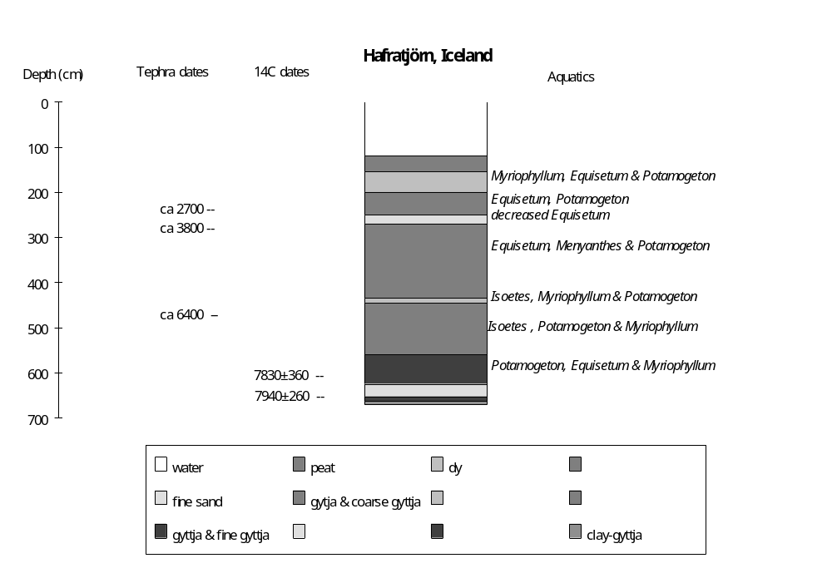

Preliminary coding: 26/5/1993; Final coding: 27/7/1993
Coded by GY and SPH
Lomatjörn, Iceland

Lomatjörn (20°20'W, 64°20'N, ca 100m above sea level) in Arnesysla, southern Iceland is a small lake surrounded by a vast fen. The water depth is ca 2m. It lies within the area glaciated during the Budi stadium (equivalent to Younger Dryas, ca 10500 yr B.P.); after that the basin was free of ice (Einarsson, 1969). The basin is situated in the belt of Quaternary volcanic intrusions, and the bedrock is Quaternary basalt (Commission for the Quaternary Map of the World, 1976; Schweitzer and Soffel, 1980).

A 4.3m core taken in water depth of ca 2m provides a sedimentary record back to ca 7200 yr B.P. (Vasari, 1972). The lake level reconstructions are based on changes in lithology, sedimentation rates and aquatic pollen assemblages. The chronology is based on three tephras (H3, H4 and H5) that have been radiocarbon-dated at other sites on Iceland (Einarsson, 1961; Vasari, 1972; Schweitzer and Soffel, 1980).

The basal sediment in the core (630-480cm below water surface) is gyttja. The aquatic assemblage contains abundant Myriophyllum, and some Potamogeton and Menyanthes. They might represent a moderate water depth. This phase is dated to ca 7200 and 5150 yr B.P. based on tephra (H5, ca 575cm below water surface) dated to 6400 yr B.P. (Einarsson, 1961; Vasari, 1972).

The sediments from 480 to 430cm below water surface are mainly coarse gyttja. This change in lithology suggests the lake became shallower. The aquatic assemblage is characterised by increased abundance of Myriophyllum, the disappearance of Potamogeton, some Equisetum, Menyanthes and Isoetes. This is consistent with shallowing. The interval is dated to between ca 5150-4490 yr B.P.

The overlying sediment (430-420cm below water surface) is clay gyttja, suggesting an increase in water depth. The aquatic assemblage contains mainly Isoetes, and Menyanthes disappears, suggesting the lake was quite deep ca 4490-4220 yr B.P.

The overlying sediments (420-230cm below water surface) are gyttja. The change in lithology suggests the lake became shallower between ca 4220-940 yr B.P. The increasing diversity of the aquatic assemblage, which contains Potamogeton, Isoetes and Myriophyllum, is consistent with shallowing. An increase in sedimentation rates from 0.076 to 0.081 cm/yr is consistent with this interpretation. Two layers of tephra in this unit (H4 in 278cm below water surface, and H3 in 188cm below water surface) are dated to 3800 and 2700 yr B.P. respectively (Einarsson, 1961; Vasari, 1972; Schweitzer and Soffel, 1980).

There is a layer of coarse gyttja at the top of core (230-200cm below water surface), suggesting shallowing after ca 940 yr B.P. The aquatic assemblage consists of abundant Isoetes, Equisetum and Potamogeton, and some Menyanthes. The appearance of Equisetum and Menyanthes are consistent with shallowing.

In the status coding, low (1) is indicated by coarse gyttja with Equisetum, Menyanthes and Isoetes; intermediate (2) by gyttja with abundant Myriophyllum and Potamogeton; and high (3) by clay gyttja with Isoetes.

Tephra dates

H5: Tephra, 6400 yr B.P., ca 575cm below water surface in Lomatjörn core; dated by 6410±170 (K-141).
H4: Tephra, 3800 yr B.P., ca 378cm below water surface in Lomatjörn core.
H3: Tephra, 2700 yr B.P., ca 288cm below water surface in Lomatjörn core; dated by 2720±130 (Y-85).

References

Commission for the Quaternary Map of the World, 1976. Geological World Atlas. sheet 9. Unesco.
Einarsson, T., 1961. Pollenanalytische Untersuchungen zur spät und postglazialen Klimageschichte Island. Sonderveröffentlichungen des Geologischen Instituts der Universität zu köln 6: 1-52.
Einarsson, T., 1969. Loftslag, sjavarhiti og hafis a forsögulegum tima. In: Hafisinn, Almenna Bokafelagid, Reykjaivik. pp 386-402.
Schweitzer, C. and Soffel, H.C., 1980. Palaeointensity measurements on postglacial lavas from Iceland. Journal of Geophysics 47: 57-60.
Vasari, Y., 1972. The history of the vegetation of Iceland during the Holocene. In: Vasari, Y., Hyvärinen, H. and Hicks, S. (eds.), Climatic changes in Arctic areas during the last ten-thousand years. Acta University of Oulu A3 (1972): 239-251.

Coding

ca 7200-5150 yr B.P. intermediate (2)
ca 5150-4490 yr B.P. low (1)
ca 4490-4220 yr B.P. high (3)
ca 4220- 940 yr B.P. intermediate (2)
ca 940- 0 yr B.P. low (1)

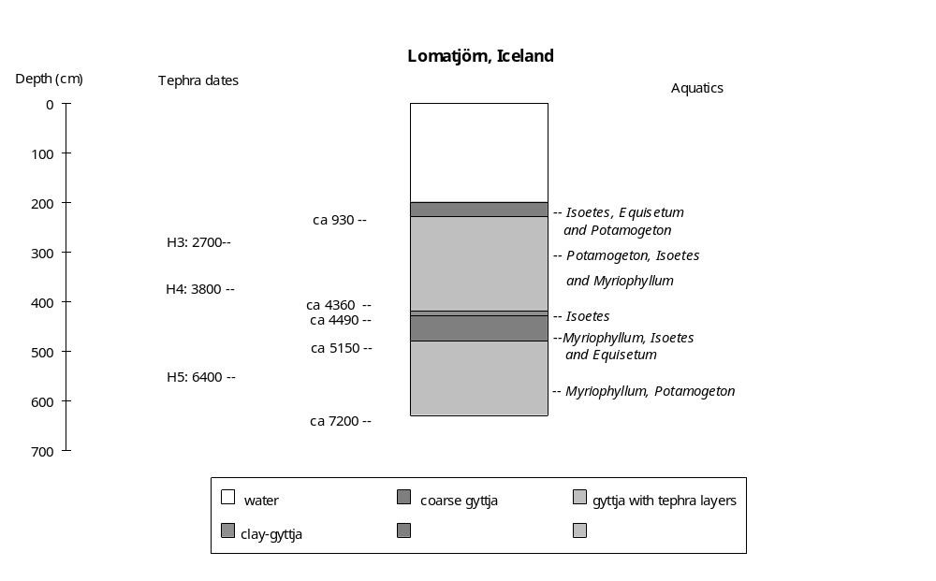

Preliminary coding: 27/5/1993; Final coding: 27/7/1993
Coded by GY and SPH

