1. Introduction
This report documents reconstructions of long-term changes in lake status from 118 lakes from Europe. Earlier versions of this data base have been used for environmental and climatic reconstructions by Harrison et al. (1991), Prentice et al. (1992), Harrison et al. (1993), Harrison and Digerfeldt (1993), and Guiot et al. (1993). The present version of the European Lake Status Data Base (ELSDB.1, December 1994) has been transferred to the National Geophysical Data Center in order to make the reconstructions freely available to the international scientific community.
The construction of the ELSDB is a contribution to an ongoing international effort to produce a new global lake data base (Harrison and Winkler, 1992) designed to be used to validate climate models. The structure of the ELSDB therefore parallels other regional data bases that have been or are being compiled under the auspices of this international effort, such as the FSU and Mongolia Lake Status Data Base (Tarasov et al., 1994) and the African Lake Status Data Base (Damnati and Harrison, in prep.).
1.1. Lakes as indicators of past climatE changes
Lakes respond to changes in the local water budget (precipitation minus evaporation over the lake surface and its catchment) by changing in depth and area. On a Late Quaternary time scale, lake status (a qualitative estimate of the hydrological balance, given by changes in lake level or relative water depth) is in equilibrium with the changing climate (Street-Perrott and Harrison, 1985; Harrison and Digerfeldt, 1993) and therefore can be used as an indicator of past climate. Both closed-basin and overflowing lakes have been used successfully to reconstruct past climate changes (e.g. Street-Perrott and Harrison, 1985; Winkler et al., 1986; Digerfeldt, 1988). Syntheses of lake status data have become an important tool for reconstructing palaeoclimatic changes at a continental to global scale (e.g. Street-Perrott and Harrison, 1985; COHMAP Members, 1988; Street-Perrott et al., 1989; Harrison et al., 1991; Guiot et al., 1993).
1.2. Previous Work on Palaeohydrological Changes IN EUROPE
Although investigations of European lakes began several decades ago, most studies focussed on reconstructions of limnological changes or vegetational history. Changes in water depth were occasionally invoked to explain sedimentary hiatuses or the presence of reworked material (e.g. Godwin and Tallantire, 1951), but there was no attempt to exploit the geological and biological evidence systematically to provide information about palaeohydrological changes. This was largely due to the assumption that overflowing lakes respond to changes in regional water budgets solely through changes in discharge (Dearing and Foster, 1986).
Gunnar Digerfeldt (University of Lund) established that lakes in southern Sweden had experienced significant changes in water level during the Holocene, despite the existence of an outflow, in a series of careful biostratigraphic investigations of lake bottom sediments (Digerfeldt, 1965, 1966, 1971, 1972, 1974, 1975, 1976, 1988). Digerfeldt developed an approach to reconstruct changes in water level, based on the use of a transect of cores from the edge to the centre of the lake so that individual sedimentary units can be traced across the basin. Changes in water depth are then interpreted from multiple lines of evidence, in particular changes in the position of the sediment limit, in sediment composition, and in the distribution of lake vegetation as indicated by aquatic pollen and/or macrofossil analysis (see Digerfeldt, 1986 for fuller discussion of method). Digerfeldt's approach has subsequently been used by other investigators, both in Sweden (e.g. Gaillard, 1984, 1985; Thelaus, 1989; Gaillard et al., 1991; Almquist-Jacobson, 1994) and in other regions of Europe (e.g. Ammann, 1975, 1982; Hjelmroos-Ericsson, 1981; Schneider and Tobolski, 1983, 1985).
On the basis of studies of modern carbonate sedimentation (Magny, 1991), Michel Magny (Besancon, France) has developed an independent approach to reconstructing lake level changes from carbonate concretion morphology. The approach utilises the fact that macroscopic carbonate concretions display distinctive morphotypes (oncolites, cauliflower-like forms, plates and tubes) which reflect their mode of origin (e.g. through bacterial or algal activity, through the photosynthetic activity of aquatic plants) and can therefore be related to the characteristic depth at which these organisms occur. Changes in the relative frequency of each of the morphotypes through time can be interpreted in terms of changes in water depth. This approach has been successfully applied to a number of lakes in the Jura (Magny, 1978; Magny and Richard, 1985, 1987, 1989; Magny et al., 1988; Magny and Mouthon, 1990). The method could potentially have a wider application.
Systematic field studies of lake-level or water depth changes have been carried out at rather few sites in Europe. However, the wealth of published stratigraphic and biostratigraphic data collected for other purposes (particularly from sites that were originally studied for vegetation history) can provide records of changes in relative water depth if properly interpreted. The methods used to extract such records has been described in detail by Harrison and Digerfeldt (1993). The approach has a number of acknowledged limitations (see Harrison and Digerfeldt, 1993 for fuller discussion of these) but it currently provides the only basis for achieving the site coverage needed for reconstruction of past regional climates and changes in atmospheric circulation patterns across Europe.
1.3. Methods

1.3.1. The Data Set
The data base contains fully documented and coded records from 118 sites across Europe (Figure 1). The data base was compiled by extracting information on changes in lake status from existing lithologic or biostratigraphic data. Most of the sites included in the data base have continuous Holocene records; many have late glacial records and about six sites along the western seaboard and in southern Europe have records extending to or beyond the last glacial maximum. A complete documentation exists for every site, describing the primary data, basin characteristics and the interpretation logic.
The sites chosen for inclusion have been screened to meet standards of dating control and consistency among different climatic indicators. Records or parts of records where water depth appears to have been influenced by non-climatic factors, such a tectonism, hydroseral development or human impact, or by factors where the climatic influence is indirect, such as sea-level changes, glacier fluctuations or fluvial influence, have been excluded from the data base. A total of 176 basins have been excluded from the data base because they do not meet these standards (see NONDATA.XLS in Appendix A).
1.3.2. Sources of Evidence for Changes in Lake Status
Changes in lake status (a measure of relative water depth or lake level) can be reconstructed using a variety of geological and biostratigraphic data. Methods of reconstructing relative water depth using existing stratigraphic, geochemical and palaeoecological data from sediment cores have been discussed by Harrison (1988, 1989) and Harrison and Digerfeldt (1993).
The major source of information on changes in lake status for most of the basins discussed in this report are changes in the nature of the sediments (including lithology, grain size, organic content, and chemical composition) and sedimentary structure (e.g. laminations, reworking and slumping, sedimentary lenses and hiatuses), as revealed in sediment cores. Palaeoecological evidence (aquatic pollen and macrofossils, diatoms, algae, moss, Cladocera, ostracodes, molluscs) have been used to provide corroborating evidence for the reconstructed changes in water depth. Geomorphological evidence (e.g. ancient shoreline features), archaeological evidence (e.g. inundated occupation sites) and historical records have also been used; these lines of evidence often permit reconstruction of absolute lake level. The reconstruction of changes in water depth at every site is based on the consensus interpretation of a minimum of two lines of evidence, following Harrison (1988), and Harrison and Digerfeldt (1993).
1.3.3. Standardisation: Lake Status Coding
For each site, an assessment of the relative water depth through time is made on the basis of all the available evidence. Where the evidence is limited or the range of variation is small, it may only be possible to distinguish two depth classes (deeper and shallower). There are sites, however, where it is possible to distinguish a greater number of depth-related differences in the geological and biostratigraphic data. This information is preserved by using a depth class categorisation that expands to the range demanded by the data. For each site, hiatuses are recorded by 0, the lowest water depth recorded is coded as status class 1 and then successively deeper water phases are coded as 2, 3, 4 and so on until the maximum water depth recognised in the basin has been coded. It should be noted that it is rarely possible to quantify the changes in depth and the status classes do not represent a linear scale of depth changes. Assessments of lake status, using this flexible coding scheme, are made on a continuous basis. This information, along with the specific basis for the depth categorisation, is given in the documentation file for each basin.

For comparison between sites, the lake status categories must be standardised. We use a 3 category scheme, where the status classes are defined as low (1), intermediate (2) and high (3). Various conventions can be used to define the boundaries of status classes. Here the boundaries were set so that for each lake record, the class "high" corresponded approximately to the upper quartile and "low" to the lower quartile of that lake's variation in level during the entire period of record, in order to ensure compatibility with the only existing global lake data base (the Oxford Lake-level Data Base: Street-Perrott et al., 1989). Status codings using this 3-category or "collapsed" status coding scheme have been made at 500-yr intervals for each lake. These collapsed status codings are given in the data base and have been used for e.g. mapping and subsequent analysis.

1.3.4. Chronology and Dating Control

The chronology of changes in lake status at individual sites is based on radiocarbon dating, annual lamination-counting, pollen or tephra correlation with a nearby radiocarbon-dated site, pollen or tephra correlation with a local or regional chronostratigraphy, or a combination of these methods. These methods of dating a record are not all equally accurate, and therefore the basis for the chronology is indicated in the data base (see Section 2.2.4).

The quality of the dating varies between different parts of the record from a single basin, and between the records from different basins. The quality of the dating control has been assessed at each 500-yr interval, using ranking schemes developed for the Cooperative Holocene Mapping (COHMAP) project (Webb, 1985). For data from continuous records, each interval was assigned a ranking (from 1 to 7) as follows:
1: Bracketing dates within a 2000-yr interval about the time being assessed
2: Bracketing dates, one within 2000 yr and the second within 4000 yr of the time being assessed
3: Bracketing dates within a 4000-yr interval about the time being assessed
4: Bracketing dates, one being within 4000 yr and the second being within 6000 yr of the time being assessed
5: Bracketing dates within a 6000-yr interval about the time being assessed
6: Bracketing dates, one within 6000 yr and the second within 8000 yr of the time being assessed
7: Poorly dated

This scheme is only appropriate when sedimentation is continuous so that interpolation between radiometric (or biostratigraphic) dates is possible. At some sites, the evidence for changes in water depth was derived from discontinuous sources, such as shorelines, lake deposits above the modern lake and archaeological features. In some lake cores there is evidence of reworking, slumping, sedimentary hiatuses or marked variations in sedimentation rates, all of which make it difficult to interpolate between the dated intervals. Even when the sediment deposition can be assumed to be both continuous and uniform, there may be situations where there is a date very near one of the time intervals being coded but where the bracketing date is rather distant. Application of the scheme for continuous records would result in such an interval being inappropriately downweighted. For data from these types of discontinuous records, each 500-yr interval was assigned a ranking (from 1 to 7) as follows:
1: Date within 250 yr of the time being assessed
2: Date within 500 yr of the time being assessed
3: Date within 750 yr of the time being assessed
4: Date within 1000 yr of the time being assessed
5: Date within 1500 yr of the time being assessed
6: Date within 2000 yr of the time being assessed
7: Poorly dated

1.4. Structure of this Report

In this report, we describe the general structure of European Lake Status Data Base (Section 2) and then provide a complete listing of the data included in the first version (ELSDB.1, December 1994) of the data base. The documentation files describing the primary data and the reconstructed changes in lake status for every site are given in Section 3. A list of references on which the reconstruction is based is given at the end of each documentation file; a complete bibliography of the palaeoenvironmental literature covering all the sites is given in Section 4. The site and dating information, the status codings at 500-yr intervals, and catchment parameters are summarised in a series of data base files. These files are listed in Appendix A. Finally, maps showing the reconstructed patterns of lake status changes at 1000-yr intervals back to 18,000 yr B.P. are given in Appendix B.

This report, and all of the data base material included in it, is also available in machine-readable form from NOAA-NGDC.

1.5. Acknowledgements

The compilation of the European Lake Status Data Base was begun under the auspices of the Cooperative Holocene Mapping Project (COHMAP) and has been supported by grants from the U.S. National Science Foundation (NSF), the Swedish Natural Science Research Council (NFR), the European Community (EC) Environment Programme, and the NOAA Climate and Global Change Program (Paleoclimatology). We would like to thank our many colleagues in Europe who have contributed information to the data base. We thank Fouzia Laarif for computer-cartographic assistance.

1.6. References TO INTRODUCTION

Almquist-Jacobson, H., 1994. Interaction of the Holocene climate, water balance, vegetation, fire, and the cultural land-use in Swedish Borderland. Lundqua Thesis 30: 82 pp.
Ammann-Moser, B., 1975. Vegetationskundliche und pollen-analytische Untersuchungen auf dem Heiden-weg im Bielersee. Beiträge zur Geobotanischen Landesaufnahme der Schweiz 56, 76 pp.
Ammann, B., 1982. Säkulare Seespiegelschwankungen: wo, wie, wann, warum? Mitteilungen der Naturforschenden Gesellschaft in Bern 39: 97-106.
COHMAP Members, 1988. Climatic changes of the last 18,000 years: observations and model simulations. Science 241, pp. 1043-1052.
Dearing, J.A. and Foster, I.D.L., 1986. Lake sediments and palaeohydrological studies. In Berglund, B. (ed.), Handbook of Holocene Palaeoecology and Palaeohydrology: 67-90. John Wiley & Sons, New York.
Digerfeldt, G., 1965. Vielången och Farlånfen. En utvecklingshistorisk insjöundersökning. Skånes Natur 52: 162-183.
Digerfeldt, G., 1966. Utvecklingshistoria och limnologiska observationer i Ranviken av sjön Immeln. Botaniska Notiser 119: 216-230.
Digerfeldt, G. 1974. The post-glacial development of the Ranviken bay in Lake Immeln. Geologiska Föreningens i Stockholm Förhandlingar 96: 3-32.
Digerfeldt, G., 1975. Post-Glacial water-level changes in lake Växjösjön, central southern Sweden. Geologiska Föreningens i Stockholm Förhandlingar 97: 167-173.
Digerfeldt, G., 1976. A pre-Boreal water-level change in Lake Lyngsjö, central Halland. Geologiska Föreningens i Stockholm Förhandlingar 98: 329-336.
Digerfeldt, G., 1986. Studies on past lake-level fluctuations. In Berglund, B. (ed.), Handbook of Holocene Palaeoecology and Palaeohydrology: 127-144. John Wiley & Sons, New York.
Digerfeldt, G., 1988. Reconstruction and regional correlation of Holocene lake-level fluctuations in Lake Bysjön, South Sweden. Boreas 17: 165-182.
Gaillard M-J., and Berglund, B.E., 1988. Land-use history during the last 2700 years in the area of Bjäresjö, Southern Sweden. Birks, H.H., Kaland, P.E. and Moe, D. (eds), The cultural landscape - Past, Present and Future. Cambridge University Press. pp 409-428.
Gaillard M-J., Dearing, J.A., El-Daoushy, F., Enell, M. and Håkansson, H., 1991. A late Holocene record of land-use history, soil erosion, lake trophy and lake-level fluctuations at Bjäresjösjön (South Sweden). Journal of Paleolimnology 6: 51-81.
Gaillard, M-J., 1984. Water-level changes, climate and human impact: A palaeohydrological study of Krageholmssjön (Scania, South Sweden). In: Mörner, N.-A. and Karlen, W. (eds.), Climatic Changes on a Yearly to millennial Basis, D. Reidel Piblishing Company. pp 147-154.
Gaillard, M.J. 1985. Postglacial palaeoclimatic changes in Scandinavian and central Europe. A tentative correlation based on studies of lake level fluctuations. Ecologia Mediteranea Tome XI (Fascicule 1): 159-175.
Godwin, H. and Tallantire, P.A., 1951. Studies in the post-glacial history of Britain vegetation. Journal of ecology 39: 285-307.
Guiot, J., Harrison, S.P. and Prentice, I.C., 1993. Reconstruction of Holocene precipitation patterns in Europe using pollen and lake-level data. Quaternary Researc 40: 139-149.
Harrison, S. P., 1988. Lake-level records from Canada and the eastern U.S.A. Lundqua Report (Lund University, Department of Quaternary Geology 29: 9, 2 appendices.
Harrison, S., Prentice, I.C. and Guiot, J., 1993. Climatic controls on Holocene lake-level changes in Europe. Climate Dynamic 8: 189-200.
Harrison, S.P. and Digerfeldt, G., 1993. European lakes as palaeohydrological and palaeoclimatic indicators. Quaternary Science Reviews 12: 233-248.
Harrison, S.P. and Winkler, M., 1992. A new global lake-level data base: advert and appeal for assistance. Royal Society of Canada, Bulletin.
Harrison, S.P., 1989. Lake-level records from Australia and Papua New Guinea. UNGI Rapport (Uppsala University, Department of Physical Geography) 72: 142.
Harrison, S.P., 1993. Late Quaternary lake-level changes and climates of Australia. Quaternary Science Reviews 12: 211-232.
Harrison, S.P., Saarse, L. and Digerfeldt, G., 1991. Holocene changes in lake levels as climate proxy data in Europe. Paläoklimaforschung 6: 159-170.
Hjelmroos-Ericsson, M., 1981. Holocene development of Lake Wielke Gacno area, northwestern Poland. Ph.D thesis, Lund University, Sweden.
Magny, M., 1978. La dynamique des dépôts lacustres et les stations littorales du Grand Lac de Clairvaux (Jura), C.R.A.S., C.R.A. Préhistorique Fr. 77: 17-25.
Magny, M., 1990. Une approche paléoclimatique de l'Holocène: les fluctuations des lacs du Jura et des Alpes du Nord françaises. Thesis, laboratoire de Chrono-Ecologie, Besançon. 633 pp.
Magny, M. and Mouthon, J., 1990. Interprétation paléolimnimétrique d'une coupe stratigraphique de la Station 2 de Chalain (Jura): comparaison des approches sédimentologique et malacologique. Archives des Sciences 43: 99-115.
Magny, M. and Richard, H., 1985. Contribution à l'histoire holocène du lac du Bourget: recherches sédimentologiques et palynologiques sur le site de Conjux-La-Chatière (Savoie, France). Revue de Paléobiologie 4: 259-277.
Magny, M. and Richard, H., 1987. Contribution a l'histoire du Lac des Rousses (Jura, France): recherches sedimentologiques et palynologiques. Revue de Paléobiologie 6: 89-103.
Magny, M. and Richard, H., 1989. Contribution à l'histoire du Petit Lac de Clairvaux. Recherches palynologiques et sédimentologiques. In: Pétrequin, P. (ed.), Les Sites Littoraux Néolithiques de Clairvaux-les-lacs (Jura). II. Le Néolithique moyen. Editions de la Maison des Sciences de l'Homme, Paris, pp. 79-84.
Magny, M., Richard, H. and Evin, J., 1988. Nouvelle contribution a l'histoire holocène des lacs du Jura français: recherches sédimentologiques et palynologiques sur les lacs de Chalain, de Clairvaux et d l'Abbaye. Revue de Paléobiologie 7: 11-23.
Schneider, R. and Tobolski, K., 1983. Palynologische und stratigraphische Untersuchungen im Lago di Ganna (Vares, Italien). Botanica Helvetica 93: 115-122.
Schneider, R. and Tobolski, K., 1985. Lago di Ganna - Late-glacial and Holocene environments of a lake in the Southern Alps. Dissertationes Botanicae 87: 229-271.
Street-Perrott, F.A. and Harrison, S.P., 1985. Lake levels and climate reconstruction.. In: Hecht, A.D. (ed.), Palaeoclimate analyses and modelling. New York, Wiley. 291-340 pp.
Street-Perrott, F.A., Marchand, D.S., Roberts, N. and Harrison, S.P., 1989. Global lake-level variations from 18,000 to 0 years ago: a palaeoclimatic analysis. U.S. DOE/ER/60304-H1 TR046. U.S. Department of Energy, Technical Report.
Tarasov, P.E., Harrison, S.P., Saarse, L. et al., 1994. Lake Status Records from the Former Soviet Union and Mongoloia: Data Base Documentation. Paleoclimatology Publications Series Report No. 2, Boulder, USA. 274 pp.
Thelaus, M., 1989. Late Quaternary vegetation history and palaeohydrology of the Sandsjön-Arshult area, southwestern Sweden. Lundqua Thesis 26: 77 pp.
Webb, T., III, 1985. A Global Paleoclimatic Data Base for 6000 yr B.P. DOE/EV/10097-6, US Department of Energy, Washington. 155 pp.
Winkler, M.G., Swain, A.M. and Kutzbach, J.E., 1986. Middle Holocene dry period in the northern Midwestern United States: lake levels and pollen stratigraphy. Quaternary Research 25: 235-250.
2. the structure of the data base

The data base consists of documentation files (EULAKE.DOC and EUREF.DOC) and summary tables (EUDATA.XLS, EUSTATUS.XLS, EUDATLST.XLS, EUDATCN.XLS, EUELEV.XLS and NONDATA.XLS). In both the documentation files (Sections 3 and 4) and the summary tables (Appendix A), the sites are arranged by country, where the country order is alphabetical. Within each country the order of the basins is alphabetical.

2.1. CONTENT AND FORMAT OF THE DOCUMENTATION FILES

2.1.1. EULAKE.DOC

These files are Word 5.0 files.

There is a separate documentation file for each site in the data base. The file contains a short description of the basin, including information (where available) on basin morphology, modern lake hydrology and catchment geology. The file also includes the reconstructed changes in lake status through time, along with a summary of the primary data on which these reconstructions are based. The basis for the status coding at each site is explicitly stated. The radiometric dates used to establish the chronology and the sources of data are listed. The status coding through time is also given. Most of the files are accompanied by simplified lithological diagrams of key cores or sequences used in the reconstruction.

2.1.2. EUREFS.DOC

This is a Word 5.0 file, containing full citation of all references used to compile the ELSDB.1. The references are listed in alphabetical order of author(s).

2.2. CONTENT AND FORMAT OF THE DATA BASE SUMMARY FILES

2.2.1. EUDATA.XLS

This is an Excel 4.0 file containing primary information:
Lake name, country, latitude, longitude, elevation, type of basin, basin origin and geology, area of basin, area of lake and mire, mean and maximum depth of lake, number of 14C dates, record length, data sources, status coding, primary references, other references, coded by, date of final coding.

The data format is:
Lake name, country, latitude (in decimal degrees, N=+), longitude (in decimal degrees, E=+, W=-), elevation (m), type of basin (overflow or closed lake, mire, bog etc.), basin origin and geology, area of basin (ha), lake and mire area (ha), mean and maximum depth of lake (m), number of 14C dates, record length (yr B.P.), data sources, status coding from 0ka back to 30 ka at 500 yr intervals (0 = hiatus, 1 = lowest, 2 = next lowest etc.; times that cannot be coded are marked n/c, times when alternative codings are possible because of dating uncertainties are shown with a slash (e.g. 2/1/0)), primary references, other references, coded by (the people specifically responsible for the coding), and date of final coding.

The following abbreviations are used to indicate who was responsible for coding specific basins:

SPH Sandy P. Harrison (Department of Physical Geography, Sölvegatan 13, Lund University, S-223 62 Lund, Sweden)
GY Ge Yu (Department of Physical Geography, Sölvegatan 13, Lund University, S-223 62 Lund, Sweden)
XY Xiaoping Yang (Department of Physical Geography, Sölvegatan 13, Lund University, S-223 62 Lund, Sweden)
GD Gunnar Digerfeldt (Department of Quaternary Geology, Tornavägen 13, Lund University, S-223 63 Lund, Sweden)
HAJ Heather Almquist-Jacobson (Departments of Plant Biology & Geological Science, 5726 Environmental Sciences Lab, University of Maine, Orono, Maine 04469-5726, USA)
MYP Marina Ya. Pushenko (Institute of Limnology, Russian Academy of Sciences Sevastianova 9, St.Petersburg, ul. 196199, Russia).

2.2.2. EUSTATUS.XLS

This is an Excel 4.0 file containing:
Site name, latitude, longitude, collapsed status codings.

The data format is:
Site name, latitude (in decimal degrees, N=+), longitude (in decimal degrees, E=+, W=-), collapsed status codings (1 = low, 2 = intermediate, 3 = high, n/c= not coded) at 500-yr intervals from 0-30 ka.

2.2.3. EUDATLST.XLS

This is an Excel 4.0 file containing:
Lake name, country, latitude, longitude, total number of 14C dates, lab. number, 14C date, positive error and negative error, description of material, depth of sample, core/profile name, and comments.

The data format is:
Site name, country, latitude (in decimal degrees, N=+), longitude (in decimal degrees, E=+, W=-), total number of 14C dates, lab. number, 14C date (yr B.P.), positive error and negative error, description of material, sample depth of radiocarbon date (m), name of core or profile if there are multiple cores or profiles from the basin, comments (ATO = age too old possible, ATY = age too young possible, CS = contamination suspected, SS = Small sample, RWKD = Reworked, Strat. inconsist = Stratigraphical inconsistent. Others have such as Rejected, Contaminated, etc.).

2.2.4. EUDATCN.XLS

This is an Excel 4.0 file containing :
Site name, status coding, collapsed status coding, dating-method control, dating control and time point information.

The data format is:
Line 1: site name.
Line 2: status coding (n/c = not coded, 0 = hiatus, 1 = lowest, 2 = next lowest etc.).
Line 3: collapsed coding (1 = low, 2 = intermediate, 3 = high, n/c = not coded).
Line 4: dating method control with a 5-point scale:
1 - radiometric dates from the site deposits themselves, or varve-counting;
2 - pollen and/or lithological correlation with radiometrically dated site within basin;
3 - pollen correlation with a specific radiometrically dated site within 50 km;
4 - pollen correlation with radiometrically dated regional pollen sequence, or archaeological dating;
5 - educated guesswork (e.g. correlation with general stratigraphic or climatic schema).
Line 5: dating control (see Section 1.3.4).
Line 6: time points used for calculating dating control:
r - radiocarbon date;
v - varve-counting date;
p - pollen correlation date;
t - tephra correlation date;
a - archaeological event date.

2.2.5. EUELEV.XLS

This is an Excel 4.0 file containing:
Site name, latitude, longitude, lake elevation, basin area and mean basin area, lake area, z-ratio, catchment parameters, references.

The data format is:
Site name, latitude (in decimal degrees, N=+), longitude (in decimal degrees, E=+, W=-), lake elevation (m), basin area and mean basin area (ha), lake area (ha), z-ratio (ratio of lake area to basin area), maximum elevation (m), mean elevation (m) and elevation range (m), references.

2.2.6. NODATA.XLS

This is an Excel 4.0 file containing information about sites excluded from ELSDB.1, including lake name, country, comments, references, if documented.

The data format is:
Lake name, country, comments, documented (yes/no), references, if documented.
3. LAKE STATUS RECORDS FROM EUROPE

Attersee, Austria

Attersee (47.86°N, 13.53°E, 469.2m above sea level) lies in the Northern Calcareous Alps. With a length of 20.1 km, a mean width of 2.4 km and a surface area of 4590ha, it is the largest lake in the Salzkammergut region (Behbehani et al., 1986). Most (ca 50%) of the surface input to the lake comes via the Mondseeache from Mondsee, although there are at least 18 other minor surface inflows. The lake drains via the Ager River into the Traun River. The lake basin can be divided into three sub-basins, separated by sills: the southern basin has a simple form and a maximum depth of 170.6m (Schneider et al., 1987); the central basin is morphologically heterogeneous; the northern basin has a maximum depth of 130m (Behbehani et al., 1986). The mean depth of the lake is 84.2m (Schneider et al., 1987). The basin was formed by tectonism during the Pliocene, but was substantially modified by glacial advances of the Traun glacier during at least three glaciations. It now has the form of an overdeepened glacial valley. The catchment area is 46350ha. The catchment includes calcareous rocks to the south, flysch to the east and morainic deposits to the north and west. These geological differences are reflected in the shoreline geomorphology and lake sedimentation patterns: the shorelines to the south and east are steep, while the shores to the north and west are more shelf-like; allochthonous inputs, including mudflows and landslide debris are more common to the south and east, and autochthonous carbonate production is typical of sedimentation in the west and north (Behbehani et al., 1986). The lake is thermally stratified in summer.

The bottom stratigraphy has been reconstructed from at least 5 cores (ATT 80/14, ATT 80/9, ATT 80/1, ATT 80/10 and AT 40) across the lake, echography and sediment mapping (Behbehani et al., 1986). Four major sedimentological units are distinguished. The depositional chronology is based on pollen dating.

The basal unit consists of moraine deposits from the last glaciation. The overlying unit consists of finely banded varved sediments deposited during an alpine arctic lake stage before 13,000 yr B.P. After 13,000 yr B.P., predominantly carbonate sediments were deposited. The unit is interrupted by turbidite deposits of allochthonous origin. According to Behbehani et al. (1986), the frequency of turbidites can be related to more humid conditions and increased runoff from the basin, and increase in frequency between 6500 and 6000 yr B.P. and just before 1200 yr B.P. The uppermost unit is marked by a reduction in carbonate content and increased sedimentation rates. According to Behbehani et al. (1986), these changes reflect forest clearance consequent upon Bavarian colonisation of the region after ca 1200 yr B.P. The sedimentation rate shows a further marked increase in the last 100 years, again corresponding to more intensive land use in the region.

The recent history of water-level changes is based on lithological studies of Neolithic settlement sites occurring in shallow water depths (ca 2-3m) at several locations around the margin of the lake. These sites include Seewachen I-III, Litzlberg I and II, Aufham I-II, Abtsdorf I-III, Misling I-III and Weyregg I and II (Offenberger et al., 1982). Detailed studies have been carried out at Weyregg I and Aufham (Offenberger et al., 1982; Behbehani et al., 1985). Additional information about changes in water depth is based on changes in mollusc assemblages and aquatic macrofossils (Offenberger et al., 1982; Schmidt, 1983). The chronology is based on radiocarbon (Felber, 1980, 1982, 1983 and 1985) and pollen dating (Offenberger et al., 1982; Schmidt, 1983).

Weyregg I lies on a broad, shallow carbonate shelf at the southern end of the Weyregg delta (Offenberger et al., 1982; Behbehani et al., 1985). The shelf has a maximum width of 200m and a maximum depth of 10m. The main profile was taken in a water depth of 2m. The basal sediments (80-100cm) consist of well-sorted carbonate deposits with abundant Characean crusts and oogonia, indicating quiet and relatively deep-water conditions. The absence of aquatic pollen (other than Cyperaceae) or macrorests is consistent with relatively deep water. According to Offenburger et al. (1982), the water depth was greater than today. The terrestrial pollen assemblages suggest that this unit was formed in the early Atlantic, pre-6000 yr B.P. Between 75-80cm, the carbonate content decreases as does the abundance of Chara, but the sand content increases. These changes suggest a decrease in water depth. The sediments between 40-75cm contain many stones, and are characteristic of the shallow sublittoral zone. According to Offenburger et al. (1982), the water depth was less than today. There is evidence of a sedimentary hiatus at ca 52cm in the pollen profile from Weyregg (Schmidt, 1983), consistent with conditions shallower than today. The overlying unit (40-45cm) corresponds to the Neolithic settlement phase, when the lake was ca 2-3.5m lower than present. A sample from this cultural horizon has been radiocarbon dated to 4660±100 yr B.P. (VRI-733). A short phase of deeper water conditions, with water depths similar to present is marked by the sediments between 20-40cm. The uppermost sediments correspond to a second cultural layer, radiocarbon dated to 4640±110 yr B.P. (VRI-732).

Aufham also lies on a gently sloping shelf, on the western side of the lake close to the village of Attersee. Three sediment profiles, taken in water depths of 1.5, 2 and 2.5m respectively, have been investigated lithologically and palynologically. The very low apparent sedimentation rate during the last ca 6000 yr in the two shallower profiles indicates the probability of hiatus in sedimentation, when the lake level was at least 2m shallower than today. The cultural layer in the deeper water profile is overlain by carbonate sediments, corresponding to an increase in water depth after the Neolithic settlement phase. This increase in water depth probably took place around 2000 yr B.P. (Offenberger et al., 1982). Dates of 1740±90 yr B.P. and 1450±70 yr B.P. on wooden structures at Wegregg and Litzlberg respectively suggest that the increase in depth may have been delayed until ca 1400 yr B.P.

In the status coding, very low (1) is indicated by Neolithic settlement, low (2) by sublittoral deposits, intermediate (3) by sediments similar to those being deposited today, and high (4) by carbonate sediments indicating quiet water conditions. Note that the increase in water depth between the two cultural horizons is too short-lived and too poorly constrained by the available dating to appear in the coding scheme.

References

Behbehani, A., Handl, M., Horsthemke, E., Schmidt, R. and Schneider, J., 1985. Possible lake level fluctuations within the Mondsee and Attersee. In: D. Danielopol, R. Schmidt and E. Schultze (eds.), Contributions to the Paleolimnology of the Trumer Lakes (Salzburg) and the Lakes Mondsee, Attersee and Traunsee (Upper Austria). Limnologisches Institut Österreichischen Akademie der Wissenschaften, Mondsee. pp 200.
Behbehani, A.-R., Müller, J., Schmidt, R., Schneider, J., Schröder, H.-G., Strackenbrock, I. and Sturm, M., 1986. Sediments and sedimentary history of Lake Attersee (Salzkammergut, Austria). Hydrobiologia 143: 233-246.
Felber, H., 1980. Vienna Radium Institute radiocarbon dates X. Radiocarbon 22: 108-114.
Felber, H., 1982. Vienna Radium Institute radiocarbon dates XII. Radiocarbon 24: 222-228.
Felber, H., 1983. Vienna Radium Institute radiocarbon dates XIII. Radiocarbon 25: 936-943.
Felber, H., 1985. Vienna Radium Institute radiocarbon dates XV. Radiocarbon 27: 616-622.
Offenberger, J., Ruttkay, E., Schmidt, R., Chondrogianni, C., Niessen, F., Schneider, J. und Stojaspal, F., 1982. Stratigraphische Untersuchungen im Bereich der neolithischen Station Weyregg I am Attersee. Fundberichte aus Österreich 20: 191-222.
Schmidt, R., 1983. Pollen und Großreste aus der neolithischen Station Weyregg I am Attersee, Oberösterreich. Fundberichte aus Österreich 21: 157-169.
Schneider, J., Müller, J. and Sturm, M., 1987. Die Sedimentoloische Entwicklund des Attersees und des Traunsees im Spät- und Postglazial. Mitteilungen der Kommission für Quartärforschung der Österreichischen Akademie der Wissenschaften 7: 51-76.

Radiocarbon Dates

VRI-300 modern bottom of Attersee Lake, wooden piling, Attersee, date disagrees with supposition of Neolithic lake dwelling
VRI-738 220±70 -1.5m below water level, Oberndorfer farm
VRI-683 910±80 bottom of Attersee Lake, wood, Schörfling
VRI-578 1450±70 -1.5m, below lake level, wood remnant, Litzlberg 2/76 (Unterbuchberg), date disproves expected La Tène age
VRI-596 1740±90 -2.0m below lake level, wood piling, Weyregg
VRI-468 2040±70 Litzlberg 1/74 (Unterbuchberg)
VRI-735 3180±90 Abtsdorf I
VRI-825 4310±90 Neolithic lake dwelling, wood remnant, Nußdorf
VRI-687 4420±100 -3.0m below lake level, wooden piling, Schörfling
VRI-775 4610±100 -2.0m below lake level, wooden piling, Abtsdorf II
VRI-732 4640±110 -2.0m below lake level, wood, upper cultural horizon, Weyregg I
VRI-733 4660±100 -2.0m below lake level, wood, lower cultural horizon, Weyregg I
VRI-731 4680±100 Abtsdorf III
VRI-730 4720±100 -2.5m below lake level, Attersee
VRI-723 4910±110 -1.7m below lake, wooden pile, Seewalchen

Coding

7500-5500 yr B.P high (4)
5900-4700 yr B.P. low (2)
4700-1400 yr B.P. very low (1)
2000-0 yr B.P. intermediate (3)

Preliminary coding: July 1988; Final coding: January 1989
Coded by: SPH
Mondsee, Austria

Mondsee (47.83°N, 13.37°W, 475m above sea level) lies in the northwestern part of the Saltzkammergut. The lake has a surface area of 1420ha and a mean depth of 36m (Irlweck and Danielopol, 1985). There is a relatively shallow zone in the Mondsee Bay, with a maximum depth of 48m, and a deeper zone in the central stretch of the lake, with a maximum depth of 68.3m. Three major rivers (Fuschler Ache, Wangauer Ache and Zeller Ache) and several minor streams flow into the lake. There is an outflow, via the Mondsee Ache into Attersee. The Mondsee basin was originally formed by tectonic processes but, as part of the Traun glacier system, has been substantially altered by glaciation (Löffler, 1983). The underlying bedrock consists of carbonate and flysch rocks.

Recent sedimentation rates have been reconstructed using 210Pb dating of ca 9 short cores from the lake bottom. Sedimentation rates of ca 0.4-0.7 cm per yr occur in sites close to sources of allochthonous inputs, but rates in the centre of the lake are of the order of 0.2-0.3cm per year (Irlweck and Danielopol, 1985).

During the last interglacial, the level of Mondsee was 60m higher than present (Klaus, 1975; Löffler, 1983). The lake was much expanded to include the Zeller See basin and may also have been joined to Attersee (Löffler, 1983). The presence of macrofossils of e.g. Najas minor (Klaus, 1975) is consistent with deep water conditions.

The recent history of lake-level changes is based on studies at the Neolithic settlement site at See (Behbehani et al., 1985; Schmidt, 1986). The See site lies in a water depth of 2-3m on a shallow shelf near the outflow from Mondsee. The lithology is reconstructed from a transect of 7 cores (Profile 3, Profile 10, Mon K1, Mon K2, Mon K3, Mon K4, Mon 10) taken in water depths down to 12m below modern lake level across the shelf. Lake-level changes are reconstructed from changes in lithology and aquatic pollen and macrofossil assemblages (Behbehani et al., 1985; Schmidt, 1986). The chronology is based on 7 radiocarbon dates (Felber, 1975, 1985, 1987; Schmidt, 1986).

The basal sediments are lacustrine marl, indicating moderately deep water conditions. The abundance of Potamogeton in this unit in core Mon K2 is consistent with relatively deep water. A wood fragment from this unit in Profile 3 was radiocarbon dated to 7180±100 yr B.P. (VRI-908).

The overlying unit in the nearshore sites (Profile 3 and 10, Mon K1) corresponds to the Neolithic cultural unit and is characterised by the presence of archaeological artefacts. It consists mainly of terrestrial material with sporadic limnic elements, including ostracodes, mollusc shells and fruits of water plants. A sample from the base of this layer in Profile 10 (ca 45-50cm) has been radiocarbon dated to 4710±110 yr B.P. A date of 5140±140 yr B.P. of bark from a depth of 22-25cm in the same Profile indicates reworking of sediments and is consistent with erosion of older material into the lake when the water level was low. It suggests that the drop in level occurred sometime around 5000 yr B.P. On the basis of dates on archaeological material (e.g. VRI-331, VRI-332, VIR-333 and VRI-823) the lake was lower by 4700 yr B.P. The archaeological evidence suggests that Mondsee was ca 2-3.5m lower than the modern outlet level during the Neolithic (Behbehani et al., 1985). It may, in fact, have been closed (see Löffler, 1983).

In the deeper water sites (e.g. Mon K2) this interval of lower water level is apparently marked by a major sedimentary hiatus. Terrestrial pollen assemblages dating to the later part of the Atlantic period are absent (Behbehani et al., 1985). Continuous sedimentation appears to resume at about 2000 yr B.P., since Juglans (which occurs from ca 60cm) is generally considered not to be present before this time.

The increase in water depth after ca 2000 yr B.P. is marked by deposition of a variable but coarse-grained transition unit at sites in a water depth of 3-10m. The uppermost unit in the deepwater cores is a carbonate sediment with siliciclastic detritus. The fact that this unit does not cover the Neolithic settlement area suggests that the water depth was not as great as before the Neolithic settlement period. This is also consistent with the presence of siliciclastic detritus and the absence of Potamogeton from this unit in Mon K2.

In the status coding, low (1) is indicated by Neolithic settlement and the presence of a major hiatus in the deepwater core Mon K2; intermediate (2) by deposition of marl with siliciclastic detritus; and high (3) by deposition of pure lacustrine marl.

Note that Behbehani et al. (1985) reconstruct lake level changes at Mondsee. Unfortunately, there seems to be some confusion in the way the reconstructed changes are described. Thus, they argue for a rise in lake level at 4700 yr B.P. (the beginning of Neolithic settlement) and suggest that the archaeological evidence indicates the lake was ca 3m deeper than today. However, they show the Neolithic lake level as ca 3.5m lower than today, point out that the stratigraphic hiatus in deepwater cores persisted until ca 2000 yr B.P. and state in their conclusions that there was a lake level lowering of between 2-3.5m during the Neolithic. We can only conclude that these discrepancies reflect typographic errors in the text.

References

Behbehani, A., Handl, M., Horsthemke, E., Schmidt, R. and Schneider, J., 1985. Possible lake level fluctuations within the Mondsee and Attersee. In: D. Danielopol, R. Schmidt and E. Schultze (eds.), Contributions to the Paleolimnology of the Trumer Lakes (Salzburg) and the Lakes Mondsee, Attersee and Traunsee (Upper Austria). Limnologisches Institut Österreichischen Akademie der Wissenschaften, Mondsee. pp 136-148.
Felber, H., 1975. Vienna Radium Institute radiocarbon dates VI. Radiocarbon 17: 247-254.
Felber, H., 1985. Vienna Radium Institute radiocarbon dates XV. Radiocarbon 27: 616-622.
Felber, H., 1987. Vienna Radium Institute radiocarbon dates XV. Radiocarbon 29: 389-396.
Irlweck and Danielopol, 1985. Caesium-137 and lead-210 dating of recent sediments from Mondsee (Austria). Hydrobiologia 128: 175-185.
Klaus, W. Von, 1975. Des Mondsee-Interglazial, ein neuer Florenfundpunkt der Ostalpen. Jahrbuch Oberösterreichischen Musealvereines 120: 315-344.
Löffler, H., 1983. Aspects of the history and evolution of Alpnine lakes in Austria. Hydrobiologia 100: 143-152.
Schmidt, R., 1986. Palynologie, stratigraphie und Großreste von Profilen der neolithischen station See am Mondsee, Oberösterreich. In: W. Johann Offenberger (ed), Pfahlbauten, Feuchtbodensiedlungen und Packwerke. Bodenmerkmale in einer modernen Umwelt 70: 227-235.

Radiocarbon Dates

VRI-332 4260±90 3.0m below lake level, wooden pilings, Mooswinkl 4 (2310 B.P.)
VRI-331 4350±90 3.0m below lake level, wooden pilings, Mooswinkl 3 (2400 B.P.)
VRI-333 4430±110 3.0m below lake level, wooden pilings, Mooswinkl 5 (2480 B.P.)
VRI-823 4660±80 2.0m below lake level, wooden remnant of pile dwelling, See.
n/a 4720±110 0.47-0.50m, detritus layer, profile 10
n/a 5140±140 0.22-0.25m, bark, profile 10, reworked
VRI-908 7180±100 0.77-0.83m, wood fragment in lake marl, profile 3

Coding

7500-5000 yr B.P. high (3)
5000-2000 yr B.P. low (1)
2000-0 yr B.P. intermediate (2)

Preliminary coding: July 1988; Final coding: January 1989
Coded by: SPH
Schwemm, Austria

The Schwemm (47°35'N, 12°10'E, 664m above sea level) is a raised bog in the Walchsee Valley, a tributary to the Inn Valley, in the western Austrian Alps (Oeggl, 1988; Oeggl and Eicher, 1989). The Walchsee Valley broadens out in its middle reaches into a basin which is longitudinally bisected by the Miesberg Hills. The Schwemm raised bog lies in the northern sub-basin. The nearby mountains are limestone (Oeggl, 1987).

The stratigraphy of the deposits was reconstructed from a grid of 46 cores (Oeggl, 1988; Oeggl and Eicher, 1989). Five of these cores were studied for pollen (A3, B1, B5, D3, F4). Core B1, taken in the centre of the raised bog where the deposits reached maximum thickness (14.15m), was also used for oxygen isotope analysis. Three radiocarbon dates were obtained from core B5 and an additional date was obtained on a core from the Miesberg Moor, 2km west of the Schwemm (Oeggl, 1988; Oeggl and Eicher, 1989). The datings were extrapolated to other cores by pollen correlation. Water-level changes are reconstructed from changes in stratigraphy, aquatic pollen and macrofossils (Oeggl, 1987; Oeggl, 1988; Oeggl and Eicher, 1989).

The basal deposits in Core B1 (11.21-14.25m) are silty or clayey lake muds. The aquatic pollen assemblage is characterised by abundant Cyperaceae and Potamogeton. The nature of the sediments and the depauperate aquatic pollen assemblage suggests that the lake was deep. On the basis of the terrestrial pollen assemblages, this unit is dated to the Oldest Dryas (pre-13,000 yr B.P.).

The overlying unit (9.20-11.21m) is a calcareous lake gyttja, indicating shallower water after ca 13,000 yr B.P. The aquatic pollen assemblage is characterised by moderate levels of Cyperaceae and occasional Potamogeton, consistent with this interpretation.

The overlying unit (8.25-9.20m) is a calcareous lake gyttja containing abundant coarse detritus, indicating a pronounced decrease in water depth. The aquatic pollen assemblage was more diverse, with abundant Myriophyllum, Nymphaea and Potamogeton sect. Eupotamogeton, and an increase in the abundance of Cyperaceae. The change in the aquatic assemblage is consistent with shallowing. The presence of abundant Phragmites macrofossils in cores from the peripheral part of the bog also suggests shallow water (Oeggl, 1988). Interpolation between the attributed radiocarbon dates suggest that this interval began ca 7900 yr B.P. and ended ca 6800 yr B.P.

An increase in water depth after ca 6800 yr B.P. is indicated by the deposition of a pure calcareous gyttja between 6.50-8.25m. The absence of limnophytes except for Potamogeton is consistent with an increase in water depth (Oeggl, 1988; Oeggl and Eicher, 1989). The uppermost 6.50m of the sediment is peat. The climatic significance of the transition to a raised bog is difficult to evaluate, and no attempt is made to code this section of the record.

In the status coding, low (1) is indicated by the deposition of calcareous gyttja with abundant organic detritus and an aquatic pollen assemblage with abundant limnophytes; intermediate (2) by the deposition of pure calcareous gyttja; and high (3) by lake muds/clays.

References

Oeggl, K., 1987. A reference site for the valleys and montane woodlands of the Western Alpine region of Austria: the raised bog "The Schwemm". Lundqua Report 27: 193-194.
Oeggl, K., 1988. Beiträge zur Vegetationsgeschichte Tirols VII: Das Hochmoor Schwemm. Berichte des naturwissenschaftlich-medizinischen Vereins Innsbruck 75: 37-60.
Oeggl, K. and Eicher, U., 1989. Pollen- and oxygen-isotope analyses of late- and postglacial sediments from the Schwemm raised bog near Walchsee in Tirol, Austria. Boreas 18: 245-253.

Radiocarbon dates

VRI-848 6450±90 B5, 6.40-6.50m, ca 7.9-8.0m in B1
VRI-847 8650±130 B5, 7.30-7.40m, ca 9.8m in B1
Hv-5289 9455±120 Miesberg Moor, 2.90-3.00m, ca 10.2m in B1
VRI-846 10370±80 B5, 7.58-7.68m, ca 10.25-10.35m in B1

Coding

-13,000 yr B.P. high (3)
13,000- 7900 yr B.P. intermediate (2)
7900 - 6800 yr B.P. low (1)
6800 - 4600 yr B.P. intermediate (2)
4600 - 0 yr B.P. not coded (raised bog)

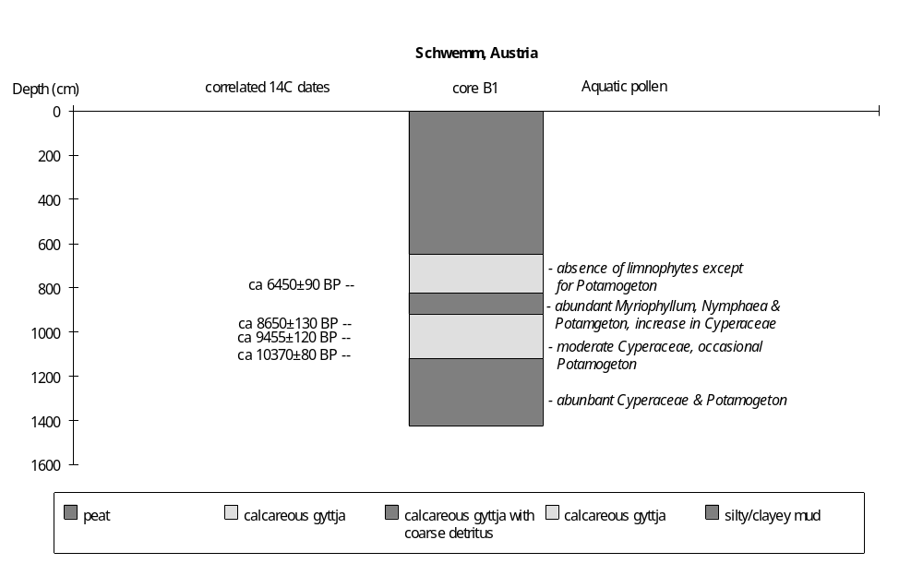

Final coding: September 1991
Coded by: SPH
Aapalampi, Finland

Aapalampi (66°48'N, 28°32'E, 204m above sea level) is a peat bog in the Salla area, northeastern Finland. It is located in a smooth valley in a fjeld (glacial erosion plateau) and was formed after deglaciation of the area (Sorsa, 1965). The peat bog overlies late glacial moraines. The region is covered by Picea and Betula forest and the bog by a Carex limosa and Sphagnum community.

A single 5m-long core taken from the peat bog provides a sedimentary record back to the late glacial (Sorsa, 1965). According to the record, the basin was occupied by a lake after deglaciation of the area during the early Holocene (ca 9200 yr B.P). The lake became overgrown after ca 4200 yr B.P. Changes in water depth during the lacustrine period are reconstructed from changes in lithology and aquatic pollen assemblages. Three samples from the core are radiocarbon-dated (Sorsa, 1965). Two dates are consistent with the regional pollen chronology, but one is too old (Sorsa, 1965; Hyvärinen, 1972). The chronology is based on the two acceptable radiocarbon dates and correlation with the regional pollen chronology.

The basal sediments below 435cm are loam, overlain by silt and sand (415-435cm), and silt and sand with gyttja (415-390cm). The coarse mineral deposits may represent glacial debris. The unit belongs to pollen zones DR3 and PB, before the beginning of the Holocene (Sorsa, 1965; Hyvärinen, 1972).

The overlying sediment (390-348cm) is lacustrine gyttja, suggesting moderately deep water. The aquatic pollen assemblage is characterised by an initial increase in Typha and Sphagnum (385-370cm), followed by a marked increase in Potamogeton (5%, 370-348cm) and the disappearance of Equisetum (375-355cm), consistent with gradually increasing water depth. A sample from the bottom of this unit (390-395cm) is radiocarbon-dated to 9155±400 yr B.P. (I-1141). The upper boundary is dated to ca 7700 yr B.P. by interpolation between radiocarbon dates.

A decrease in water depth after 7700 yr B.P. is indicated by a layer of Carex peat between 348-315cm. A sample from the top of peat is radiocarbon-dated to 6340±170 yr B.P. (310-300cm, I-1488).

The overlying sediment is dy (315-200cm), suggesting a return to deep water. Below ca 260cm, the presence of Nymphaea, Potamogeton and Nuphar suggests moderately deep water. Above ca 260cm, the aquatic pollen assemblage also included by Typha, Myriophyllum, Sparganium and Menyanthes. The increases in Typha and Menyanthes suggest decreased water depth after ca 5400 yr B.P.

The uppermost sediment (above 200cm) is Sphagnum peat with abundant Cyperaceae and Sphagnum pollen. This change probably reflects infilling processes and peat bog development after ca 4200 yr B.P.

In the status coding, low (1) is indicated by peat between lacustrine deposits; intermediate (2) by dy and a pollen assemblage including Typha and Menyanthes; high (3) by dy and a pollen assemblage including Nymphaea, Potamogeton and Nuphar, or gyttja with Potamogeton. Peat deposition after ca 4200 yr B.P. is considered to reflect infilling, and is not coded.

Radiocarbon dates

I-1140 12,350±400 yr B.P. 410-415cm, silty layer. ATO, REJECTED.
I-1141 9155±400 yr B.P. 390-395cm, gyttja.
I-1488 6340±170 yr B.P. 310-300cm, dy.

References

Hyvärinen, H., 1972. Flandrian regional pollen assemblage zones in eastern Finland. Commentationes Biologicae 59: 1-25.
Sorsa, P., 1965. Pollenanalytische untersuchungen zur spätqartären vegetations und klimaentwicklung im östlichen Nordfinland. Annales Botanici Fennici 2: 301-413.

Coding

ca 9200-7700 yr B.P. high (3)
ca 7700-6400 yr B.P. low (1)
ca 6400-5400 yr B.P. high (3)
ca 5400-4200 yr B.P. intermediate (2)
ca 4200-0 yr B.P. infilling, not coded.

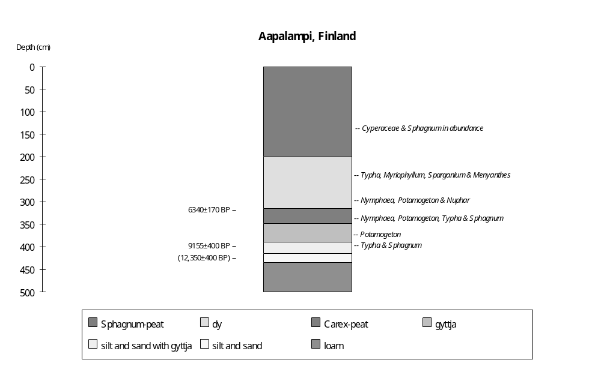

Preliminary coding: 5/5/1994; Final coding: 20/5/1995
Coded by GY and SPH
Ahvenainen, Finland

Lake Ahvenainen (61°02'N, 25°07'E, 122.2m above sea level) is a small (7.8ha), productive, oligotrophic lake (Tolonen, 1978a). The greater part of it less than 10m deep, the mean depth is 5.8m and the maximum depth 18.7m. The lake has no visible inlet or outlet. Water pH values are between 6.2 and 9.3. Phytoplankton production in the upper 5m is 96-68 mgC/m3 day (Tolonen, 1978c). The lake is situated in a kettle-hole depression, located between two terminal moraine systems on an esker sand outwash plain. The catchment area is 34.5ha. The bedrock around the lake is microlite granite, mica gneiss and amphibolite. The lake has been closed since 10200 yr B.P. when it became isolated from the Baltic Ice Lake (Tolonen, 1978a).

Six cores (A, B, C, D, E and F), forming 2 transects (A-B-C-D and A-B-F-E) were taken from the lake (Tolonen, 1978a). Core A (ca 249cm long) and core B (ca 414cm long) were taken in a water depth of 18.5m deep from the centre of the lake. Core C (ca 220cm long from 5m deep) and core F (ca 590cm long from 3.3m deep) were taken in shallow water. Core D (ca 100cm long from 2m deep) and core E (ca 70cm long from 1.7m deep) come from the nearshore zone. The longest core F provides sediment sequence back to over 10000 yr B.P. Lithological, chemical, macrofossil, pollen, diatom and charcoal analyses have been made of the cores (Tolonen, 1978a, b, c). Tolonen (1978c) reconstructs fluctuations in the water level of Lake Ahvenainen. The lake level changes described here are based on changes of lithology, sediment distribution, and biology (aquatics, diatom and moss etc.), and broadly follow those described by Tolonen (1978c). The chronology is based on varve counting back to the Atlantic period (Tolonen, 1978a) and radiocarbon dating for the interval before ca 5000 yr B.P.

The basin lies on gravel (core C, core D and core E). The overlying sediment is sandy varved clay that can be seen in core F (590-550cm). It is missing in the other shallow water or marginal cores, and was not reached in the central cores. This distribution and the coarse nature of the sediment suggest that it was a nearshore lacustrine unit. There are only a few aquatic plant macrofossils, such as three seeds of Ranunculus spp, indicating a shallow water environment. The diatom assemblage contains frequent Campylodicus noricus, Amphore ovalis, A. robusta and Pinnularia borealis, consistent with shallow water. This interval is dated to Younger Dryas period, before ca 10000 yr B.P.

The overlying sediment is a laminated detritus gyttja in core A (0-249+cm) and core B (0-414+cm), grading into a laminated silty detritus gyttja in the shallow water core F (550-420cm), and a non-laminated silty detritus gyttja in nearshore cores C, D and E. The lithology and sediment distribution indicate the lake became deeper.

Biological changes recorded in core F allow this unit to be subdivided. Between 550-540cm, the aquatic assemblage includes Isoetes lacustris, Equisetum, Carex and Typha latifolia. Some species of planktonic diatom, such as Melosira ambigua, Cyclotella kuetzingiana occur. They reflect rising water level between ca 10000 and 9000 yr B.P. In the middle part (540-530cm), littoral diatoms, both benthic and epiphytic taxa, such as Navicula pupula, Nitzschia fonticola and Fragilaria construens are dominant. The decline in planktonics and increase in benthic and epiphytic species suggest that the lake was shallower ca 9000-8000 yr B.P. In the upper part of this unit (530-420cm) the sediment has a clear varved structure. The aquatics include Potamogeton natans and P. pusillus, Nymphaea alba, and Equisetum. Planktonic diatoms such as Cyclotella kuetzingiana, C. iris and Pinnularia spp. increase. The coarse matter value is quite low. Tolonen (1978c) interpreted these changes as indicating a rise in water level ca 8000-6000 yr B.P.

The overlying sediment in both the central cores and the shallow water cores is laminated detritus gyttja. The preservation of laminations indicates deep water. In core F (420-351cm) the aquatic assemblage is characterised by an increase in Potamogeton and Nymphaea alba, consistent with deep water. This interval is dated to between ca 6000 and 4900 yr B.P. (2978 BC, varve date from core A).

After 4900 yr B.P., the lake level fell. This interval is represented by non-laminated detritus gyttja in shallow water and marginal cores (C, D, E and F), although laminated detritus gyttja deposition continued in the central cores. Tolonen (1978c) commented that the disappearance of the laminated sediment in shallow water cores and the appearance of fruit stones in central cores indicate lowering of water level around the Atlantic/sub-Boreal boundary.

In core F, this detritus gyttja has lighter and darker bands. The biological record from this detritus gyttja shows slightly higher water levels initially. Planktonic diatoms such as Epithemia spp. and Cymbella cuspidata are present in the lower part of this unit (351-300cm), suggesting moderately deep water ca 4900-2800 yr B.P. In the upper part of the unit (351-300cm), there are abundant Potamogeton natans fruit stones and Najas flexilis seeds. The maximum depth of Potamogeton natans is 2.5m to 6m (Jalas, 1958; Maristo, 1941), suggesting that water depth was low. Moreover, there are four thin moss layers within the detritus gyttja (304-230cm). The moss layers contain mainly Drepanocladus, which commonly occurs at a depth of < 2m in mesotrophic and eutrophic lakes (Koponen, 1977). Tolonen (1978c) suggests a frequently minor lowering of water level since ca 2800 yr B.P.

There is a layer of lake mud in core F (above 30cm). It reflects decreased water depth since ca 270 yr B.P., mainly due to human activity (Tolonen, 1978a). There is now 3.3m of water at the nearshore coring site (core F), and the sediment still consists of laminated detritus gyttja in the central cores (A and B), suggesting a moderately deep water in the recent past.

In the status coding, very low (1) is indicated by detritus gyttja with moss layers; low (2) by sandy varved clay with diatoms from shallow water; intermediate (3) by detritus gyttja with planktonic diatoms, or laminated silty detritus gyttja with benthic and epiphytic diatoms; high (4) by laminated silty detritus gyttja with abundant planktonic diatoms in the central cores; very high (5) by laminated detritus gyttja in both the shallow water and central cores.

Radiocarbon dates

Su-690 800±100 64-69cm, laminated detritus gyttja, core A
Su-691 970±100 86.5-89cm, laminated detritus gyttja, core A
Su-692 1470±100 101.5-104cm, laminated detritus gyttja, core A
Su-693 2010±100 114-116.5cm, laminated detritus gyttja, core A
Su-722 2080±100 133-140cm, laminated detritus gyttja, core A
Su-723 2300±100 144.5-154.5cm, laminated detritus gyttja, core A
Su-724 2770±100 167-174cm, laminated detritus gyttja, core A
Su-695 3440±100 184-189cm, laminated detritus gyttja, core A
Su-698 3290±100 189-194cm, laminated detritus gyttja, core A
Su-696 3550±100 201-206cm, laminated detritus gyttja, core A
Su-701 4040±100 223-226cm, laminated detritus gyttja, core A
Su-702 4450±100 236-241cm, laminated detritus gyttja, core A
Su-700 4820±100 252-254cm, laminated detritus gyttja, core B

References

Maristo, L., 1941. Die Seetypen Finnlands auf floristischer und vegetationsphysignomisher Grundlage. Annales Botanici Societatis Zoologicae-Botanicae Fennicae Vanamo 15: 1-314.
Jalas, J. 1958. Suuri kasvikirja. Helsinki. pp 851.
Koponen, T. 1977. Drepanocladus tenuinervis, a new moss from Finland. Memoranda Society Fauna Flora Fennica 53: 9-13.
Tolonen, M. 1978a. Paleoecology of annually-laminated sediments in Lake Ahvenainen, South Finland. I: Pollen and charcoal analysis and their relation to human impact. Annales Botanici Fennici 15: 177-208.
Tolonen, M. 1978b. Paleoecology of annually-laminated sediments in Lake Ahvenainen, South Finland. II: Comparison of dating methods. Annales Botanici Fennici 15: 209-222.
Tolonen, M. 1978c. Paleoecology of annually-laminated sediments in Lake Ahvenainen, South Finland. III: Human influence on lake development. Annales Botanici Fennici 15: 223-250.

Coding

pre 10000 yr B.P. low (2)
ca 10000-9000 yr B.P. high (4)
ca 9000-8000 yr B.P. intermediate (3)
ca 8000-6000 yr B.P. high (4)
ca 6000-4900 yr B.P intermediate (3)
ca 2800-270 yr B.P. very low (1)
ca 270-0 yr B.P. intermediate (3)

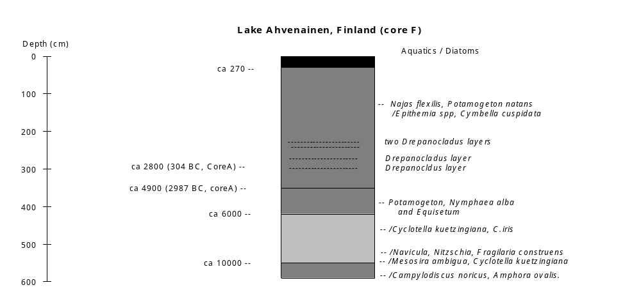

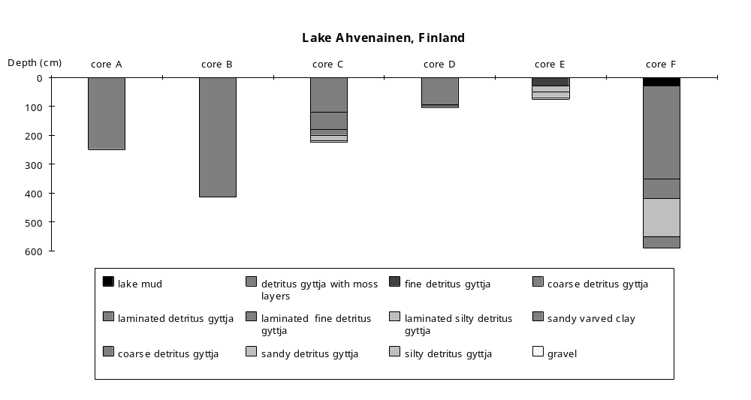

Preliminary coding: 4/6/1993; Final coding: 29/7/1993. Coded by: SPH and GY
Hakojärvi, Finland

Lake Hakojärvi (61°15'N, 25°12'E, 145.6m above sea level) is a dimictic polyhumic oligotrophic lake located in southern Finland. The lake area is 17.3ha with a maximum depth of 16.3m and a mean depth of 4.9m. There is a inflow on the northern shore and a outflow to the south. The catchment area is ca 180ha, and includes 40ha of peatland and two small lakes. The pH of the lake is 6.2-6.5, the transparency is 1.5m, and the specific conductivity is 40-50 µS (Lehmusluoto and Ryhänen, 1972). Aquatic vegetation is poorly developed, consisting mainly of Nuphar and Nymphaea (Tikkanen, 1972). Planktonic production is very low, about 5-8 C/m2 yearly (Huttunen et al., 1978). Hakojärvi is a kettle hole lake. The basin is situated in a transition geological zone between gneiss and granite areas, and is covered with moraine (Huttunen et al., 1978).

Three cores (A, B, C) from the lake provide a sedimentary record back to ca 9400 yr B.P. (Huttunen et al., 1978). Core A was taken from shallow water (ca 2m deep), cores B and C (ca 10m apart) came from the centre of the lake (over 16m deep). Huttunen et al. (1978) reconstructed fluctuations in water level since ca 9400 yr B.P. The lake-level changes described here amplify the descriptions by Huttunen et al. (1978), and are based on changes in lithology, geochemistry, diatom and aquatic pollen assemblages. There are 15 radiocarbon dates from core C. However, only three dates are consistent with the regional pollen chronology and with radiocarbon datings of peat samples from southern Finland (Huttunen et al., 1978). The chronology is therefore based on these three radiocarbon dates (Hel-283, Hel-284 and Hel-324) and the regional pollen chronology (from Tolonen and Runhijärvi, 1976).

The basal sediment (below 5.0m in core B) is silt, suggesting shallow water deposited in nearshore conditions. The diatom assemblage is dominated by benthic forms (e.g. Frustulia rhomboides). The unit is absent from the littoral zone (core A). Huttunen et al. (1978) interpret the benthic diatom assemblage and the low sediment limit as indicating very shallow water before 9400 yr B.P.

The overlying sediment (ca 4.7-5.0m in core B) is fine detritus gyttja, indicating deeper water than before. The unit extends across the whole basin, consistent with increased depth. A decline in sedimentation rate (0.01 cm/yr) is consistent with this interpretation. Huttunen et al. (1978) interpret this unit as indicating a rise in water level, ca 9400-8200 yr B.P.

The overlying sediment in core B (4.4-4.7m) is coarse detritus gyttja with increased organic content and increased sedimentation rate (0.12 cm/yr), suggesting the lake became shallower. Huttunen et al. (1978) consider that the aquatic macrophyte assemblage, characterised by Potamogeton berchtholdii and Naias flexilis, and the decrease in planktonic diatoms indicate high productivity and increased erosion. These features are also consistent with shallow water ca 8200-7400 yr B.P.

The overlying sediment (4.4-0m in core B) is dy, suggesting moderately deep water. Biological changes allow the unit to be subdivided.

Between 3.5-4.4m, there is increased organic content and high influx of elements (Fe, Mg, Ca). Huttunen et al. (1978) interpret these changes as reflecting erosion in the basin ca 7400-6400 yr B.P. The diatom assemblage is characterised by the dominance of benthic diatoms and a decrease in the abundance of planktonic diatoms, consistent with shallowing.

Between 2.2-3.5m, planktonic diatoms (Cyclotella comta, C. kuetzingiana and Melosira ambigua) are dominant, suggesting an increase in water depth ca 6400-4700 yr B.P. The low sedimentation rate (0.07 cm/yr), is consistent with this interpretation.

The overlying sediment (0.8-2.2m) still has a predominantly planktonic diatom assemblage, but benthic diatoms increase in abundance, indicating a slight decrease in water depth. A decrease in sedimentation rate (0.02 cm/yr) suggests only moderately deep water between 4700 and 1200 yr B.P.

The uppermost dy (0-0.8m) is characterised by increased coarse matter, and an increase in benthic and decrease in planktonic diatoms, suggesting lower water level during last 1200 years. Huttunen et al. (1978) suggest this reflects human impact. The lake still has a water depth of over 16m in the centre.

In the status coding, low (1) is indicated by silt, dominance of benthic diatoms, and low sediment limit; moderately low (2) by coarse detritus gyttja with abundant aquatic macrophytes; intermediate (3) by dy with moderate organic value or low abundances of planktonic diatoms; moderately high (4) by dy with both benthic and planktonic diatoms, and low sedimentation rates; high (5) by fine detritus gyttja with a high sediment limit; or dy with planktonic diatoms dominant. The record after 1200 yr B.P. is assumed to reflect human impact and is coded accordingly.

Radiocarbon dates

Hel-232 570±130 yr B.P. 21-32cm, dy core C, error suspected.
Hel-233 960±130 yr B.P. 144-155cm, dy core C, error suspected.
Hel-236 1200±140 yr B.P. 155-166cm, dy core C, error suspected.
Hel-283 4190±140 yr B.P. 205-215cm, dy core C
Hel-301 4540±140 yr B.P. 205-215cm, dy core C, error suspected.
Hel-234 730±160 yr B.P. 246-257cm, dy core C, error suspected.
Hel-236 5030±180 yr B.P. 287-298cm, dy core C, error suspected.
Hel-284 5900±150 yr B.P. 355-370cm, dy core C
Hel-302 5980±160 yr B.P. 355-370cm, dy core C, error suspected.
Hel-237 4420±200 yr B.P. 358-369cm, dy core C, error suspected.
Hel-238 4620±220 yr B.P. 458-476cm, dy core C, error suspected.
Hel-324 7250±220 yr B.P. 475-490cm, dy core C
Hel-333 6620±230 yr B.P. 475-490cm, dy core C, error suspected.

References

Huttunen, P., Meriläinen, J. and Tolonen, K., 1978. The history of a small dystrophied forest lake, southern Finland. Polskie Archiwum Hydrobiologii 25: 189-202.
Lehmusluoto, P. and Ryhänen, R., 1972. Lake Hakojärvi, a polyhumic lake in Southern Finland. Verhandlugen Internationale Vereinigung Limnologie 18: 403-408.
Tikkanen, T., 1972. Uber die höheren Wasserpflanzen des polyhumosen Sees Hakojärvi. Memoranda Societatis pro Fauna et Flora Fennicica 48: 55-61.
Tolonen, K. and Runhijärvi, R., 1976. Standard pollen diagrams from the Salpausselkä region of Southern Finland. Annnales Botannici Fennici 13: 155-196.

Coding

- ca 9400 yr B. P. low (1)
ca 9400-8200 yr B.P. high (5)
ca 8200-7400 yr B.P. moderately low (2)
ca 7400-6400 yr B.P. intermediate (3)
ca 6400-4700 yr B.P. high (5)
ca 4700-present. moderately high (4)

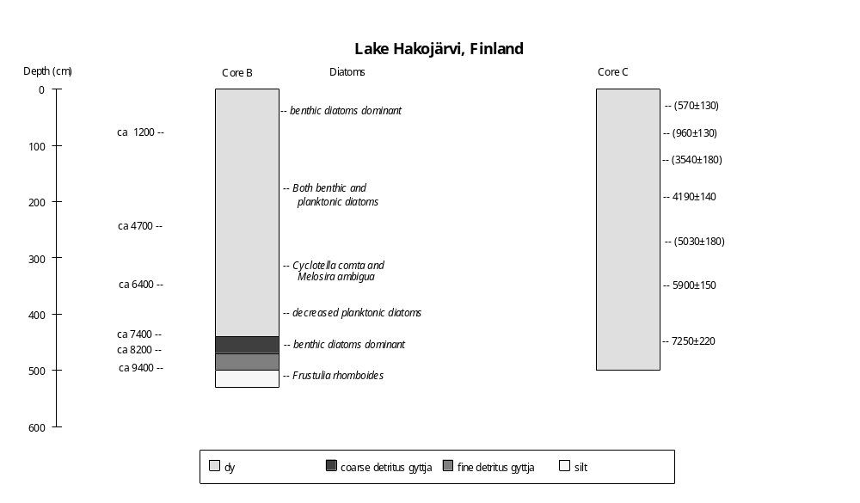

Preliminary coding: 28/6/1993; Final coding: 24/2/1992
Coded by GY and SPH

Isohattu, Finland

Isohattu (68°38'30"N, 23°36'24"E, 386m above sea level) is a small lake in western Finnish Lapland. The lake has an area of ca 6-7ha and water depth of less than 5m (Hyvärinen and Alhonen, 1994). There are no surface inflows but the lake drains westwards via an outlet stream to the lake Tuorkottajajärvi. Isohattu lies in a shallow, flat-bottomed basin in glaciofluvial sediments. The bedrock in the catchment is granite with amphibolites. The area was deglaciated in the early Holocene between 10,000 and 9000 yr B.P. (Hyvärinen, 1973).

A core, taken from a depth of 3m near the lake centre, provides a sedimentary record back to ca 9000 yr B.P. (Hyvärinen and Alhonen, 1994). Hyvärinen and Alhonen (1994) state that the lakes in this area are surface expressions of the groundwater table and hence are sensitive to changes in hydrological budget. They reconstruct lake-level changes in the Holocene on basis of changes in lithology, diatom and cladoceran assemblages. The chronology is based on five radiocarbon dates (Hyvärinen and Alhonen, 1994). The record of changes in relative depth presented here follows their reconstruction.

The basal sediments (below ca 2.3m) are sand and sandy silt. The unit may represent glacial debris deposited before ca 9000 yr B.P.

The overlying sediment (2.2-2.3m) is a thin layer of silty gyttja and gyttja, suggesting deep water. There are abundant Pediastrum boryanum and planktonic/meroplanktonic diatoms (Aulacoseira spp.), consistent with deep water. A sample from 2.10-2.25m, near the top of this unit, is radiocarbon dated to 7710±120 yr B.P.

The overlying sediment (above 2.2m) is coarse detritus mud, suggesting a decrease in water depth. Hyvärinen and Alhonen (1994) divide this unit into two intervals based on changes in the diatom and cladoceran assemblages.

The basal part of the unit (2.2-1.6m) is characterised by a reduction in planktonic species, and an increase in littoral and epiphytics species. The cladoceran assemblage is characterised by the disappearance of Bosmina and an increase in Alona affinis. The diatom assemblage is characterised by a decrease in Aulacoseira spp. and an increase in Eunotia. The culmination of the shallowing is characterised by a maximum in Eunotia (50% in ca 1.6-2.0m), suggesting paludification of the basin margins between 6200 and 3800 yr B.P., which is estimated by sedimentation rate based on the radiocarbon dates (Hel-3239, Hel-3240 and Hel-3241). Hyvärinen and Alhonen (1994) argue that the low sedimentation rate (ca 0.1-0.2 mm/yr) and compactness of the lowermost organic sediments also suggest dry conditions during the early and mid-Holocene.

An increase in water depth after ca 3800 yr B.P. (above ca 1.6m) is indicated by an increase in planktonic cladoceran and diatom species. In the cladoceran assemblage, Bosmina spp. increases at the expense of Chydorus spp. and Alonella. This coincides with a decrease in littoral diatoms, such as Eunotia, and an increase in e.g. Aulacoseira distans, Cymbella, Navicula and Tabellaria. Accelerated rates of sedimentation (ca 0.5-0.6 mm/yr) are consistent with increased depth (Hyvärinen and Alhonen, 1994).

In the status coding, low (1) is indicated by coarse detritus mud with maximum values of Eunotia; intermediate (2) by coarse detritus mud with abundant planktonic Cladocera and diatoms; high (3) by gyttja and silty gyttja with planktonic diatoms dominant.

References

Hyvärinen, H. 1973. The deglaciation history of eastern Fennoscandia - recent data from Finland. Boreas 2: 285-99.
Hyvärinen, H. and Alhonen, P. 1994. Holocene lake-level changes in the Fennoscandian tree-line region, western Finnish Lapland: diatom and cladoceran evidence. The Holocene 4: 251-258.

Radiocarbon dates

Hel-3237 1330±110 0.50-0.65m detritus mud
Hel-3238 2030±120 0.90-1.05m detritus mud
Hel-3239 3020±100 1.30-1.45m detritus mud
Hel-3240 4390±140 1.70-1.85m detritus mud
Hel-3241 7710±120 2.10-2.25m detritus mud

Coding

ca 9000-7710 yr B.P. high (3)
7710-3800 yr B.P. low (1)
3800-0 yr B.P. intermediate (2)

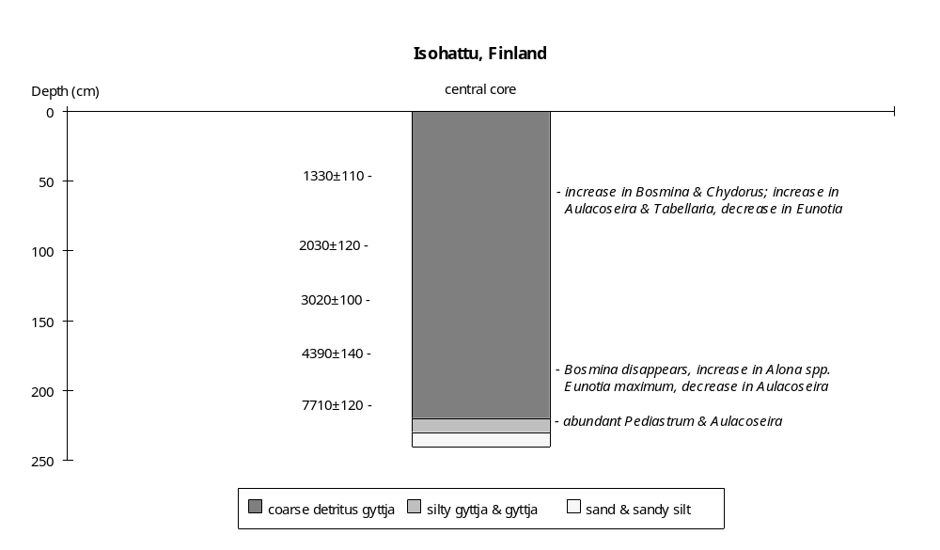

Preliminary coding: 10/11/1994; Final coding: 28/11/1994
Coded by GY and SPH

Jierstivaara, Finland

Jierstivaara (68°40'N, 23°44'E, 456m above sea level) is a small lake in western Finnish Lapland. The lake has an area of ca 6-7ha and a water depth of less than 5m (Hyvärinen and Alhonen, 1994). There is no channelled inflow into the lake and no surface outlet. The lake lies in a shallow, flat-bottomed basin in glaciofluvial sediments. The bedrock in the catchment is granite with amphibolites. The area was deglaciated in the early Holocene between 10,000 and 9000 yr B.P. (Hyvärinen, 1973).

A core, taken from a depth of 2.5m near the lake centre, provides a sedimentary record back to ca 9000 yr B.P. (Hyvärinen and Alhonen, 1994). Hyvärinen and Alhonen (1994) state that the lakes in this area are generally closed-basin expressions of the groundwater table and hence sensitive to changes in hydrological budget. Hyvärinen and Alhonen (1994) reconstruct lake-level changes in the Holocene on the basis of changes in lithology, diatom and cladoceran assemblages. The chronology is based on six radiocarbon dates (Hyvärinen and Alhonen, 1994). The reconstruction presented here follows their reconstruction.

The basal sediments (below ca 3.05m) are sand and sandy silt. The unit may represent glacial debris deposited before ca 9000 yr B.P. The overlying sediment (2.85-3.05m) is silty gyttja and gyttja, suggesting deep water. The cladoceran assemblage is characterised by dominance of Bosmina spp. (ca 70%), consistent with deep water. There are abundant planktonic/meroplanktonic diatoms (Aulacoseira spp.), consistent with deep water. A sample from the top of this unit (2.85-2.95m) is radiocarbon dated to 7630±150 yr B.P.

The overlying sediment (above 2.85m) is coarse detritus mud, rich in moss remains, suggesting a decrease in water depth. Based on changes in diatom and cladoceran assemblages, Hyvärinen and Alhonen (1994) divide this unit into two intervals.

The basal part of the unit (2.85-2.10m) is characterised by a reduction in planktonic species and an increase in littoral species. The cladoceran assemblage is characterised by the disappearance of Bosmina and an increase in Alonella spp. The diatom assemblage is characterised by a decrease in Aulacoseira and an increase in epiphytics. The culmination of the shallowing is characterised by a maximum in Eunotia, suggesting paludification of the basin margins between 5000 and 6000 yr B.P. A maximum estimate of the lowest lake level would be 4-5m below the present level (Hyvärinen and Alhonen, 1994). Hyvärinen and Alhonen (1994) argue that the low sedimentation rate (ca 0.1-0.2 mm/yr) and compactness of the lowermost organic sediments also suggest dry conditions during the early and mid-Holocene.

An increase in water depth after ca 4000 yr B.P. (above ca 2.10m) is indicated by an increase in planktonic cladoceran and diatom species. In the cladoceran assemblage, Bosmina spp. increases at the expense of e.g. Alonella spp., Chydorus spp. and Alona spp. This coincides with a decrease in littoral diatoms, such as Eunotia, and an increase in e.g. Frustulia spp. and Cymbella spp. Accelerated rates of sedimentation (ca 0.5-0.6 mm/yr) are consistent with increased depth (Hyvärinen and Alhonen, 1994).

In the status coding, low (1) is indicated by coarse detritus mud with maximum values of Eunotia, and low values of planktonic Cladocera and diatoms; intermediate (2) by coarse detritus mud with dominance of planktonic Cladocera and diatoms; high (3) by gyttja and silty gyttja with planktonic diatoms dominant.

References

Hyvärinen, H. 1973. The deglaciation history of eastern Fennoscandia - recent data from Finland. Boreas 2: 285-99.
Hyvärinen, H. and Alhonen, P. 1994. Holocene lake-level changes in the Fennoscandian tree-line region, western Finnish Lapland: diatom and cladoceran evidence. The Holocene 4: 251-258.

Radiocarbon dates

Hel-3167 1220±120 0.50-0.65m detritus mud
Hel-3166 1510±130 1.10-1.25m detritus mud
Hel-3165 3250±130 1.75-1.90m detritus mud
Hel-3164 5270±140 2.35-2.50m detritus mud
Hel-3163 6230±160 2.60-2.75m detritus mud *
Hel-3162 7630±150 2.85-2.95m silty gyttja
* The date is given as 6320±160 on diagram (Figure 3, Hyvärinen and Alhonen, 1994); assumed to be incorrect.

Coding

ca 9000-7630 yr B.P. high (3)
7630-4000 yr B.P. low (1)
4000-0 yr B.P. intermediate (2)

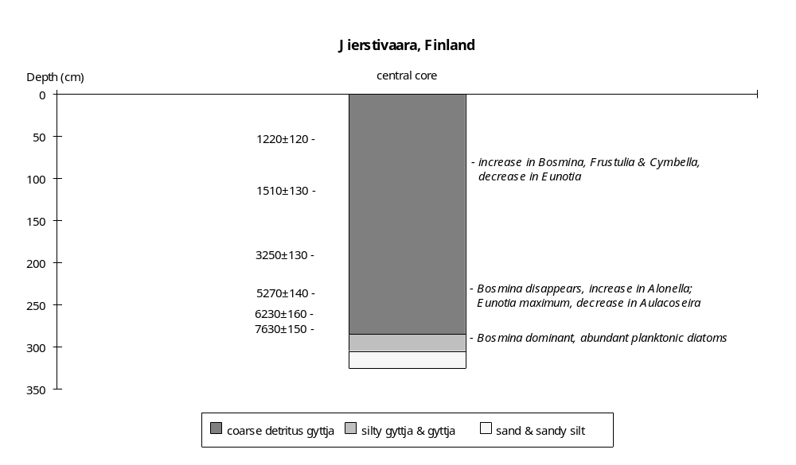

Preliminary coding: 10/11/1994; Final coding: 28/11/1994
Coded by GY and SPH

Kaunispää, Finland

Kaunispää (68°25'N, 27°25'E, 300m above sea level) is a peat bog in the Salla area, northeastern Finland. It is located in a valley on a fjeld (glacial erosion plateau) and was formed after deglaciation of the area (Sorsa, 1965). The peat bog overlies late glacial moraines. A stream from the basin flows eastwards to the River Lutto. The region is covered by Betula and Picea forest and the bog by a Sphagnum-Carex community.

The stratigraphy of the lacustrine deposits has been reconstructed from four cores along an east-west transect across the peat bog (Sorsa, 1965). Two cores were taken from the western part of the peat bog (27°25'E): one is 2.8m-long (XXVI) and the other 3.2m-long (XXV). Two cores were taken from the eastern part of the peat bog: one is 1.9m-long (XXVIII, 27°26'E) and the other 1.2m-long (XXVII, 27°27'E). The basin was occupied by a lake after deglaciation of the area during the early-Holocene, ca 9000 yr B.P (Sorsa, 1965), and then became progressively infilled from the west to the east from the early Atlantic to the Subboreal. Changes in water depth during the initial lacustrine period are reconstructed from changes in lithology and aquatic pollen assemblages. Three samples from core XXV are radiocarbon dated (Sorsa, 1965). The dates are consistent with the regional pollen chronology (Sorsa, 1965; Hyvärinen, 1972). The chronology is based on the radiocarbon dates.

The basal sediments (below 270cm in XXVI, below 290cm in XXV and below 180cm in XXVIII) are sands. These coarse mineral deposits probably represent glacial debris.

The overlying sediment is fine sandy detritus gyttja in the deepest basin (290-270cm in core XXV), with loam deposits in the lateral basin (260-270cm in core XXVI, and 180-170cm in core XXVIII), suggesting shallow water in the initial lake. The aquatic assemblage (core XXV) is characterised by abundant Menyanthes, Equisetum and Sparganium, and sparse Potamogeton, consistent with shallow water. A sample from the top of the sandy detritus gyttja (272-280cm in core XXV) is radiocarbon-dated to 8530±120 yr B.P. (B-566). Extrapolation of the sedimentation rate (0.039 cm/yr) from the overlying unit suggests that the formation of the fine sandy gyttja began ca 9000 yr B.P.

A change to detritus gyttja in core XXVI (260-250cm) and to gyttja in core XXVIII (170-155cm), with continued fine sandy detritus gyttja in core XXV, implies an extension of the lake and an increase in water depth. The aquatic assemblage (cores XXVI and XXVIII) is characterised by Sparganium. The absence of Menyanthes and Equisetum is consistent with increased water. This unit belongs to the early Boreal pollen zone (270-245cm in core XXVI and 170-155cm in core XXVIII), and is dated to ca 8800-8600 yr B.P.

A decrease in water depth is characterised by peat deposition in the western lake (250-245cm in core XXVI), with continued lacustrine deposits in the rest of the lake (fine sandy detritus gyttja in core XXV and gyttja in core XXVIII). The synchronous changes in cores XXV (270-280cm) and XXVIII (160-150cm) are marked by an increase in Menyanthes. This interval with shallow water conditions belongs to the uppermost part of the early Boreal pollen zone, and is dated to ca 8600-8400 yr B.P.

The overlying sediment is detritus gyttja in three cores (200-270cm at XXV, 245-200cm at XXVI and 110-90cm at XXVII), and dy in core XXVIII (155-42cm). The deposition of lacustrine sediments over the entire lake, indicates the lake became much bigger, implying deep water conditions. The change from peat to gyttja in core XXVI and disappearance of sand in core XXV also suggest an increase in water depth. The disappearance of Menyanthes in core XXV (200-270cm) is consistent with an increase in water depth. A slight decrease in sedimentation rate from 0.039 to 0.036 cm/yr (above 245cm in core XXV) is also consistent with this interpretation. A sample from the unit (240-250cm) is radiocarbon-dated to 7740±200 yr B.P. (B-567).

There is a time-transgressive transition from lacustrine to peat bog conditions beginning ca 7500 yr B.P. In the western sub-basin, the transition to lake peat and then Carex-Sphagnum peat (above 180cm in core XXVI and above 170cm in core XXV) occurred between ca 7500 and 6500 yr B.P. During this interval, open-water conditions persisted in the eastern sub-basin and are represented by the deposition of diatomaceous gyttja (70-90cm in core XXVII) and dy (below 42cm in core XXVIII). The transition to Carex-Sphagnum peat in the eastern sub-basin (above 42cm in core XXVIII and above 75cm in core XXVII) occurred ca 3300 yr B.P. The transition to peat bog conditions may reflect natural infilling and hydroseral development. However, the long interval during which lacustrine conditions persisted in the eastern basin, suggests that the transition to peat formation in the western basin may have been initiated by shallowing.

In the status coding, low (1) is indicated by peat between lacustrine deposits in the western lake, with abundant Menyanthes in the lake centre; moderately low (2) by fine sandy detritus gyttja over the whole lake, with abundant Menyanthes, Equisetum and Sparganium; intermediate (3) by detritus gyttja in the lake centre, fine sandy detritus gyttja in the western lake; moderately high (4) by dy and diatomaceous gyttja in the eastern lake, peat deposition in the western lake; high (5) by dy or detritus gyttja over the whole lake. Peat deposition in the eastern basin after ca 3300 yr B.P. is considered to reflect infilling, and is not coded.

Radiocarbon dates

B-568 2180±120 yr B.P. 40-50cm, Carex-Sphagnum peat.
B-567 7740±200 yr B.P. 240-250cm, detritus gyttja.
B-566 8530±120 yr B.P. 272-280cm, fine sandy detritus.

References

Hyvärinen, H., 1972. Flandrian regional pollen assemblage zones in eastern Finland. Commentationes Biologicae 59: 1-25.
Sorsa, P., 1965. Pollenanalytische Untersuchungen zur spätquartären Vegetations und Klimaentwicklung im östlichen Nordfinnland. Annales Botanici Fennici 2: 301-413.

Coding

9000-8800 yr B.P. moderately low (2)
8800-8600 yr B.P. intermediate (3)
8600-8400 yr B.P. low (1)
8400-7500 yr B.P. high (5)
7500-3300 yr B.P. moderately high (4)
3300-0 yr B.P. infilling, not coded
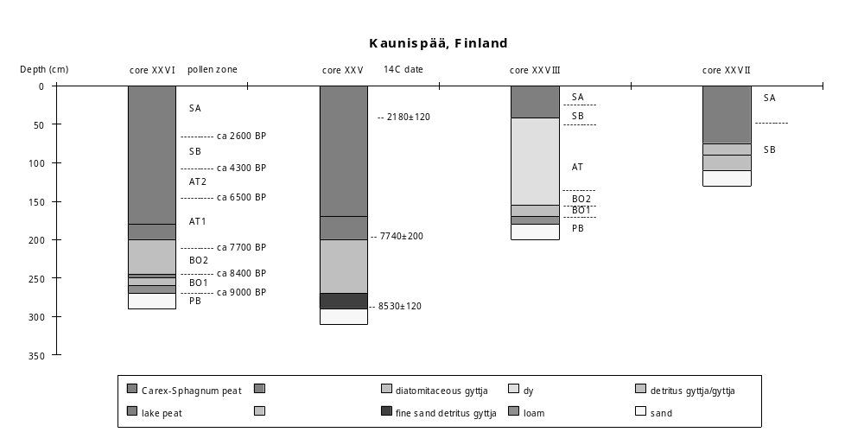 Preliminary coding: 6/3/1994;Final coding: 22/5/1994. Coded by GY and SPH
Kissalammi, Finland

Kissalammi (61°17'N, 24°21'E, 90.4m above sea level) is a small lake situated in the Finnish Lake District of Pälkäne, southern Finland. The lake has an area of 4.7ha, a mean depth of 8.7m and a maximum depth of 15m. It is eutrophic with pH values of 6.6-6.9 and conductivity of 94 - 114 µS 20°/cm2 (Tolonen, 1981). The lake lies in a circular kettle hole with steep sides (Tolonen, 1981, 1984). There is no inflow stream, but the lake overflows along a ditch on the eastern side. The deglaciation of the region took place somewhat before 10,200 yr B.P., and the basin was isolated from the sea in the early Holocene, ca 8000 yr B.P. (Tolonen, 1984). There are shore lines higher than the modern level, indicating that the lake was formerly deeper than today (Tolonen, 1984).

The stratigraphy of the lake deposits has been reconstructed from a transect of five cores across the lake (Tolonen, 1984). Three shallow water cores (core 1: 0.6m-long from a water depth of 5.0m; core 2: 1.75m-long from a water depth of 7.5m; core 3: 1.98m-long from a water depth of 4.5m), and two laminated cores from the centre of the lake (core 4-a: 1.60m-long from a water depth of 15m; and core 4-b: 2.15m-long from a water depth of 14.1m), provide a sedimentary record back to ca 8000 yr B.P. (Tolonen, 1981, 1984). Core 4-a has been used for varve and pollen studies (Tolonen, 1981). Changes in water depth are reconstructed from changes in lithology, aquatic macrofossil assemblages, and lamination structures. Varve counts from core 4-a indicate that the laminated sediment record covers the last 5500 years (Tolonen, 1981). There are also three radiocarbon dates from core 4-a (Tolonen, 1981). One of the radiocarbon dates is ca 600-800 years too old according to the annual varves (Tolonen, 1981). The chronology is therefore based on annual varve counts and two radiocarbon dates in the late Holocene, and pollen correlations for the early part of the record.

The basal sediments are sand and gravel (below 215cm in core 4-b, below 175cm in core 2), grading to silty clay (215-190cm in core 4-b, 175-170cm in core 2, below 198cm in core 3 and below 60cm in core 1 and). These units were deposited before the lake became isolated, ca 8000 yr B.P. (Tolonen, 1984).

The overlying sediment is fine detritus gyttja (190-180cm in core 4-b, 198-190cm in core 3, and 170-165cm in core 2). In the central core, there are laminations at 184-188cm. These sediments mark the onset of lacustrine conditions in the basin, and suggest moderately deep water. Aquatic pollen is sparse. The upper boundary of this unit is dated to ca 7200 yr B.P. by extrapolation of sedimentation rate (0.01 cm/yr) from the overlying unit with varve and radiocarbon dates.

The overlying sediments are laminated detritus gyttja in the centre of the lake (180-140 in core 4-b, probably below 140cm in core 4-a) grading to detritus gyttja towards the margin (190-120cm in core 3, 165-80cm in core 2 and 60-10cm in core 1). The preservation of laminations indicates deep water conditions. The very low sedimentation rate (<0.05 cm/yr) in core 4-a below 140cm is consistent with deep water conditions. In the lower part of this unit in the marginal cores (cores 1 and 2), there are finer and silty grains, and the aquatic macrofossil assemblage is characterised by abundant Nuphar luteum (190-160cm in core 3 and 170-130cm in core 2), consistent with increased water depth. The upper boundary of this unit is dated to ca 4300 yr B.P., based on the increase of Picea in cores 4-b and 4-a, and varve-counting on core 4-a.

The change from laminated detritus gyttja to laminated coarse detritus gyttja in the central part of the lake (ca 140-95cm in core 4-a), and the increasing coarseness of the detritus gyttja (core 1) in the lake margin, implies decreased water depth. An increase in sedimentation rate from 0.05 to 0.01 cm/yr above 135cm in core 4-a is consistent with decreased depth. The abundance of Bryales remains in core 3 is consistent with shallowing. Between 160-110cm in core 3 and 130-80cm in core 2, the disappearance of Nuphar luteum and marked decrease in aquatic macrofossils probably indicates decreased water depth. There are two radiocarbon from this unit: 3060±120 yr B.P. (Hel-1108, 125-130cm) and 3940±120 yr B.P. (Hel-1107, 141-145cm). These dates are consistent with varve-dating which places the unit between ca 4300-1450 yr B.P.

An increase in water depth after 1450 yr B.P. is indicated by deposition of clay gyttja at the lake margin (above 120cm in core 3, above 80cm in core 2 and above 10cm in core 1). Somewhat clayey and silty laminated coarse detritus gyttja was deposited in the centre of the lake (above 95cm in core 4-a). The aquatic macrofossil assemblage from core 3 is characterised by increases in Potamogeton natans, Nuphar luteum and Sparganium emersum, consistent with increased water depth.

In the status coding, low (1) is indicated by laminated coarse detritus gyttja in the lake centre and coarser detritus gyttja at the lake margins, with remains of Bryales peat; intermediate (2) by laminated fine detritus gyttja in the centre and fine detritus gyttja in the lake margins; moderately high (3) by laminated coarse detritus gyttja in the centre, and clay gyttja in the lake margin, with increase in Potamogeton natans, Nuphar luteum and Sparganium emersum; high (4) by laminated detritus gyttja in the lake centre and finer detritus gyttja in the lake margins, with abundant Nuphar luteum. The coding begins after the lake was isolated from the Baltic Sea, ca 8000 yr B.P.

Radiocarbon dates
Hel-1109 2400±110 100-105cm, coarse detritus gyyja core 4-a ATO
Hel-1108 3060±120 125-130cm, coarse detritus gyyja core 4-a.
Hel-1107 3940±120 141-145cm, coarse detritus gyyja core 4-a.

Varve counts
ca 5850-4850 yr B.P. 160-150cm, core 4-a.
ca 3950 yr B.P. 147-143cm, core 4-a.
ca 3250-2950 yr B.P. 130-122cm, core 4-a.
ca 2550-1500 yr B.P. 117-100cm, core 4-a.
ca 1500-500 yr B.P. 100-70cm, core 4-a.
ca 500-15 yr B.P. 70-10cm, core 4-a.

References
Sauramo, M., 1958. Die geschichte der Ostsee. Annales Academiae Scientiarum Fennicae A, III, 51: 1-522.
Tolonen, M. 1981. An absolute and relative pollen analysis study on prehistoric agriculture in South Finland. Annales Botanici Fennici 18: 213-220.
Tolonen, M. 1984. Differences in pollen and macrophytic remains in sediments from various depths in a small kettle-hole lake in southern Finland. Boreas 13: 404-412.

Coding
ca 8000-7200 yr B.P. intermediate (2)
ca 7200-4330 yr B.P. high (4)
ca 4300-1450 yr B.P. low (1)
ca 1450-0 yr B.P. moderately high (3)
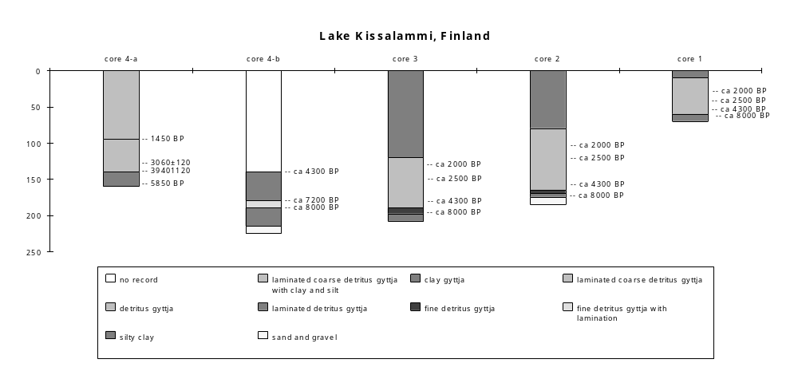
Preliminary coding: 13/5/1994; Final coding: 20/5/1995. Coded by GY and SPH
Kyrösjärvi, Finland

Kyrösjärvi (61°45'N, 23°10'E, 83m above sea level) is the biggest lake of the Ikaalinen watercourse of Finland, approximately 36km long and 5 km broad basin (ca 18,000ha) with several long bays. The maximum water depth is 48m. The lake receives additional water from the middle-sized lakes of Northern Satakunta. And its outlet goes through the rapids of Kyröskoski to Kirkkoselkä and beyond to the Kokemäki river. The lake was artificially lowered in 1865. The pH value in water is 5.9-6.5 and conductivities 33-51µS. The Precambrian bedrocks in the basin are gneiss, peridotites, gabbros, diorites and granites.

There are 29 cores from the lake, forming 7 transects (Alhonen, 1967). Five cores (core 5, 20m water deep; core 29, 6m water deep; and 4 near shore cores: core 16, core 14 and core 8) have been used for pollen analysis. Core 14, ca 6m long taken from the shore of Peltosaari at a place where the depth of water is 0.5m, also provides a diatom, cladoceran, lithological and chemical record. The sediment sequence from all of the cores is generally similar although the thickness of individual units varies. Changes of water depth after the lake was isolated from the Baltic Sea (ca 8000 yr B.P.) are based on changes in lithology, geochemistry, and diatom, aquatic pollen and cladoceran assemblages. The chronology is based on the regional pollen stratigraphy and correlation with the radiocarbon-dated site Sarkkianjärvi (61°45'N, 23°06'E) which lies about 5km east of Kyrösjärvi (Alhonen, 1967).

The lacustrine sediment lies on till (below 5.9m in core 14). The overlying sediment (2.4-5.9m in core 14) is clay. The diatom assemblages shows that this unit was formed when the lake was still connected to the Baltic Sea (Alhonen, 1967).

The overlying sediment (2.4-1.8m deep in core 14, 1.24-1.02m deep in core 5, 1.10-0.55m deep in core 29, 0.63-0.55m deep in core 8, and 0.5-0.45m deep in core 16) is clay gyttja formed after the lake was isolated from the Baltic Sea ca 8000 yr B.P. The occurrence of this unit in both deepwater and nearshore cores suggests that the lake was deep. The diatom assemblage includes both planktonic (e.g. Melosira spp.) and benthic diatoms (e.g. Tabellaria fenestrata). The minerogenic material value is quite low (5-20%). Bosmina, a typical planktonic cladoceran, is very abundant (ca 12k/cm3), consistent with a moderately deep lake between ca 8000 and 6600 yr B.P.

The overlying unit is fine detritus gyttja (1.8-0.45m in core 14, 1.28-0.27m in core 5, 0.55-0.12 in core 29, 0.45-0.15m in core 16, and 0.55-0.25m in core 8). The change in lithology is consistent with shallowing. In the lower part of this unit (1.3-1.8m in core 14), Bosmina decreases in abundance, consistent with shallowing. Minerogenic matter increases continuously. The diatom assemblage is dominated by benthic species, reflecting shallowing during the later Atlantic period ca 6600-5400 yr B.P.

Between 0.7-1.3m, minerogenic matter increased to its maximum value. Bosmina continued to decrease. This suggests continued lowering of water level ca 5400-3400 yr B.P.

In the upper part of the fine detritus gyttja (0.45-0.7m), planktonic diatoms such M. italica are increasingly important and minerogenic matter decreases with some fluctuation. These changes suggest a rise in water level during the later Sub-Boreal period (ca 3400-2400 yr B.P.).

The overlying sediment is clay gyttja (0.45-0.05m in core 14, 0.22-0.05m in core 5, 0.12-0m in core 29, 0.25-0.05m in core 8, and 0.15-0m in core 16), indicating an increase in water depth. A marked increase in the planktonic cladoceran Bosmina and a decrease in minerogenic matter, is consist with deeper water during Sub-Atlantic period (ca 2400-280 yr B.P.).

There is a thin layer of coarse detritus gyttja at the top of cores (0-0.05cm in core 14, core 5 and core 8), suggesting the lake became shallower ca 280 yr B.P. An increase in minerogenic matter and the dominance of benthic diatoms is consistent with lowering or infilling. The lake still has a water depth over 40m in the centre.

In the status coding, low (1) by fine detritus gyttja, with increased minerogenic matter and decreases in planktonic Cladocera; intermediate (2) by fine detritus gyttja, with reduced minerogenic matter and increases in planktonic Cladocera or planktonic diatoms; high (3) by clay gyttja with low minerogenic matter and abundant planktonic Cladocera. The coding begins after the lake was isolated from the Baltic Sea, ca 8000 yr B.P. The presence of coarse detritus gyttja in the marginal cores is assumed to reflect hydroseral development and marginal infilling rather than a drop in lake level after ca 280 yr B.P., and is coded accordingly.

Reference

Alhonen, P., 1967. Palaeolimnological investigations of three inland lakes in South-western Finland. Acta Botanica Fennica 76: 1-59.

Coding

ca 8000-6600 yr B.P. high (3)
ca 6600-5400 yr B.P. intermediate (2)
ca 5400-3400 yr B.P. low (1)
ca 3400-2400 yr B.P. intermediate (2)
ca 2400- 0 yr B.P. high (3)

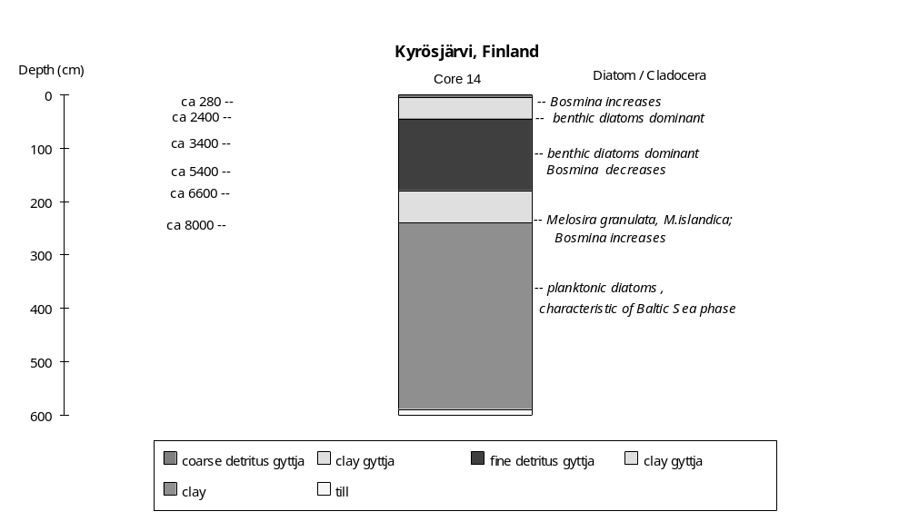

Preliminary coding: 6/7/1993; Final coding: 29/7/1993
Coded by GY and SPH
Lampellonjärvi-Lamminjärvi, Finland

Lampellonjärvi (61°04'N, 29°04'E, 108.6m above sea level) is a highly eutrophic small lake in southern Finland. It has a maximum depth of 10m, a mean depth of 4.5m and is 9.7ha in area. The lake has one inlet, a brook about 500m long which flows through cultivated land and enters the lake from the northeast. The water pH is about 6.9 and the specific conductivity about 85 µ/cm2. The biomass of phytoplankton is very high (6 mg/l in August, 1975) (Tolonen et al., 1976.). The deepest, southern part of the lake is surrounded by steep slopes forming the proximal side of a large fluvioglacial delta (Tolonen, 1980). The basin is situated in a kettle hole depression covered by moraines and other glaciofluvial deposits (Huttunen, 1980). The deglaciation of the area took place somewhat before 10,200 yr B.P. and the lake was isolated from its connection with the Baltic Ice Lake at the end of the Yoldia Stage somewhat before 9000 yr B.P. (Sauramo, 1958). The catchment area is 101.9ha.

Before 1703 A.D., Lampellonjärvi was united with the nearby lake Lamminjärvi (61°05'N, 25°02'E, 108.5m above sea level). About 100 years ago, the level of this large lake was artificially lowered, resulting in the separation of Lamminjärvi from Lampellonjärvi (Tolonen, M., 1980c). Mire development around Lamminjärvi resulted in the open water area becoming restricted to some tens of square metres. The maximum depth of Lamminjärvi is 4.75m. Lampellonjärvi and Lamminjärvi were one lake through out the Holocene.

There are four cores taken from the united lake: a marginal core (core M, Alhonen and Vuorela, 1974) and a central core (core C, Tolonen, M., 1980 a; b; and c) from Lamminjärvi, and a 7m long core (core A1, a water depth of ca 7.0m) and a frozen monolith (profile A2) from the same site at the centre of Lammpellonjärvi (Tolonen et al., 1976). Profile A2 is made up of six overlapping sections with a total length of 881cm but covering the uppermost 407cm of the sediment sequence (Tolonen, K., 1980). There are eight radiocarbon dates from A1 (Tolonen, K., 1980). A2 is varve-dated (3372 varves) (Tolonen, K., 1980). There are discrepancies between the varve dates and the radiocarbon dates. Most of the radiocarbon dates appear to be too old due to hard water in the lake (Tolonen, K., 1980). Changes in water depth are reconstructed from changes in lithology, varve thickness, diatom assemblages and aquatic pollen assemblages. The chronology is based on varve dating after ca 5000 yr B.P. and radiocarbon dates before 5000 yr B.P.

The basal sediment is varved clay (core A1 and A2 in 700-675cm, core C below 450cm) and clay gyttja (core M below 422cm), deposited in the Baltic Ice Lake before 9000 yr B.P

The overlying sediments are non-laminated fine gyttja in core A1 and A2 (675-670cm), silty clay in core C (450-445cm) and fine detritus gyttja in core M (above 422cm), suggesting shallow water. The aquatics in core M include abundant Myriophyllum with Potamogeton and Equisetum, consistent with shallowing. This unit is dated in ca 9000-8800 yr B.P.

The overlying sediment is laminated gyttja in cores A1 and A2 (670-385cm), indicating deeper conditions after ca 8800 yr B.P. The laminations are thin (0.5mm per lamina) consistent with rather deep water. The diatom assemblage is dominated by Tabellaria fenestrata, a benthic species. There are some planktonic taxa such as Cyclotella stelligera and M. italica (from 396-395cm), consistent with deeper water. Low sedimentation rates in this unit (0.04-0.06 cm/yr) are also consistent with this interpretation.

In Lamminjärvi, the sediment is fine detritus gyttja (422-117cm in core M and 445-140cm in core C), ca 8800-2000 yr B.P. This period can be subdivided into five intervals according to the moss layers, diatom and aquatic assemblages in core M.

The sediment between 422-320cm has very few aquatics, only some Myriophyllum and Typha. The diatom assemblage is dominated by non-planktonic species, such as Stauroneis anceps, Navicula pupula and N. radiosa. The assemblage suggests moderate water depth ca 8800-6400 yr B.P.

Between 320-238cm, planktonic diatoms increase (Melosira italica) and benthic diatoms decrease (Stauroneis anceps, Navicula pupula and N. radiosa), suggesting water depth increased. The aquatics are characterised by increased Myriophyllum, with some Nymphaea and Nuphar, consistent with deep water ca 6400-4800 yr B.P.

A layer of moss (238-226cm) suggests very shallow conditions, ca 4800-4500 yr B.P.

Between 226-107cm, the diatom assemblage is characterised by a decrease in planktonic species (Melosira italica and M. granulata) and an increase in benthic diatoms (Tabellaria fenestrata and Navicula pupula), suggesting decrease in water depth ca 4500-2300 yr B.P.

A second moss layer occurs between 117-107cm, suggesting continued shallowing ca 2300-2000 yr B.P.

After ca 2000 years in Lamminjärvi, sediment is coarse detritus gyttja (70-140cm in core C and 60-107cm in core M), indicating a low water. The aquatic assemblage in core M is marked by Typha and Potamogeton, suggesting shallowing. The diatoms are characterised by an increase of Fragilaria construens, Melosira granulata and Tabellaria fenestrata. The increase in benthic diatoms is consistent with decreased water depth. The top of sediment in the lake margins (above 60cm in core M and above 70cm in core C) is Sphagnum/Sphagnum-Carex peat, probably indicating hydroseral development at the lake margins after ca 1200 yr B.P.

A more precise record of water depth changes during last ca 3000 years can be obtained from two laminated cores A1 and A2 in Lampellonjärvi.

Between 385-380cm, there is a layer of non-laminated gyttja, indicating shallowing ca 2988 to 2850 yr B.P.

The overlying sediment in core A1 and A2 (380-270cm) is laminated gyttja, suggesting increased water depth. The unit has thin laminations (ca 8-12mm per lamina at 380-270cm, and ca 2-5mm per lamina between 215-110cm), consistent with increased water depth. The presence of planktonic diatoms, such as Melosira islandica, Cyclotella stelligera, and Synedra cf. nana is also consistent with deeper water. A low sedimentation rate (0.05-0.10 cm/yr) is consistent with deep water. This unit is varve-dated to ca 2850-1691 yr B.P.

The overlying sediment in core A1 and A2 (270-215cm) is laminated silty gyttja. The coarse matter suggests somewhat shallower conditions. The diatom assemblage is characterised by dominance of benthic taxa such as Tabellaria flocculosa and a decrease in planktonics such as Asterionella formosa and Synedra cf. nana, consistent with shallowing. The laminae are quite thick (8-12mm per lamina) and the sedimentation rate is high (0.25-0.15 cm/yr), also consistent with shallowing. This unit is varve-dated to 1691-1373 yr B.P.

The overlying sediment is laminated gyttja in core A1 (215-110cm), suggesting increased water depth. The lamination thickness (about 2-5mm per lamina) and sedimentation rate (0.1-0.15 cm/yr) both decrease, consistent with increased water depth. Microscopic examination of the laminations between 116-123cm shows abundant planktonic diatoms such as Melosira islandica and Cyclotella stelligera, consistent with deep water. This unit is varve-dated to 1373-757 yr B.P.

The overlying sediment is laminated silty gyttja in core A1 (110-50cm), suggesting decreased water depth. Increases in lamination thickness and in sedimentation rate are consistent with this interpretation. The diatoms is marked by dominance of benthics (Tabellaria flocculosa) and a decrease in planktonic diatoms such as Asterionella formosa and Synedra cf. nana, consistent with shallowing. This interval is dated to 757-278 yr B.P.

The top part in core A1 (50-0cm) is thinly laminated gyttja (0.5mm per lamina), suggesting a return to deep water. The diatoms include planktonic taxa such as Melosira italica, M. distans, Asterionella formosa and Synedra nana, consistent with deep water. The unit is varve-dated to after 278 yr B.P. Lampellonjärvi still has a water depth of 10m in the centre today.

In the coding status, low (1) is indicated by a moss layer; moderately low (2) by non-laminated fine gyttja in the lake centre, fine detritus gyttja in the lake margins; intermediate (3) by laminated silty gyttja in the centre with benthic diatoms; moderately high (4) by laminated gyttja with thin laminations and planktonic diatoms, fine detritus gyttja with benthic diatoms in the margins; high (5) by laminated gyttja with thin laminations in the centre and fine detritus gyttja in the margins, both with planktonic diatoms. The presence of coarse detritus gyttja and peat in marginal cores is assumed to reflect hydroseral development and marginal infilling after ca 2000 yr B.P. and is coded accordingly.

Radiocarbon dates

Su-581 1450±50 yr B.P. 0.62-0.72m silty gyttja core A1
Su-576 1830±130 yr B.P. 2.06-2.14m silty gyttja core A1 ATY
Su-582 1840±130 yr B.P. 1.12-1.20m silty gyttja core A1
Su-583 2310±90 yr B.P. 1.32-1.42m silty gyttja core A1
Su-577 2100±150 yr B.P. 2.46-2.54m silty gyttja core A1
Su-578 2330±70 yr B.P. 2.76-2.84m silty gyttja core A1
Su-579 3580±150 yr B.P. 4.36-4.44m gyttja core A1
Su-580 4430±170 yr B.P. 4.90-4.94m gyttja core A1

References

Alhonen, P. and Vuorela, I., 1974. Lamminjärvi kerrostumien siiteplöly-a piilevästratigrafia. Luonnon Tutkija 78: 40-47.
Huttunen, P., 1980. Early land use, especially the slash-and-burn cultivation in the commune of Lammi, southern Finland, interpreted mainly using pollen and charcoal analysis. Acta Botanica Fennica 113: 1-45.
Sauramo, M., 1958. Die geschichte der Ostsee. Annuales Academiae Scientiarum Fennicae (A, III) 51: 1-522.
Tolonen, K., 1980. Comparison between radiocarbon and varve dating in Lake Lampellonjärv, south Finland. Boreas 9: 11-19
Tolonen, K., Tolonen, M., Honkasalo, L., Lehtovaara, A, Sorsa, K. and Sundberg, K. 1976. The influence of prehistory and historic land Lake Lampellonjärv, south Finland (in Finish). Luonnon Tutkija 80: 1-15.
Tolonen, M. 1980a. Identification of fossil Ulmus pollen in sediments of lake Lamminjärvi, S Finland. Annales Botanici Fennici 17: 7-10.
Tolonen, M. 1980b. Degradation analysis of pollen in sediment of lake Lamminjärvi, S Finland. Annales Botanici Fennici 17: 11-14.
Tolonen, M. 1980c. Postglacial pollen stratigraphy of lake Lamminjärvi, S Finland. Annales Botanici Fennici 17: 15-25.

Coding

ca 9000-8800 yr B.P. moderately low (2)
ca 8800-6400 yr B.P. moderately high (4)
ca 6400-4800 yr B.P. high (5)
ca 4800-4500 yr B.P. low (1)
ca 4500-2988 yr B.P. moderately high (4)
ca 2988-2850 yr B.P. moderately low (2)
ca 2850-2300 yr B.P. moderately high (4)
ca 2300-2000 yr B.P. low (1)
ca 2000-1691 yr B.P. moderately high (4)
1691-1373 yr B.P. intermediate (3)
1373- 757 yr B.P. moderately high (4)
757- 278 yr B.P. intermediate (3)
278- 0 yr B.P. moderately high (4)
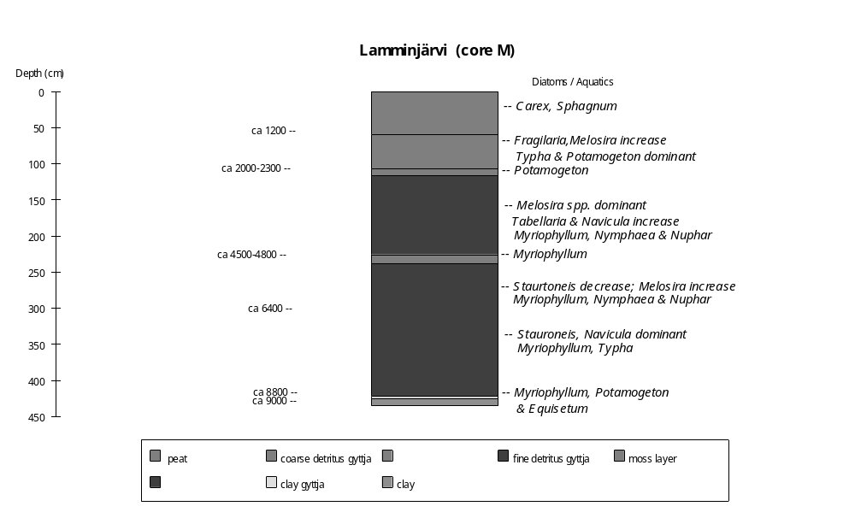

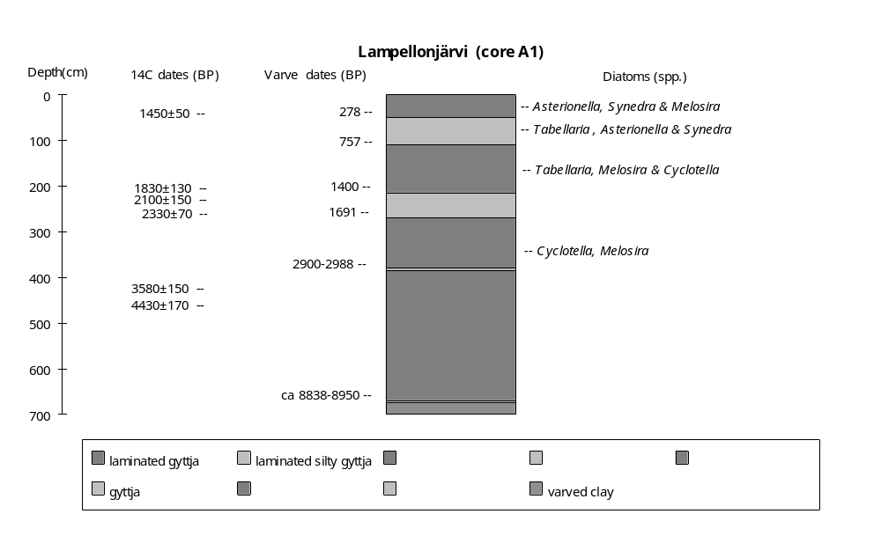
Preliminary coding: 23/5/1993;Final coding: 15/5/1994
Coded by GY and SPH
Lovojärvi, Finland

Lovojärvi (61°05'N, 25°02'E, 108.2m above sea level (Huttunen and Tolonen, 1975; Saarnisto et al., 1977; 108m in Kukkonen and Tynni, 1972; 90m in Heikkinen et. al., 1974)) is a small lake with an area of 4.8ha (Huttunen and Tolonen, 1975; Huttunen, 1980; Saarnisto et al., 1977; 5.2ha in Simola and Tolonen, 1981), a maximum depth of 17.5m and a mean depth of 7.7m. It is a eutrophic lake with an annual primary production of about 100 g Cass/m2. The mean pH was 8.2 at the surface and 6.7 at a depth of 17m in 1971 (Ilmavirta et al., 1974). Four small streams drain into the lake, one from Lake Lamminjärvi, the others from cultivated areas. There is a outlet to the northeast. The catchment area is 570ha. The underlying bedrock is mica gneiss with amphibolites. The basin is situated in a kettle hole depression in moraine and glaciofluvial deposits. The deglaciation of the area took place somewhat before 10,200 yr B.P. and the lake was isolated from its connection with the Baltic See at the end of the Yoldia Stage, more than 9000 yr B.P. (Sauramo, 1958).

Six cores have been taken from the basin. Core 1 (3.94m long) from the deepest part of the basin has been used for lithological, chemical, pollen and diatom analyses (Kukkonen and Tynni, 1972). There are two radiocarbon dates from this core (Heikkinen et. al., 1974; Kukkonen and Tynni, 1972). The other five cores (A, B, C, D and E) were taken along a transect across the lake (Huttunen and Tolonen, 1975): Core A (5m-long from a water depth of 17.5m), core B (ca 5m-long from a water depth of 15m), cores C and D (5m-long from a water depth of 7m) and core E (2.5m-long from a water depth of 2m). Cores A and C have been used for varve, diatom and pollen analyses (Huttunen and Tolonen, 1975; Saarnisto et al., 1977; Huttunen, 1980). Nine samples from core A and five samples from core C are radiocarbon-dated (Heikkinen et al., 1974; Huttunen and Tolonen, 1975). The lake level changes are reconstructed from changes of lithology, aquatic pollen and diatom assemblages.

Varve counts on core A indicate that the laminated sediment record covers the interval from 1967 A.D. to ca 3000 B.C (4929 annual varves from Huttunen, 1980). There are discrepancies between the chronology based on varve counting and the radiocarbon dates. Some of the radiocarbon dates are too old due to the presence of redeposited material (Saarnisto et al., 1977), and some are slightly too young due to contamination (Huttunen, 1980). The chronology is based on annual varve counts in the late Holocene and radiocarbon dates for the early part of the record.

The basal sediments in the centre of the lake are gyttja with mineral particles (5.00-4.95m in cores A and B) or organic mud (below 3.76m in core 1), grading to silty gyttja (4.00-3.00m in core C) and sand (below 2.50m in core E) near the lake margins. These units were deposited before ca 9000 yr B.P. when the area was part of the Baltic Sea (Kukkonen and Tynni, 1972).

The overlying sediments are varved organic gyttja (4.95-3.00m in core A), grading to varved coarse detritus gyttja in core B (above 4.95m), gyttja in the marginal core (2.20-2.50m in core E). These sediments mark the onset of lacustrine conditions in the basin. The preservation of laminations suggests deep water. In core 1 (3.76-2.58m), there is mud stained black by sulphides and with small lenses of viviante, suggesting that the lake was deep with anoxic bottom waters. The diatom assemblage from core 1 is characterised by Cyclotella kützingiana + var. radiasa, consistent with deep water. The aquatic assemblage in core A is dominated by Potamogeton and Myriophyllum, consistent with deep water. A sample from the bottom of the unit in core 1 is radiocarbon-dated to 8550±100 (Su-135, 3.50-3.70m); and three samples from the unit in core A to 3820±130 (Hel-491, 3.27-3.30m or 20.77-20.80m below water surface), 4520±140 (Hel-445, 3.77-3.80m or 21.25-21.30m below water surface) and 5730±150 (Hel-446, 4.27-4.30m or 21.77-21.80m below water surface). The uppermost two dates correlate well with varve counts of 3749 yr B.P. and 4909 yr B.P. respectively. This unit is dated to ca 9000-3600 yr B.P.

A decrease in water depth after 3600 yr B.P. is indicated by deposition of peaty mud with wood and sedge remains in the marginal core E (1.92-2.20m). In cores A and C, there is coarse detritus gyttja, consistent with shallowing. There is a layer of sedge-peat in core 1 (2.58-2.16m). Kukkonen and Tynni (1972) argue that the peat is not in situ, but was formed by a raft of peat that became detached and floated out to the centre of the lake, and sank to bottom. Hydroseral development consequent on shallowing would, however, have facilitated the formation of peat rafts and their transport to the centre of the basin. On the basis of two radiocarbon-dates of 2620±180 (2.30-2.40m or 9.30-9.40m below water surface in core C) and 3600±100 yr B.P. (Su-134, 2.40-2.60m in core 1), this shallow interval is dated to 2600-3600 yr B.P.

The overlying sediments are coarse detritus gyttja both in the central and marginal cores (2.35-3.00m in core A; 0.12-4.00cm in core C and 0.15-2.20m in core E), suggesting the lake was low. The diatom assemblage from core 1 is characterised by Tetracyclus lacustris, Meridion circulare and Tabellaria fenestrata. Tetracyclus lacustris is a shallow water benthic form which thrives only in depths of less than 5m (Meriläinen, 1971). This shallow interval is dated to 2600-1200 yr B.P.

The uppermost sediments are laminated clay and mud with sulphide in the centre (0-2.35m in core A, 0-2.16m in core 1), and laminated gyttja with clay near the lake margin (0-0.12m in core C), suggesting increased water depth. The presence of black sulphide mud in the central cores indicates the lake was deep with anoxic bottom waters. The diatom assemblage from core 1 (above 1m) is characterised by abundant planktonic forms, such as Fragilaria capucina, Synedra acus and Cyclotella pseudostelligera, consistent with deep water. The aquatic assemblages from core A and C are characterised by a decrease in Sparganium and the disappearance of Nymphaea and Nuphar, consistent with increased water depth. This unit is dated to after 1200 yr B.P. based on varve-counting (Saarnisto et al., 1977).

In the status coding, low (1) is indicated by peaty mud in the lake margin and coarse detritus gyttja in the centre; intermediate (2) by coarse detritus gyttja in both the lake centre and at the margins; high (3) by laminated gyttja and clay. The coding begins after the lake was isolated from the Baltic Sea, ca 9200 yr B.P.

Radiocarbon dates

Hel-439 1050±140 18.00-18.10m below water surface, gyttja, core A, ATO
Hel-440 1120±100 18.50-18.60m below water surface, gyttja, core A, ATO
Hel-683 1130±140 7.90-8.00m below water surface, coarse detritus gyttja, core C
Hel-682 1210±100 7.30-7.35m below water surface, coarse detritus gyttja, core C
Hel-441 1580±100 19.00-19.10m below water surface, gyttja, core A, ATO
Hel-442 2030±140 19.50-19.60m below water surface, gyttja, core A
Hel-684 2160±110 8.25-8.30m below water surface, coarse detritus gyttja, core C
Hel-444 2260±170 19.67-19.90m below water surface, gyttja, core A
Hel-580 2280±130 8.80-8.90m below water surface, coarse detritus gyttja, core C
Hel-443 2500±180 20.10-20.20m below water surface, coarse detritus gyttja, core A
Hel-579 2620±180 9.30-9.40m below water surface, coarse detritus gyttja, core C
Su-134 3600±100 2.4-2.6cm, peat, core 1
Hel-491 3820±130 20.77-20-80m below water surface, gyttja, core A
Hel-445 4520±140 21.25-21.30m below water surface, gyttja, core A, ATY
Hel-446 5730±150 21.77-21.80m below water surface, gyttja, core A, ATY
Su-135 8550±100 3.5-3.7cm, sulphidic dy, core 1

References

Heikkinen, A., Koivisto, A. and Aikaa, O., 1974. Geological survey of Finland radiocarbon measurements VI. Radiocarbon 16: 252-268.
Huttunen, P. and Tolonen, K., 1975. Human influence in the history of Lake Lovojärvi, S.Finland. Finska Forminnesföreningen 82: 68-105.
Huttunen, P., 1980. Early land use, especially the slash-and-burn cultivation in the commune of Lammi, southern Finland, interpreted mainly using pollen and charcoal analysis. Acta Botanica Fennica 113: 1-45.
Ilmavirta, V., Ilmavirta, K. and Kotimaa, A.-L., 1974. Phytoplanctonic production during the summer stagnation in the eutrophicated lakes Lovojärvi and Ormajärvi, southern Finland. Annales Botanici Fennici 11: 121-132.
Kukkonen, E. and Tynni, R., 1972. Sediment core from lake Lovojärvi, a former meromictic lake (Lammi, south Finland). Annales Academiae Scientiarum Fennicae, Fennica 1972: 70-82.
Meriläinen, J., 1971. The recent sedimentation of diatom frustules in four meromictic lakes. Annales Botanici Fennici 8: 160-178.
Saarnisto, M., Huttunen, P. and Tolonen, K., 1977. Annual lamination of sediments in Lake Lovojärvi, south Finland, during the past 600 years. Annales Botanici Fennici 14: 35-45.
Sauramo, M., 1958. Die geschichte der Ostsee. Annuales Academiae Scientiarum Fennicae A, III, 51: 1-522.
Simola, H. and Tolonen, K., 1981. Diurnal laminations in the varved sediment of Lake Lovojävi, south Finland. Boreas 10: 19-26.

Coding
9000-3600 yr B.P. high (3)
3600-2600 yr B.P. low (1)
2600-1200 yr B.P. intermediate (2)
1200-0 yr B.P. high (3)
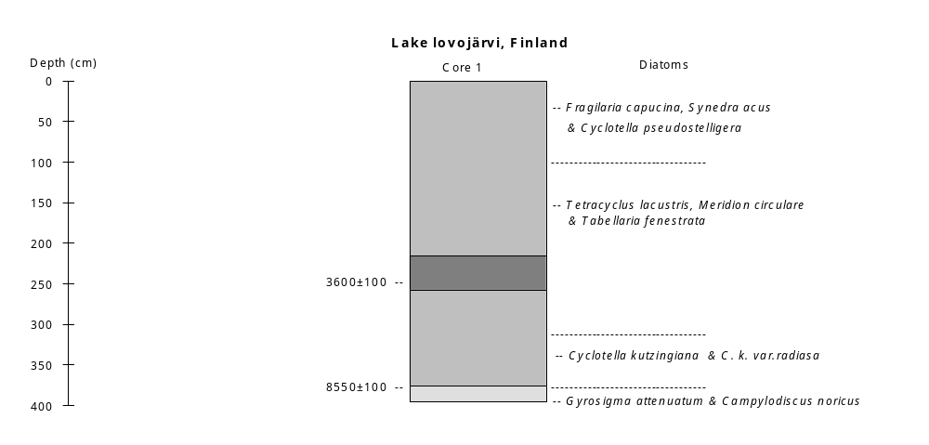
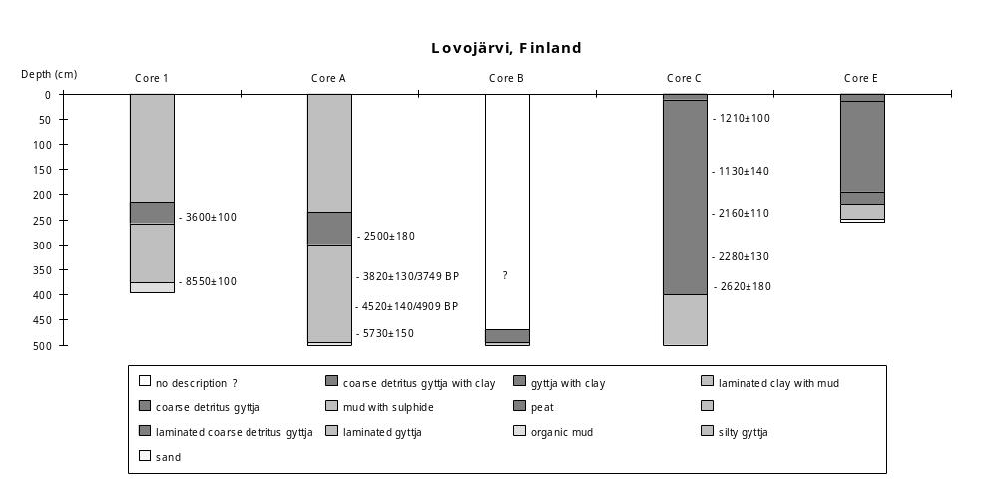
Preliminary coding: 25/5/1993; Final coding: 29/4/1994. Coded by GY and SPH
Pieni Majaslampi, Finland

Pieni Majaslampi (24°35'39"E, 60°19'15"N, 97.3m above sea level) is a small (1.1ha) hilltop lake situated in a rock depression in the Nuuksio upland, 16km from the south coast of Finland. The lake has a maximum depth of 6.3m. The lake water has a pH of 4.5, 20.7 µS conductivity, and low productivity. There is no inflow into the lake or surface outflow. The catchment area is 3.5ha. The lake lies in the drainage basin of the River Mankinjoki, which flows into the Gulf of Finland. The bedrock is granite and granodiorite. The basin is covered by thin layers of weathered gravel or washed till. The basin originated through faulting, and emerged from beneath the ice ca 11,700 yr B.P. (Niemelä, 1971). The lake became hydrologically isolated from the Baltic Ice Lake ca 10,200 yr B.P. (Eronen, 1988).

A 3.64m long core, taken from the centre of the lake, provides a sedimentary record of the last 10,200 yr B.P. (Korhola and Tikkanen, 1991). Korhola and Tikkanen (1991) considered the changes in diatom-inferred pH values as indicating fluctuations of water level, where higher pH values correspond to regional high water-level, and vice verse for lower pH values. Here, changes in water depth are reconstructed from changes in lithology, geochemistry, diatom and Cladocera assemblages, and broadly correspond with those interpreted by Korhola and Tikkanen (1991). There are five radiocarbon dates from this core, concentrated in the early Holocene. The upper three ages are in stratigraphical order and in good agreement with the regional pollen chronology (Korhola and Tikkanen, 1991). The basal two dates are thought to be too young, and are not used in the chronology. Dating of the later Holocene is based on the regional pollen stratigraphy (Korhola and Tikkanen, 1991).

The basal sediment in the core is coarse sand and pebbles (364-370cm) grading into silty clay (364cm). This unit is interpreted by Korhola and Tikkanen (1991) as representing sediments deposited in the Baltic Ice Lake and older than 10,200 yr B.P.

The overlying sediments are gyttja clay (360-364cm) and clay gyttja (360-353cm) with very low organic content (ca 2%), suggesting deep water. There are very few diatoms present (only Pinnularia spp., Cymbella spp. and Fragilaria construens). The Cladocera assemblage includes Bosmina longirostris, typical of the planktonic community of a eutrophic lake. The character of the sediment and the Cladocera assemblage are consistent with moderately deep water, ca 10,200-9700 yr B.P.

The overlying unit (353-348cm, ca 9700-9500 yr B.P.) is fine detritus gyttja. The occurrence of detritus suggests decreased water depth. The unit is characterised by a marked increase in organic content to ca 20%., consistent with shallowing. The diatoms include Cymbella spp., Navicula radiosa and Nitzschia hantzschiana, and the Cladocera assemblage is still dominated by Bosmina longirostris. A sample from this unit is radiocarbon-dated to 9630±130 yr B.P. (Hel-2705, 348-350cm).

The overlying sediment is lake mud (348-338cm, ca 9500-9100 yr B.P.), suggesting a rise in water level. A marked decrease in organic matter is consistent with deeper water. The Cladocera assemblage is still dominated by Bosmina longirostris, but Bosmina longispina increases. The diatoms include Cymbella spp., Frustulia rhomboides, Navicula radiosa, N. hoefleri, Nitzschia hantzschiana, Pinnularia spp. and Stenopterobia sigmatella. The appearance of planktonic diatoms (Stenopterobia spp.) is consistent with deeper water. A sample from the lake mud is radiocarbon-dated to 9130±140 yr B.P. (Hel-2704, 340-342cm).

The overlying unit is fine detritus gyttja (338-334cm, ca 9100-8800 yr B.P.). The detritus suggests a decrease in water depth. The diatom assemblage is characterised by Eunotia spp., Frustulia rhomboides, Navicula spp., Pinnularia spp. and Stenopterobia sigmatella. The increase in epiphytes (Eunotia spp.) is consistent with shallowing. The Cladocera assemblage is still dominated by Bosmina longirostris, with increased Bosmina longispina. This unit is dated to 9100-8800 yr B.P.

The overlying sediment (334-0cm) is lake mud, suggesting increased depth after ca 8800 yr B.P. The unit can be divided into five intervals according to changes in the Cladocera and diatoms.

In the lower part (334-280cm), the Cladocera assemblage is characterised by an abundance of planktonic species such as Bosmina longirostris and Bosmina longispina, Daphina longispina and Diaphanosoma brachyurum. This planktonic assemblage suggests increased water depth. Abundant planktonic diatoms (Stenopterobia sigmatella) are present between 330-310cm, consistent with deep water. Korhola and Tikkanen (1991) reconstructed high pH values, consistent with deeper water, ca 8400-7400 yr B.P. A sample from the near bottom of this unit is dated to 8820±140 yr B.P. (Hel-2703, 332-334cm).

In the overlying unit (280-160cm), the diatom assemblage is marked by a decrease in planktonic species and an increase in benthic diatoms (Cymbella spp., Navicula spp.), suggesting shallowing. Changes in the relative abundance of Bosmina are consistent with decreased water depth. The unit is dated to 7400-3300 yr B.P. (Korhola and Tikkanen, 1991).

There are changes in the relative abundance of the Bosmina (160-110cm), suggesting an increased water depth. The diatoms are represented by Navicula spp., Tabellaria quadriseptata, Pinnularia spp. and Eunotia spp. Korhola and Tikkanen (1991) reconstructed higher pH values, consistent with deeper water, ca 3300-2200 yr B.P.

Between 110-50cm, the abundance of planktonic Cladocera slightly decreases, and littoral Cladocera such as Alona, Alonella and Rhyncotalona increase. The diatoms are still represented by Navicula spp., Tabellaria quadriseptata, Pinnularia spp. and Eunotia spp. The assemblage of benthic and epiphytic diatoms indicate shallow water. Korhola and Tikkanen (1991) reconstructed lower pH values, consistent with shallower water, ca 2200-1400 yr B.P.

In the uppermost 50cm, the organic content declined. There is an increase in Bosmina longispina, suggesting increased water depth. Planktonic diatoms (Stenopterobia sigmatella) are present between 20-0cm, consistent with deep water. Korhola and Tikkanen (1991) reconstructed higher pH values, consistent with deeper water, after ca 1400 yr B.P.

In the status coding, low (1) is indicated by fine detritus gyttja; intermediate (2) by lake mud with benthic and littoral Cladocera; high (3) by clay gyttja or gyttja clay with very low organic content; or lake mud with abundant planktonic Cladocera/diatoms.

Radiocarbon dates

Hel-2703 8828±140 yr B.P. 332-334cm lake mud
Hel-2704 9130±140 yr B.P. 340-342cm lake mud
Hel-2706 9280±130 yr B.P. 357-362cm clay-gyttja, ATY
Hel-2828 9500±130 yr B.P. 353-360cm clay-gyttja, ATY
Hel-2705 9630±130 yr B.P. 348-350cm gyttja

References

Eronen, M., 1988. A scrutiny of the late Quaternary history of the Baltic Sea. Geological Survey of Finland, Special Paper 6: 11-18.
Korhola, A.A. and Tikkanen, M.J., 1991. Holocene development and early extreme acidification in a small hilltop lake in southern Finland. Boreas 20: 333-356.
Niemelä, J., 1971. Die quartäre Stratigraphie von Tonablagerungen und der Rückzug des Inlandeises zwischen Helsinki und Hämeenlinna in Südffinland. Geological Survey of Finland, Bulletin 253: 1-79.

Coding

ca 10,200-9700 yr B.P. high (3)
ca 9700-9500 yr B.P. low (1)
ca 9500-9100 yr B.P. intermediate (2)
ca 9100-8800 yr B.P. low (1)
ca 8800-7400 yr B.P. high (3)
ca 7400-3300 yr B.P. intermediate (2)
ca 3300-2200 yr B.P. high (3)
ca 2200-1400 yr B.P. intermediate (2)
ca 1400-0 yr B.P. high (3)

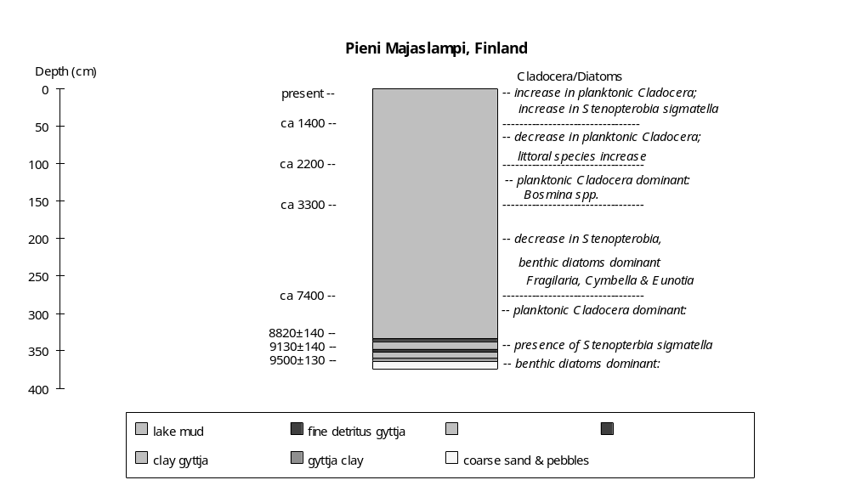

Preliminary coding: 30/6/1993; Final coding: 28/4/1994
Coded by GY and SPH
Sarkkilanjärvi, Finland

Sarkkilanjärvi (61°45'N, 23°06'E, 87m above sea level) is a small lake with an area of about 24ha (800x300m). The maximum depth is ca 11m and the average depth is about 6m (Alhonen, 1967). The lake is spring fed and there is an outflow into Kyrösjärvi. The water transparency is quite high (2.3m), the pH is 6.1-7.2 and the conductivity is 52-56 µ S (Alhonen, 1967). The basin is surrounded by Precambrian bedrocks of gneiss, peridotites, gabbros, diorites and granites.

A 4.4m long core taken in a water depth of 4m from the middle of the basin has been used for lithology, chemistry, pollen, diatom and Cladocera analysis (Alhonen, 1967). Changes of water depth are based on changes in lithology and biology. The chronology is based on four radiocarbon dates from the core.

The basal sediments are sand (below 440cm), clay (190-440cm) and clay gyttja (185-190cm). The diatom assemblage indicates that these deposits were formed when the lake was still part of the Baltic Sea.

The overlying sediment is fine detritus gyttja (0-185cm) formed after the lake was isolated from the Baltic Sea, ca 8000 yr B.P. (Alhonen, 1967). The unit can be divided into four parts based on variations in loss-on-ignition, aquatic, Cladoceran and diatoms assemblages.

The lower part of this unit (185-120cm, ca 8000-6100 yr B.P.) is characterised by the presence of Equisetum, Nuphar and Sphagnum, suggesting shallow water. The abundance of planktonic Cladocera (Bosmina) is low, consistent with shallow conditions. The diatom assemblage is characterised by low abundances of planktonic species (Melosira distans var spp.) and an abundance of Fragilaria pinnata, a species characteristic of eutrophic, shallow water. A sample from this unit (T-529, 165-175cm) is radiocarbon-dated to 7980±250 yr B.P.

Between 120-45cm (ca 6100-2400 yr B.P.), Equisetum, Nuphar and Sphagnum are absent, suggesting the water became deeper. Increases in planktonic species (Bosmina and Melosira distans) and a slight decrease in Fragilaria pinnata are consistent with deeper water. Loss-on-ignition is high. If the mineral content of the sediments is derived from erosion, then this high loss-on-ignition is consistent with deep water. The loss-on-ignition curve is roughly parallel to that of Bosmina, which suggests it reflects intensive paludification of the surroundings consequent on a rise in water level (Alhonen, 1967), which in turn would have minimized input of material derived from erosion in the catchment. Three samples from this layer (I-1922, 35-45cm; T-526, 60-70cm and T-527, 75-85cm) are radiocarbon-dated to 2440±120, 4040±350 and 4620±180 yr B.P. respectively.

In the upper part of the fine detritus gyttja (45-10cm, ca 2400-600 yr B.P.), the presence of Equisetum, Nuphar and Sphagnum suggests a return to shallow water. Bosmina decreases in abundance, consistent with shallowing. The diatom assemblage is characterised by a marked decrease in Melosira distans var spp. and an increase in Fragilaria pinnata to its maximum abundance, consistent with shallowing. The marked drop in loss-on-ignition, accompanied by the reappearance of Equisetum, suggests an increase in catchment erosion and is consistent with decrease in water depth.

The top of the unit (0-10cm, ca 600-0 yr B.P.) has very high loss-on-ignition values and Bosmina increases, suggesting increase in water depth. The abundance of Melosira distans increases to its maximum and Fragilaria pinnata decreases to a minimum, consistent with increasing water depth.

In the status coding, low (1) is indicated by fine detritus gyttja with low loss-on-ignition, the presence of Equisetum, low abundances of planktonic Cladocera and diatoms, and abundant Fragilaria pinnata; high (2) by fine detritus gyttja with high loss-on-ignition, the absence of Equisetum, abundant planktonic diatoms or Cladocera and low abundance of Fragilaria pinnata. The coding begins after the lake was isolated from the Baltic Sea, ca 8000 yr B.P.

Reference

Alhonen, P., 1967. Palaeolimnological investigations of three inland lakes in South-western Finland. Acta Botanica Fennica 76: 1-59.

Radiocarbon dates

I-1922 2440±120 yr B.P. 35-45cm, fine detritus gyttja.
T-526 4040±350 yr B.P. 60-70cm, fine detritus gyttja
T-527 4620±180 yr B.P. 75-85cm, fine detritus gyttja.
T-529 7980±250 yr B.P. 165-175cm, fine detritus gyttja.

Coding

ca 8000-6100 yr B.P. low (1)
ca 6100-2400 yr B.P. high (2)
ca 2400-600 yr B.P. low (1)
ca 600-0 yr B.P. high (2)

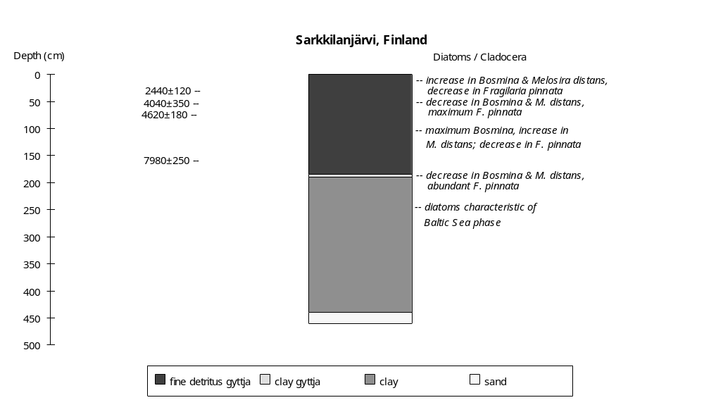

Preliminary coding: 7/7/1993; Final coding: 2/2/1994
Coded by GY and SPH
Tankavaara, Finland

Tankavaara (68°11'N, 27°14'E, 335m above sea level) is a peat bog in the Waldlappland area, northeastern Finland. It is a shallow depression between the Isompi and Pienempi Tankavaara mountains (468m). The basin is located in a fjeld (glacial erosion plateau) and was formed after deglaciation of the area (Sorsa, 1965). The peat bog overlies late glacial moraines. The region is covered by Betula and Picea forest and the bog by a Carex community.

The stratigraphy of the lacustrine deposits has been reconstructed from three cores along an east-west transect across the peat bog (Sorsa, 1965). Two cores were taken from the eastern peat bog (27°14'E): a 2m-long core at site XX and a 1m-long core at site XXI. One core was taken from the western peat bog (27°10'E): a 2.5m-long core at site XXII. The basin was occupied by a lake after deglaciation of the area during the early-Holocene (Sorsa, 1965), and then became progressively infilled from the west to the east, with peat formation in the Atlantic period in the western basin (core XXII) and in the Subboreal period in the eastern basin (cores XX and XXI). Changes in water depth during the lacustrine period are reconstructed from changes in lithology, aquatic pollen assemblages and sedimentation rate. Four samples from core XX are radiocarbon-dated (Sorsa, 1965). Three radiocarbon dates are consistent with the regional pollen chronology but the lowest date (7920±120 yr B.P., B-579) is too young. The chronology is therefore based on three radiocarbon dates and correlations with the regional pollen chronology for the early Holocene (Sorsa, 1965; Hyvärinen, 1972).

The basal sediments from core XX are sand (below 240cm), grading to fine sand detritus (190-170cm in XX). The coarse mineral deposits may represent glacial debris. The unit belongs to the early Preboreal pollen zone (Sorsa, 1965; Hyvärinen, 1972).

The overlying sediment is peaty gyttja in core XX (170-150cm), suggesting the onset of lacustrine deposits in the basin with moderate water depth. Sparganium pollen is present (2-4%), consistent with moderate water depth. The unit belongs to the late Preboreal, around pre 9000 yr B.P. (Sorsa, 1965). A sample from the overlying unit (115-130cm) is radiocarbon-dated to 7880±120 yr B.P. (B-578). Extrapolation of the sedimentation rate (0.026 cm/yr) from the overlying unit gives an age of ca 8960 yr B.P. for the upper unit boundary, consistent with pollen chronology.

A change to peat (150-130cm in core XX) suggests a marked decrease in water depth after 9000 yr B.P. The aquatic pollen is characterised by the disappearance of Sparganium, increases in Equisetum and Sphagnum (2-3%) and the presence of abundant Cyperaceae (35%), consistent with very shallow water. The unit belongs to the early Boreal pollen zones, and is dated to ca 9000-8200 yr B.P.

The overlying sediments are dy (core XX: 130-50c) and diatomaceous gyttja (core XXII: 240-225cm), suggesting increased water depth. Equisetum disappears in the lower part of the unit (core XX: 130-100cm), consistent with deepening. The unit was deposited during the late Boreal and the early Atlantic. A sample from the unit (115-130cm) is radiocarbon-dated to 7880±120 yr B.P. (B-578).

A change to dy (225-210cm) in core XXII, with continued dy deposition in core XX (100-65cm), suggests a slight decrease in water depth after 7050 yr B.P. An increase in Equisetum in core XX (100-60cm) is consistent with this change. At the margin of the lake (core XXI), sandy detritus gyttja (95-55cm) was deposited. The unit belongs to the Atlantic pollen zone. A sample from the unit (85-100cm) is radiocarbon-dated to 6740±160 yr B.P. (B-577). In core XXII, Carex peat began to form above 210cm, consistent with shallowing on the beginning of infilling in the western part of the lake after ca 6700 yr B.P. (the early Atlantic pollen zone).

An increase in depth after 4750 yr B.P. is characterised by a change to dy in core XXI (50-40cm), with continued dy deposition in core XX (65-50cm). Cyperaceae decreases to its minimum in core XX (above 70cm), consistent with increased depth. A decrease in sedimentation rate from 0.026 cm/yr to 0.016 cm/yr in core XX is also consistent with increased depth. A sample from the top of this unit (30-50cm) is dated to 3550±160 yr B.P. (B-576).

The uppermost sediment (above 50cm in core XX and 40 cm in core XXI) is Carex-Sphagnum peat. This change in deposition may reflect hydroseral development and infilling processes in the basin, after ca 3600 yr B.P.

In the status coding, low (1) is indicated by peat between lacustrine deposits, with abundant Cyperaceae; moderately low (2) by peaty gyttja with increase in Sparganuim; intermediate (3) by dy and sandy detritus gyttja with Equisetum; high (4) by diatomaceous gyttja with no Equisetum, or dy with no Equisetum or Cyperaceae and low sedimentation rate. Peat deposition after ca 3600 yr B.P. is considered to reflect infilling, and is not coded.

Radiocarbon dates

B-579 7920±120 yr B.P. 160-170cm, peaty gyttja. ATY.
B-578 7880±120 yr B.P. 115-130cm, dy.
B-577 6740±160 yr B.P. 85-100cm, dy.
B-576 3550±160 yr B.P. 30-50cm, Carex-Sphagnum peat.

References

Hyvärinen, H., 1972. Flandrian regional pollen assemblage zones in eastern Finland. Commentationes Biologicae 59: 1-25.
Sorsa, P., 1965. Pollenanalytische untersuchungen zur spätqartären vegetations und klimaentwicklung im östlichen Nordfinland. Annales Botanici Fennici 2: 301-413.

Coding

pre-9000 yr B.P. moderately low (2)
ca 9000-8200 yr B.P. low (1)
ca 8200-7050 yr B.P. high (4)
ca 7050-4750 yr B.P. intermediate (3)
ca 4750-3600 yr B.P. high (4)
ca 3600-0 yr B.P. infilling, not coded.
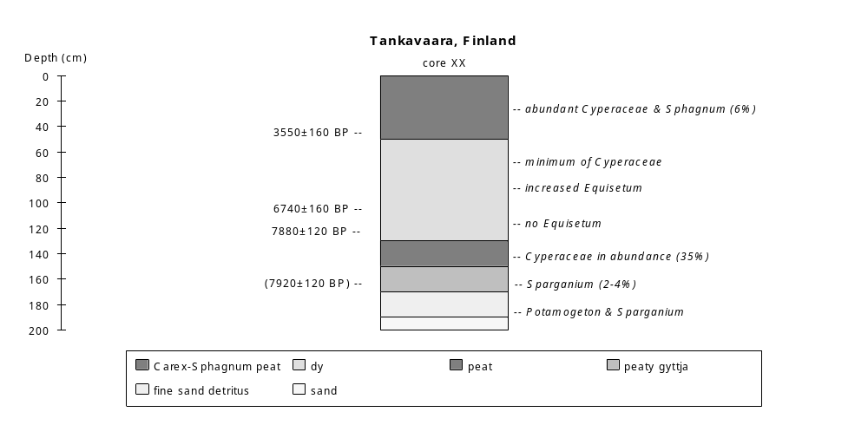 Preliminary coding: 20/5/1994; Final coding: 22/5/1994. Coded by GY and SPH
Työtjärvi, Finland

Työtjärvi (60°59'N, 25°28'E, 142.8m above sea level) is an oligotrophic lake situated in a shallow basin on top of Salpausselkä, Finland. The lake area is ca 90ha, the maximum water depth is 7m and the mean depth is 1-2m. Some of the shores of the lake are bordered by bogs. The basin was isolated from the Baltic Ice Lake about 10200 years ago (Donner, 1967). The lake level was artificially lowered about 2m at the turn of the century by the creation of outflow channel. Before that the lake had no outflow.

Three cores (A, B and C), taken in water depths of less than 3m, provide a sedimentary record back to 10200 yr B.P. Core A (ca 2m long) was used for radiocarbon dating and pollen analyses; Core B and C (ca 2.3m long) were used for diatom and Cladoceran analysis (Donner et al., 1978). Changes in water depth are reconstructed from changes in lithology, aquatic pollen, diatom and Cladoceran assemblages. The chronology is based on 17 radiocarbon dates. The reconstructed changes broadly follow those outlined by Donner et al. (1978).

The basal sediment in core A and B (below 1.85-1.9m) is silty clay, suggesting a moderate water depth. Aquatic assemblage is characterised by the dominance of Potamogeton and Myriophyllum with some Menyanthes, consistent with shallow conditions. the diatom assemblage is dominated by benthic species, such as Pinnularia spp., Stauroneis phoenicenteron and Cymbella cuspidata. The Cladocerans are mainly littoral forms. Donner et al. (1978) interpret these biotic assemblages as indicating shallow water in the initial phase after the lake became isolated, ca 10200-9200 yr B.P.

The overlying sediment is clay mud (1.85-1.90m in core B), and mud in core A (above 1.85m), suggesting an increase in water depth. However, benthic diatoms and littoral Cladocera are still dominant. This interval is dated in ca 9200-8000 yr B.P.

The overlying sediment (above ca 1.85m in both core A and B) is lake mud, indicating deep water. The aquatic assemblage is dominated by Isoetes, Potamogeton and Nuphar, consistent with deep water. Donner et al. (1978) interpret an increase in planktonic Cladocera and diatoms (Melosira distans represent 85% at 1.55m in core B) as indicating high water levels between 8000-2500 yr B.P.

Towards the top of the lake mud (above 0.5m), Sphagnum shows a large increase, occurring with Isoetes, Myriophyllum, Potamogeton and Sparganium in core A. In core B (above 0.45m), the Cladoceran assemblage is characterised by decreases in both planktonic and littoral species, which are replaced by Chydrus as a result of cultural eutrophication of the lake (Tolonen et al., 1976). The diatom assemblage is marked by a decrease in Melosira distans, the abundance occurrence of Eunotia spp. and an increase in Fragilaria spp. and Tabellaria spp. Donner et al. (1978) interpret these changes as reflecting high production in a gradual shallowing of lake sduring the last 2500 years.

In the status coding, low (1) is indicated by silty clay with Menyanthes, benthic diatoms and littoral Cladocera; intermediate (2) by clay mud or mud with benthic diatom and littoral Cladocera; high (3) by lake mud with Isoetes, Potamogeton and Nuphar and with planktonic Cladocera and planktonic diatom.

Radiocarbon dates

Hel-740 1220±110 yr B.P. 20-30cm, lake mud core A.
Hel-850 1590±90 yr B.P. 30-40cm, lake mud core A.
Hel-770 2350±100 yr B.P. 40-50cm, lake mud core A.
Hel-849 2950±150 yr B.P. 50-60cm, lake mud core A.
Hel-739 3460±150 yr B.P. 60-70cm, lake mud core A.
Hel-848 4210±150 yr B.P. 70-80cm, lake mud core A.
Hel-771 4690±110 yr B.P. 80-90cm, lake mud core A.
Hel-847 5270±130 yr B.P. 90-100cm, lake mud core A.
Hel-738 5620±140 yr B.P. 100-110cm, lake mud core A.
Hel-830 6150±150 yr B.P. 110-120cm, lake mud core A.
Hel-772 7230±140 yr B.P. 120-130cm, lake mud core A.
Hel-829 7410±160 yr B.P. 130-140cm, lake mud core A.
Hel-737 7870±180 yr B.P. 140-150cm, lake mud core A.
Hel-828 7690±160 yr B.P. 150-160cm, lake mud core A.
Hel-773 8480±180 yr B.P. 160-170cm, lake mud core A.
Hel-827 8580±170 yr B.P. 170-180cm, lake mud core A.
Hel-674 9020±190 yr B.P. 180-188cm, lake mud core A.

References

Donner, J.J., 1967. The Late-glacial and early Post-glacial pollen stratigraphy of southern and eastern Finland. Commentationes Biologieae 29:1-24.
Donner, J.J., Alhonen, P., Eronen, M., Jungner, H. and Vuorela, I., 1978. Biostratigraphy and radiocarbon dating of the Holocene lake sediments of Työtjärvi and the peats in the adjoining bog Varrasuo west of Lahti in southern Finland. Annales Botanici Fennici 15: 258-280.
Tolonen, K., Tolonen, M., Honksalo, L., Lehtovaara, A., Sorsa, K and Sundberg, K., 1976. The influence of prehistoric and historic land use on Lake Lampellonjärvi, South Finland. Luonnon Tutkija 80: 1-15.

Coding

ca 10000-9200 yr B.P. low (1)
ca 9200-8000 yr B.P. intermediate (2)
ca 8000-2500 yr B.P. high (3)
ca 2500-0 yr B.P. intermediate (2)
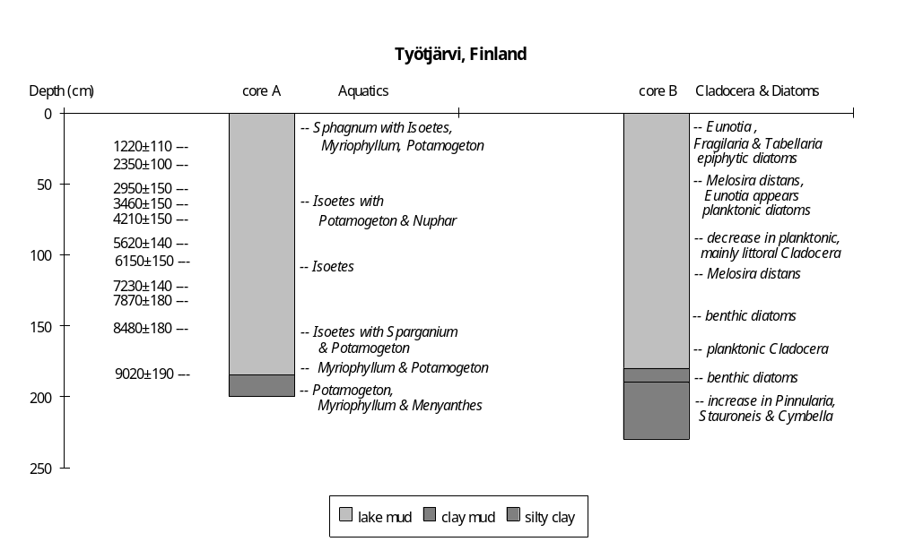

Preliminary coding: 29/6/1993; Final coding: 26/9/1994
Coded by GY and SPH
Vanhalampi, Finland

Vanhalampi (66°22'N, 29°35', 205m above sea level) is a small lake (ca 0.8ha area, ca 3.8m maximum water depth) in northeastern Finland (Vasari et al., 1963). The basin is fringed by meso- to eutrophic mires on the slope of the hill Korvasvaara. The lake is fed by groundwater and runoff from spring on the slope above, and it drains to the west via a threshold which is now completely overgrown by peat. The lake water is quite alkaline (pH 8-9) and poor in macrophytes (Vasari et al., 1963). The bedrocks in the catchment are limestones, mainly dolomite. The basin is covered by glacial till and surrounded by an esker chain; the lake occupies a glacial depression (Vasari, 1962).

Lumiala (1939) made the first palynological investigations of this lake and obtained a core (core 1939) that covered the Holocene. A marginal core (core 1962) was obtained by Vasari (1962) who re-examined the lowermost parts of the series. Our reconstructions are based mainly on four more recent cores (A1, A2, A3 and B2) from the lake which provide a sedimentary record back to before 9300 yr B.P. (Hyvärinen et al., 1990). Core A1 is ca 2.8m long from ca 1.2m water deep; core A2, core A3 and core B2 are all ca 2.8 long from water depths of 3.5, 3.7 and 3.8m respectively. The stratigraphy of the four cores is generally similar. Core A1 has been used for pollen analysis and 18O and 13C analysis (Hyvärinen et al., 1990). The sediments have been studied for ostracods (Kinnunen, 1988). Lake-level changes are reconstructed from changes in lithology and aquatic pollen. The chronology is based on correlation with the regional pollen stratigraphy from NW Finland (Hyvärinen et al., 1990; Vasari, 1962); cores A2, A3 and B2 are correlated with core A1 on the basis of the sedimentary sequence.

The basal sediment is sandy silt and silty sand in core A1 (below 2.7m), core A3 (below 2.8m) and core 1939 (below 4.1m), which we interpret as a coarse, nearshore deposit suggesting quite shallow water. The interval is dated to ca 10000-9300 yr B.P. According to Vasari (1962), the aquatic assemblage in core 1962 at the same period is characterised by Potamogeton (40%), Typha (30%) and some Menyanthes, Myriophyllum and Sparganium. The abundance of Typha and the occurrence of Menyanthes are consistent with shallow conditions.

The overlying sediment is mud and silty mud (core A1: 268-262cm, core A3: 280-250m and core B2: 280-260cm). The occurrence of lake mud even in the shallow water cores suggests deep water between ca 9300 to 9000 yr B.P. In core 1962, there are very few aquatics, of which Nymphaea accounts for 29% and Potamogeton 71% (Vasari, 1962), consistent with deep water.

The overlying sediment is lake marl (core A1: 262-135cm, A2: below 140cm, A3: 250-180cm and B2: 260-200cm), suggesting shallowing after ca 9000 yr B.P. The marl has only 1-3% clastic mineral component, the rest is organic matter with frequent thin laminae of plant detritus and a few bands of dark calcareous gyttja (Hyvärinen et al., 1990). Remains of Characeae were reported by Kinnunen (1988), but otherwise the marl contains no aquatic macrophytes remains (Vasari et al., 1963). In the pollen assemblage, Equisetum increases to 2-5%, consistent with shallower water.

The overlying sediment is lake mud (core A1: 135-130cm, core A2: 140-0cm, A3: 180-0cm and B2: 200-0cm), suggesting a rising water after ca 6200 yr B.P. Values of _18O are low (ca 13%o) between ca 6200-6000 yr B.P., indicating low summer temperature and low evaporation (Hyvärinen et al., 1990). This climatic reconstruction is consistent with the observed high lake level.

The overlying sediment in the marginal core A1 is lake marl (130-40cm), although lake mud continued to be deposited in the central cores (A2, A3 and B2). This suggests that the lake became somewhat shallower after ca 6000 yr B.P. The continuation of lake mud deposition in the central cores indicates that the lake did not become as shallow as during the earlier interval of marl deposition. The aquatic pollen assemblage for this interval in core 1962 is dominated by Nymphaea, consistent with somewhat shallower conditions.

The overlying unit in both the central cores and the marginal core is lake mud, indicating increased water depth after ca 4000 yr B.P.

The top of core 1938 (220-0cm) and core 1962 (above 155cm) is peat, suggesting that the lake margins have been subjected to infilling during the last ca 2000 years. Lake mud has continued to be deposited in the central cores and core A1 during this interval.

In the status coding, very low (1) is indicated by sandy silt or silty sand with abundant Typha and Menyanthes; low (2) by lake marl deposition in both marginal and central cores; intermediate (3) by marl deposition in marginal core and lake mud deposition in central cores; high (4) by lake mud deposition in core A1 and the central cores.

References

Hyvärinen, H., Martam, T. and Punning, J-M., 1990. Stable isotope and pollen stratigraphy of a Holocene lake marl section from NE Finland. Boreas 19: 17-24.
Kinnunen, H., 1988. Fossil ostracods in the calcareous sediment of Lake Vanhalampi, Fuusamo (in Finnish). Unpublished master's thesis, Department of Geology, University of Oulu.
Lumiala, O.V., 1939. Das Moor Vanhalammensuo (Kuusamo, Korvasvaara). Annales botanici Societatis Zoologicae Botanicae Fennicae 'Vanamo' 12: 1-16.
Vasari, Y., 1962. A study of the vegetational history of the Kuusamo district (north east Finland) during the late-Quaternary period. Annales Botanici Societatis Zoologicae Botanicae Fennicae 'Vanamo' 33: 1-138.
Vasari, Y., Vasari, A. and Koli, L., 1963. Purkuputaanlampi, a calcareous mud series from Kuusamo, North East Finland. Archivum Societatis Zoologicae Botanicae Fennicae 'Vanamo' 18: 96-104.

Coding

ca 10000-9300 yr B.P. very low (1)
ca 9300-9000 yr B.P. high (4)
ca 9000-6200 yr B.P. low (2)
ca 6200-6000 yr B.P. high (4)
ca 6000-4000 yr B.P. intermediate (3)
ca 4000- 0 yr B.P. high (4)
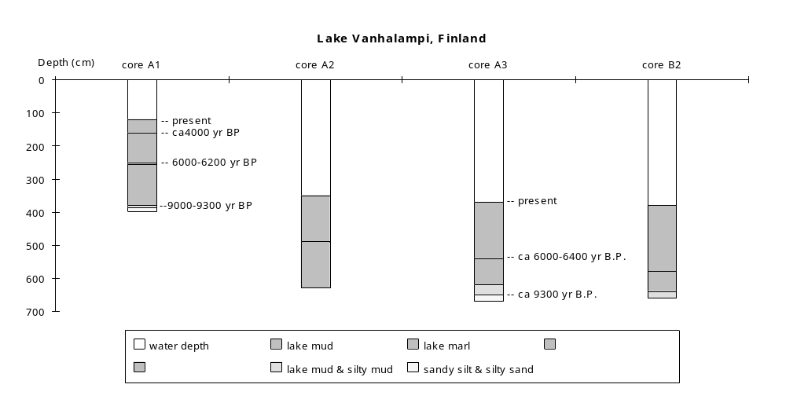

Final coding: 21/5/1993. Coded by GY and SPH

